Research Paper on Sandro Botticelli
Student’s Name
Class
Date

Research Paper on Sandro Botticelli
Introduction
Sandro Botticelli whose original name is Alessandro di Mariano di Vanni Filipepi was born on March 1st, 1445 in Florence Italy was an Italian painter whose works were major during the Renaissance period. He became one of the most innovative painters of his time and his work represents the linear grace of the Early Renaissance. Sandro withdrew from school to become an apprentice. He first trained as a goldsmith and later started working for the artist Fra Filippo Lippi. Botticelli began his artistic career through painting churches and the cathedrals in Florence. He trained with Filippo and Antonio Del Pollaiuolo and he had his own workshop by 1470. Botticelli joined the fraternity of Florentine painters. He got a breakthrough in his work by completing a piece of work by Filippino known as the Adoration of the Kings. Working as an apprentice with Fra Filippo enabled him to have many contacts. Botticelli spend most of the time working for the Medici family and their friends. Botticelli became famous and in 1481the Pope called him to help decorate the walls of the Sistine Chapel in Vatican. The work of Botticelli is highly appreciated due to his creativity. He introduced his famous mythological work which is loved by many. Some of his creative works include the birth of Venus
Figure 1 shows a nude woman at the center who is believed to be Venus. She has been isolated and no other figure overlaps her. Additionally, she has a slight tilt of her head and leans in an awkward stance. The painter gives much attention to her hair and beauty as her face has no blemish. On the left side, Venus rides on a seashell and sea form to depict that she was born out of form and rides to the shore. For the painting, Sandro used tempera on canvas as the medium of the painting. In those years, wood was mostly used as the surface for the painting but Botticelli chooses to use canvas as it had started to gain acceptance by most painters. Canvas had a lower cost as compared to wood. Additionally, the canvas was less formal; therefore, it was appropriate for the painting. The function of the painting is to show the writings of the traditional poet known a Homer. The painting shows how Venus rode on a seashell and sea form after she was born. Also, in Figure one Botticelli uses dark lines around the contours of Venus’ body. The effect of this is to allow the viewer see the bodily form against the background. Additionally, it emphasizes on the color of her skin which is milky. Figure 1 depicts several gods where Venus is the goddess of love and is blown to the shore by Zephyr the west wind god. Horae the seasons goddess is prepared to dress the newborn goddess. Additionally, the painting brings a new view to nudity. In the Renaissance period nudity was not allowed or portrayed but the emergence of humanism renewed interest in ancient Rome myths and the resurrection of nudes.
Figure 2 shows a family that is made up of a man, his wife in a blue cloak and a new born baby which depicts the Holy family. There are three men kneeling near the baby as the rest of the crowd shows different expressions. The family has been placed at the center of the painting and the three men to show the religious aspect of the Florence and the painter. Additionally, it shows important figures from the Florentine society and the powerful members of the Medici family. The setting of the painting is in old ruins and Christ, Mary and Joseph look like normal humans which depict Christ's humble roots. Figure 2 uses bright colors to show the three Magi who came to worship Christ. The kneeling men in black, red and white with gold represent the Magi and the rest are their attendants. The Magi represent members of the Medici family. Additionally, the painting uses a wide range of colors and imagery to show the wealth of the people in Florence. Botticelli uses Tempera on wood as the media for the painting to show that Sandro does not pay attention to the linear texture. The use of the vivid bright colors brings out the strength in the aesthetic of the painting. The painting shows the culture in Florence in particular how the Florentines dressed and looked. Figure 2 has biblical connotations and historical traditions; therefore, it has a religious meaning. The painting involves the Holy family of Joseph, Mary, and Christ who are at the center. The three Magi who had brought gifts to offer them to the Holy family and are kneeling show that Christ deserves to be worshiped. Also, the painting shows sacredness and humble realism through the old ruins setting.
Conclusion
The works done by Botticelli depict innovation and creativity. He uses different themes to capture the attention of the viewers. Additionally, Botticelli focuses on the Medici family in most of his paintings. The family was made of powerful politicians and bankers who ruled Florence at the time of the Renaissance. Additionally, Botticelli shows the lifestyle and beliefs of the people of Florence in most of his works. He adds a blend of culture, beliefs and religion to his work. The work of Sandro has become an inspiration to many in the modern day era as he is placed in the view of contemporary intellectual movements. The majority of the works of Botticelli are still reliable and up to date with the current lifestyle of people.

Figure 1: Birth of Venus: Sandro Botticelli, Tempera on Canvas, c. 1484-86
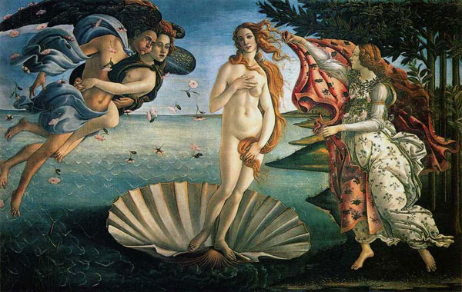
Analysis of the Art of Renaissance Italy “Botticelli's Birth Of Venus - Italianrenaissance.Org". Italianrenaissance.Org, 2016, http://www.italianrenaissance.org/botticelli-birth-of-venus/.

Figure 2: Botticelli, Adoration of the Magi, 1481, 28"x 41". National Gallery of Art, Washington, D.C
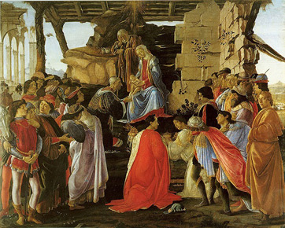
National Art Gallery "The Adoration Of The Magi". Nga.Gov, 2016, http://www.nga.gov/content/ngaweb/Collection/art-object-page.24.html.

Work Cited
"Botticelli's Birth Of Venus - Italianrenaissance.Org". Italianrenaissance.Org, 2016, http://www.italianrenaissance.org/botticelli-birth-of-venus/.
"The Adoration Of The Magi". Nga.Gov, 2016, http://www.nga.gov/content/ngaweb/Collection/art-object-page.24.html.

