Name
Instructor
Class
Date
Republic
The Roman republic was indeed the first country known in history to use elected official in representing the issues and interests of its citizens. The picture below is of Gaius Gracchus, who was a leader of the Roman republic in 123 BC (Mirys 1880). Gracchus is seen in the picture to be presiding over the Plebian Council or the legislative assembly of the Roman Republic. He was also elected by the council, whose members were the only ones allowed to vote for leaders of the council unlike the Republics of today that enable each citizen to vote. This image illustrates the value of political systems where elected leaders come together to develop new policies and laws that govern a republic. The picture illustrates Gracchus governing the council or gathering their opinions and thoughts that they have gathered from the citizens. In the background, there are also members of the pubic present meaning they are there to witness the political process taking place. The area is also illustrated as most parliaments or legislative assemblies where legislative members come together to discuss, alter, pass, and contest new and existing legislation and laws. The leader of the council sets the debate for discussion or a motion that will see the agenda of the day disused and a resolution reached. The republic relies on laws and regulations. The picture also illustrates how the constitution, which governs a republic is developed to ensure that the elected few develop and change new and existing policies and laws. The picture is also a sign of equity since the issues of policy are not developed by a single person, but through a democratic process of voting or passing on new laws.
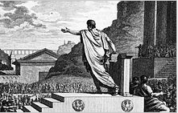
Mirys, D. Silvestre. Gaius Gracchus, tribune of the people, presiding over the Plebeian Council. 1880. ISSUU. Web. 6 October 2016. <https://issuu.com/romanroadsmedia/docs/draft_2_of_art_guide>
The second image illustrates Roman Forum, which was the cultural, commercial, and political hub of the Roman city and republic. This are of place housed most of the republic’s offices and meeting places for elected officials (Panini 1800). It is notable to each country on the buildings that are used by top government officials and elected members. For instance, in the U.S, the Senate and White House are symbolic constructions that illustrate the values of a republic. For once, these are building where historical policies or laws are developed. They reflect the ability of elected officials to represent the interest of the many in closed doors and emerge with a policy that shapes the entire republic. This picture clearly illustrates the Roman Forum as it was later after the Roman republic seized. Although it may be in ruins and occupied by citizens, t still holds increased value in the historic politics of the republic. Even significant features of a republic such as the constitution are passed through the closed doors of parliaments and state houses. The same case applies here where the picture clearly illustrates the Roman Forum as a historical site in the political events of the Roman republic. Both images are a clear illustration of the democratic system of politics, which is a unique value in a republic. Most countries engage intensively on legislative matters in parliament. Furthermore, the the first picture of Gracchus could also be the same place as the second picture. Therefore, it illustrates that the pictures do tell the values and features of the first ever republic as well as reflects on the values in today’s republics.
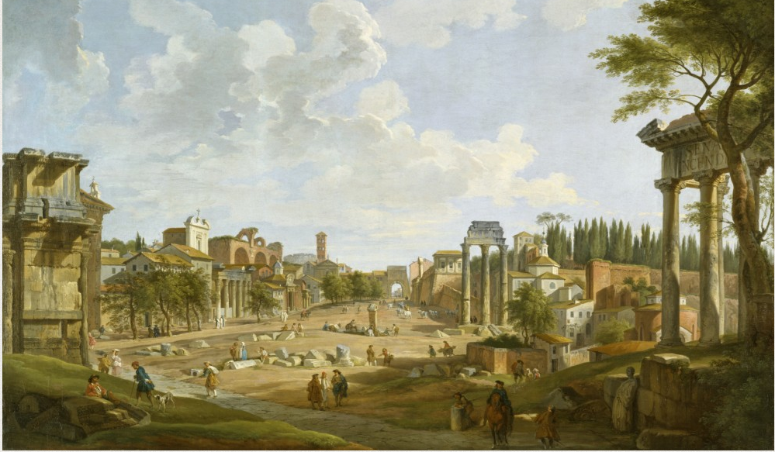
Panini, P. Giovanni. View of the Roman Forum. 1700s. The Walters Museum. Walters Museum. Web. 6 October 2016. <http://art.thewalters.org/detail/24230/view-of-the-roman-forum/>

Works Cited
Mirys, D. Silvestre. Gaius Gracchus, tribune of the people, presiding over the Plebeian Council. 1880. ISSUU. Web. 6 October 2016. <https://issuu.com/romanroadsmedia/docs/draft_2_of_art_guide>
Panini, P. Giovanni. View of the Roman Forum. 1700s. The Walters Museum. Walters Museum. Web. 6 October 2016. <http://art.thewalters.org/detail/24230/view-of-the-roman-forum/>

