Why might an increase in government expenditure give rise to inflation?

Name:
University affiliation:
Course:
Date:

Table of Contents
1.0 Introduction 3
2.0 Causes of inflation 3
3.0 How the government inflates prices of goods and services 5
4.0 How to control inflation 6
5.0 Conclusion 6

1.0 Introduction
In the global economy, there is a mutual agreement that when the economy begins to deteriorate, the government should do “something” to improve the economic environment of the economy through spending. The government respond by either increasing borrowing or printing more money. However, increased government spending has been well known to cause inflation. Inflation can be defined as the general increase in prices of goods and services. Bagus, Howden and Gabriel (2014) suggested that even analysts who claim to understand the causes of inflation advocate increased government spending. These economists seem not to understand the dismal history of government attempts to control economic downturn by increasing spending. The impact of increased government spending has been studied by different economists such as Keynes and Friedman. According to Keynes, when the government employs expansionary fiscal policy, it leads to persistent inflation.

2.0 Causes of inflation
During expansionary policy, the government tends to increase spending through borrowing or printing more money in order to spur economic growth. However, increased money circulation in the economy causes the general price of goods and services to increase. The government has many ways it can improve money circulation in the economy or reduce it. For instance, if the level of inflation is too high, the government can increase taxes which would reduce money circulation in the economy. If the government increases both taxes and spending, it would lead to increased GDP. Hussman (2016) elucidated that during a recession, consumers reduce spending that is associated with high private sector saving. Thus, even if the government increases taxes, it might not reduce spending as much. The impact of increase government spending is the multiplier effect which supports GDP growth.
Inflation is the result of money supply in the economy being higher than the aggregate growth rate of the economy. The direct impact of increased government spending is a general rise in price that is not a result of the fluctuation of demand and supply. In simple term, during inflation, there are too many dollars in the economy purchasing too few goods. The result of this scenario is a general increase in prices of goods and services. This can also be compared to deflation when the economy grows faster than money supply. The result is few dollars chasing many goods. Increased government spending result to what is termed as wage inflation and price inflation, however; these terms are rarely used by economists. Wage inflation is the impact of market-based response to changes in demand and supply for labor while price inflation is the result of changes in demand and supply of goods and services. In many countries such as the US and the UK, the central banks are mandated to implemented expansionary policies that maximizes economic growth while minimizing inflation. However, it is difficult to predict the outcome of an expansionary policy perfectly (in order to achieve stasis) many central banks predicts an inflation of <2% since inflation is not much of a problem to the economy compared to deflation. For instance, the graph below shows that as federal spending increases, inflation rate also rises.
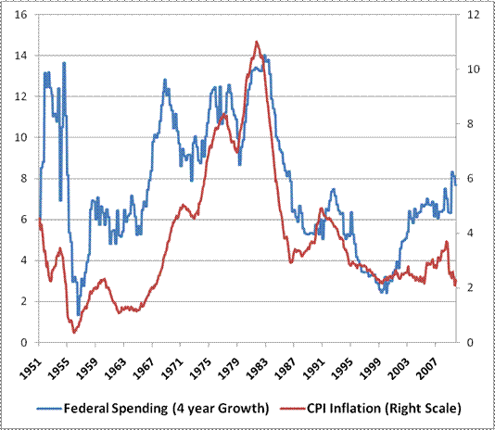
Retrieved from http://www.hussmanfunds.com/wmc/wmc100119.htm
There are several ways the government can increase the money supply in the economy. For instance, the US government increases the money supply by expanding the money market through monetizing of the federal budget or through the credit expansion by commercial banks. Increased government spending leads to change in supply and demand for labor, goods and services. During this period, the economy is expected to grow due to the high supply of money in the economy. High private sector spending can also cause inflation, however, in both cases, spending does not result in inflation. So the main question is what causes inflation in the economy. There are many reasons why inflation occurs is due to government printing more money. In the US for instance, when the central bank prints more dollars which are pumped into the economy it causes inflation. Money supply in the economy plays a critical role in determining the prices of goods and services. If the money in the economy is more, there will be a general rise of goods and services. In some cases, it might result in hyperinflation which is associated with increased price of goods and services.

3.0 How the government inflates prices of goods and services
He and Zou (2016) argue that inflation is a deliberate action of politicians who do not intend to reduce government spending. Since government spending is higher than money being collected from the economy, new money is created to cover the deficit. In most cases, unbalance budget causes the government to print more money because what is being collected through taxes cannot meet the current expenditure. Therefore, the inflation stems from the unwillingness of the government to reduce spending or borrow from the public. The politician wants to increase government spending but they do not want to raise taxes. Since raises taxes is unpopular, inflation becomes the end result of deficit financing. To resolve the deficit, the government prints more money and citizens benefit because they do not have to pay higher taxes. However, the public later realizes that the dollars are not worth what they use to be previously. This strategy can be referred as monetary debasement where the government scheme is applied to take money from people.
Some exorbitant government spending is the result of the government effort to ensure equal distribution of good and services. Politician uses their abilities, rationality and ability to control the society to ensure equal distribution of goods and services to support the most deserving people in the country. Inflation enables money transfer from creditors to debtors (the federal government is the largest debtor). This enables the government to pay debt with a currency that is worth less compared to when the debt was assumed. Consequently, inflation causes the government to repudiate a debt by depreciating the purchasing power of debts.

4.0 How to control inflation
Olasunkanmi and Yetunde (2016) concluded that the best way of controlling inflation is through contractionary policy. The main objective of this policy is to reduce money supply in the economy by either reducing bond prices or rising interest rates. This strategy is effective because it reduces public spending by taking more money from the economy. It also means there is less available credit because it is expensive to borrow.
5.0 Conclusion
government policies have a direct impact on the level of inflation in a country. Inflation is the result of increased government spending without raises taxes. The government finances the deficit through borrowing or printing more money. When the flow of money into the economy is higher than the economic growth rate, the price of goods and services rise. Since there is a lot of money in the economy, the dollars lost value in terms of the goods they can buy compared to previous periods. Inflation stems from the unwillingness of the government to reduce spending or borrow from the public. The politician wants to increase government spending but they do not want to raise taxes. Since raises taxes is unpopular, inflation becomes the end result of deficit financing.

References
Bagus, P., Howden, D., & Gabriel, A. (2014). Causes and Consequences of Inflation. Business & Society Review (00453609), 119(4), 497-517.
He, Q., & Zou, H. (2016). Does inflation cause growth in the reform-era China? Theory and evidence. International Review Of Economics & Finance, 45470-484.
Hussman, J. (2016). Hussman Funds - Weekly Market Comment: Inflation Myth and Reality.Hussmanfunds.com. Retrieved 26 September 2016, from http://www.hussmanfunds.com/wmc/wmc100119.htm
Olasunkanmi, O. I., & Yetunde, S. H. (2016). Does Fiscal Deficit Granger Cause Impulsiveness in Inflation Rate in Nigeria?. Acta Universitatis Danubius: Oeconomica, 12(4), 208-216.

