International Marketing-Overseas Expansion of Made Group to Phillipines
Name
University

Executive summary
This report has focused on the international expansion strategy of Made Group, one of the leading beverage companies in Australia. From this report, it has been established that Made Group manufactures a wide range of beverages including Impressed Cold Dressed Juice, Rokeby Farms High Protein, Cocobella Coconut Water, and NutrientWater. Over the past three years, the company has recorded a significant growth in revenue, reaching 65 million US dollars in the last three years. Considering this, the company needs to expand one of its product; NutrientWater, overseas, in an attempt to increase its sales and profits. Precisely, the company needs to expand its enhanced water to Philippines, which is one of the largest potential markets in Asia. With a population of about 98 people, it has been established from this report that Philippines will be an excellent market that Made Group need to tap into. Besides, the country has a robust economic growth coupled with political stability. In order to tap this market, this report has established the company will exporting will be the preferred choice of market entry, where the company will use various distributors in the country as well as sales representation. Despite the fact that there are various firms in the industry which sell enhanced water to consumers, differentiation strategy that will be employed by the company, where the company will provide unique enhanced water, free from artificial ingredients. With this strategy, Made Group is expected to record substantial sales of NutrientWater, which will improve the overall profitability of the company.

Table of Contents
1.0 Introduction 3
2.0 Company and product analysis 3
3.0 Comparative country and product market attractiveness 4
3.1 Comparative analysis of Philippines and Singapore 4
3.2 Assessment of macro-environment of Philippines 5
3.3 Product market analysis 6
3.4 Competitor analysis 7
3.5 Buyer analysis 7
4.0 Market selection 8
5.0 Entry strategy 8
6.0 Conclusion 9
References 10

1.0 Introduction
For most firms across the globe, building and maintaining local customer base of usually one of the main steps towards success (Cateora et al. 2012). However, after an organisation has established itself successfully, there is always a significant need to consider expanding overseas. This is usually for the primary reason of increasing sales and profits. According to Casson (2013), increased globalisation over the last few years have made expanding into foreign markets substantially easier for both large as well as small businesses. Despite the fact that the process of expanding overseas is usually hindered by various factors such as laws, languages, and cultures, many organisations have been able to overcome these roadblocks. In this light, Banalieva and Dhanaraj (2013) have asserted that one of the ways of minimising the impact of these challenges is choosing an effective entry strategy. Taking this into consideration, this report focuses on international expansion of Made Group with its main product, NutrientWater. The report carries a comparative analysis of Philippines and Singapore, which are potential market. The report also recommends the best country that Made Group should consider, as well as the entry mode strategy.

2.0 Company and product analysis
Founded in 2005 by Luke Marget, Bran Wilson, and Matt Denis, Made Group is one of the vertically integrated beverage companies in Australia (Made Group, 2016). While Made Group is headquartered in Melbourne, the company has offices in Sydney, Perth, and Brisbane. Over the past few years, Made Group has gained a lot of customers, who have significantly contributed to the growth of the company. Specifically, the company currently has a network distribution network of more than 20000 retail customers, who range from independent customers to various retail chains across Australia (Made Group, 2016). As explained by Mitchel (2016), this valued distribution network, coupled with its own manufacturing facility has provided the company with the best resources needed to bring new product innovations to the market. Besides, these factors have substantially helped in delivering growth in the company over the last couple of years. As depicted by Carmody (2016), nutrition, convenience, hydration, as well as enjoyment has been the consistent qualities across all the brands of the company. Taking this into consideration, the Made Group Company has over the years used fresh and natural ingredients. This has set the company apart from other firms in the industry, which use artificial substitutes and preservatives. Taking this into account, Mitchel (2016) asserts that this has been part of the company’s commitment when it comes to promoting healthy lifestyles. While the company has been able to manufacture various brands over the years, the most popular brands of the company include Impressed Cold Dressed Juice, Rokeby Farms High Protein, Cocobella Coconut Water, and NutrientWater, which is enhanced water (Made Group, 2016). Over the past years, the company has aimed at identifying a niche in food as well as beverages category, which have a significant potential to become mainstream and developing various processing techniques that can enable the company to sell premium products as prices that are affordable.
NutrientWater is one of the leading enhanced water brands in Australia (Cavusgil, 2014). In this light, the product is made up of purified water, natural flavours and colours, as well as a dose of essential nutrients. According to Mitchel (2016), NutrientWater was the first product to be launched by the company. Taking this into consideration, since its launch, NutrientWater has significantly created a new category in the Australian market as regards the non-alcoholic beverage industry in the country. Additionally, the boom in the enhanced water industry in Australia has followed the recent changes by the national food regulations, which allow various vitamins to be added to products that are water-based. Therefore, this has considerably created a significant demand for NutrientWater, which in turn has translated to more profits margins by the Made Group Company. This has been made possible through effective distribution channel of the company. Precisely, the company has over 20 sales representatives across the country, who market the product across various customers. Taking this into account, the target market for the company in relation to NutrientWater include independent cafes, health food stores, bakeries, gyms and sporting clubs, petro stations, grocery chains, as we;; as convenience stores among others (Carmody, 2016). Some of the main customers of the company include Coles and Woolworths. In terms of promotion, Made Group has invested heavily on various methods of sales promotion, which has included rigorous advertisements as well as the use of various social media platforms such as Facebook and Twitter. Besides, the company has uniquely designed the packaging of NutrientWater, with different colour combinations. This as a result has made the product attractive among most of the consumers across Australia. In terms of pricing, although the Made Group Company has provided quality enhanced water to the customers, it has ensured that the prices have remained affordable to most of its customers (Mitchel, 2016). This perhaps explains why the sales of the company have recorded upward growth over the last three years.
Despite the fact that expanding overseas is usually dependent on various factors, Banalieva and Dhanaraj (2013) have emphasised that availability of resources is one of the main factors. Taking this into consideration, Made Group can be considered to have adequate resources for expanding its NutrientWater to international market. As found out by Carmody (2016), the revenue of the company has grown by about 50 percent annually over the last three years to 65 million US dollars. In this regard, the products of the company have generated retail sales of about $120 million US dollars in the last three years. With such, it can be deduced that the company has enough resources to expand to overseas market in relation Nutrient Water.

3.0 Comparative country and product market attractiveness

3.1 Comparative analysis of Philippines and Singapore
Both Philippines and Singapore are ideal locations for global business. Taking this into account, as explained by Yoneda (2015), both Philippines as well as Singapore have strong trade and investment aspects, which make them to among the most competitive Asian countries when it comes to starting and operating business. Therefore, when it comes to the case of Made Group expanding its NutrientWater in this country, it can be a significant milestone for the company. This is due to the fact that tapping any of these countries can substantially increase the profitability of the country. Additionally, the economic growth Philippines and Singapore have been growing at a steady rate of 5% and 6.8% respectively (Yoneda, 2015). This means that the purchasing power of consumers in these countries has increased, and therefore more customers will be able to purchase the enhanced water of Made Group. In both countries, there is political stability, and therefore business can do their operations effectively with the fear of any political arrest. Furthermore, as explained by Lin and Ewing-Chow (2016), pollution rate in both Philippines and Singapore is significantly high. Taking this into consideration, the choices of drinking water have significantly gone down. Owing to this factor, enhanced water has now remained the most preferred choice of drinking water among most of the people in these countries. This implies that there is ready market in these countries for Made Group to tap in. Nevertheless, despite the ease of doing business in both Philippines and Singapore is almost the same, the market size is much different. Specifically on this, while the population of Philippines is approximately 98 million, the population of Singapore is just 5.6 million (Lin & Ewing-Chow, 2016). Considering this, it shows that there are more business prospects in Philippines as compared to Singapore. Given the disparity of the market sizes between the two countries, Made Group will consider expanding its NutrientWater to Philippines. This is due to the fact that the option will yield the most benefits in terms of sales as well as profitability.

3.2 Assessment of macro-environment of Philippines
PEST as espoused by Arnold (2004) is one of the most crucial frameworks used in assessing the micro-environment of a business. Precisely, PEST analysis is used in identifying the external forces that affect an organisation. This is typically in terms of political, economical, social, as well as technological aspects. The PESR model is depicted in the figure 1 below;
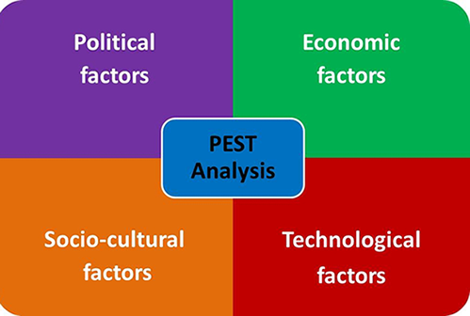
Figure 1: PEST model
Source: Arnold (2004)
Taking the above into consideration, in terms of political aspect, just as in Australia, the political environment in Philippines is significantly stable. This implies that the environments in both countries are conducive for businesses to thrive in. Nevertheless, just like in Australia, the corporate tax in Philippines stands at 30 percent (Rosborg et al., 2015). This percentage is significantly higher as compared to other countries in the regions, such as China, which standards at only 15 percent. Therefore, such high tax rates on the corporate tax may significantly affect the expansion of Made Group into the country in relation to its product, NutrientWater. However, given the corporate tax in both Australia and Philippines is the same, Made Group will incur the same operations costs as far as the corporate tax is concerned.
When it comes to the economic aspect of the PEST framework, Roxas et al. (2016) has asserted that there are various economic factors that affect how organisations operate and male decisions. Some of these factors as opined by Yoneda (2015) include economic growth, inflation rate, exchange rates, as well as interest rates among other factors. Taking this into consideration, when it comes to Philippines, Tamayo (2016) has noted that over the past one decade, the Philippine economy has recorded an annual economic growth of 5 percent (As shown in figure 2 below). This is against the 3 percent annual increase in Australia (Bhattacharya, 2015). Besides, just like in Australia interest rates as well as inflation rates in Philippines have considerably gone down over the last one year. Considering this, the purchasing power of the customers in the country has become higher than ever before. Therefore, this can create an excellent opportunity for Made Group, as it attempts to expand its enhanced water into the country. This implies that expansion of NutrientWater to Philippines by the Made Group will significantly improve the profitability of the company.
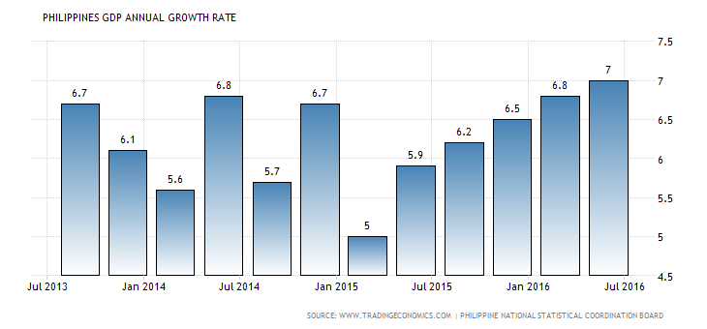
Figure 2: Philippines economic growth
Source: Tamayo (2016).
As regards to the social aspect, Casson (2013) states that it entails cultural aspects, attitudes, age distribution, and population growth among other factors. Taking this into account, just like in Australia, the demand for enhanced water in Philippines has increased considerably over the last few years. This is as many people across all ages crave to live healthy lives. Besides, as explained by Francisco (2014), most people in Philippines believe that enhanced water is far much healthier as compared to other beverages including alcohol as well as carbonated drinks. Therefore, expanding to the country will substantially increase the profitability of the Made Group as far as the sale of the NutrientWater is concerned. Additionally, unlike the low population of Australia of just 24 million (Bhattacharya, 2015), Philippines has a high population of 98 million (Co, 2015). In this light, given that the demand of enhanced water usually span across all ages, Philippines is a ready market for NutrientWater. Therefore, with entry into the Philippine market, Made Group will be assured of increased sales of its enhanced water. This as a result will see the company move to significantly high levels in terms of sales as well as profitability.
Lastly, when it comes to the aspect of technology, Yoneda (2015) has indicated that it typically takes into account various aspects such as automation, R&D, technological change, as well as technology incentives. Such factors, as depicted by Ambler and Styles (2000) can significantly determine entry barriers, outsourcing decisions, as well as minimum efficient production levels among other factors. As regards to the technological aspects in Philippines, just as in Australia, the food processing industry in the country has witnessed a drastic technological improvement over the last couple of years. This has included availability of various technological equipments needed for the manufacturing as well as storage of various foods and beverages. Some of these equipments include immersion freezers, vacuum packaging machine, and water retort among other state of the art equipments (Rosborg et al., 2015). Besides, most firms in the industry have invested heavily on R&D for the purpose of manufacturing products that meet the demand of the customers in the country. Therefore, with expansion of Made Group into the country, the company will leverage on these factors. Consequently, this will be able to provide enhanced water that meets the needs of all the customers in the country.

3.3 Product market analysis
As explained by Santos et al, (2015), the sale of enhanced water in Philippines has registered an annual growth of 4 percent over the last three years. This has been driven by the consumer’s reliance on enhanced water as the main source of drinking water. As noted by Rosborg et al. (2015), most consumers in the country have been found to purchase enhanced water in bulk for the aim of avoiding a wide range of waterborne diseases such as cholera and typhoid fever. Furthermore, Santos et al. (2015) has indicated that the sale of enhanced water is expected to continue growing in the same rate over the next couple of years. This will be fuelled greatly by the increasing population growth in the country of about 1.7 per annum. Additionally, as explained by Rosborg et al. (2015), enhanced water is likely to remain the preferred choice of drinking water in the next many years. Precisely on this, most of the customers in the country are not likely to shift to tap water as their main source of drinking water owing to the concerns about pollution as well as diseases. Given that drinking water is a major necessity among all the consumers in Philippines, there are no major segments in when it comes to the enhanced water market in the industry. Nevertheless, the middle-income earners have in the country have been targeted by most of the firms in this industry owing to their high purchasing power. Precisely, the percentage of middle class in the country stands at 33 percent, and this percentage is expected on grow in the coming years (Rosborg et al., 2015). This creates a ready market for enhanced water in the country. In relation to the product life cycle, enhanced water is at the growth stage, implying that Made Group can leverage on this status through introducing its enhanced water, NutrientWater, in the country. As explained by Francisco (2014), most of the enhanced water manufacturers are usually local. Such manufacturers include Asia Brewery, Genesis Water Technologies, and General Oceanic among many others. However, there are few foreign suppliers including the Coca-cola, which supplies its popular brand, Dasani (Rosborg et al., 2015). In terms of distribution, just like in Australia, most of the distribution network entails the use of retailers including groceries, supermarket, and filling stations.

3.4 Competitor analysis
Just like any other ideal industry, the enhanced water industry in Philippines is competitive to a considerable extent. As aforementioned, there are various competitors in the enhanced water market in Philippines. These competitors are both local as well as international. As depicted by Co (2015), the entry of new enhanced water brands as well as expansion of the existing brands in the country over the last few years have led to reduced prices of enhanced water. This as a result has fuelled the demand of enhanced water across all income levels in the country. The presence of the many firms in the industry has created price wars, as firms struggle to gain a significant market share in the industry. As found out by Francisco (2014), most of the firms that manufacture enhanced water in the country usually have their own manufacturing facilities. In terms of distribution, most of these firms usually use various retailers in making their products available to the consumers. Sales promotion among these firms is intensive, which mostly entails social media advertisements, as well as the use of sales representations. For instance, taking the case of Asian Brewery into account, the company has over 50 sales representatives across the country (Santos et al., 2015).Nevertheless; it has been found that most of the firms in the country use artificial ingredients as well as flavours in the manufacture of enhanced water. Taking this into account, Made Group is likely to gain a competitive edge through the introduction of NutrientWater. This is because the company uses natural ingredients in the manufacture of NutrientWater. Therefore, this differentiation strategy of the company will see it gain a significant market share, as most consumers in the country opt to buy products manufactured using natural ingredients as opposed to artificial ones.

3.5 Buyer analysis
As aforementioned, most of the consumers of the enhanced water in Philippines are the middle-income earners. While this market segment is likely to grow substantially over the coming years, the demand for enhanced water is likely to increase proportionally. Considering this, the target group for the Made Group Company is the middle-income earners in the country. Therefore, as Made Group expands its product in the country, the company will have a significant market share in the market. As asserted by Santos et al. (2015), most of the middle-income earners in Philippines have high disposable income. This means that they can comfortably manage to purchase NutrientWater. Additionally, most of consumers in this group crave for differentiated products. Therefore, given that differentiation is the strategy that will be employed by the Made Group Company in the enhanced water market in Philippines, the company will be in a position of attracting a lot of consumers in the country. This is because the company will introduce a unique product in the market, which is dominated by many firms. However, for the purpose gaining a considerable competitive edge in the industry, there are various aspects that the Made Group will have to put into account for the purpose of attracting the target customers. Firstly, the company will have to consider the aspect of price. On this, Co (2015) has indicated that despite the high spending habits of the middle-income earners in the country, most of the customers are price sensitive. Therefore, in order for Made Group to attract customers, there is need to put premium prices for NutrientWater. In terms of product quality, the company should continue manufacturing the enhanced water using natural products in order to attract and retain customers. In relation to promotion, in order to remain competitive Made Group will leverage on various sales promotions methods. For instance, given that most of the target customers are on various social media platforms such as Facebook, the company will also use this platform in attempt to attract customers.

4.0 Market selection
From the above, it has been established that Philippines is the country that Made Group should consider venturing. This is due to the fact that the market size in the country is much bigger s compared to Singapore. Thus, it will be more feasible for Made Group to expand its enhanced water to Philippines as compare to Singapore. With a population of about 98 people, Philippines stand out to be an excellent market that Made Group need to tap into. Taking this into consideration, expanding NutrientWater to the country will make the company increase its customer base, which will translated to more profits. Despite the fact that there are many firms in the industry which sell enhanced water to consumers, it is a fact that the differentiation strategy that will be employed by the company will give a competitive edge over other firms in the industry. Specifically, unlike most of the firms in the industry which manufacture their enhanced water through the use of artificial ingredients and flavour, Made Group will use natural resources. Through this, the company will produced a unique product, that will meet the need of the customers, who have become health conscious. Through such, Made Group will have a significant market share in the industry.

5.0 Entry strategy
A marketing entry strategy, as depicted by Roxas et al. (2016) usually maps out various ways of selling, delivering as well as distributing products in another country. According to Arnold (2004), when an organisation has decided to enter into an overseas market, there are various options that it can take into consideration. Nonetheless, Ambler and Styles (2000) have asserted that these options typically vary with the cost, risk, as well as the degree of control that can be exercised over them. While there are various foreign market entry strategies, the most common ones include exporting, licensing, franchising, partnering, and joint venture (Cateora et al. 2012). These strategies have been depicted in the figure 3 below. According to Banalieva and Dhanaraj (2013), the simplest form of foreign market entry strategy in exporting. Taking this into account, exporting is typically the process of selling of goods as well as services produced in one country to another country. Yoneda (2015), on the other hand terms exporting as the marketing as well as direct sale of locally produced goods in another country. Exporting is one of the most established methods of reaching foreign markets. Given that exporting does not need the goods or services to be produced in the target country, investment in production facilities is not required. In this light, most of the costs associated with exporting mostly usually involve transportation and marketing expenses. As explained by Roxas et al. (2016) there are ideally two types of exporting. These are direct and indirect exporting. As regards to direct importing, it typically involves selling and delivering products to the client directly. In this case intermediaries are usually avoided at all costs. On the other hand, when it comes to indirect exporting, it involves the case where an organisation decide to import through the use of intermediaries. Such intermediaries may a trading house, a representative, or a foreign distributor.
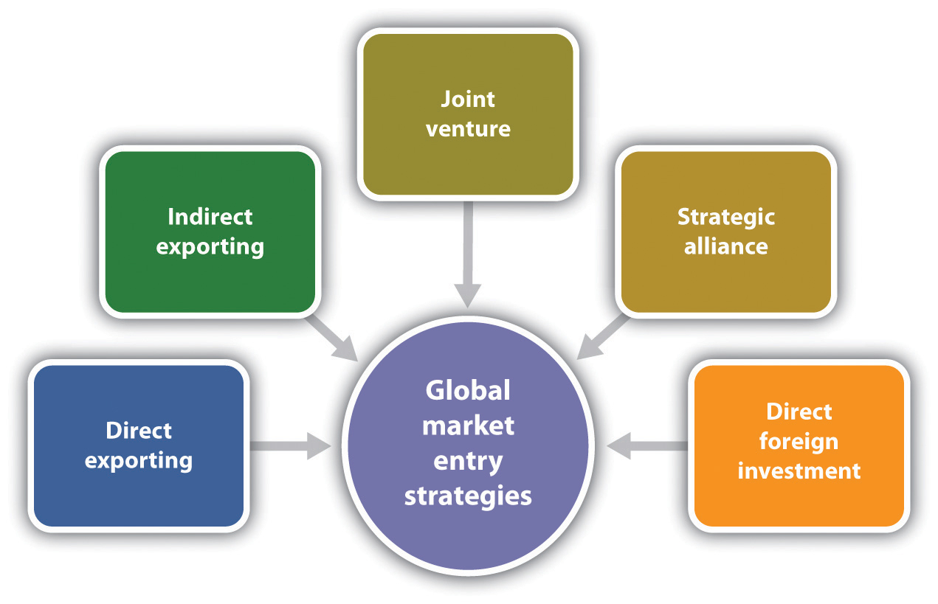
Figure 3: Foreign market entry strategy
Source: Ambler and Styles (2000)
When it comes to the entry strategy that will be employed by the Made Group Company in entering Philippines with the NutrientWater, exporting will be the best option. Precisely, the company will use direct exporting, the company will sell its products to various wholesalers across the world. Sea transportation will be used by the company, given that is usually cheaper as compared to air transport. This will ensure that the company does not incur a lot of expenses. However, Made Group will consider opening warehouses in Manila City. This will be the primary hub from where the product will be taken to various distributors across the world. Some of the distributors that the company will target include large supermarkets in the country including Ever supermarket, Fisher Supermarket, Isetann, Robinsons Supermarket, and SM Prime Holdings among other supermarkets in the country. Beside, just as it carries its operation in Australia, Made Group will also use cafes, filling stations, as well as groceries in distributing NutrientWater across the world. Made Group will also make use of sales representatives, who will market NutrientWater across Philippines. Precisely, given the high population of Philippines, about 200 sales representatives will be used to market NutrientWater across different regions in the country. Through this, NutrientWater will attract more customers, who will help the company increases its sales as well as profitability.

6.0 Conclusion
This report has found out that Made Group is one of the leading beverage companies in Australia, manufacturing a wide range of beverages including coconut water and enhanced water. The performance of the company over the last three years as seen in this report has been promising to a considerable extent. Taking this into account, the company needs to expand one of its product; NutrientWater, overseas, in an attempt to increase its sales and profits. From this report, it has been established that Philippines is the country that Made Group should consider venturing as compared to Singapore. This is because the market size of Philippines is much bigger s compared to Singapore. With a population of about 98 people, Philippines will be an excellent market that Made Group need to tap into. In order to tap this market, the company will direct exporting will be the preferred choice of market entry, where the company will use various distributors in the country as well as sales representation. Although it has been established from this report that firms in the industry which sell enhanced water to consumers, differentiation strategy that will be employed by the company, where the company will provide unique enhanced water, free from artificial ingredients. Through this strategy, Made Group will have a significant market share, which will see it move to higher heights in the near future.

References
Ambler, T., & Styles, C. (2000) The Silk Road to International Marketing: Profit and Passion in Global Business. Financial Times Management.
Arnold, D. (2004) The mirage of global markets: How globalizing companies can succeed as markets localize. Upper Saddle River, NJ: Prentice Hall.
Banalieva, E. R., & Dhanaraj, C. (2013) “Home-region orientation in international expansion strategies”, Journal of International Business Studies,44(2), 89-116.
Bhattacharya, M. (2015) “Business growth, size and age: Evidence from the Business Longitudinal Survey (BLS) data in Australia”, Australian Economic Papers, 53(3-4), 129-138.
Carmody, B. (2016) What Luke Marget has learnt from starting up $65 million beverages company MADE Group. Smart Company. Retrieved from: http://www.smartcompany.com.au/entrepreneurs/influencers-profiles/69904-what-luke-marget-has-learnt-from-starting-up-65-million-beverages-company-made-group/
Casson, M. (Ed.). (2013) The Growth of International Business (RLE International Business). Routledge.
Cateora, P. R. Sullivan Mort, G., D’Souza, C., Taghian, M., Weerawardena, J & Graham, J., (2012) International marketing. New York: McGraw-Hill Irwin.
Co, M. J. (2015) “Perceived institutional obstacles in doing business: a comparative study of South Africa and the Philippines”, South African Journal of Economic and Management Sciences, 7(1), 89-99.
Cavusgil, S. T., Knight, G., Riesenberger, J. R., Rammal, H. G., & Rose, E. L. (2014) International business. Pearson Australia.
Francisco, J. P. S. (2014) “Why households buy bottled water: a survey of household perceptions in the Philippines” International Journal of Consumer Studies, 38(1), 98-103.
Lin, L., & Ewing-Chow, M. (2016) “The Doing Business Index on Minority Investor Protection: The Case of Singapore”, Singapore Journal of Legal Studies, 46.
Made Group. (2016) Our Brands. Retrieved from: http://madegroup.com/our-brands/
Mitchel, S. (2016) Australian beverage company MADE is heading to Asia. Business Insider Australia. Retrieved from: http://www.businessinsider.com.au/australian-beverage-company-made-is-heading-to-asia-2016-5
Rosborg, I., Nihlgård, B., & Ferrante, M. (2015) Mineral Composition of Drinking Water and Daily Uptake. In Drinking Water Minerals and Mineral Balance (pp. 25-31). Springer International Publishing.
Roxas, B., Ashill, N., & Chadee, D. (2016) Effects of Entrepreneurial and Environmental Sustainability Orientations on Firm Performance: A Study of Small Businesses in the Philippines. Journal of Small Business Management. 5(34), pp.78-112,
Santos, J., Latayan, J., Pagsuyoin, S. A., & Srija, S. (2015, April) A stakeholder-based survey for assessing the viability of a water biofilter concept in the Philippines. In Systems and Information Engineering Design Symposium (SIEDS), 2015 (pp. 13-18). IEEE.
Selvanathan, S., Selvanathan, S., & Keller, G. (2014) Business Statistics: Australia/New Zealand. Cengage Learning.
Suzuki, S., & Okamuro, H. I. R. O. Y. U. K. I. (2015, May) Determinants of Academic Startup's Orientation toward International Business Expansion. InDRUID 2015 conference proceedings.
Tamayo, A. (2016) Social Market Economy, Government and Philippine Development Introductory Concepts to Social Market Economy. Article appeared in http://www. cdpi. asia/index. php/2016-02-05-03-09-27/publication.
Whitelock, J. (2013) “Entry and co‐operative strategies in international business expansion”, International Marketing Review. 6(3), pp.23-78
Yap, E. G. (2012) “Role of a local government of CEBU in attracting and maintaining investments in Central Philippines”, IAMURE International Journal of Business and Management, 1(1), pp.100-123.
Yoneda, M. (2015) “Doing Business in the Global Village: Japanese Professionals on EL Needs in Singapore”, Education Research and Perspectives (Online), 42(1), pp.166.

