1.1 Rationale of the Study
Risk is the main cause of uncertainty in any organisation. Thus, companies increasingly focus more on identifying risks and managing them before they even affect the business. The ability to manage risk will help companies act more confidently on future business decisions. Their knowledge of the risks they are facing will give them various options on how to deal with potential problems. Risk can be caused by internal and external sources. The external risks are those that are not in direct control of the management. These include political issues, exchange rates, interest rates, and so on. Internal risks, on the other hand, include non-compliance or information breaches and operational risk among others. Recently, many companies have added risk management departments to their team. The role of this team is to identify risks, come up with strategies to guard against these risks, to execute these strategies, and to motivate all members of the company to cooperate in these strategies. Larger organisations generally face larger risks, so their risk management strategies also need to be more sophisticated. Also, the risk management team is responsible for assessing each risk and determining which of them are critical for the business. The critical risks are those that could have an adverse impact on the business; these should then be given importance and should be prioritized. The whole goal of risk management is to make sure that the company only takes the risks that will help it achieve its primary objectives while keeping all other risks under control. Risk management is important in an organisation because without it, a firm cannot possibly define its objectives for the future.
The effectiveness of the business environment in the insurance sector is based on healthy risk assessment and management. Failure to comprehensively employ mechanisms that reduce the instances of uncontrollable risk in the business can result in complete business failure. The grand guardian insurance company has over the years grew into an institution that addresses the insurance need in Myanmar thus a need to establish the mechanisms, policies or plans that its management has put in place to ensure the success. This study will focus on establishing a link between its policies, its success in offering its insurance policies and the effects of the policies to the situation of risk management in the large insurance industry.

1.2 Objectives of the study
There are two objectives in this study.
- To identify the type of risk occurred and risk management process in Grand Guardian Insurance (GGI)
- To analyse the effectiveness of risk management process in Grand Guardian Insurance (GGI)

1.3 Scope and Method of the study
In this study, thirteen insurance private and public insurance company in Myanmar, only mainly focused on the risk management of Grand Guardian Insurance Public Company Limited in Yangon because that company is increase growth in insurance market and system and procedures are smooth and effective. Descriptive research method is applied to explore the fundamentals of risk management and benefit of risk management proactive of Grand Guardian Insurance Company. To achieve the main objective of the study, both primary and secondary data will be applied. The primary data is acquired from in depth interview with responsible persons of Grand Guardian Insurance Public Company Limited Head Office and general field observation of risk management practices. Secondary Data will use Audited Annual Report of financial statement from GGI Website during the period from, 1st April 2013 to 31 March 2017, previous risk management research paper, relevant Risk Management Text books and Internet websites. This research paper is analysed the risk management process of GGI based on collected data and information. There is no previous research paper of MBF graduate. Therefore online surfing about risk management is undertaken. In this thesis paper is specialized on a risk management, Insurance Principles and Market Practice by The Malaysian Insurance Institute Text Book.

1.4 Organizational of the study
This study is organized into five chapters. Chapter one is introduction; it includes rational of the study, objectives of the study and scope and method of the study and organization of the study. Chapter two involves theoretical Background of risk management process, which consists of develop risk mitigation strategies and finally manage the company risks manner. Chapter three is profile of Grand Guardian Insurance Public Company Limited, type of insurance risks and risk management process of GGI. Chapter four is analyses of the risk management of Grand Guardian Insurance Public Company Limited. Chapter five is the part of the finding, recommendation of the study and limitations and need for further research.

2.3 Risk Management Policy and Process
In simple terms a policy should address why risk management will be undertaken, who within and outside the organization will undertake it , how it will be undertaken by reference to the framework and process and internal functions and what those who are responsible will be required to undertake. This will include describing the specific responsibilities of the board and (depending on the size of the organisation) internal audit, external audit, the risk committee, the corporate governance committee, the central risk function, employee and third party contractors-in implementing risk management. Risk management process is broken down into seven stages communication. While activities follow a largely sequential patten, it may be a highly interactive process over time. For instance, as new risks are identified, the earlier processes of identification and analysis are revisited and the subsequent processes are repeated through to the implementation of risk response actions.
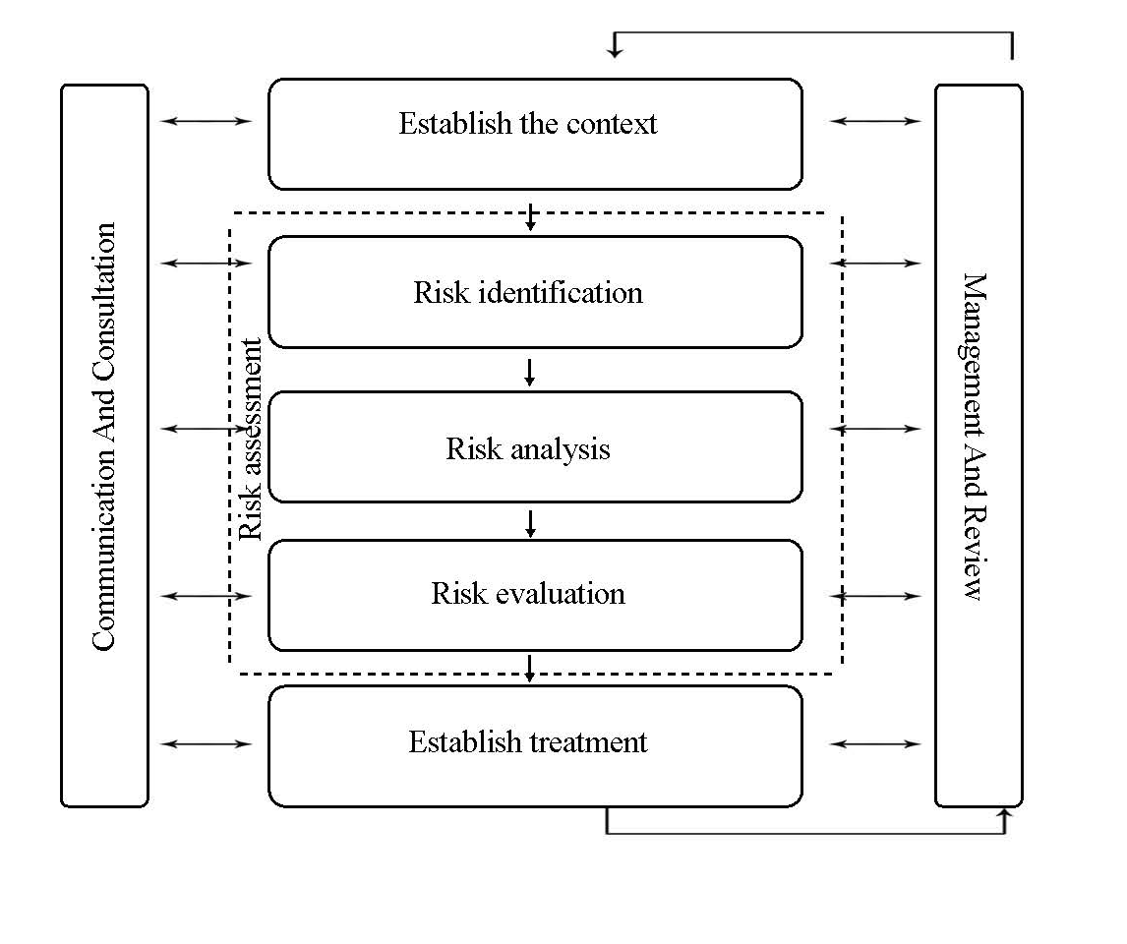
The risk management concept evolves with the gradual emergence of new risk measures and involves the combination of some basic steps. Risk analysis begins with the risk identification, an evaluation of the insurance’s exposure to uncertainty. This requires a detailed view, not only of the bank’s philosophy and operation but also of the market and of the general environment in which it operates and exists. The steps in risk management must be carried out one step at a time, beginning with risk identification. A wrongly identified risk may cause the entire risk management process to be wrong, be of no value or even haven an adverse effect.
Figure 2.1 The Model of Risk Management Process

Source: Carmen Nadia Ciocoiu and Razvan Catalin ( based on ISO31000 : 2009 )

Risk Identification
The first step in risk management is risk identification. This step looks at all pure risks to identify: any physically damage to property, business interruption losses, possibility of liability lawsuits and losses arising from fraud, criminal acts of key employees. Loss exposures can be identified using various sources including questionnaires, financial statement, flow charts and personal inspection of facilities.
Risk Evaluation
Once the potential risk exposures are identified, the next step is to evaluate possible losses firstly using a Quantitative Analysis where numbers such as severity and frequency of risk exposure are used. This is further supported by a Qualitative Analysis which uses workflow, open-ended questionnaires or verbal structure interviews to establish information.
Selection
The Selection Process includes Risk Avoidance – For example, selling off the property, Loss Control – Risk Managing methods to control losses, Risk Transfer – To transfer the risk to an insurer and Risk Retention – To set aside some funds to manage losses internally. The selection process will be based on the financial impact on the profitability of the organization as well as any humanitarian aspects and legal requirements.
Implementation
Once the organization has decided on the selection process, implementation will automatically follow. The selection process may include the most appropriate technique or a combination of techniques.
Risk Control
Upon the implementation of a risk management programme, the outcome must be monitored consistently to ensure its effectiveness. Risk management is a dynamic programme. Changes are made whenever necessary to the implemented programme so that there is continuity of positive results and to avoid redundancy or ineffectiveness in an implemented programme.This guideline establishes a set of principles for identifying, assessing and mitigating risks involved in the insurance business processes.

