MOI UNIVERSITY
MAIN CAMPUS
SCHOOL OF EDUCATION-ARTS
PRESENTED BY : MUTUKU J. KIVINYA
REG. NO : C/ED/111/13
TEACHING PRACTICE ZONE : NAIROBI-NAIVASHA ZONE
TEACHING PRACTICE SCHOOL : GILGIL GARRISON DAY SECONDARY SCHOOL
REPORT TITLE : FURNITURE SHORTAGE IN SECONDARY SCHOOLS
COURSE TITLE : TEACHING PRACTICE AND PROJEC REPORT
COUSE CODE : CIM 399
AREA SUPERVISOR : DR. MBUTITIA
DATE : 7th April, 2017
SIGNATURE : …………….

ACKNOWLEDMENTS
I would like to acknowledge the various persons who offered their generous support towards production of this project report.
First and foremost I would like to take this golden opportunity to thank the Almighty God for granting me good health. Secondly I would like to send special gratitude to my lecturers at MOI UNIVERSITY main campus for their professional support either directly or indirectly in making the undertaking of this project report a success. Third in the list is the staff and Gilgil Garisson secondary School fraternity for every kind of support they offered.
Finally, I sincerely wish to thank my dear parents and more so my father, who gave me their moral support to undertake my studies not forgetting a few of my friends who also have had a part to play in the success of this project report.

DECLARATION
I Mutuku J. Kivinya do hereby certify to the best of my knowledge that this is my own work which is original and has not been presented anywhere else for the award of any certificate whatsoever.
Name: Mutuku J. Kivinya
Reg. No: C/ED/111/13
Sign: ………………………..
Date: 7th April, 2017

ABSTRACT
This report is as a result of the work done during the teaching practice at Gilgil Garrison Day secondary school in Gilgil Nakuru County. The report has chosen on the shortage of furniture in secondary schools as a problem and entails an exploration of the problem through statement of the problem, evaluation of the available literature, data collection and analysis and discussion of the findings that presents the causes of the problem as well as its effects on teaching and learning process. It finally concludes by giving possible recommendations on ways to mitigate the problem.

TABLE OF CONTENTS
Acknowledgement……………………………………………………………………………………….………………………………………..2
Declaration…………………………………………………………………………………………………………………………………………….3
Abstract ………………………………………………………………………………………………………………………………………………….4
Table of contents……………………………………………………….……………….……………………………………………….…………5
1.0 CHAPTER ONE: Introduction………………………………………………………………………………..…………………….…...7
1.1 Background information…………………………………………………………………………………………………………………..7
1.2 Foundation of the school …………………………………………………..…………………………………………………………….8
1.3 Physical facilities …………………………………………………………………………………………………………………………….12
1.4 School activities ……………………………………………………….……………………………………………………………………13
1.5 School Calendar …………………………………………………………………..….…………………………………………………….14
1.6 Relationship between the school and the local community ……………………………………………………………14
1.7 School routine ………………………………………………………………………………………………………………….…………….15
1.7.1 Monday – Friday school routine …………………………………………………………………………….……..15
1.7.2 Saturday programme ……………………………………………………………………………………………….……17
1.7.3 Sunday programme ………………………………………………….…………………………………………….………17
1.8 The school Motto, Vision, Mission and type of administration…………………………………….………….………18
1.8.1 The School Motto ………………………………………………………………………………………………………..……18
1.8.2 The School Vision ………………………………………………………………..…………………………………….……..18
1.8.3 The School Mission ……………………………………………………..……………………………………………………18
1.8.4 The type of administration ………………………………………………………………………………….…….……..18
1.9 Teacher preparedness ………………………………………………………………………………………………………….…………18
2.0 CHAPTER TWO …………………………………………………………………………………….………………………….…………20
2.0 Statement of the problem…………………………………………………………………………..…………………………………..20
2.1 Purpose of the study……………………………………………………………………….……………………….……….……….20
2.2 Objectives of the study…………………………………………………………………….………………………………….......……………20
2.3Research questions…….……………………………………………………………..………….………….…………………..….………………20
2.4 Hypothesis……………………………………….…………………..………………………20
2.5 Significance of the study….……………………………………..………………………….21
2.6 Limitation of the study …………………………………..……..……………………………21
2.7 Methods of data collection …………………………………..…….………………………...21
2.7.1Interviews ………………………………………….………………………………..21
2.7.2 Observation …………………………………………………………………………21
CHAPTER THREE ……………………………………………………………….……………………22
FINDINGS ………………………………………………………………………………………22
3.1 Causes of water shortage ………………………………………………..…………………22
3.1.1 Inadequate rainfall………………..……………………………………………….22
3.1.2 Influence of unscrupulous water merchants ……………………………...……….22
3.1.3Corruption …………………………………………………..………….………….22
3.1.4 Inadequate capital to increase water supply …………………..…………………..23
3.2 Effect of water shortage to the teaching and learning activities in school…………….…..…23
3.2.1The students lack adequate water for bathing ……………………...………..………23
3.2.2 Lack water in the toilets ……………………………………………………..………23
3.2.3 Inadequate drinking water ……………………………….…….…………..………...23
3.2.4 Inadequate water for washing …………………………………………….…………23
SUMMARY AND CONCLUSION OF THE REPORT ……………………….…………………… 24
3.3 conclusion ………………………………...………………………….……………24
3.4 recommendations ……………….…………………………………………………24
APPENDICES ………………………………………………………………………….………25
4.0 Appendix 1:Personal timetable…………………...……………...…………………25
4.1 Appendix 2: Administrative structure ……………………..………………………25
4.2 Appendix 3: List of teaching staff and their teaching combinations….……..……..27
4.3 Appendix 4:list of support staff ……………………………………………….…..31
4.4 School photographs ………………………………………..……………..….……32
4.5 Appendix 5: School rules and regulations …………………………..………….…33
.
CHAPTER ONE: INTRODUCTION AND BACKGROUND
  - Background of the Problem
The primary purpose of teaching and learning process is to bring a significant change in behavior through active participation and critical thinking of the learner. This cannot take place without the availability and proper use of school facilities and other needed resources. Quality of education that students receive depends on the availability of an overall school facilities in which teaching and learning takes place. School facilities, which consist of all types of buildings used for academic and non-academic purposes, equipment, classroom facilities, furniture, library and laboratory materials and others play a crucial role to smooth teaching and learning process.
Availability of school facilities can affect the interest of the teacher to teach effectively in turn that positively affects the students’ academic achievements. Therefore, the school facilities in the school needs a proper attention as they have a great value in the support of teachers and students morale, motivation and plays a significant role to improve the quality of education.
Furniture is a crucial part of the school facility that has been neglected in many of the Kenyan schools. This has been mainly because of the overcrowding in public schools as a result of the free secondary school education initiative by the jubilee government. This has actually been the case in Gilgil Garrison Day Secondary school. This study therefore aims at exploring the furniture shortage challenge in this school as a representation of the secondary schools in Kenya.

1.2 Statement of the Problem
In every institution, regardless of how strong it may be, it must have strengths and weaknesses. Some of the weaknesses include high population, poor performance in some subjects like humanities, inadequate teaching staff and infrastructural factors such as furniture and equipment. Strengths include availability of support staff, availability of enough learning materials and the willingness of the students to learn.
Furniture has been underestimated in many of the schools. It is a problem that has been suffered by most of young schools and has been a contributing factor as far as the academic performance of the students is concerned. Seats and lockers are so important as they give the students the kind of comfort required for their attentiveness in class. My report is going to explore into depth the problem of lack of furniture and will be based on Gilgil Garrison Day Secondary School in Gilgil.
1.3 Rationale for the Study
Infrastructure is very important even for profit making organization as it enhances smooth running of the activities of the organization. Learning institution require proper infrastructure to ease teaching and learning processes. There is a lot of giving and taking in a learning situation and both the giver and receiver should be placed in a conducive environment that promotes both their readiness and morale.
This project report explores the problem of shortage of furniture as part of infrastructure that is not only in the school in subject but has been a menace in the learning industry at large. School management teams have been bothered about teaching materials such as books, chalks and other related requirements but has forgotten the furniture especially those that are to be used by the student; the seats and the lockers.
Students need proper seats that will provide the optimal comfort required for their attentiveness and proper lockers for the security of their books and biro pens not forgetting that they write from the top of the lockers. These two sets of furniture therefore play a great role in the learning process as students must seat in class and should have somewhere to place their books as they write and if these are no okay then it is easy for the students to get bored and divert their attention.
I found it important to engage in this research because I have observed form my field exposure and also available literature that shortage of furniture is a problem that needs to be addressed for improvement of performance in learning institutions. The findings of the study can be used by school management teams to improve the situation at their specific institutions, the government through the policy making segments in the education department to develop policies to govern the situation at public education sector regarding infrastructure.

1.4 Objectives, Questions and Hypothesis of the Study
1.4.1 Objectives
- To examine the furniture shortage problem at Gilgil Garrison Mixed Secondary School
- To establish the effects of furniture shortages on both teaching and learning activities in the school.
- To find out what the administration has done to improve on the situation
- To suggest possible ways to curb the effects of furniture shortages on overall performance of the school.

1.4.2 Research Questions
The following were the research questions for the study;
- Is furniture shortage a challenge in Gilgil Garrison Secondary School?
- What are the effects of furniture shortage on both teaching and learning processes in Gilgil Garrison secondary school?
- What are possible measures to curb the furniture shortage problem?
1.4.3 Study Hypothesis
This study tests the hypothesis that;
- Furniture shortage affects teaching and learning processes
- Furniture shortage can be controlled by funds allocation
1.5 Importance of the Study
After looking into available literature about the subject matter for this study, I have discovered that minimal research has been done. There is limited evidence regarding the ill effects of shortage of furniture in learning institutions. According to my observations I thought this phenomenon could have a link to school performance. This is therefore the main reason as to why I got an insight to the topic.
The information obtained through this study is so crucial not only to the school management teams but also the common teacher. It is very important for the teacher to have a better knowledge of any aspect that may be affecting the students so that they can be able to develop and improvise proper measures to improve the learning process. With this knowledge, relevant persons will be able to device measures to curb both the problem and the shortcomings which are as a result of the problem.
1.6 Scope of the Study
Furniture shortage is a common problem among several schools especially those that are at the early and middle stages of development. This report is based on Gigil Garrison secondary school but is a representation and can be generalized to account for the problem in all schools at these levels in Kenya.
The report was limited to the three months of teaching practice as this was the only time during which I was able to interact with the people at Gilgil Garrison secondary school. Limiting the study to this time period would help cut costs because teaching and non-teaching as well as the students were available and thus data collection was simpler.
The data for the study was collected from the school fraternity; the students, teaching and non-teaching staff. Random interviews were carried and in special cases questionnaires used to obtain information.

CHAPTER TWO: LITERATURE REVIEW
Every society or nation in the world sets up its own educational goals based on its cultural and social needs. In fact, it is the culture of a society that helps to shape the content of education and its aims or goals and the mode of provision. To specify a goal is thus to provide a motive for an action which a person is performing or will perform.
Education not only in Kenya but in the whole of Africa has suffered several shortcomings over time. These challenges appear in varied forms ranging from poor infrastructure to shortage of teachers not forgetting the poor education system and curriculum in many of our African nations. Evidence from earlier researches show that approximately half of the schools in any African country are not fully equipped in terms of infrastructure.
A report on a South African School indicates that due to lack of furniture, specifically seats and lockers students sit on empty sacks, beer crates or bricks during classes. Students are also forced to make use of wreckages from old broken desks. Saddest part of it is when more than three students are forced to share one of the broken desks. This has by far affected the learning of such students and no doubt they cannot reap the best out of the time they have invested in the school. Following this, the education minister has been put in a questioning and the view is that this is a violation of the constitutional obligation that requires that students are provided with desks and chairs for a conducive learning environment. The constitution states that desks and chairs are a basic requirement for the students and not a luxury a reason why they should be by all cost provided for the students.
Another report presents the same issue as it is in India. According to the report, it has been stated that shortage of furniture is not a problem being faced at the secondary level but a problem faced even at nursery levels. The government ought to give attention to such a problem because it is its obligation to ensure safe and conducive atmosphere for education. The government of India through the education minister takes the problem upon its shoulders by obtaining the schools’ needs regarding this particular challenge and pressing to provide reliable furniture. In the report, the government shows that it is the duty of the school to take care of the infrastructure a reason why the government needs to get full account of the furniture available and what is required. It is hereby indicate that if schools were held responsible for the security and safety of their infrastructure then this problem could not get its way to the present heights.
According to the report, the Indian government not only looks at the students learning environment bur also at the teachers’ comfort. It is due to this fact that the education minister promises that the national treasury should in its budgetary allocations set aside enough funds to cater for both students’ and teachers’ furniture needs at school.
According to a report based in Namibia, teachers at the Greenwell Matongo secondary School in Katima Mulilo have expressed anger over students who are forced to sit on cold floors during lessons because of shortage of chairs and desks. The acute shortage of classroom furniture has been aggravated by the growing number of learners that enrolled for the 2015 school year, which has led to congested classrooms. It is indicated that the poor planning of the management team has in one way or the other caused the menace. If proper planning was done then no student would be enrolled without the knowledge of what they would sit on. A well-placed source at the government-run school says learners, many of them from disadvantaged backgrounds, are not coping, because current conditions at the school are not conducive to learning.
These students are facing more than a disturbing environment because the problem is also heightened by the lack of textbooks and teaching materials. The school is still making use of old textbooks procured in 2006 when the school was first established. Details indicate that in every classroom (Grade zero to seven), there are at least ten learners without desks or chairs who are forced to sit on the floor. Some learners allegedly have to share desks and chairs, while some only come to school in the afternoon, when they can be accommodated at the afternoon classes. The double shift places a burden on teachers and according to the report; it is the school administration that is to be blamed for failure to give attention to the problem. The government is said to chip in to ensure that all learners have desks and chairs. The ministry, through the Directorate of Education in the Zambezi region, took an action to procure desks and chairs for the school. The ministry has also, in the meantime, contracted the vocational training center to repair the broken school furniture.
Kenyan schools also not been left by this challenge. Since the introduction of free primary education in the year 2003 by the NARC government and free secondary education in the year 2013 by the Jubilee government, Kenyan schools have faced varied problems both infrastructural and other aspects. As a result of the free education program, Kenyan schools have with time received increasing numbers of students. It is therefore clear that free education initiative has led to overcrowding in schools because students from all backgrounds can finally find a place in a public school. Many students would go through the primary education and stop it at that due to lack of fees to continue with secondary education.
In the year 2012, the jubilee government put in its manifesto free secondary education and after winning the polls the jubilee team was honest enough to implement that promise. This meant an increase in the number of students flowing into secondary schools. For this reason the public secondary schools got overcrowded and many of them initially did not have as many resources as they need to cater for the great numbers.
Evidence indicate that since the year 2014 Kenyan public secondary schools have continued to experience furniture shortages among other resources. Reports have shown that due to the big financial responsibility that the government has placed on itself; provision of basic infrastructure such as classes, electricity, books and paying the teachers, it has been a big burden for the government and thus many a times only deficit budgets are left to prevail. This is therefore the reason why Kenyan public schools have continued to suffer shortages in infrastructure.

CHAPTER THREE: METHODOLOGY
Data collection and analysis are crucial stages in any study. To make the results of any study reliable one must make use of relevant data collection methods that will help them pick on the most crucial data. However too much of information is not bad so it is important to obtain every bit of information at your disposal regarding your subject topic. It is also important to be keen about the representation of the population because it might be so hard to get to everyone especially in the case of a school where we have the students, the teaching and non-teaching staff. This calls for sampling.
3.1 interviews
Face to face interviews were common during my study. I chose this technique because it provided for extensive explanations about the challenge and different people could show different emotional expressions too. In this technique, my samples were random but I made sure to take care of representation. My sample was made up of 40 students 10 from each class, 5 normal teachers and the principal making a total of 46 people.
3.2 Observations
Observation has been a reliable method for me since the start of the teaching practice. I have been able to observe the students behavior in class. Joining observations with interviews has made me reap the best for my study because I could inquire to know the reason for varied behaviors.

3.3 Questionnaires
I made use of two kinds of questionnaires; the open ended and the closed, that were meant to acquire more specific information from specific people. I preferred questionnaires for the specific information because they could tie the respondent to what is important for my study and that way I was able to get some even semi confidential information from the school heads.
CHAPTER FOUR: FINDINGS
It was my observation over the period I have been in Gilgil Garrison secondary school that shortage of furniture is a real challenge for the learning process in the school. The school has been able to acquire a few sophisticated (one locker and one chair-for one student) lockers and chairs that cannot serve the whole population of the students. There is also insufficient supply of furniture at the labs and thus most of the practical lessons are done while standing.
Students are therefore forced to share especially the lockers. This kind of sharing has caused congestion and discomfort.
4.1 Effects of Shortage of Furniture on Learning Processes
4.1.1 Congestion
Students say that it has been hard for them to make notes during dictated classes due to squeezed seats. A student has also complained that he has been unable to improve on his handwriting because he cannot find free space on the desk to write. Congestion has also been associated with discomfort that diverts the students’ attention in class.

4.1.2 Copying in Examinations
Teachers on their side say that sharing of desks has led to cheating in examinations in which many teachers penalize copied answers leading to low grades. Mathematics teachers say that many students especially those sharing desks with the brighter students consistently get poor grades in mathematics for giving the answers and not being able to show their working.
4.1.3 Reduced Morale
Students say that they feel so discouraged when they see their colleagues who have been lucky to get the sophisticated lockers use them. They feel as if they are not equal to those others and that discourages them and even reduces their morale towards class participation and learning in general. Teachers have also concurred that classes with the sophisticated locker and seat set are lively.
4.1.4 Dangers at the Laboratory
The laboratory at gilgil Garrison secondary school has not been left out by the shortage of furniture problem. Students carry on their practical lessons while standing. Chemicals are most of the times place on one table and that can cause fire if flammable and highly reactive chemicals mix. This also means students will be moving a lot to pick chemicals from the “one’ table and this is also dangerous. For these reason practical lesson have been minimized in the school.
4.2 Reasons for Shortage of Furniture in Learning Institutions
There are several reasons for shortage furniture in learning institutions. The following are some of the reasons as per the findings of my study.
4.2.1 High Intake
High intake is an example why an institution can find itself unable to supply the students and the staff with enough furniture. Gigil garrison secondary school falls in this bracket. It has for the last five years been picking more students than its furniture can accommodate a reason why this has been a challenge today.
4.2.2 Poor Management
The school management ought to balance the school population with the available resources. It is poor management that actually leads to large intakes that surpass the resources available. Earlier principals have had this problem of influx and the problem is becoming a tradition in Gilgil Garrison secondary school. I have also learnt that there were once good and enough furniture at this school but a particular principal in his tenure never ensured repairs and replacements for the furniture and this also paved way for the present problem.
4.2.3 Poor Allocation of Funds by the school towards Furniture
The school has been allocating very little funds for the furniture bearing in mind that furniture is becoming a challenge.
4.2.4 Little allocation of Funds from the Government
With the coming of the free secondary education introduced by the current jubilee government, schools now rely on funds from the national treasury for development. The government allocates too little to cater for all needs of the learning institutions and to make the ,matters worse the disbursements are delayed so much making it hard to plan.
4.2.5 Lack of Repair and Replacement
I have learnt that in the last five years the school had enough and well vanished furniture but due to lack of repairs and replacement the numbers have with time gone down.

CHAPTER FIVE: CONCLUSION AND RECOMMENDATION
5.1 Conclusions
By exploring through the available literature on the topic and from the findings of the study, it is clear that infrastructure and more specifically furniture is important for learning in our schools today. Evidence from the above results and the provided literature review indicate that furniture shortages has been a challenge to many of our schools and might be one of the biggest causes of poor performance in the schools. The government has invested a lot in infrastructure such as buildings, electricity and others leaving behind furniture.
Students need not to be made so comfortable but they need a kind of comfort that will maintain their attention in class, improve their morale and prevent uncalled for vices such as copying as it has been in the case of Gigil garrison. It should be the responsibility of the whole society and the government to make sure that our children are secure and in a conducive environment for learning when at school.
5.2 Recommendation
From the findings i will recommend the following courses of action to mitigate this problem;
5.2.1 Parents involvement Policy
If a policy was developed that would involve the parents in developmental planning as well as funding of issues like this then such a problem would be curbed. Parents would take it as their responsibility to provide and protect the furniture and poor management would be eliminated. Replacements and repairs would be timely done.
5.2.2 Frequent “Stock taking”
If time to time checks were done to confirm the status as well as the numbers of the chairs and lockers then this problem would be curbed because a record would always show what is there and what needs to be added for who.
5.2.2 Consider having a staff for that
The school administration should consider having someone employed and mandated with ensuring that all the furniture is in the best condition and the required numbers.

References

APPENDICES
APPENDIX 1
Personal timetable
TIME  /DAY | 8:00-8:40 | 8:40-9:20 | 9:20-9:30 | 9:30-10:10 | 10:10-10:50 | 10:50-11:00 | 11:10-11:50 | 11:50- 12:30 | 12:30- 1:20 | 1:20-  2.00 | 2:00-2:40 | 2:40-2:50 | 2:50-3:30 | 3:30-4:10
Mon | MAT  F2W |  | B |  |  | B | MAT  F1E | MAT  F2W | L |  |  | B
Tue |  | MAT  F1E | R | GEO  F1W |  | R | MAT  F2W |  | U |  |  | R
Wed |  |  | E |  | MAT  F2W | E | MAT  F1E |  | N |  |  | E
Thur | MAT  F1E |  | A |  | MAT  F1E | A | MAT  F2W |  | C |  | GEO  F1W | A
Fri |  | MAT  F2W | K | MAT  F1E |  | K |  |  | H |  |  | K |  | GEO  F1W

APPENDIX 2
Administrative Structure

Principal

Deputy Principal

Heads of Departments

Teachers

Support Staff

Students

APPENDIX 3
List of Staff and Their Teaching Subject Combination
CODE | NAME | SUBJECTS/RESPONSIBILITIES
1. | Mr. Njoroge | Principal  Biology/Geography
2. | Mrs. Ngere | Deputy  English Literature
3 | Mr. .Karanja | H.O.D Agriculture  Biology/Agriculture
4. | Mr. Waweru | H.O.D Languages  English Literature
5. | Mr. Kiarie | H.O.D Sciences  Biology/Agriculture
6. | Mr. Waititu | H.O.D Mathematics  Mathematics/Business
7. | Mr. Migele | H.O.D Examinations  Mathematics/Physics
8. | Mrs. Mosigisi | H.O.D Humanities  History/C.R.E
9. | Mr. Ihugo | Biology/Chemistry
10. | Mr. Langat | Biology/Chemistry
11. | Mr. Bahati | Biology/Chemistry
12. | Mr. Muraguri | Physics/Chemistry
13. | Miss. Leah | English Literature
14. | Miss Lillian | Kiswahili/C.R.E
15. | Miss Christine | History/Kiswahili
16. | Mrs. Vidis | Kiswahili/C.R.E
17. | Miss Dida | Geography/Kiswahili
18. | Ms. Mutuku | Student Teacher  Mathematics/Geography
19. | Mr. Kariuki | Student Teacher  Kiswahili/C.R.E
20. | Mr. Omare | Student Teacher  Mathematics/Business Studies
21. | Ms. Mbolu | Student Teacher  English Literature
22. | Ms. John | Student Teacher  Kiswahili/Geography
23. | Ms. Kiamba | Student Teacher  History/C.R.E
24. | Ms. Tabitha | Student Teacher  History/C.R.E

APPENDIX 4
List of Support Staff
S/N | NAME | DESIGNATION
1. | Peter Maina | Bursar
2. | Betty Wambui | Laboratory Assistant
3. | Sarah Wangui | Cook
4. | John Nyandegwa | Cook
5. | Wyckliff | Librarian
6. | Ezra Kasiano | Store Clerk
7. | Geoffrey Kamau | Watchman
8. | Caroline Wanjiru | Cleaner
9. | Peter Waweru | Carpenter

Gilgil Garrison Administration Block | School Laboratory
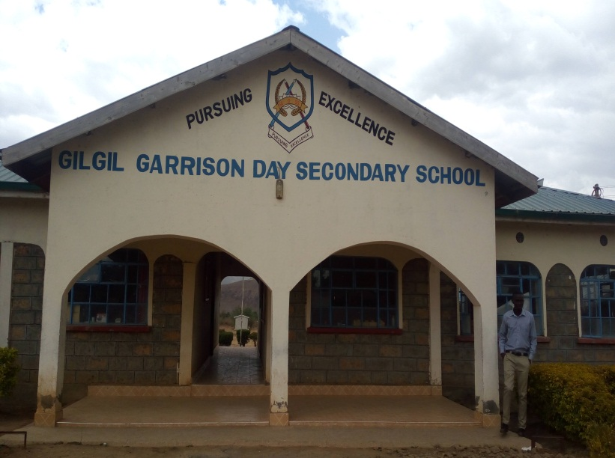 | 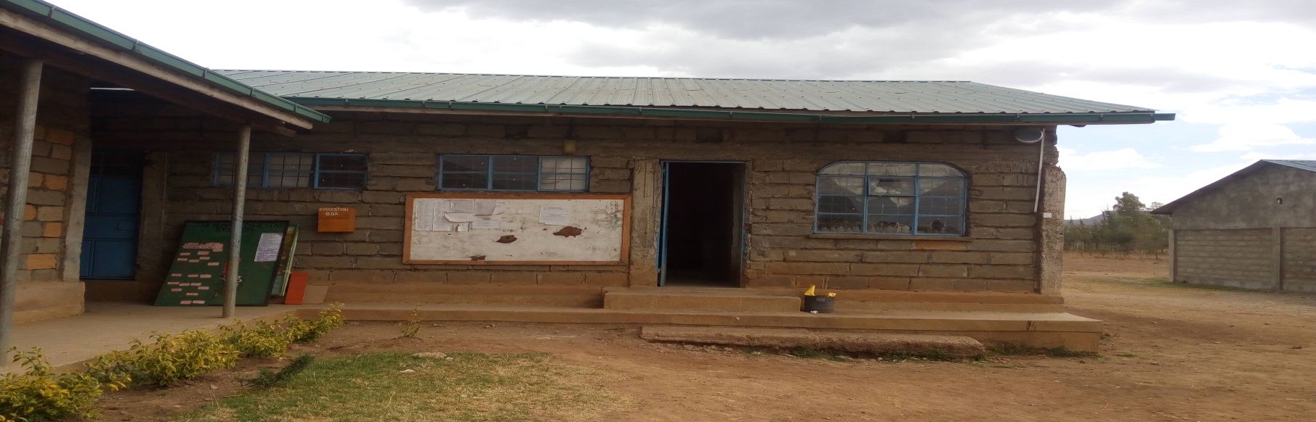
Students in Class
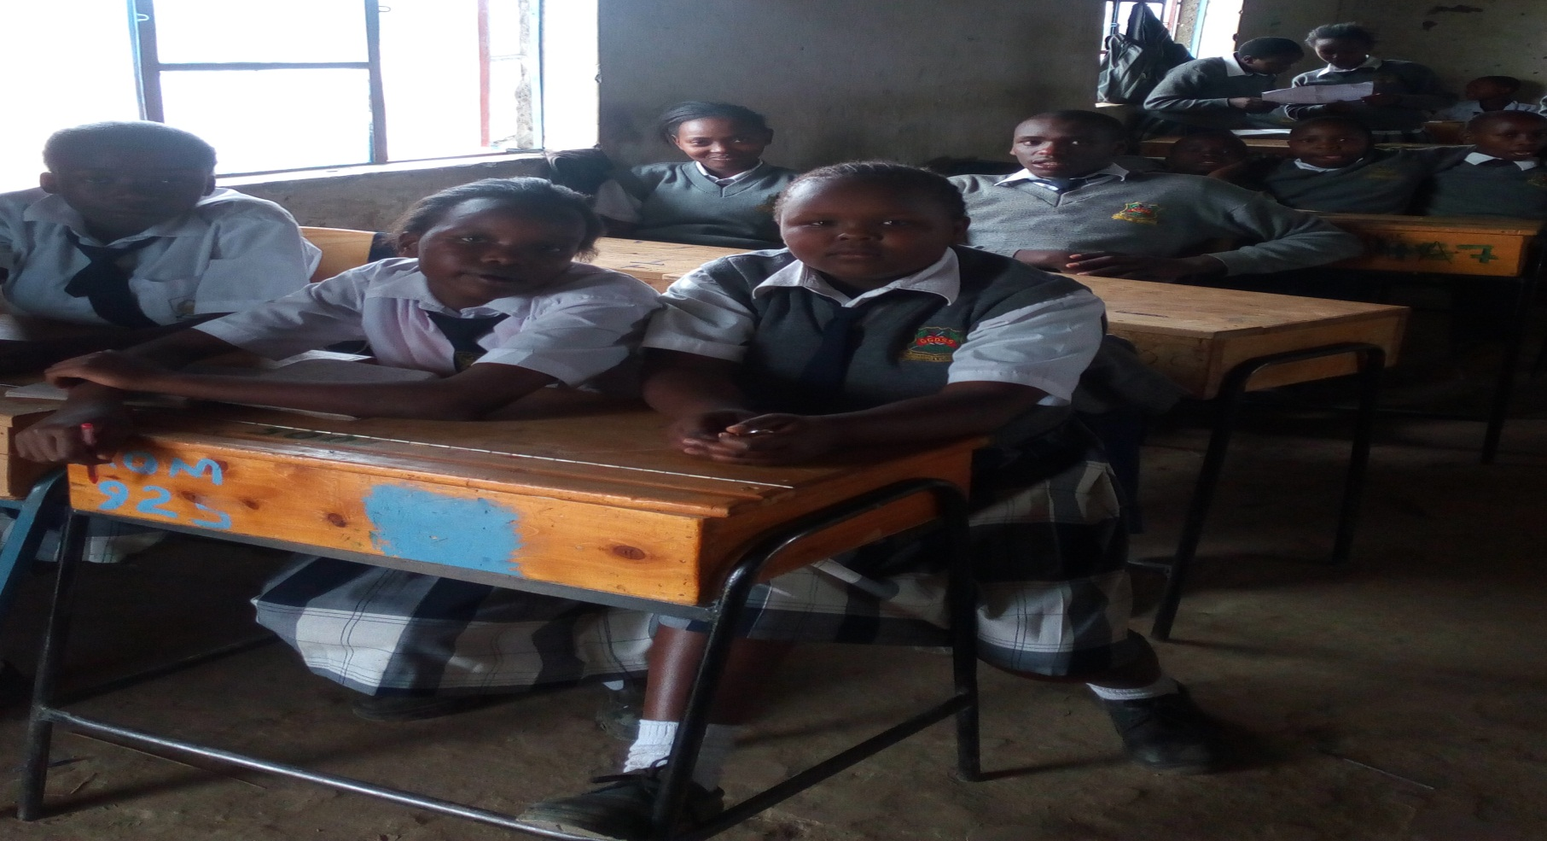

APPENDIX 5
SCHOOL RULES AND REGULATIONS
- PUNCTUALITY
Punctuality must be observed at all times. Students must be at the right place at the right time
- CONDUCT
- No student should fight or use abusive language to other students or be rud to the teachers, other students or members of non-teaching staff. English and Kiswahili are the official languages of communication.
- Any student found smoking, sneaking out of school or absconding classes wi; be suspended from school.
- Mobile phones are strictly forbidden in school.
- Screaming is strictly forbidden
- Students going out on trips should always display good behavior
- The school will not tolerate any cases of theft
- Home clothes are not allowed in school; students must always appear decent in school uniform while in school. ANY UNAUTHORIZED ITEMS IF FPOUND WILL BE CONFISTICATED
- The staffroom and laboratories are out of bounds to all students unless they have a special permission.
- Silence and order must be maintained in classrooms all the times, there should be no movement during preps time.
- All boys must ,maintain their hair short at all times

