Student's Name
Professor's Name
Course
Date
Research Paper: Gun Control
Gun control is undoubtedly a controversial issue in the American society, which has witnessed one of the highest rates of fun violence and mass shootings. The Second Amendment allows Americans to bear arms as a constitutional right. This right has never changed in all of America’s history since its passing. The only changes adopted have been on stricter gun ownership laws such as background checks and permits. However, it is clear that America has failed to regulate gun control based on the evidence in terms of gun violence, crime, suicide, and mass shooting. Despite the decade-long debate, American have always avoided to follow examples models of other countries where tougher gun laws have made tremendous and remarkable improvements. Americans including citizens, politicians, and policy makers approach gun control with different beliefs and attitudes. Gun control in America has failed due to deeply entrenched beliefs and attitudes that tend to advocate for guns rather than restricting their use for appropriate situations such as protection. The following paper aims at illustrating how strict gun laws have been proved to work as well as the challenges surrounding appropriate gun laws in America. Gun control in America is more to do with political and cultural struggles, rather than the ultimate aim of restricting gun misuse in crime, violence, and suicides.
The first major argument about the failed gun control regulations in America is based on mass shootings. The U.S constitution offers a right to bear arms or own guns to its citizens for the purposes of security and protection. However, this does not reflect the experience America has undergone in terms of mass shootings. From the past few centuries, America has witnessed over 91 mass shooting involving more than four victims and not related to crime or gun violence (Oremus 1). Mass shootings involve individuals who indiscriminately shoot innocent people in masses. The most recent mass shooting was in a Florida school that claimed 17 lives sparking a renewed debate surrounding gun control. The deadliest mass shooting in American history was during the 2017, Las Vegas shooting where 59 people died and over 800 suffered injuries (Spitzer 59). Despite all these mass shooting, little to no progress has occurred nation-wide to introduce significant or stricter gun control laws. To understand the irony in America’s historical reaction to mass shooting, it is important to consider the case of Australia.
Australia strengthened it gun control laws following the Port Arthur mass shooting in Tasmania. This was the worst mass shooting ever recorded in Australia with a casualty of 35 people and 23 injured (Oremus 1). The events were met with increased public uproar and ultimate reaction from the commonwealth government. The then PM John Howard adopted the 1988 National Firearms Agreement proposal in order to enforce tougher gun laws. This was met with increased resistance from States since the Commonwealth government had no power in regulating or enacting gun laws. Howard however threatened a national referendum to alter the constitution and offer the Commonwealth government powers to regulate gun laws. The results of his efforts were a ban on semi-automatic guns, rifles, and shotguns as well as strict permitting and ownership laws (Oremus 1). What followed was a massive gun-buy-back program that lasted a year and recovered over 1 million guns from Australians that were all destroyed. Currently, Australia has never witnessed another mass shooting since 1996 involving more than four people. Furthermore, Australia has some of the toughest laws in the world. All gun users and owners are required to possess a firearm license by proving a genuine reason (which should not be self-defense) for owning a firearm license. Such individuals should not have criminal record. Lastly, all firearms are registered with a serial number to the holder who has a firearm license. This means that even tracking a firearm is easier. Oremus asserts that Australia has one of the most effective gun control approaches in the entire world based on its 1996 actions that resulted in 0 mass shooting since (1).
This is something that most people do not understand, despite its complexities. In America, mass shootings are over 91 or even more. Even with the clear evidence that making strict gun laws can seriously reduce mass shootings. However, the main challenge is that Americans and Australians have different cultures, attitudes, and political opinions and resources when it comes to gun control. With such evidence, it is no doubt that if the number of guns in circulation was reduced in America and a ban on semiautomatic weapons would reduce the number of mass shootings or gun violence. A stunning fact is that even in America, evidence has illustrated that tougher gun laws can reduce the negative effects of gun ownership. In Connecticut, the state did not require any permit for someone to own a handgun. Again, before 1995, Missouri had strict gun laws that required permits and waiting-time before they were revoked in 2007 (Rosen 17). During these periods, studies. Currently, acquiring a gun in Connecticut takes time and a rigorous process to acquire a permit and pass a safety test. In Missouri, owning a gun is a walk in the park as the only requirement is passing an FBI background check that takes minutes. However, between 2014 and 2015, Connecticut recorded a 40% decrease gun-related homicides while Missouri witnessed an 18% increase in gun-related homicides (Rosen 17). This illustrates consistent evidence that stricter gun laws can significantly reduce their misuse especially in cases of mass shootings.
However, this does not occur for a number of reasons. The first main reason behind the current controversy of gun control in America surrounds America’s culture or history and attitude towards guns. In America, guns played a significant role from their use for hunting to defense by militia. America as a nation is founded on its freedom, which was attained through the American Revolution (Patrick 1). Guns played a critical role in acquiring American freedom, and since then they have been appreciated as a means of defense, protection, as well as a sense of the American freedom. Therefore, Americans approach gun control with a different attitude and culture than other countries around the world. Oremus states that
“So deeply embedded is the gun culture of the US, that millions of law-abiding, Americans truly believe that it is safer to own a gun, based on the chilling logic that because there are so many guns in circulation, one's own weapon is needed for self-protection. To put it another way, the situation is so far gone there can be no turning back” (1).
In turn, this has made it near impossible to enact any significant gun laws that can help reduce the number of violent gun-related crimes such as mass shooting. For instance, in 1994, the U.S government banned manufacture of semi-automatic guns for a period of 10 years, but later it was uplifted in 2004 (Washington Post 1). The result of such murky gun controls is increasing the problem rather than addressing it. Currently, the gun ownership has reduced while gun sales continue to increase. Most people involved in mass shooting in America possess more than one gun. It is very ironical for America to allow people to own more than one gun, which illustrates the cultured, political, and national attitude towards gun control. The following graphic illustrates the current situation in terms of gun control especially regarding strict laws.
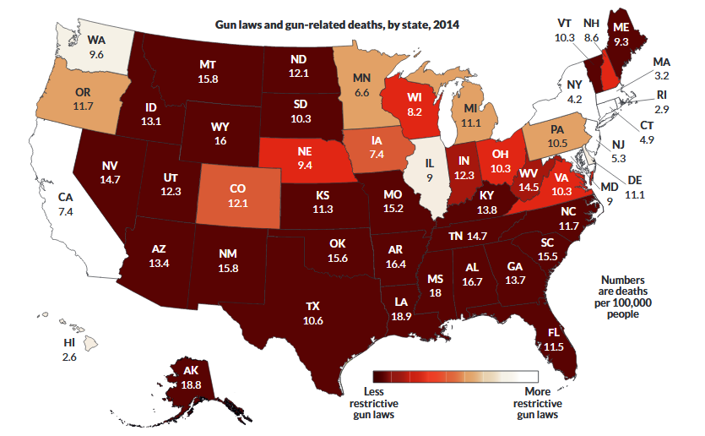
Fig 1 (Rosen 20)
Gun ownership advocates especially under the National Rifle Association are opposed to tougher gun laws based on inadequate and inconclusive data and research. Most of the supporters of gun ownership have argued that there is minimal evidence of linking gun ownership to violent crimes such as shootings and homicides. Overall, there is a shortage of data and research to support any policy changes about toughening gun laws in America. This has been the crucial advantage for pro-gun supporters. However, the lack of data and evidence is due to institutional and political obstacles and limitations. Firstly, America does not keep a record of gun owners meaning it is impossible to trace who owns what gun. There is no national registry of firearm ownership such as in Australia. Moreover, Rosen argues that the Bureau of Alcohol, Tobacco, Firearms and Explosives (ATF) has been limited in terms of information they can share with scientists and other agencies (17). Such limitations have made it impossible for law enforcement agencies to trace firearms used in criminal activity. Another major challenge why there lack enough data and research on gun ownership and violent crimes is lack of funding. For instance, a 1996 amendment prohibited the Center for Disease Control (CDC) from using funds to promote or advocate for gun control (Rosen 20). Despite all these limitations, there still exists solid and reliable evidence that tougher gun control laws are needed to make America safer. For example, there is proven evidence that the presence of a gun in a home maximizes the chances that a person will commit suicide by a ratio of 3 to 1 (Rosen 20). Pro-gun advocates counter such research through their political lobbyist that become impossible for any strict laws to be passed especially in a nation-wide context. Despite all these issues, America remains behind in passing tougher gun laws illustrating the cultural, political, and social attitudes towards gun laws.
In conclusion, gun control in America has more to do with political and cultural struggles, rather than the ultimate aim of restricting gun misuse in crime, violence, and suicides. America has a profound history of guns as a means of freedom, protection, and national pride. This has turned the whole gun control debate into a controversial issue. Clearly, Americans appreciate gun ownership over the costs of lives lost in violent gun crimes. As long as Americans remain with the same attitude, culture, and political viewpoint, gun control will continue to be a controversial issue in the future.

Works Cited
Oremus, Will. In 1996, Australia Enacted Strict Gun Laws. It has not had a mass shooting since. Slate. 2 Oct. 2017. Web, http://www.slate.com/technology/2018/04/are-you-really-facebooks-product-the-history-of-a-dangerous-idea.html. Accessed 28 April 2018.
Patrick, Odysseus. Australia’s Gun Laws Are Not a Model for America. New York Times, 23 Feb. 2018. Web, https://www.nytimes.com/2018/02/23/opinion/australias-gun-laws-america.html. Accessed 28 April 2018.
Rosen, Meghan. "MISFIRES in the Gun Control Debate. (Cover Story)." Science News, vol. 189, no. 10, 14 May 2016, pp. 16-21.
Spitzer, Robert J. "Gun Law History in the United States and Second Amendment Rights." Law & Contemporary Problems, vol. 80, no. 2, Apr. 2017, pp. 55-83.
Washington Post. History of gun-control legislation. Washington Post, 2012. https://www.washingtonpost.com/national/history-of-gun-control-legislation/2012/12/22/80c8d624-4ad3-11e2-9a42-d1ce6d0ed278_story.html?utm_term=.f9b7e1dfa45f. Accessed 9 Dec. 2017.

