Health Risk Assessment
Student’s Name
Institution
Date

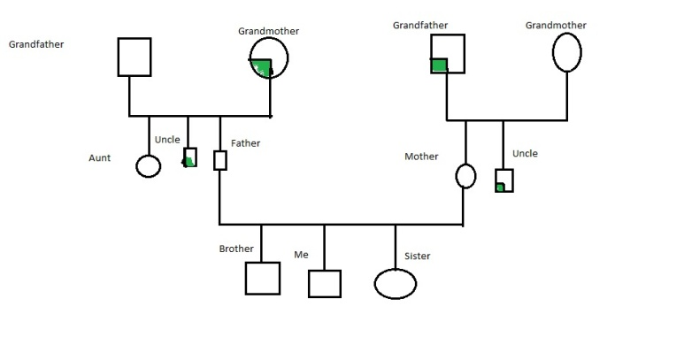
The above diagram is a genogram showing a family tree and the members suffering from diabetes. It can be observed that my grandparents and uncles have diabetes. Therefore, it can be deduced that the family, from both sides, is susceptible to diabetes. Therefore, the family needs to take several relevant measures to ensure that the issue is contained. For example, the family can take the necessary dietary measures that would enhance diabetes prevention and control. Dietary control entails the reduction of fatty food intake and maintenance of balance on calorie intake (Diabetes Prevention Program Coordination Center, 2018). Individuals need to understand their bodies in order to ascertain the calories required daily and strive to maintain the desired balance. It can be observed that diabetes can be prevented and controlled by proper dieting. In addition to dieting, it would also be important for the family to strive against excessive weight gain. Individual members should ensure they observe their body weight and maintain a balanced Body Mass Index (Steyn et al., 2004).
Individuals can maintain reasonable weight through regular exercises. Exercises such as brisk walking, play significant roles in burning fat and ensuring that body weight is regulated (Diabetes Prevention Program Coordination Center, 2018). Since individuals have different capabilities, each person needs to identify their most appropriate exercise such as bicycle riding, aerobic dance, swimming, and skating, among others (Dunstan, Zimmet, Slade, Harper, & Burke, 2003). The most important objective is to exercise and burn calories and maintain healthy body weight. Thus, it is possible for the family to prevent and control diabetes through the identified measures.

References
Diabetes Prevention Program Coordination Center. (2018). The Diabetes Prevention Program (DPP). American Diabetes Association. Online ISSN: 1935-5548. Retrieved from http://care.diabetesjournals.org/content/25/12/2165
Dunstan, D. W., Zimmet, P., Slade, R., Harper, S., & Burke, L. (2003). Diabetes and physical activity. Retrieved from https://powcs.med.unsw.edu.au/sites/default/files/powcs/page/Diabetes+Position+Statement+Hlth+M.pdf
Steyn, N. P., Mann, J., Bennett, P. H., Temple, N., Zimmel, P., Tuomilehto, J.,…& Louheranta, A. (2004). Diet, nutrition and prevention of type 2 diabetes. Public Health Nutrition, 7(1A), 147-165.

