Keith John's Leadership Skills Rating

Your leadership skills are extraordinarily positive.
Extraordinary leaders achieve exceptional results because they do not settle for the ordinary. You are achieving more than the average leader, but you are not optimizing your leadership role. In some areas, you are settling for second best. Otherwise stated, you are not employing Optimal Thinking to achieve your greatest mission, vision, values, guiding principles, strategy and best tactics.
When you optimize your leadership skills with Optimal Thinking, you rise above the extraordinary, into the realm of the highest and best. You eliminate the "could haves," and "should haves" because you surround yourself with the right people and choose the most constructive option in every circumstance. Optimal Thinking empowers you to optimize -- not just improve -- your leadership skills.
Keith, are you ready to optimize your thinking and leadership skills? OptimalThinking.com can provide you with our proprietary in-depth rate your thinking 360 multi-rater assessment, leadership skills seminars, executive coaching, resources for executives in transition, and like-minded people to optimize your vision, and your team's performance. Are you ready for this?

Attract the Best People for Your Company
Exercising due diligence with references, background checks, and credentials does not uncover the thinking style that best fits a team's dynamics and the company's culture. The Optimal Thinking Online 360 Multi-Rater Assessment objectively measures the thinking styles of your candidates, so that you can accurately determine which candidates are the best fit for your organization.
Keith, when you hire Optimal Thinkers (people who are motivated to do their best regardless of the circumstances), you minimize the need for incentives, rewards and recognition. Your new hires will optimize each task and perform most effectively with their team.
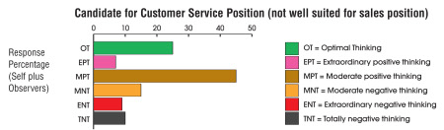

Maximize Employee Performance and Retention
When employees think in suboptimal terms, performance is impaired. The Optimal Thinking Online Assessment provides employees with a comprehensive understanding of their dominant thinking style, their other thinking styles, their performance levels, strengths, weaknesses and blind spots. They learn how to contribute their best and interact optimally with others in any circumstance.
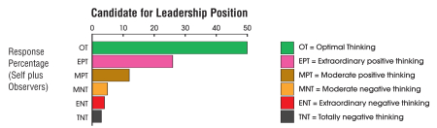
Because thinking is a core performance indicator, the Optimal Thinking Online Assessment rises above traditional personality tests. The Assessment immediately uncovers and resolves the thinking that compromises employee engagement, satisfaction and loyalty. Optimal Thinking employees seek and create the best opportunities for advancement. The Assessment empowers leaders and employees to employ best practices as they move up through the organization.

Call (424) 204-6133 Monday to Friday, 8:30 am - 5 pm PT
to discuss how to customize this leadership assessment for your organization.

Be Your Best, and Bring Out The Best In Others: Keith, Get Your Discount

