Name:
Tutor:
Course:
Date:
Analysis of Susan Sontag’s Regarding the Pain of Others, Chapter 2
In her book, Regarding the Pain of Others, Susan Sontag challenges the reader to reflect on what happens when the sufferings of the people in war-torn areas are viewed third-hand. In the second chapter, Sontag challenges the objectivity of the photographs the point of view of the photographers, and the notion that photographs can create the real picture of the war events. In this chapter, Sontag focuses on the role of war and atrocities images in representing the actual events, and more so the suffering of the war victims. She talks about the proliferation of information through various mediums, and the how such information may affect the view of the recipients about the war. She also focuses on the role of photographs as a medium of representing war scenes, and its difference from the other mediums. This paper will analyze the second chapter of Sontag’s Regarding the Pain of Others in reference to the important elements that Sontag discusses including photography as a medium of communicating war agonies, its objectivity and point of view, artistry among others.
In the second chapter of Regarding the Pain of Others, Sontag questions the notion that the News that are presented in various mediums are enough in understanding what is happening around the world. She cites a common media axiom which says, “You give us twenty-two minutes, we’ll give you the world” (18). This axiom means that the media wants people to believe that what they present in the few minutes as News is enough to understand what is happening in the entire world. The significance of this axiom lies in its hyperbolism. Indeed, through this statement, Sontag calls the attention of the readers, requiring them to reflect on how a few minutes would be enough in understanding every detail of the global occurrences. Through this reflection, the reader is able to figure out that what they see and/ or hear in the news is just a peak of the iceberg.
The comprehension derived by the readers from the News hyperbolized axiom is important in helping Sontag explain to the reader, that what they see in the war photographs is an understatement of the real occurrences on the war ground. This can be further supported by Sontag’s description of a radio station that regularly contradicts the news axiom, by pointing out that an hour is “geographically and thematically” negligible when compared to the world. As a result, even the most important world news that is worth knowing is broadcasted “tersely and emphatically” (18). This means that the Media is more focused on portraying what it deems important for the viewers, and thus it may intentionally omit other important details. The same case would apply in war and atrocity photographs. The photographers are not able to cover every happening, and therefore they categorically choose to photographs events which they deem important, making it impossible to convey the reality of the situation on the ground. In this case, Sontag wants to mean that relying on photography to understand war and atrocity is misleading. According to Bertelsen, this false impression is likely to restrict an individual’s responsibility and capacity to comprehend the pain of the victims of war and atrocity (1).
Also, in the second chapter Sontag emphasizes the restrictions of photography as a medium of creating awareness of the evils of war and atrocity. He indicates that “photography has only one language” (18). This means that, what can be read from a photograph is only what can be seen by the eye. On the contrary, Sontag argues that while different people are able to elicit different meanings from a written account, every person looking at a photograph is only able to see the same thing that other people can see, the image as it is. This could have used this expression to call the reader’s attention to the bias in photographs. Everyone looking at a photo is restricted to only what the eye can see. For instance, in figure 2, the viewer cannot understand anything about the subjects in the photo, beyond what is visible to the eye.
What is more, Sontag notes that the single language of photography is “destined potentially for all” (18). This means that people getting information through other mediums such as print and reported information are able to make different interpretations of the information. As such, they are those who might get the right message, while others might get the right message from the conveyed information. On the other hand, people getting information from a photograph are restricted to only a single interpretation. This means that if the photograph is misleading, all the people would be mislead. Therefore, when a whole society misinterprets a photograph of war and atrocity, it is at high risk of failing to read the pain of the war victims (Bertelsen, 1).
Also, in the second chapter, Sontag argues that a representation of war and atrocity occurrences would never reveal the real happenings. She notes, “A catastrophe that is experienced will often seem eerily like its representation” (19). This means that the war and atrocity images being portrayed by the media may depict the real situation as it is, and even seem real to viewers. However, this representation is only an abstract depiction of the real happening. Of course, it is inarguable that the images portray a captured moment of reality. This notwithstanding, the representation concurrently obscures the accounts and the identities of the depicted reality; making the message derived from the representation, a mockery of the real event. Bertelsen notes that the lack of context in the representation yields a biased interpretation of the representation, whereby people tend to read the war images in ways that reiterate their beliefs (1). As a result, the viewers of the represented event may not understand the severity of the real event, and may sometimes view the representation as unreal, exaggerated, or even regard it as a movie. In turn, the misinformed interpretation turns out to be a significant hindrance in understanding the pains of the victims of war and atrocity.
In addition, in the second chapter, Sontag expounds on how overexposure to agonizing images would neutralize the significance of their role in depicting war and atrocity agonies. Sontag notes that this overexposure and the endeavor of the photographers to capture the most dramatic images results in photography producing “the image as a shock and the image as cliché” (21). The paradox in this statement can be interpreted to mean that photographers are more and more inclined to capturing images that would “arrest attention, startle, and surprise” (20). Of course, they manage to capture dramatic images which are shocking, and thus appealing to the public. As such, it can be said that the “shocking” elements is there in the images. Nevertheless, the overexposure to the shocking war images makes them become monotonous. As such, in every shocking image, the viewer is not able to elicit the magnitude of the events behind the image, because they view the image as “just another war image.”
A good illustration in how the photographers focus on creating dramatic images instead of representing the actual events of the war can be read from figure 1(Robert Capa’s "Falling Soldier") which is captured when the soldier is simultaneously being hit by a bullet. Sontag notes that the dramatic view of the soldier falling backwards on a hill, with his arm tossed behind him, and his gun leaving his grasp is bound to be embedded on the reader’s mind. The paradox of a shocking cliché image would arise from this picture because; due to the proliferation of dramatic war images, the “shocking” element in the image is neutralized, and it is viewed as another one of the war images.
In chapter two, Sontag compares photographs with the other mediums used to represent war and atrocity, citing that photographs have turned out to have more authority over the other mediums. He attributes this turn of events to the camera’s ability to record and define reality. Unlike other mediums such as reporting, photographs are an objective representation of the reality. Nonetheless, Sontag argues that the objectivity of the photograph cannot be passed without considering its point of view. Sontag is quick to admit that the photographs offer a record of unquestionable reality that can never be attained by even the most unbiased printed and spoken word. However, he challenges this objectivity by introducing the point of view of photographs. The photographers are important players in photography. They are the point of view in photographs. But they are not always objective, as depicted by their inclination in capturing dramatic images, which could appeal to their audience. As such, the objectivity of photographs as a medium is undermined by the point of view of the images.
Sontag also notes that in atrocity photographs people are more interested in the level of witnessing as opposed to the aesthetic elements of the photograph. She notes, “For the photography of atrocity, people want the weight of witnessing without the taint of artistry” (23). This means that when viewing the atrocity and war photographs, viewers are more interested in the photographer’s ability to capture the moment, as opposed to how dramatic the moment is framed. The “anti-art style” that Sontag mentions is a direct and unsentimental style where the photographer is interested in capturing the moment as true as it appear, without artistic emphasis that could enhance the dramatic vantage of the image. Although Sontag does not take positions in determining whether the anti-art images are authentic, she emphasizes that artistically, they are indeed considered authentic, because they are less manipulated. A good example of an anti-art style is depicted in figure 2, in which the photographer has captured the image and the subjects as real as they appear, without any aesthetic enhancements.
In her chronological assessment of the advancement of photography, Sontag mentions the first color photographs and the effect they had in adding the “shock” element. Referring to Larry Burrow’s colored photos of the Vietnam War, Sontag notes that color was another “gain in shock” (31). By this she means, the color would obviously bring out the dramatic effect in a better way than in black and white images. As a result, the more dramatic colored photos would be important in adding the shock element that the photographers always endeavored to bring out. A good example of how color could enhance shock can be viewed by comparing a black and white photo in figure 3. The blue color of the sky and the green color of the grass make the colored image alive, when compared to its black and white counterpart.
In the conclusion of chapter two, Sontag undermines the role of the point of view in determining how viewers interpret a photograph. She notes, “The photographer’s intentions do not determine the meaning of the photograph” (32). This is to mean that while the interpretation of the image in the photograph is universal, the meaning of the image varies for different viewer. For instance, the government may view a war photo as the inevitable cost it has to pay, a soldier may see heroism, and a politician may see pathos in which to base his/her rhetoric.
In conclusion, in reading the pain of others, Sontag evaluates various elements of photographs as a medium of representing war and atrocity. She focuses on the irony of the mediums assuming they could represent the world in a few photographs, or few minutes of news broadcasting. She then compares photograph against other medium, citing its capability to unite objectivity and the bias of point of view. She emphasizes the artistic authenticity of the anti-art style in war photography, and the role of color in adding a dramatic effect in the atrocity photographs. She concluded the chapter by explaining how different people can elicit different meaning in war photographs.

Works Cited
Bertelsen, Allan. Review: regarding the pain of others. Canadian Journal Of Communication, vol. 25, no. 1, 2004.
Sontag, Susan. Regarding the Pain of Others. https://monoskop.org/images/a/a6/Sontag_Susan_2003_Regarding_the_Pain_of_Others.pdf

Appendix
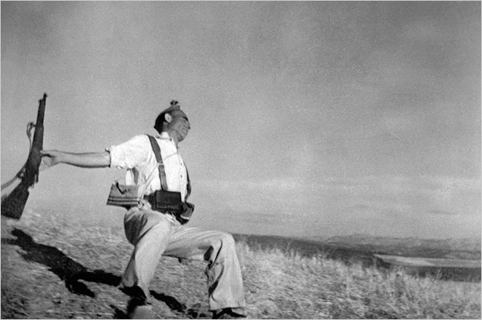
Figure 1 Robert Capa’s "Falling Soldier," from the Spanish Civil War, borrowed from New York Times, https://www.nytimes.com/2009/08/18/arts/design/18capa.html

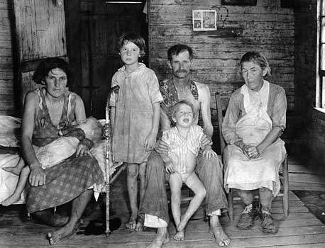
Figure 2 Bud Fields and His Family, Hale County, Alabama, photograph by Walker Evans, C. 1930s Encyclopedia Britannica, https://www.britannica.com/biography/Walker-Evans

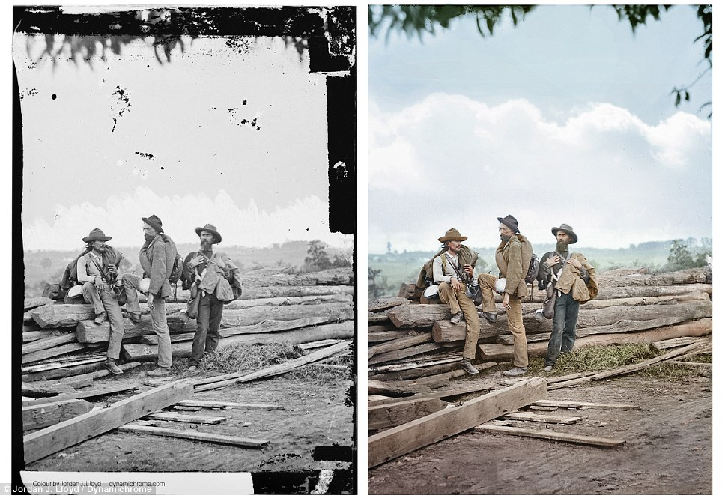
Figure 3; A civil war photo from Living Witness. http://livingwitness.net/a-war-over-color-is-no-longer-in-black-and-white/

