Name:
Tutor:
Course:
Date:
English Questions
Section 1
Q: Think about your life. Where do you see examples of Appadurai’s ‘scapes’? What ‘scapes’ do you participate within, at work, when travelling, when shopping, or in your home?
In His five concepts of ‘scapes’ Appadurai conceptualizes how the movement of people, money, ideas, technology and images is contributing to the shaping of a new cultural economy in a globalized world. Of course I have experienced Appadurai’s scapes in various aspects of my life. For instance, in regard to technoscape, online shopping allows me shop for items from other countries while I am sitting at the comfort of my home. Technology also makes my studies easier by accessibility to online academic resources. In regard to ethnoscape, I get a chance to visit our family friends in India, and I have borrowed a lot from their cuisine and other cultural elements. In regard to mediascape, advertisements on the TV, has often influenced what I buy.
Q: Appadurai’s piece was written in the late 1990s. How might we update these concerns today? What still holds, what is new?
Appadurai’s scopes could be taken as a theoretical framework for studying the outcomes of globalization. Since Appadurai coined the five scapes, the third wave of globalization has advanced, bringing the world even closer together, and generating more intense interdependencies and interactions. As such, nothing much has changed. As a matter of fact, the concept of the five scapes apply best in today’s time, as exhibited by the proliferation of media and technology, joining of the global economies, invention of numerous social media platforms, and the aggravated immigrations. The massive distribution of media images and the rapid flow of technology today have significantly fostered ideoscape. Nonetheless, the rapid globalization and interconnectedness has yielded a global culture. Concepts such as global citizenship which places each individual as the first actor in the global world, as opposed to Appadurai’s placement of the individual actor as the last locus of his five scapes (Israel 1, Appadurai 296).
Q: How might we understand Appadurai’s discussion of nation, state and scapes in the contemporary Australian context?
In the Australian context, the national-state element could be taken as a subset of what Appadurai refers to as multiple worlds, which are defined by the historically placed imaginations of persons (Appadurai 297). As a state, Australia affects and is affected by the global movement of people, money, images, ideologies, as well as the worldwide configuration of technology. For instance, in ethnoscape, many foreign students and other immigrants come to Australia. They may learn and adopt some elements of the Australian culture, and they may also to some extent influence the Australian culture. Also, the Australian government has to make immigration policies. Foreign investors in Australia must adhere to the nation-state regulations. Another example should be derived by Australia advertising itself as a tourism destination; it would have to send images around the world for advertisement through the use of technology. Also, if a global event is to be held in Australia, the Australian flag would be used to send out an ideology signifying Australia as a nation. As such, in the global arena, Australia is a nation-state actor of the “perspectival” set of scapes (Appadurai 296).
Section 2:
Should humans wipe out mosquitoes? How might the concept of genocide relate to this action?
According to Hafner Mosquitoes have been recognized as the deadliest animal in the world; causing a wide range of disease. Even though scientists have already coined ways in which they could manipulate genes to kill all mosquitoes in a few months, the question of whether mosquitoes should be eradicated still prevail. To some extent, wiping out all the mosquitoes could be related to genocide because it raises ethical questions. Humans are supposed to save species instead of making them extinct. What is more, mosquitoes act as a source of food for other animals including birds, fish, and frogs among other animals. Some mosquitoes are also agents of pollination. What is more, out of the more than 3500 species of mosquitoes, only a few cause diseases. In fact, other species of mosquitoes feed on the larvae of the harmful mosquitoes (1). Therefore, probably a way should be found to wipe out only the mosquitoes that transmit diseases. However, the harmless mosquitoes should be spared in order to save the mosquito species.
Section 3:
Q: How do we define what Australian heritage is?
Australian heritage can be defined as the places, values, occurrences, experiences and customs that depict where Australia has come from, where it stands currently, and where it is headed as a nation (Department of the Environment and Energy a) . Heritage encompasses all those elements that pass the stories of the Australian progress as a nation, while at the same time defining the future of the nation from one generation to another.
Q: Is ‘feral’ an ecological or cultural category?
The term feral frequently points out to cultural values which typify free-ranging animals as a pest species that compete with the native animals for habitat, food and shelter. They are also deemed to yield negative impacts such as degradation of the Australian soil and waterways, introduction of diseases and pests, and predation of the native animals and plants. As such they are not considered as a part of the natural ecosystems which they inhabit (Department of the Environment and Energy, Australian Government b).
Q: How do you see ideas of ‘the wild’ – or ‘wildness’, or ‘wilderness’ – featuring in these arguments? Is ‘wildness’ considered part of Australia’s heritage? And if so, how to protect such a thing?
Based on the above definition, it is clear that the feral animals which include goats, pigs, rabbits, foxes are not classified as domesticated animals. Yet, they are not classified among the Australian wildlife, which consists of the native animals. In short feral animals in Australia are considered intruders; living in a landscape they are not meant to. Wildness however is considered as an Australian heritage. The government can control it by preventing its degradation.
Section 4:
Q: What are some other maps you could draw of Australia? (Feel free to upload them.)
- Economic maps
- Traditional land ownership
- Urbanization maps
- Resources map
Q: How might other maps, and/or maps of migration patterns disrupt some of these depictions of place? Who or what would be disrupted?
The immigration patterns can disrupt the demographics of the people living in the depicted places. Policies could also be disrupted.

Works Cited
Department of the Environment and Energy a. "About Australia's Heritage".Department Of The Environment And Energy, Australia, 2018, http://www.environment.gov.au/heritage/about. Accessed 6 Sept 2018.
Hafner, Josh. "What Would Happen If We Killed All The Mosquitoes?".Usatoday.Com, 2017, https://www.usatoday.com/story/news/nation-now/2017/04/28/what-would-happen-if-we-killed-all-mosquitos/100082920/. Accessed 6 Sept 2018.
Department of the Environment and Energy b. "Feral Animals In Australia".Department Of The Environment And Energy, Australia, http://www.environment.gov.au/biodiversity/invasive-species/feral-animals-australia. Accessed 6 Sept 2018.
Australian Physical Landmarks. "Tourism Australia". Australian Physical Landmarks, https://australianphysicallandmarks.weebly.com/. Accessed 6 Sept 2018.
Maori Law Review. "The Political Ecology And Political Economy Of The Indigenous Land Titling ‘Revolution’ In Australia – Māori Law Review". Maorilawreview.Co.Nz, 2014, http://maorilawreview.co.nz/2014/03/the-political-ecology-and-political-economy-of-the-indigenous-land-revolution-in-australia/. Accessed 6 Sept 2018.
Appadurai, Arjun. "Disjuncture And Difference In The Global Cultural Economy".Theory, Culture & Society, vol 7, no. 2-3, 1990, pp. 295-310. SAGE Publications, doi:10.1177/026327690007002017. Accessed 6 Sept 2018.
Israel, Ronald. "What Does It Mean To Be A Global Citizen?". Kosmosjournal.Org, 2012, https://www.kosmosjournal.org/article/what-does-it-mean-to-be-a-global-citizen/. Accessed 6 Sept 2018.

Appendix
Traditional Land Ownership Map
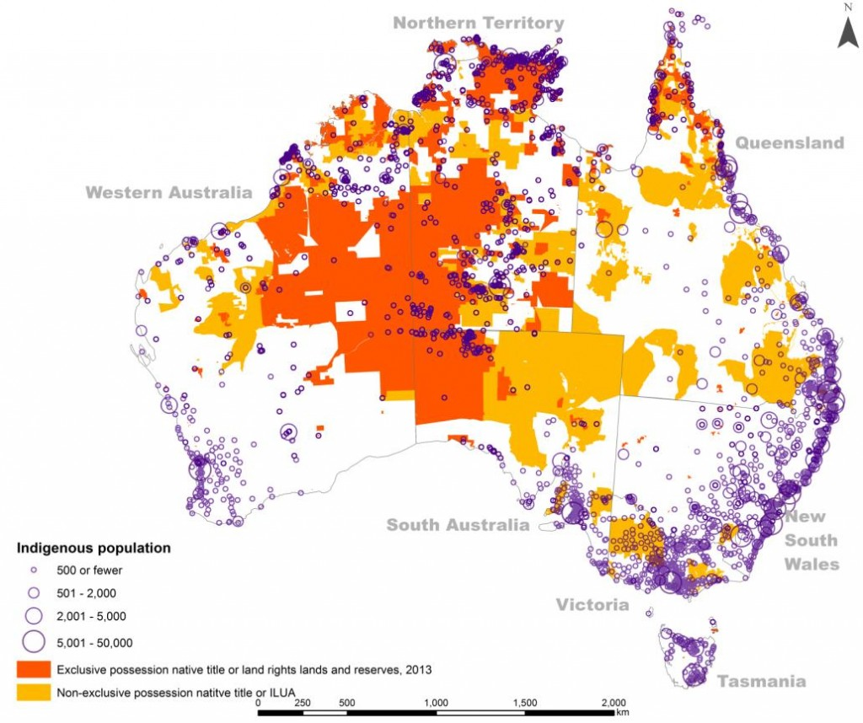
*Note: Maori Law Review. "The Political Ecology And Political Economy Of The Indigenous Land Titling ‘Revolution’ In Australia – Māori Law Review". Maorilawreview.Co.Nz, 2014, http://maorilawreview.co.nz/2014/03/the-political-ecology-and-political-economy-of-the-indigenous-land-revolution-in-australia/. Accessed 6 Sept 2018.

Resources map depicting the mineral deposits and indigenous lands
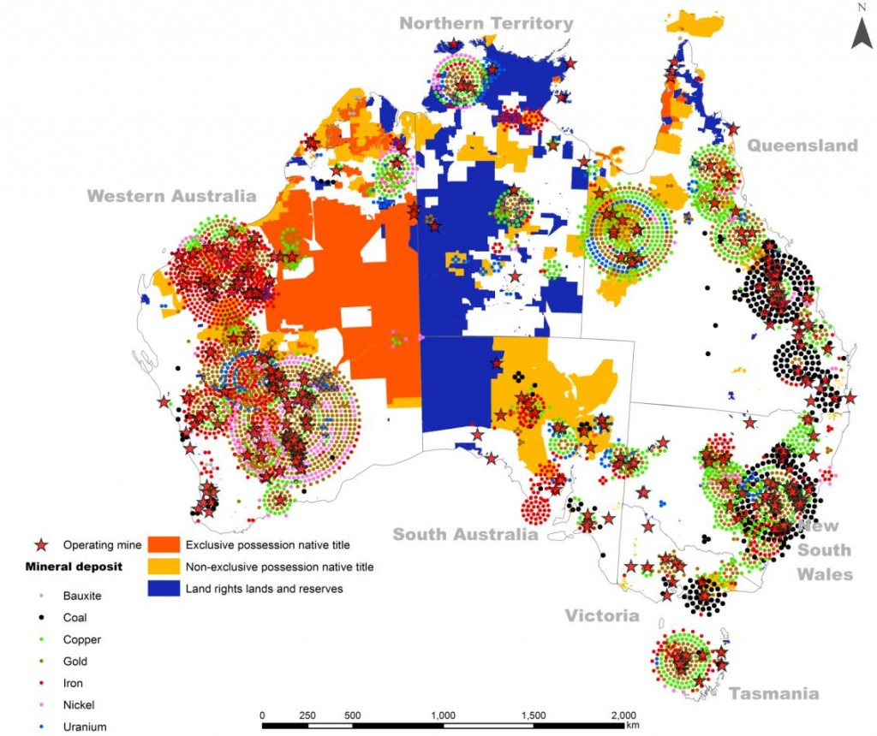
*Note: Maori Law Review. "The Political Ecology And Political Economy Of The Indigenous Land Titling ‘Revolution’ In Australia – Māori Law Review". Maorilawreview.Co.Nz, 2014, http://maorilawreview.co.nz/2014/03/the-political-ecology-and-political-economy-of-the-indigenous-land-revolution-in-australia/. Accessed 6 Sept 2018.

A Tourism Map Depicting the Major Floristic Types
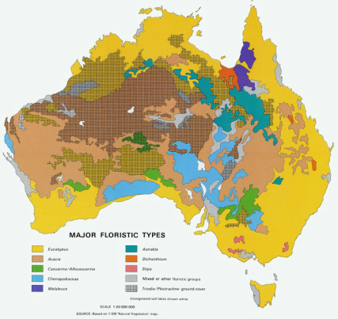
*Note: Australian Physical Landmarks. "Tourism Australia". Australian Physical Landmarks, https://australianphysicallandmarks.weebly.com/. Accessed 6 Sept 2018.

