Compare and Contrast Meiosis & Mitosis
Student’s Name
Institution
Date

Meiosis can be termed as the process of production of the female and male gametes by organisms that possess organized nucleus, commonly known as eukaryotic organisms (Lenormand, Engelstadter, Johnston, Wijnker, & Haag, 2016). It is worth noting that cells contain two duplicates of each chromosome, whereby each parent donates each chromosome. This condition can be termed as the diploid chromosome and homologous is the term given to paired chromosomes. It is worth noting that meiosis is responsible for converting and getting four haploid granddaughter cells from a diploid cell, with each possessing a single copy of each chromosome. The process is significant because it assists in the enhancement of a species’ genetic diversity.
It is worth noting that meiosis is a unique process based on the maintenance of similar chromosome numbers in every generation. The process decreases the number of chromosomes by half-to 23 from 46- to form eggs and sperm (U.S. National Library of Medicine, 2018). When the egg and sperm cells and joined during conception, they combine the 23 chromosomes from each cell to ensure the embryo gets the typical 46 chromosomes (U.S. National Library of Medicine, 2018).
Mitosis encompasses cell division where the mother cell generates two daughter cells with similar genetics to the mother cell (U.S. National Library of Medicine, 2018). In the cell cycle context, mitosis is a division process that oversees the splitting of the DNA cell’s nucleus into two identical chromosome sets. It can be observed that mitosis forms a fundamental life process due to the duplication of cell contents’ including its chromosomes and splitting to form two identical cells. This process is highly significant such that several genes have to carefully control the mitosis steps to avoid unwarranted and unhealthy cell duplication (U.S. National Library of Medicine, 2018).
The following figures show the variation between meiosis and mitosis processes

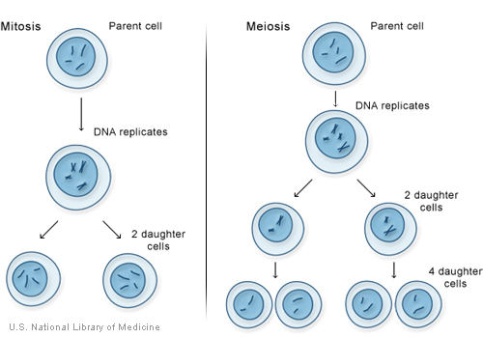
[Source: U.S. National Library of Medicine, 2018]

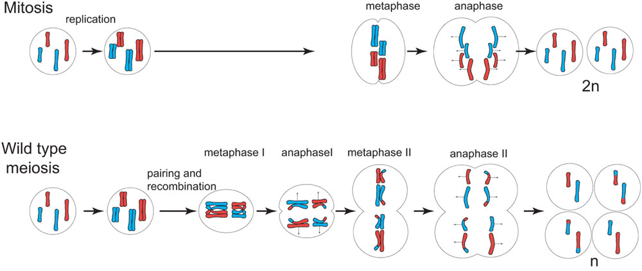
[(Source: Hill, 2018)]
In the above diagram regarding meiosis, it can be observed that several phases such as metaphase I, anaphase I, metaphase II, and anaphase II take place (Hill, 2018). In metaphase I, the homologous chromosome pairs are arranged in the metaphase plate. In anaphase I, the separation of the homologous chromosomes takes place and they are moved to the cell’s opposite poles. The metaphase II constitutes the attachment of the spindle fibers to the chromosomes, while the anaphase II constitutes the separation of the chromosomes and move to the contrary poles of the cell (Hill, 2018).
It is worth noting that mitosis undergoes several phases such as prophase, metaphase, anaphase, and telophase. During the early prophase stage, the process of chromosome division starts when the cell breaks down and the condensation of the chromosomes (Hill, 2018). Additionally, the formation of the mitotic spindle also begins. The disappearance of the nucleolus signifies readiness to break down. In the prometaphase, the chromosomes are captured and organized by the mitotic spindle. During this time, the chromosomes are extremely compact because they have accomplished the condensation process (Hill, 2018).
In the metaphase stage, each chromosome’s kinetochores attach to microtubes from opposite poles of the spindle (Hill, 2018). In the metaphase stage, an important process, known as the spindle checkpoint takes place. This process ascertains that all chromosomes are properly aligned or attached to microtubes before heading to the anaphase stage (Hill, 2018).
The anaphase stage witnesses the separation of the sister chromatids and pulled towards opposite ends of the cell. The sister chromatics get detached, thus becoming separate and each becomes a chromosome. In the next phase, the telophase, there is the breaking down of the mitotic spindle, which results in the reappearance of the nucleoli and nuclear membranes. Additionally, the chromosomes start to decondense (Hill, 2018).
Mendel’s principle of independent assortment defines the variation in genes as they separate during the development of reproductive cells (Mneimneh, 2012). The independent assortment principle can be observed during meiosis as the chromosomes are decreased by half during cell division to generate four gametes. In human beings, 46 chromosomes are constituted in a diploid cell, whereby an individual inherits 23 chromosomes from each parent chromosomes (U.S. National Library of Medicine, 2018). During meiosis, the division of the homologous chromosome means that the resultant cell will have a combination of genes from both parents. Therefore, the combination of cells from two parents will lead to variations in genes.

References
Hill, M. A. (2018). Cell division-Meiosis. Retrieved from https://embryology.med.unsw.edu.au/embryology/index.php/Cell_Division_-_Meiosis.
Lenormand, T., Engelstadter, J., Johnston, S. E., Wijnker, E., & Haag, C. R. (2016). Evolutionary mysteries and meiosis. Philosophical Transactions of the Royal Society B, 371(1706): 20160001. Doi: 10.1098/rstb.2016.0001. Retrieved from https://www.ncbi.nlm.nih.gov/pmc/articles/PMC5031626/
Mneimneh, S. (2012). Crossing over…Markov meets Mendel. PLoS Computational Biology, 8(5), e1002462. Doi: 10.1371/journal.pcbi.1002462. Retrieved from https://www.ncbi.nlm.nih.gov/pmc/articles/PMC3355070/
U.S. National Library of Medicine. (2018). How do cells divide? Retrieved from https://ghr.nlm.nih.gov/primer/howgeneswork/cellsdivide

