Future of healthcare in Australia
Student’s Name

Professor
Course

Institution
City
Date

I am optimistic about the future of Australia’s healthcare. This statement is based on the Organisation for Economic Cooperation and Development (OECD)’s findings that the healthcare system in Australia is among the best globally (Dixit and Sambasivan, 2018). These findings indicate that the quality of provided healthcare services is high. This understanding increases the optimism that it can further be improved to be the leading healthcare system globally.
Additionally, Australia has invested heavily on technology, which has become an economic wealth source and has influenced the way healthcare is provided (Slides). With these technological advancements, it can be argued that service delivery quality will continue to improve. Technological advancements can play critical role in the detection and management of grave ailments and conditions such as cancer. The technology has the capability of enhancing real-time microscope imagery delivery and multi-site videoconferencing (Slides).
However, even with the technological advancements, Australia has a challenge concerning the days that patients have to wait to receive hip or knee replacements from the time they were assessed by doctors. It can be observed that Australian patients have to wait for more days compared to patients in Canada.
The following graph shows the median days waiting time from the time of assessment to the time of receiving the hip or knee replacement surgeries.

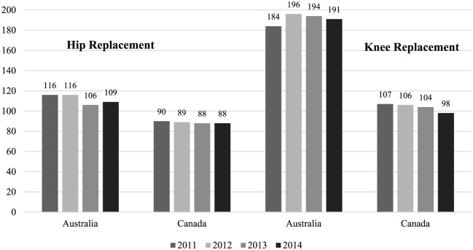
[Source: (Dixit and Sambasivan, 2018)]
From the graph, it can be observed that Australians have to wait for more days before they get their replacement surgeries compared to Canadians. However, these challenges do not diminish the optimism because Australia has the potential of improving. Moreover, the government has been asked to increase healthcare funding to levels enjoyed by countries such as France and Canada (Australian Healthcare & Hospital Association, 2017). Therefore, Australian healthcare has the potential to improve.

References
Australian Healthcare & Hospital Association. (2017). Efficiency in the health system. [PDF]: AHHA. Available at: https://ahha.asn.au/sites/default/files/docs/policy-issue/ahha_position_statement_-_efficiency_in_the_health_system_1.pdf [Accessed 22 Sep. 2018].
Dixit, S., and Sambasivan, M. (2018). A review of the Australian healthcare system: A policy perspective. SAGE Open Medicine,[Online] Volume 6. Available at: https://www.ncbi.nlm.nih.gov/pmc/articles/PMC5900819/ [Accessed 22 Sep. 2018].

