Disease Process: Dehydration is a serious condition caused by a short supply of body fluids due to excessive loss of water in the body or inadequate intake of fluids. As such, it ensues when an individual does not drink enough fluids to replace the lost fluids (VanMeter & Hubert, 2018). It is worth noting that without enough water, the body cannot function correctly. The severity of dehydration ranges from mild, moderate to severe. Per se, mild to moderate dehydration is precipitated by the consumption of insufficient fluids particularly during summer or performing vigorous exercises. Severe dehydration is a health condition caused by bouts of diarrhea or extreme vomiting.

Pathophysiology: Notably, water is an important rudiment in maintaining manifold normal functions within the body, whereby the human body is 55% to 65% of water. The body comprises of twofold fluid compartments namely, intracellular fluid (ICF) and extracellular fluid (ECF). In this light, the ICF contains two thirds of the complete body water, however the ECF encompasses the remaining amount which is further alienated into the interstitial fluid and plasma (VanMeter & Hubert, 2018). Water loss is supplemented by a loss of electrolytes, thus impacting water balance due to the osmotic pressure change between the two compartments. Additionally, the body has an intricate system tailored to preserve euvolemia. Water homeostasis is controlled through the osmoreceptors, wherein dehydration rouses the thirst center in the hypothalamus, leading to water consumption. When hypothalamus perceives lower water concentration, it triggers the posterior pituitary to release antidiuretic hormone which activates the kidneys to reabsorb more water causing dehydration (Taylor & Jones, 2022). In older adults, dehydration is epitomized by the physiological modifications including renal failure whilst in children gastroenteritis leads to dehydration.

Risk factors: Infants, children and older adults.
Individuals at higher altitudes.
Athletes.
People with chronic health conditions (Shaheen et al., 2018).

Major signs and symptoms: (image if you can find one)
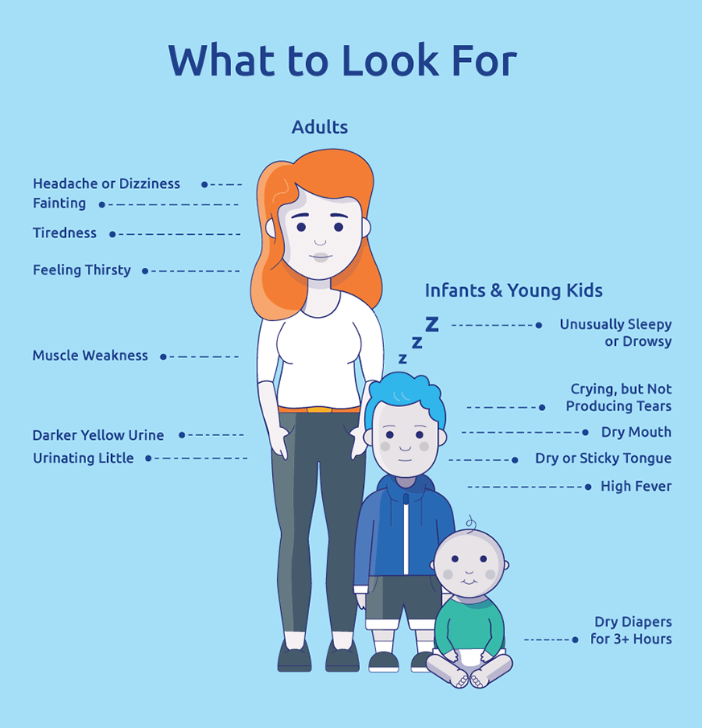 (Nestlé Pure Life, n.d.).

Diagnostic testing: Blood tests to check the levels of electrolyte. Urinalysis. Serum and plasma osmolality tests. Physical examination (VanMeter & Hubert, 2018).

References:
Nestlé Pure Life. (n.d.). Dodging dehydration: Signs and symptoms of dehydration. https://www.nestlepurezavital.com.ar/dodging-dehydration
Shaheen, N. A., Alqahtani, A. A., Assiri, H., Alkhodair, R., & Hussein, M. A. (2018). Public knowledge of dehydration and fluid intake practices: variation by participants' characteristics. BMC public health, 18(1), 1346. https://doi.org/10.1186/s12889-018-6252-5
Taylor, K., & Jones, E. B. (2022, May 15). Adult dehydration - StatPearls - NCBI bookshelf. National Center for Biotechnology Information. https://www.ncbi.nlm.nih.gov/books/NBK555956/
VanMeter, K. C., & Hubert, R. J. (2018). Gould's pathophysiology for the health professions. (6th ed.). Elsevier Saunders. Chapter 2: Fluid, Electrolyte, and Acid-Base Imbalances

