Disease Process: Pernicious anemia is a megaloblastic type of anemia that results from a paucity of either folic acid also denoted as vitamin B9 or cyanocobalamin which is vitamin B12. Additionally, vitamin B12 is triggered by a deficit of the intrinsic factor. As such, this condition can be described as an autoimmune syndromes because of the presence of the gastric autoantibodies controlled contrary to the parietal cells and the intrinsic factor (VanMeter & Hubert, 2018).

Pathophysiology: Pernicious anemia is the most pervasive form of megaloblastic anemia that is instigated by the abnormal assimilation of vitamin B12 due to the scantiness of intrinsic factor. Per se, vitamin B12 and intrinsic factor cohere to receptors on the ileum to allow for absorption (VanMeter & Hubert, 2018). Once B12 is completely engrossed becomes a cofactor for the methionine synthase enzyme, which contributes to the process of converting homocysteine to methionine. If at all the procedure does not take place as a result of pernicious anemia, the homocysteine levels accrue making it difficult for the pyrimidine bases to form. Thus, meddling with the DNA synthesis that causes vitamin B12 deficiency and weakened maturation of erythrocytes (Htut, Thein & Oo, 2021). When these erythrocytes are damaged precipitately, anemia manifests. When the parietal cells cease to generate hydrochloric acid, low levels of the acid persist in the gastric secretions and inhibits the initial digestion of protein in the stomach. As well as the absorption of iron causing iron-deficiency anemia

Risk factors: Some of the risk factors include
A family history of pernicious anemia.
Having undergone stomach and small intestine surgery.
Autoimmune syndrome that encompasses endocrine glands.
Poor nutrition and being a vegetarian who does not take vitamin B12 supplements (Rodriguez & Shackelford, 2020).

Major signs and symptoms
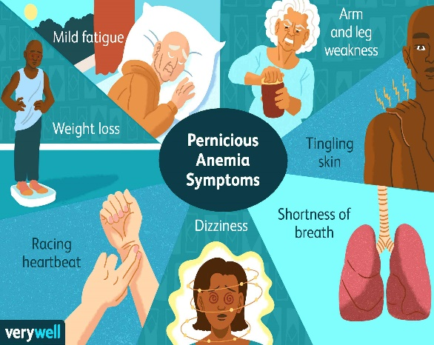

(Hickman, 2021).
Diagnostic testing: The key diagnostic tests of pernicious anemia are anti-intrinsic factor, serum gastrin test, full blood count and parietal cell antibodies. The anti-intrinsic factor is the gold standard test that detects whether the patient has pernicious anemia in its totality (Htut, Thein & Oo, 2021).
References
Hickman, R. J. (2021). What should I know about pernicious anemia? Verywell Health. https://www.verywellhealth.com/pernicious-anemia-5085455
Htut, T. W., Thein, K. Z., & Oo, T. H. (2021). Pernicious anemia: Pathophysiology and diagnostic difficulties. Journal of evidence-based medicine, 14(2), 161–169. https://doi.org/10.1111/jebm.12435
Rodriguez, N. M., & Shackelford, K. (2020, November 21). Pernicious anemia - StatPearls - NCBI bookshelf. National Center for Biotechnology Information. https://www.ncbi.nlm.nih.gov/books/NBK540989/
VanMeter, K. C., & Hubert, R. J. (2018). Gould's pathophysiology for the health professions. (6th ed.). Elsevier Saunders. Chapter 10: Blood and Circulatory Systems Disorders

Case Presentation Response:
P.M is a 62-year old Caucasian female who visits the clinic with chief complaints of general fatigue, muscle weakness, recurrent headaches, weight loss and dizziness for the last three weeks. In addition, the patient admits to experiencing shortness of breath. Upon enquiry the patient reports to having gastrectomy five years ago and a history of iron deficiency anemia as well as hypertension. The patient takes iron supplements and amlodipine drugs. On physical examination, the client had a pale conjunctiva with an icteric sclera, she had bleeding gums and was weak. P.M’s vital signs were normal albeit her heart rate was 132beats/minute and the neurologic workup was normal. The patient’s tongue was red and swollen. Auxiliary anemia examination also indicated vitamin B12 deficiency at 60 pg/mL. Homocysteine and methyl-malonic acid levels were at 22.4 μmol/L. As such, based on the client’s symptoms, clinical features and age the diagnosis is pernicious anemia (Esposito et al., 2022). The diagnostic tests ordered were the complete blood count to determine which type of anemia the patient has and its severity and the full blood count to measure the amount of the patient’s hemoglobin per red blood cells and detect vitamin B12 deficiency. The treatment recommended for the patient is the vitamin B12 monthly injections (Marchi et al., 2020). However, the client will receive daily B12 injections during the first week of commencing treatment with subsequent weekly and monthly shots, respectively. 1,000 to 2,000 mcg/day is the recommended dosage.
Reference 1
Esposito, G., Dottori, L., Pivetta, G., Ligato, I., Dilaghi, E., & Lahner, E. (2022). Pernicious anemia: The hematological presentation of a multifaceted disorder caused by cobalamin deficiency. Nutrients, 14(8), 1672. https://doi.org/10.3390/nu14081672

Reference 2
Marchi, G., Busti, F., Zidanes, A. L., Vianello, A., & Girelli, D. (2020). Cobalamin Deficiency in the Elderly. Mediterranean journal of hematology and infectious diseases, 12(1), e2020043. https://doi.org/10.4084/MJHID.2020.043

