Week 4 Assignment: Major Depressive Disorder (MDD) in Pediatric Populations
Name:
Institution:
Course:
Date:

Major Depressive Disorder (MDD) in Pediatric Populations
Major depressive disorder (MDD) is a common psychiatric condition affecting children and adolescents. Notably, the rate of MDD increases into adulthood from childhood through adolescents. According to Mullen (2018), approximately 12.8% of United States (U.S.) aged 12 to 17 years were diagnosed with a minimum of an episode of MDD in 2016. Additionally, an estimated 8% of adolescents aged 12 – 17 years diagnosed with MDD completed suicide by young adulthood making suicide the second cause of death in this population (Mullen, 2018). The paper is a patient medication guide for the treatment of MDD in the pediatric population focusing on causes, symptoms, MDD diagnosis, and medication considerations including risks, side effects, and FDA-approved medications. The guide will further focus on the importance of monitoring labs, comorbid issues, special considerations, follow-up information, and an example of a proper prescription.
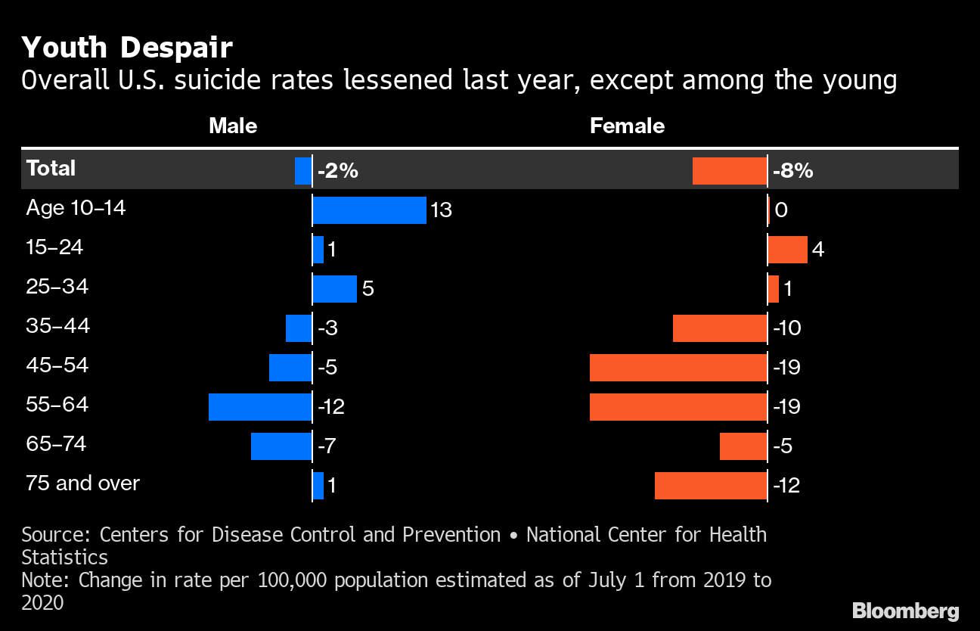
Depressive Disorder Causes and Symptoms
Causes

The incidence rate of pediatric MDD increases with age and diagnosis of MDD has spiked over the years following puberty. Some of the causes of the spike include physical changes such as augmented production of hormonal, signaling along with changes in a social environment such as greater responsibilities, and psychosocial pressures (Neavin et al., 2018). In addition, adverse childhood experiences increase the risk of MDD such as childhood abuse including physical and sexual abuse, and household challenges such as parental separation along with neglect either emotionally or physically. As well, familial history of MDD increases the risk, and girls have a twofold rate to be diagnosed with MDD than boys.

Symptoms

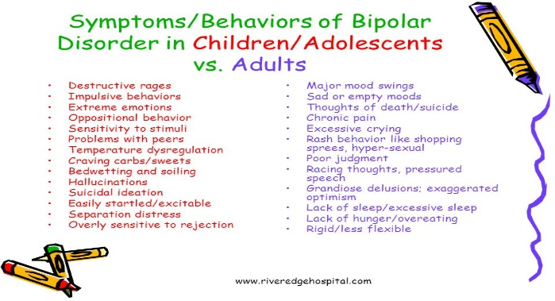Preschoolers aged as young as 3 years are habitually not likely to verbalize their feelings, cannot meet the diagnostic criteria for the adult population, present self-destructive themes in the play, and marked decreased interest in play (Mullen, 2018). Children aged 3-8 years present more somatic complaints, irritability, crying, shouting outbursts, and exhibit anxiety symptoms. Pediatrics aged 9 – 12 years exhibit low self-esteem, guilt, boredom, the feeling to run away, and fear death. However, adolescents present impulsivity, behavioral change, impair academic performance, increased irritability, disturbance in appetite and impaired sleep patterns, and suicidality (Mullen, 2018).

Why pediatric population is considered vulnerable

The pediatric population are at a critical of their life and MDD causes functional impairment. In addition, clinical presentation and severity in pediatric MDD vary and the condition is usually underreported and underdiagnosed. In those diagnosed with MDD, barely half of the patients receive appropriate treatment (Patra & Kumar, 2021). In addition, pediatric depression and suicide is a major global public health issue as suicide is the second cause of death in the adolescent population.
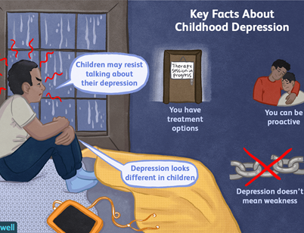
How Depression Is Diagnosed In Pediatric Population
Pediatrics may lack sufficient emotional vocabulary or insight and have difficulties communicating their emotional well-being making the diagnosis of MDD complex. As such, an initial assessment is required involving a parent and child interview. Open questions are recommended to help rule out comorbid conditions such as anxiety and understand contextual factors including familial, school, and interpersonal interactions (Suravi Patra). The United States Preventive Services Task Force (USPSTF) recommends routine screening for children between 12 and 18 years (Grade B evidence) but did not recommend screening for children below the age of 11 due to lack of evidence. There are numerous assessment tools for screening pediatric depression or suicide with different formats, tools, completion duration, recommended age, and availability (Patra & Kumar, 2021).
The two specific tools commonly used include the Patient Health Questionnaire for Adolescents (PHQ-9A) and the Beck Depression Inventory-Primary Care Version which assess the frequency and severity of symptoms. The tools help in the diagnosis of pediatric MDD through the clinical presentation with five or more main symptoms including depressed mood or reduced pleasure or interest (Patra & Kumar, 2021).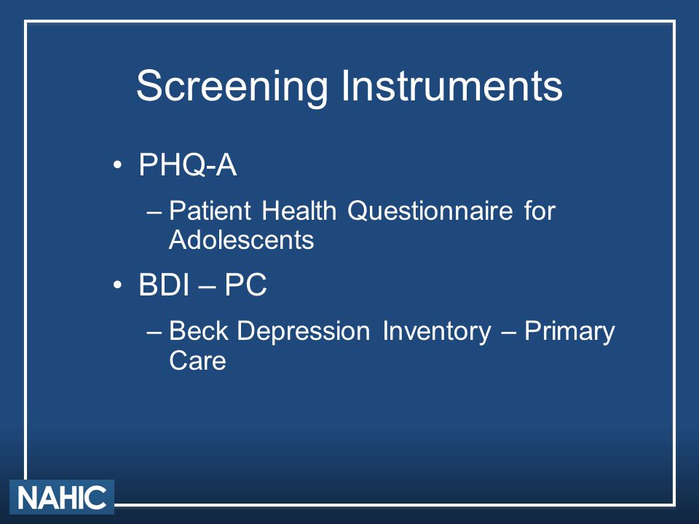
Medication Treatment Options
The recommended treatment for pediatric MDD involves psychotherapy and selective serotonin reuptake inhibitors (SSRIs). The first line of treatment involves psychotherapy and interpersonal interventions including cognitive behavioral therapy (CBT) and interpersonal therapy (IPT). CBT helps teach pediatrics how to identify maladaptive thinking, or cognitive distortions and replace them with constructive thoughts (Neavin et al., 2018). Subsequently, the approach helps in lessening self-destructive behavior and improves emotional stress. IPT help in building their relationship and improving communication skills. Other interventions include psychoeducation in chronic depression along with supportive psychotherapy for behavioral activation and improve their problem-solving skills (Patra, 2019).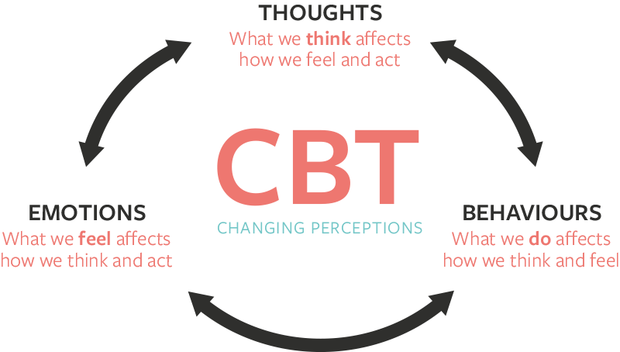
Non-pharmacological interventions are pharmacotherapeutic interventions. The United States Food and Drug Administration (FDA)-approved two SSRIs for the treatment of adolescent MDD including fluoxetine (8-18 years) and escitalopram (12–17 years). These drugs have demonstrated efficacy in reducing depression symptoms and great remission (Neavin et al., 2018). Using FDA black box warning, SSRIs are associated with a small increase in suicidality, increased agitation, and hostility but the risks of not treating them outweigh treatment of pediatric MDD. The FDA recommends that pediatric patients on fluoxetine or escitalopram should be monitored to alleviate the risk of suicide weekly in the first months and twice weekly for the following month.
Medication Considerations of Medication
The choice of medications is also grounded on the evidence base, depression severity, characteristics of the patient, chronicity, family history on response, response to treatment, comorbid conditions or medical condition as well as preference and expectations of the parent or the family (Patra, 2019). Other factors according to Mullen (2018) include the danger of overdose, drug interactions due to cytochrome inhibition, adverse effects profile, and timing of therapeutic effect.
Importance of Monitoring Labs and Comorbid Medical Issues
Children and adolescents may present comorbidities seen in approximately 80%–95% including Axis disorders including attention deficit hyperactivity disorder conduct disorders, and the most common being anxiety disorders such as separation anxiety disorder (Patra, 2019). There is no specific imaging or lab test that can be done in diagnosis, especially for adolescents aged 12 to 18 years. However, it is crucial to perform some evaluations to rule out differential diagnoses, and further investigating should be ordered in suspicion of medical illnesses. Some examples include complete blood count (CBC), vitamin B-12 levels, and electrolytes levels including magnesium, calcium, and phosphate (Alsaad et al., 2018). As well, it is crucial to conduct renal function tests and Liver function tests.
Special Considerations
Initially, children and adolescents are younger than the legal age of 18 years, and hence parental consent prior to assessment or screening of a child. Appropriate informed consent involves a health provider disclosing relevant information related to the treatment process and making them actually understand (Varkey, 2021). A mental health practitioner should uphold the moral obligation to act to benefit the patient defend the right of the patient, and prevent harm by applying the ethical principles of beneficence and maleficence (Varkey, 2021). The intention of the whole process of assessing, diagnosis, and treatment should be to relieve pain and improve outcomes. In addition, it is crucial to practice particularity morality and uphold professional standards by respecting cultural values and beliefs, and religions regarding psychiatric conditions. It is imperative to understand the socioeconomic status of the children to be able to understand children's lives and factors that might lead to MDD or increase the risk of MDD such as stress levels.
Follow Up In the Local Community for Further Information
A close-up follow-up is needed in patients with depression parents can gather more information in the local communities including joining the “Children's Mental Health Matters!” campaign in Maryland. Here is the link for a Maryland public education campaign https://www.mhamd.org/wp-content/uploads/2016/07/FRK-2016.pdf
Example of a Prescription

A safe and effective prescription involves the prescriber understanding the level of scheduling, mechanism, and properties of medication along with interactions. In prescriptions of medications, it is crucial to consider the patient's age, drug name, drug strength, dosage form, quantity to be prescribed, the direction of use, and the number of refills (Kenny & Preuss, 2019).
An example of fluoxetine prescription to an 8-year-old child with acute MDD;
Patient Name: HA
DOB: 8/21/2014
Prozac 10mg
Disp - PO qDay
Start at 10 mg/day
Gradually increase the dosage after 1 week; Do not exceed 20 mg qDAy
Refills –
Sign: ______ Date: _9/15/2022_

References
Alsaad, A. J., Azhar, Y., & Al Nasser, Y. (2018). Depression in children. In StatPearls [Internet]. StatPearls Publishing. https://www.ncbi.nlm.nih.gov/books/NBK534797/
Kenny, B. J., & Preuss, C. V. (2019). Pharmacy prescription requirements. In StatPearls [Internet]. StatPearls Publishing. Retrieved from https://www.ncbi.nlm.nih.gov/books/NBK538424/
Mullen, S. (2018). Major depressive disorder in children and adolescents. Mental Health Clinician, 8(6), 275-283. https://doi.org/10.9740%2Fmhc.2018.11.275
Neavin, D. R., Joyce, J., & Swintak, C. (2018). Treatment of major depressive disorder in pediatric populations. Diseases, 6(2), 48. https://doi.org/10.3390%2Fdiseases6020048
Patra, K. P., & Kumar, R. (2021). Screening For Depression and Suicide in Children. In StatPearls [Internet]. StatPearls Publishing. Retrieved from https://www.ncbi.nlm.nih.gov/books/NBK576416/
Patra, S. (2019). Assessment and management of pediatric depression. Indian Journal of Psychiatry, 61(3), 300. https://doi.org/10.4103%2Fpsychiatry.IndianJPsychiatry_446_18
Varkey, B. (2021). Principles of clinical ethics and their application to practice. Medical Principles and Practice, 30(1), 17-28. https://doi.org/10.1159/000509119

