Week 5 Discussion 1: Obesity – An American Epidemic
Obesity is among the pandemics facing United States, with the rates of its occurrence being grater compared to other developed nations. The prevalence of obesity had created a health and financial burden with the United States Federal government spent nearly $1.1 trillion dollars on healthcare, and 10% of this money ($110 billion) was utilized to combat obesity driven concerns. Besides, obesity is linked to causing different chronic illnesses including diabetes, cardiovascular illness, cancer, stroke as well as high blood pressure (Wang et al., 2020). It is significant for the APRNs to be aware of what is happening in the society and how it affects our health as a country. In this light, this discussion explores the state of obesity in the country. The following is a visual picture reflecting on the state of obesity in the United States.
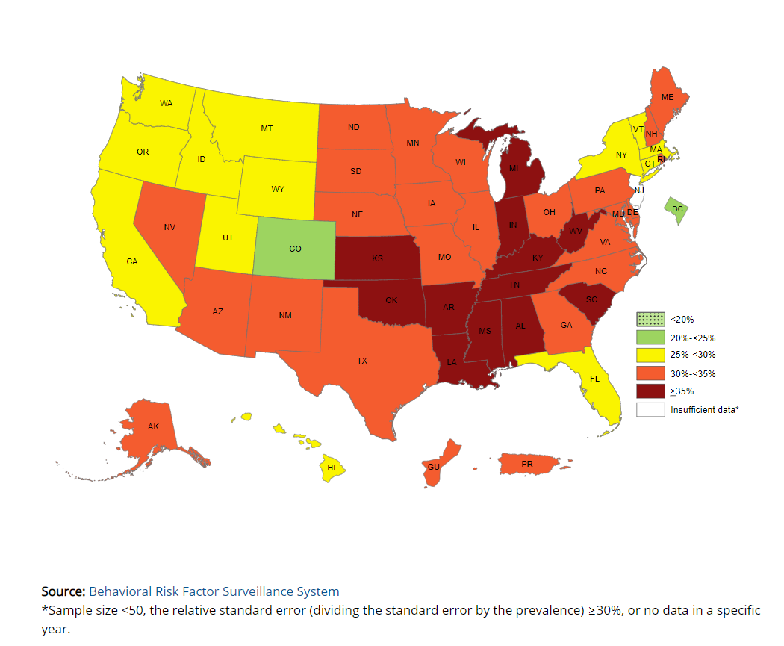

(CDC, 2022)

The visual picture reflects on the state of obesity in the United States in the year 2019 and how it has risen into a pandemic across the country. The visual picture reflection reveals that the rate of adult obesity in the United States is higher than 35% in approximately 12 states (CDC, 2022). The visual picture illustration also revealed that obesity affects the United States differently with some states having higher rate of adult obesity compared to others. Among all the states, only the state of Colorado has an adult obesity level of below 25%, while the majority states have an obesity level of between 25% to 35% (CDC, 2022).
The obesity pandemic in the U.S is a major health issues, and with the recent approximations appears to be getting worse. The current national adult obesity rate is at 29.7% with the approximations indicating that almost half of the adult population will be obese by the year 2030 (Centers for Disease Control and Prevention, 2022). Different states are affected differently by the obesity pandemic with some having higher rates of adult obesity. The state of Maryland ranks 24th on the states with the highest adult obesity rate in the U.S. (Centers for Disease Control and Prevention, 2022). In Maryland approximately 31.6% of the total adult residents reports to have a body mass index of 30 or greater which is the BMI rate for obesity. In Mary obesity is the leading risk factor for type 2 diabetes and approximately 11.1% of Maryland residents aged 20 and above have diabetes (Centers for Disease Control and Prevention, 2022).
There are different health disparities affecting my community that are linked to obesity. As aforementioned in the state of Maryland obesity is the leading risk factor for type 2 diabetes and approximately 11.1% of Maryland residents aged 20 and above have diabetes which is higher compared to the national rate of 10.5% for the same group (Maryland.gov, 2020). The community is also challenged by the higher rates of individuals with low income that makes it challenging to afford proper medical care and healthy lifestyles. Besides, there is the challenge of insufficient sleep that predisposes them to the risk of being obese, as approximately 37.7% of the adults in Maryland report not getting enough sleep (Maryland.gov, 2020).
References
CDC. (2022). New adult obesity maps. Centers for Disease Control and Prevention. Retrieved from https://www.cdc.gov/obesity/data/prevalence-maps.html#overall
Centers for Disease Control and Prevention. (2022, May 19). Obesity is a common, serious, and costly disease. https://www.cdc.gov/obesity/data/adult.html
Maryland.gov. (2020). Maryland Diabetes Action Plan. Maryland.gov Enterprise Agency Template. Retrieved from https://health.maryland.gov
Wang, Y., Beydoun, M. A., Min, J., Xue, H., Kaminsky, L. A., & Cheskin, L. J. (2020). Has the prevalence of overweight, obesity and central obesity levelled off in the United States? Trends, patterns, disparities, and future projections for the obesity epidemic. International journal of epidemiology, 49(3), 810–823. https://doi.org/10.1093/ije/dyz273

