Week 2 Assignment 1: Neurotransmitters Mind Maps
Name:
Institution:
Course:
Date:

Neurotransmitters Mind Maps
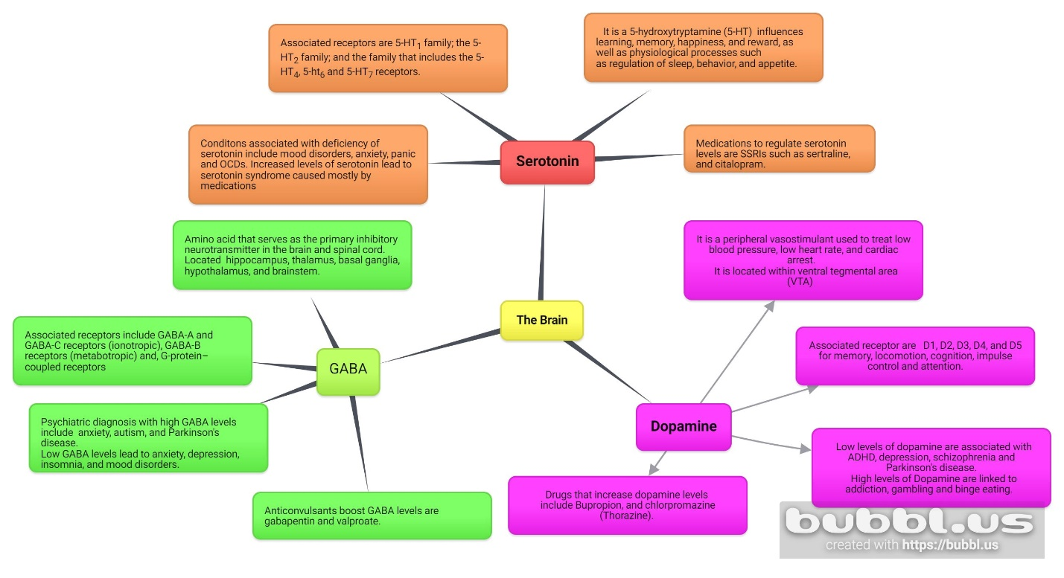
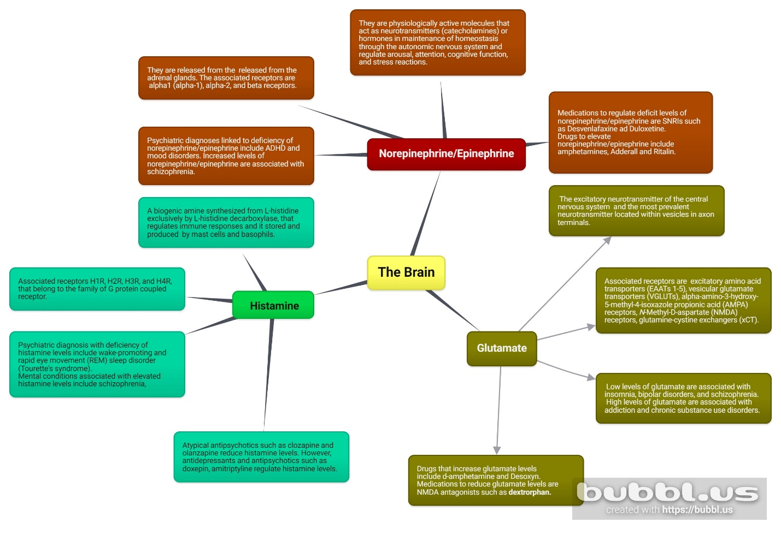

References
Bamalan, O. A., & Al Khalili, Y. (2019). Physiology, serotonin. In StatPearls [Internet]. StatPearls Publishing. https://www.ncbi.nlm.nih.gov/books/NBK545168/
Jewett, B. E., & Sharma, S. (2018). Physiology, GABA. In StatPearls [Internet]. StatPearls Publishing. https://www.ncbi.nlm.nih.gov/books/NBK513311/
Paravati, S., Rosani, A., & Warrington, S. J. (2018). Physiology, catecholamines. In StatPearls [Internet]. StatPearls Publishing. https://www.ncbi.nlm.nih.gov/books/NBK507716/
Patel, R. H., & Mohiuddin, S. S. (2022). Biochemistry, Histamine. In StatPearls [Internet]. StatPearls Publishing. https://www.ncbi.nlm.nih.gov/books/NBK557790/
Scammell, T. E., Jackson, A. C., Franks, N. P., Wisden, W., & Dauvilliers, Y. (2019). Histamine: neural circuits and new medications. Sleep, 42(1), zsy183. https://doi.org/10.1093%2Fsleep%2Fzsy183
Sonne, J., Goyal, A., & Lopez-Ojeda, W. (2021). Dopamine. In StatPearls [Internet]. StatPearls Publishing. https://www.ncbi.nlm.nih.gov/books/NBK535451/
Stallard, C. N., Anoruo, M., & Saadabadi, A. (2021). Biochemistry, Glutamate. In StatPearls [Internet]. StatPearls Publishing. https://www.ncbi.nlm.nih.gov/books/NBK537267/

