Neurotransmission Mind Map Assignment
Student
Professor’s Name
Course Code
Date

Nursing
When one neuron releases a signaling molecule across a synapse, it is called a neurotransmitter. The target cell might be another neuron, but it could also be a gland cell, muscle cell, or any other major body component or target cell. The transmission of nerve impulses across a synaptic gap is called neurotransmission.
Neurotransmitters in CNS
The excitatory neurotransmitter glutamate is the most abundant in the neurological system. It's the brain's primary neurotransmitter. The cognitive processes of thinking, learning, and remembering rely heavily on them.
Key Used in the Mind Map
AL means Anatomical Location, AR means Associated Receptors, and PD means Psychiatric Diagnosis that could occur with a deficit or surplus of the neurotransmitter.
Neurotransmitters Mind Map
Part A
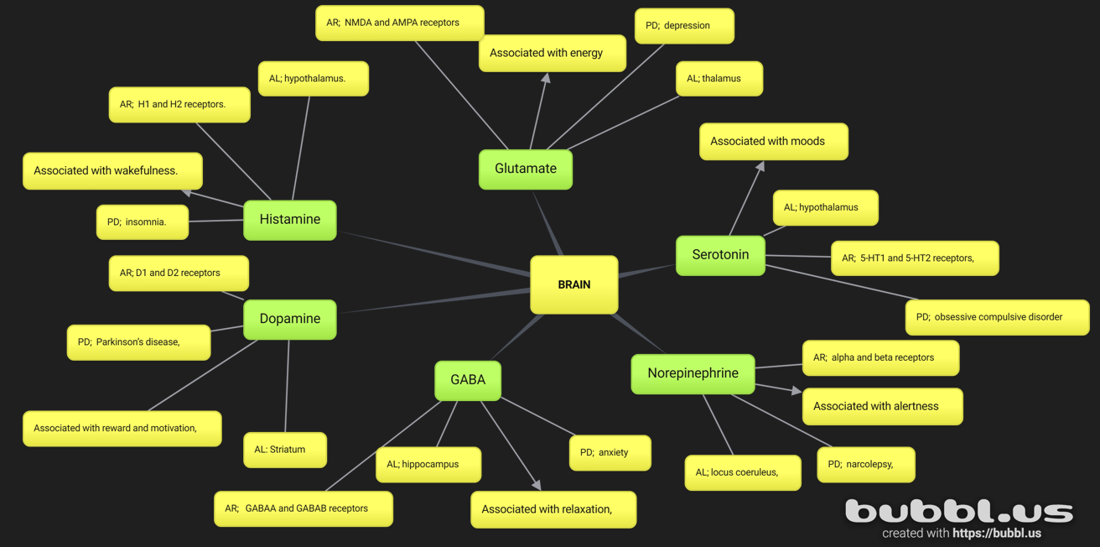
Part B
How Medications/Drug Classes Can Increase and Decrease the Effects of the Neurotransmitters.
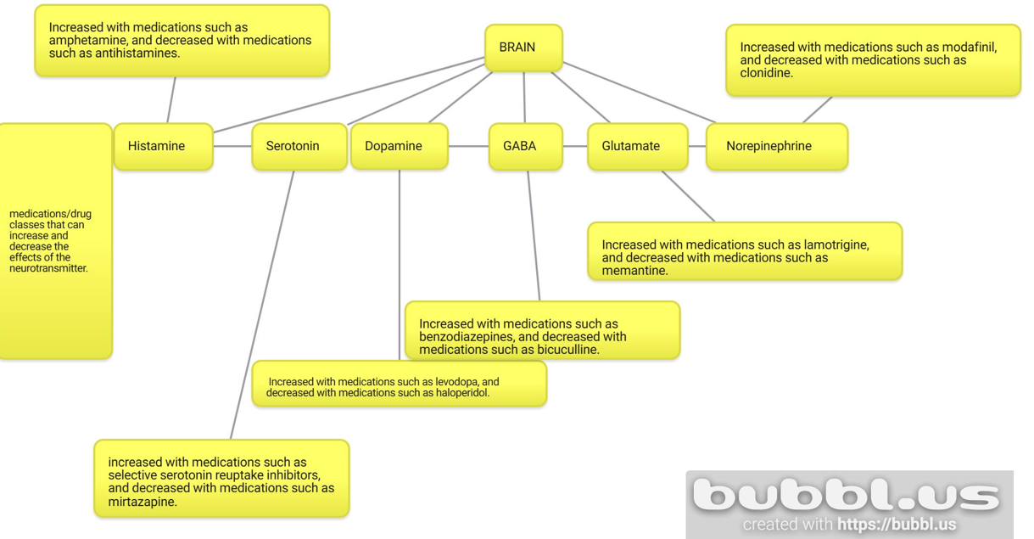

References
Blum, K., Braverman, E. R., Holder, J. M., Lubar, J. F., Monastra, V. J., Miller, D., ... & Comings, D. E. (2000). The reward deficiency syndrome: A biogenetic model for the diagnosis and treatment of impulsive, addictive and compulsive behaviors. Journal of psychoactive drugs, 32(sup1), 1-112.
Brunello, N., Blier, P., Judd, L. L., Mendlewicz, J., Nelson, C. J., Souery, D., ... & Racagni, G. (2003). Noradrenaline in mood and anxiety disorders: basic and clinical studies. International clinical psychopharmacology, 18(4), 191-202.
Goldman-Rakic, P. S., & Selemon, L. D. (1997). Functional and anatomical aspects of prefrontal pathology in schizophrenia. Schizophrenia bulletin, 23(3), 437-458.
Lewis, D. A., Volk, D. W., & Hashimoto, T. (2004). Selective alterations in prefrontal cortical GABA neurotransmission in schizophrenia: a novel target for the treatment of working memory dysfunction. Psychopharmacology, 174(1), 143-150.
Murphy, D. L., Andrews, A. M., Wichems, C. H., Li, Q., Tohda, M., & Greenberg, B. (1998). Brain serotonin neurotransmission: an overview and update with an emphasis on serotonin subsystem heterogeneity, multiple receptors, interactions with other neurotransmitter systems, and consequent implications for understanding the actions of serotonergic drugs. Journal of Clinical Psychiatry, 59(15), 4-12.
Nayeri, T., Sarvi, S., & Daryani, A. (2022). Toxoplasmosis: targeting neurotransmitter systems in psychiatric disorders. Metabolic Brain Disease, 37(1), 123-146.
Nieoullon, A. (2002). Dopamine and the regulation of cognition and attention. Progress in neurobiology, 67(1), 53-83.

