Student Lesson Plan

Overview
- Program Competencies
- Course Outcomes
- Weekly Objectives
- Main Concepts
- Applies organizational and system leadership skills to affect systemic changes in corporate culture and to promote continuous improvement in clinical outcomes. (PO 6)
- Appraises current information systems and technologies to improve health care. (POs 6, 7)

Schedule
Section | Read/Review/Complete | Course Outcomes | Due
Prepare | Assigned Readings | COs 3, 4, 5, 6 | Wednesday
Explore | Lesson | COs 3, 4, 5, 6 | Wednesday
Translate to Practice | Discussion: Initial Post | COs 3, 4, 5, 6 | Wednesday
Translate to Practice | Discussion: Follow-Up Posts | COs 3, 4, 5, 6 | Sunday
Reflect | Reflection | COs 3, 4, 5, 6 | No submission

Foundations for Learning
Start your learning this week by reviewing the following resources:
Centers for Disease Control and Prevention. (n.d.). Public health series.Links to an external site. https://www.cdc.gov/publichealth101/e-learning/informatics
GMR Web Team. (2018). Healthcare marketing on social media and other digital platformsLinks to an external site. [Video]. YouTube. https://www.youtube.com/watch?v=HlAxBcIZZDE

Student Learning Resources
Click on the following tabs to view the resources for this week.
- Required Textbooks
- Required Articles
- Additional Resources
McBride, S., & Tietze, M. (2023). Nursing informatics for the advanced practice nurse: Patient safety, quality, outcomes, and interprofessionalism (3rd ed.). Springer Publishing Company.
- Read Chapters 5, 16, 28

Learning Success Strategies
- Review the assigned readings to ensure you understand the key terms and can relate them to consumer informatics and telehealth.
- Read the resources to gain an understanding of consumer informatics, population health, telehealth, mobile technology, and social media.
- Be ready to share your thoughts through the interactive discussion board regarding telehealth services, applications, mobile health, and social media. Consider legal and ethical issues.
- Review the discussion board guidelines and review the rubric.
- Remember the vast number of resources available to you! There is help in the library, writing resources, links to evidence for the course, your textbooks, and other places!
- Supplemental resources are not mandatory but can provide additional knowledge and understanding.
- Your course faculty is here to support your learning journey. Reach out for guidance with study strategies, time management, and course-related questions.
- Let’s Check-In: Tips for Success are available several weeks throughout the course. Check announcements and please listen to the recording posted in the announcement if unable to attend.

Interacting with Feedback
Each week your course faculty will provide feedback in the rubric on any assignment you have submitted. Take a moment to review the following video on how to view rubric feedback in Canvas. (After clicking the link, scroll down or click on the title in the Summary area to jump directly to the video.)
- Link (video): Looking at FeedbackLinks to an external site. (2:26)
Review the following video on how to accept/reject track changes when viewing course faculty feedback on your assignment:
- Link (video): Word: Track Changes and Comments (4:19)
Technology Meets Healthcare: Healthcare at a Distance

Remote Care through Consumer Health Informatics
Consumer health informatics (CHI) is an emerging domain of informatics that is leading to new models of care delivery and patient empowerment. Bridging the gap between patients and healthcare resources, CHI spans diverse areas such as telehealth, mobile health (mHealth), social media, personal health records, and patient portals. Such portable technologies enable consumers to remotely access and participate in healthcare processes and decisions. CHI tools serve as a catalyst to eliminate healthcare disparities and provide support for vulnerable populations (Brooks et al., 2020).

Telehealth Technologies
In a few short years, telehealth technologies have become commonplace for patient care delivery. Using technology, patients and families can remotely monitor and record vital signs, track symptoms of a disease, transmit data to or communicate with a healthcare provider, and access educational resources. Such technologies support patients in actively monitoring and managing their healthcare and receiving services needed.
View the following video to explore the use of telehealth technology in patient care.
Telehealth Monitoring (2:34)

Telehealth Services
Innovation in digital health technology also improves access to healthcare services, while reducing hospitalizations and allowing for early detection and intervention. One such example is the use of telehealth video technology by the Department of Veterans Administration (VA) to provide care for veterans. The VA (2019) reported surpassing more than one million annual video telehealth patient visits with over 780,000 veterans using one of three telehealth programs across 900 VA sites in more than 50 medical specialties.
Further your exploration of telehealth technologies by discovering how video technology is transforming the care of veterans in the following video:
- Link (video): Introduction to VA Telehealth ServicesLinks to an external site. (2:08)
Next, enhance your learning by viewing Healthcare Information and Management Systems Society (HIMSS) TV video featuring the use of telehealth psychiatry in treating acute care patients in the Emergency Department following an Opioid-related adverse event:
- Link (video): Telemedicine's Big Promise in Helping with the Opioid CrisisLinks to an external site. (6:27)
Transforming Healthcare through Health Information Technology

Mobile Health Technology
Mobile health known as mHealth is another portable technology that is revolutionizing healthcare. This mode of CHI uses mobile communication devices to support communication, access to health information and care delivery, and clinical decision making. The emergence of smart phones and tablets has accelerated the growth of mHealth, introducing new opportunities for health services in both high and low-resource settings. Global health interventions now utilize mHealth tools to promote disease prevention and management and communication with hard-to-reach populations (Brooks et al., 2020). Many public health agencies also use mobile technologies to address public health challenges. One example is the U.S. Department of Veterans Affairs (VA) use of mobile apps designed especially for the needs of veterans.
View the following video to explore popular health-related mobile apps available for Veterans:
- Link (video): VA App Store mobile.va.gov/AppstoreLinks to an external site. (1:15)

VA App Store Video Transcript

Social Media
Social media platforms and tools are other forms of consumer health information that are transforming healthcare. From Facebook to Twitter, Blogs, YouTube, business review sites, and community websites and networks, social media platforms are engendering the democratization of healthcare by empowering consumers to take an active and informed role in managing their own health and healthcare.
View the following diagram to investigate the increasing use of social media in healthcare.
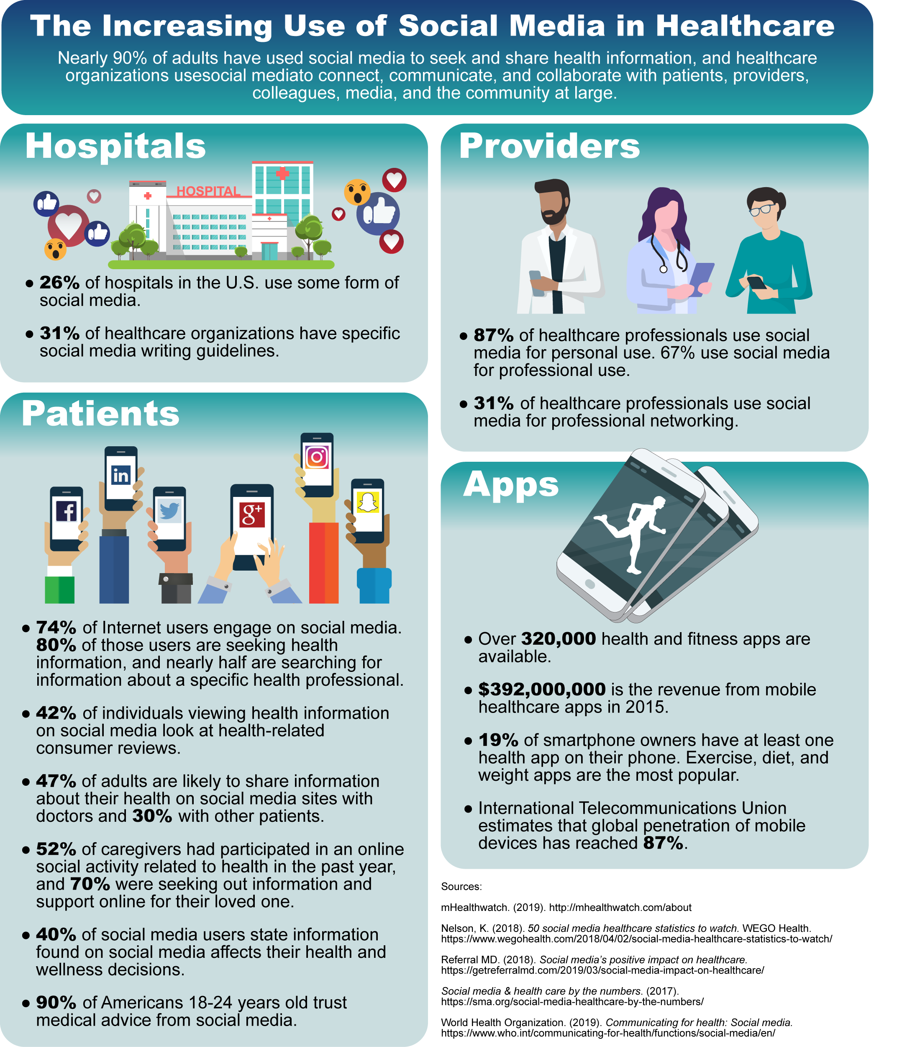

Social Media Image Description

Enhancing Consumer Access and Engagement Through Technology

Technology is providing new opportunities to improve health literacy and self-care management for patients. Over half of the patients with chronic disease believe the benefits of technology overrides the risks to privacy (McBride & Tietze, 2023). Numerous factors influence consumer engagement by technology, including, but not limited to, individual health literacy and computer literacy along with support systems, organizational policies, and social norms. Interprofessional collaborative education results in a higher-level quality of care through enhanced communication.
Technology enhances efficiency and supports decision-making. Consumer engagement with technology is empowering and motivates the patient to be an active participant in the proposed care (Brooks et al., 2020). The continuum of engagement supports the concept of self-determinism, the right to choose and make decisions over one’s lifetime. These decisions are based upon individual beliefs, values, and experiences intertwined with interprofessional support to achieve a greater sense of well-being.
Healthcare in the 21st century in the United States reveals a national calamity impacting concepts of equality, respect, and self-determinism threatening individuals’ well-being sufficiency. One significant precipitating issue is healthcare access. Healthcare access disparity negatively sways true self-determinism. Clusters of disadvantaged citizens with limited access to healthcare indicate a missed opportunity in utilization of services and technology to combat illness and to promote health. According to Benda et al., (2020), broadband internet access should be considered a new social determinant of health to capitalize on the technology transforming healthcare.
The traditional patient-physician decision-making model is evolving. Social contexts are now influencing and defining the value of health for many individuals. Disadvantaged individuals who experience social injustices, often have limited healthcare access. Furthermore, too often government policies may reflect financial considerations ignoring ethical implications and well-being sufficiency levels.
Healthcare policy ethics must consider individual, cultural, and societal views when attempting to address equality of healthcare goods distribution. The term “differences” refers to a variance among individuals or groups that cannot be changed or eliminated. However, inequalities lead to an interactive and accumulative cyclic disadvantage. By analyzing patterns of cultural disadvantage, societal disadvantage, and individual disadvantage levels, a clearer interpretation of justice can be realized.
Healthcare access can be one barometer assessing equality of healthcare resource distribution. Social justice will improve when healthcare disparities regarding access are minimized. Economic and social circumstances deleterious to healthcare access are not necessarily equalized but must reach an acceptable well-being sufficiency level for social justice to exist.
One government initiative to decrease healthcare disparity was the Meaningful Use initiative now referred to as the Promoting Interoperability Program. This multi-billion-dollar program provided financial incentives for the adoption of certified electronic health information systems along with the implementation of specific objectives related to the health information system design. The technology initiative created to span several years was broken down into three stages. Each previous stage provided a foundation for the next stage.
- 1st stage: Electronic data capture
- 2nd stage: Process improvement & interoperability
- 3rd stage: Improved patient health outcomes
The program objectives used technology, specifically certified electronic health record technology, to improve quality care and safety, engage patients, families, and caregivers; improve communication; improve population health; and still ensure the patient’s personal health information remained safe and secure.
View the graphic below depicting the three stages of Meaningful Use.
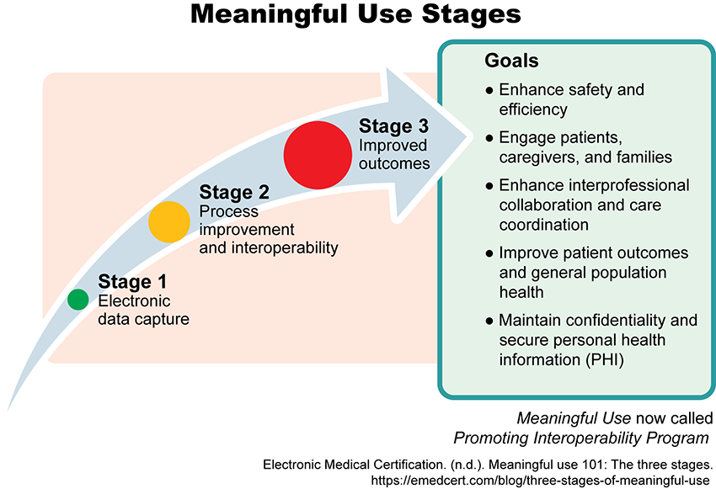

Meaningful Use Image Description

Benda, N., Veinot, T., Sieck, C., & Ancker, J. (2020). Broadband internet access is a social determinant of health! American Journal of Public Health, 110(8), 1123. https://doi.org/10.2105/AJPH.2020.305784
Brooks, R., Nieto, O., Swendeman, D., Myers, J., Lepe, R., Cabral, A., Kao, U., Donohoe, T., & Conulada, W. (2020). Qualitative evaluation of social media and mobile technology interventions designed to improve HIV health outcomes for youth and young adults living with HIV: A HRSA SPNS initiative. Health Promotion Practice 21(5), 693-704. https://doi.org/10.1177/1524839920938704
McBride, S., & Tietze, M. (2023). Nursing informatics for the advanced practice nurse: Patient safety, quality, outcomes, and interprofessionalism (3rd ed.). Springer Publishing Company.

onsumer Informatics/Telehealth Case Study

Discussion

Purpose
The purpose of this discussion is for you to investigate telehealth and technology relationships to social justice principles.

Case Study Scenario
Watch the following video.
Consumer Informatics/Telehealth Case Study (1:55)

Instructions
Review the case scenario above and address the following:
- Examine concepts such as equity, respect, self-determinism, health literacy, cyclic disadvantage, and healthcare disparities among marginalized populations or groups and how they affect patient outcomes.
- Compare and contrast how each patient in the video may benefit from telehealth services and the ethical considerations from the viewpoint of the nurse.
- Propose barriers that must be removed to achieve well-being, sufficiency, and healthcare access for all.
Please click on the following link to review the DNP Discussion Guidelines on the Student Resource Center program page:
- Link (webpage): Graduate Discussion Grading Guidelines and RubricLinks to an external site.

Program Competencies
This discussion enables the student to meet the following program competencies:
- Applies organizational and system leadership skills to affect systemic changes in corporate culture and to promote continuous improvement in clinical outcomes. (PO 6)
- Appraises current information systems and technologies to improve health care. (POs 6, 7)

Course Outcomes
This discussion enables the student to meet the following course outcomes:
- Design programs that monitor and evaluate outcomes of care, care systems, and quality improvement. (PC 4; PO 7)
- Evaluate the types of healthcare information systems, knowledge-based systems, and patient care technology and the impact on patient safety, quality of care, and outcome measurement. (PC 4; PO 7)
- Appraise consumer health information sources for accuracy, timeliness, and appropriateness. (PC 4; PO 7)
- Resolve ethical and legal issues related to the use of information, communication networks, and information and patient care technology. (PCs 2, 4; PO 6)

Due Dates
- Initial Post: By 11:59 p.m. MT on Wednesday
- Follow-Up Posts: By 11:59 p.m. MT on Sunday
Search entries or author
Filter replies by unreadUnread Collapse replies Expand replies
Subscribe
ReplyReply to Week 3: Discussion | Consumer Informatics/Telehealth Case Study

Collapse SubdiscussionKatie Hooven

Katie Hooven
SaturdayLocal: Oct 21 at 8:20am<br>Course: Oct 21 at 6:20am
Manage Discussion Entry
Welcome to week 3!

Remember: you may begin posting for credit on Sunday of Week 3. Please do not post before then.

When you make your initial response, click on the “Reply” arrow above this post. In Canvas this will set your post apart from all others. When you reply to another’s post, you will click the “Reply” arrow under that particular post.
.
Please read the question carefully to understand all the components. Then respond in a scholarly manner following the Graduate Discussion Grading Guidelines and Rubric. Our interactive discussion addresses the following course outcomes:
CO 3: Design programs that monitor and evaluate outcomes of care, care systems, and quality improvement. (PC 4; PO 7)
CO 4: Evaluate the types of healthcare information systems, knowledge-based systems, and patient care technology and the impact on patient safety, quality of care and outcome measurement. (PC 4; PO 7)

CO 5: Appraise consumer health information sources for accuracy, timeliness, and appropriateness. (PC 4; PO 7)
CO 6: Resolve ethical and legal issues related to the use of information, communication networks, and information and patient care technology. (PCs 2,4; PO 6)

Consider your own experiences as well as the literature.

I am looking forward to your discussions.
Dr. Hooven
ReplyReply to Comment

