WK8- 730

Student Lesson Plan

Overview
- Program Competencies
- Course Outcomes
- Weekly Objectives
- Main Concepts
- Integrates scientific underpinnings into everyday clinical practice. (POs 3, 5)
- Applies organizational and system leadership skills to affect systemic changes in corporate culture and to promote continuous improvement in clinical outcomes. (PO 6)
- Uses analytic methods to translate critically appraised research and other evidence into clinical scholarship for innovative practice improvements. (POs 3, 5)
- Appraises current information systems and technologies to improve health care. (POs 6, 7)
- Analyzes health care policies to advocate for equitable health care and social justice to all populations and those at risk due to social determinants of health. (POs 2, 9)
- Creates a supportive organizational culture for flourishing collaborative teams to facilitate clinical disease prevention and promote population health at all system levels. (PO 8)
- Leads others in professional identity, advanced clinical judgment, systems thinking, resilience, and accountability in selecting, implementing, and evaluating clinical care. (POs 1, 4)

Schedule
Section | Read/Review/Complete | Course Outcomes | Due
Prepare | Assigned Readings | COs 2, 3 | Wednesday
Explore | Lesson | COs 2, 3 | Wednesday
Translate to Practice | Discussion: Initial Post | COs 1, 2, 3 | Wednesday
Translate to Practice | Discussion: Follow-Up Posts | COs 1, 2, 3 | Saturday
Reflect | Reflection | COs 1, 2, 3 | No submission

Foundations for Learning
American Association of Colleges of Nursing. (2006). The essentials of doctoral education for advanced nursing practice.Links to an external site. https://www.aacnnursing.org/DNP/DNP-Essentials (Note: These Essentials outline the foundational competencies of advanced nursing practice for the DNP.)

Student Learning Resources
Click on the following tabs to view the resources for this week.
- Required Textbooks
- Required Articles
- Additional Resources
None

Learning Success Strategies
- Review the assigned readings to ensure you understand the key terms and can relate them to the role of the DNP-prepared nurse.
- As you review weekly content, consider how each concept and discussion can be translated into practice in your unique setting.
- Be ready to share your thoughts through the interactive discussion. It is important to share your own thoughts so that we hear your voice. Also, support your positions with evidence from the literature. Growing in your ability to share your ideas is encouraged, and the use of first-person is accepted for the discussion board.
- Review the discussion guidelines and rubric to optimize your performance.
- You have access to a variety of resources to support your success. Click on the DNP Resources tab on the home page to access program and project resources.
- Your course faculty is here to support your learning journey. Reach out for guidance with study strategies, time management, and course-related questions. Review rubric feedback and individual comments to optimize performance.
- As a reminder, the course ends at 11:59 p.m. MT on Saturday. All course work must be submitted before 11:59 p.m. MT on Saturday to receive credit in this course.

Interacting with Feedback
Each week your course faculty will provide feedback in the rubric on any assignment you have submitted. Take a moment to review the following video on how to view rubric feedback in Canvas. (After clicking the link, scroll down or click on the title in the Summary area to jump directly to the video.)
- Link (video): Looking at FeedbackLinks to an external site. (2:26)
Review the following video on how to accept/reject track changes when viewing course faculty feedback on your assignment:
- Link (video): Word: Track Changes and Comments (4:19)

Lesson
Traveling Through the Project & Practicum Experience

A Look Back at Your Journey
Throughout your DNP degree program, your identity as a professional nurse has gone through a transformation. Through your didactic courses, you have laid a foundation that will prepare you for your Project & Practicum experience. Each milestone of your DNP journey has moved you closer to the development of your DNP practice change project.
In this course, you have continued to develop practice readiness as a DNP-prepared nurse through the examination of a gap in practice. As a doctoral student, you have learned the importance of continually returning to the literature to explore the available research on a topic of interest. You identified a practice problem that is influencing healthcare outcomes at the micro, meso, or macrosystem level and that is of concern in your practice environment. You have gathered and analyzed data regarding the practice problem from a local to a global perspective. A search of the literature assisted you in the identification of an evidence-based intervention. You paired the evidence to the gap in practice to ensure the intervention has proven effective in addressing the identified practice problem. While developing a practice question, you identified measurable outcomes for your project. The stakeholders impacted by the practice problem have been ascertained and a plan for implementing your project has been drafted.
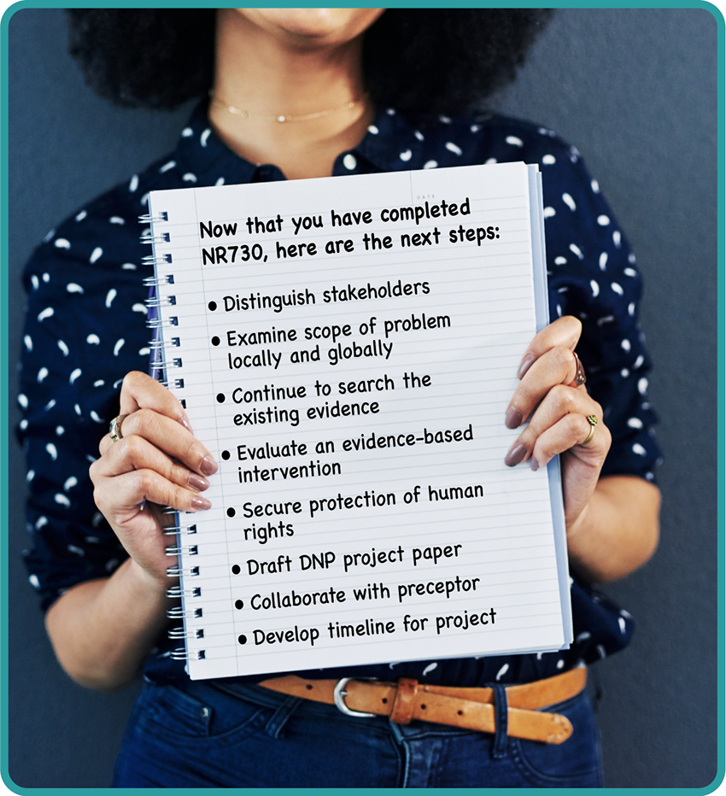

Next Steps Image Description
The protection of human rights is a critical component in research and when implementing practice change. As the project manager for your DNP practice change project, you are responsible for ensuring all ethical and legal practices are deployed throughout the design, implementation, and evaluation of your project. Through interprofessional collaboration with your preceptor, you have developed a timeline for the implementation phase of your DNP practice change project that is acceptable to the practicum site and congruent with the DNP curriculum..

Moving Forward
So you may wonder, what’s next? Just as you have evolved as a doctoral student throughout your DNP degree journey, your project will also continue to evolve as you enter your first DNP Project & Practicum course—NR702. You will draw from the knowledge and skills you have learned thus far to refine the rigor and quality of your DNP project. Each Project & Practicum course will guide you through the next phase of design, implementation, and evaluation of your scholarly project and the culmination of your DNP degree.
Click through the following interactive for an overview of the Project & Practicum courses.

Project & Practicum Overview Interactive Transcript

Click on the following hourglass and take a moment to reflect on the questions.

Time to Pause Interactive Transcript

Reflection on Learning and Practice Readiness

Discussion

Purpose
The purpose of this discussion is to reflect on your readiness to practice as a DNP-prepared nurse and consider what you learned in this course and how this knowledge will impact your practice.

Instructions
Each week, you have been reminded that reflective inquiry allows for expansion of self-awareness, identification of knowledge gaps, and assessment of learning goals. As you reflect on your own readiness to practice as a DNP-prepared nurse, it is important to consider what you learned in this course.
As you review the course outcomes and your experience in this course, address the following:
- Analyze and evaluate how your thinking was challenged in this course related to the role of a DNP-prepared nurse in using evidence from the literature to implement practice change and improve practice outcomes.
- Considering this new knowledge, examine how this learning prepares you to practice as a DNP-prepared nurse.
Please click on the following link to review the DNP Discussion Guidelines on the Student Resource Center program page:
- Link (webpage): DNP Discussion GuidelinesLinks to an external site.

Program Competencies
This discussion enables the student to meet the following program outcomes:
- Integrates scientific underpinnings into everyday clinical practice. (POs 3, 5)
- Applies organizational and system leadership skills to affect systemic changes in corporate culture and to promote continuous improvement in clinical outcomes. (PO 6)
- Uses analytic methods to translate critically appraised research and other evidence into clinical scholarship for innovative practice improvements. (POs 3, 5)
- Appraises current information systems and technologies to improve health care. (POs 6, 7)
- Analyzes health care policies to advocate for equitable health care and social justice to all populations and those at risk due to social determinants of health. (POs 2, 9)
- Creates a supportive organizational culture for flourishing collaborative teams to facilitate clinical disease prevention and promote population health at all system levels. (PO 8)
- Leads others in professional identity, advanced clinical judgment, systems thinking, resilience, and accountability in selecting, implementing, and evaluating clinical care. (POs 1, 4)

Course Outcomes
This discussion enables the student to meet the following course outcomes:
- Prioritize and apply ethical considerations and theories relevant to translation science. (PCs 1, 3, 8; POs 3, 4, 5)
- Apply clinical scholarship methodologies for designing, developing, implementing, and evaluating quality improvements and the translation of evidence-based practice to improve healthcare outcomes at the micro, meso, or macrosystem level. (PCs 1, 3, 5; POs 3, 5, 9)
- Appraise and synthesize the highest level of evidence available to improve the quality, cost-effectiveness, and healthcare outcomes of diverse populations. (PCs 1, 2, 3, 4, 6, 8; POs 4, 5, 6, 8)

Due Dates
- Initial Post: By 11:59 p.m. MT on Wednesday
- Follow-Up Posts: By 11:59 p.m. MT on Saturday
Search entries or author
Filter replies by unreadUnread Collapse replies Expand replies
Subscribe
ReplyReply to Week 8: Discussion | Reflection on Learning and Practice Readiness

Each week, you have been reminded that reflective inquiry allows for expansion of self-awareness, identification of knowledge gaps, and assessment of learning goals. As you reflect on your own readiness to practice as a DNP-prepared nurse, it is important to consider what you learned in this course.
As you review the course outcomes and your experience in this course, address the following:
1. Analyze and evaluate how your thinking was challenged in this course related to the role of a DNP-prepared nurse in using evidence from the literature to implement practice change and improve practice outcomes.
2. Considering this new knowledge, examine how this learning prepares you to practice as a DNP-prepared nurse.

