Week 8Student Lesson Plan

Overview
- Program Competencies
- Course Outcomes
- Weekly Objectives
- Main Concepts
- Integrates scientific underpinnings into everyday clinical practice. (POs 3, 5)
- Uses analytic methods to translate critically appraised research and other evidence into clinical scholarship for innovative practice improvements. (POs 3, 5)
- Appraises current information systems and technologies to improve healthcare. (POs 6, 7)
- Analyzes healthcare policies to advocate for equitable healthcare and social justice to all populations and those at risk due to social determinants of health. (POs 2, 9)
- Leads others in professional identity, advanced clinical judgment, systems thinking, resilience, and accountability in selecting, implementing, and evaluating clinical care. (POs 1, 4)

Schedule
Section | Read/Review/Complete | Course Outcomes | Due
Prepare | Assigned Readings | COs 1, 2, 3 | Wednesday
Explore | Lesson | COs 1, 2, 3 | Wednesday
Translate to Practice | Discussion: Initial Post | COs 1, 2, 3 | Wednesday
Translate to Practice | Discussion: Follow-Up Posts | COs 1, 2, 3 | Saturday
Reflect | Reflection | COs 1, 2, 3 | No submission

Foundations for Learning
Institute for Healthcare Improvement. (2020). Business plan template with patient safety goals.Links to an external site. http://www.ihi.org/resources/Pages/Tools/BusinessPlanTemplate.aspx

Student Learning Resources
Click on the following tabs to view the resources for this week.
- Required Textbooks
- Required Articles
- Additional Resources
Waxman, K. T., & Knighten, M. L. (2023). Financial and business management for the Doctor of Nursing Practice (3rd ed.). Springer Publishing Company.
- Read Chapters 15, 18, 19

Learning Success Strategies
- Review the assigned readings to ensure you understand the key terms and can relate them to the changing and evolving roles of the DNP-prepared nurse.
- As you review weekly content, consider how each concept and discussion can be translated into practice at your unique setting.
- Importantly, consider the Global Burden of Disease and National Practice Problems facing us every day in our healthcare settings. You will begin to consider your ability to bring forward practice changes as you search for research solutions.
- Be ready to share your thoughts through the interactive discussion. It is important to share your own thoughts so that we hear your voice. Also, support your positions with evidence from the literature. Growing in your ability to share your ideas is encouraged, and the use of first person is accepted for the discussion board.
- Review the discussion guidelines and rubric to optimize your performance.
- You have access to a variety of resources to support your success. Click on the DNP Resources tab on the home page to access program and project resources.
- Your course faculty is here to support your learning journey. Reach out for guidance with study strategies, time management, and course-related questions.
- Remember that Week 8 closes on Saturday at 11:59 pm MT.

Interacting with Feedback
Each week your course faculty will provide feedback in the rubric on any assignment you have submitted. Take a moment to review the following video on how to view rubric feedback in Canvas. (After clicking the link, scroll down or click on the title in the Summary area to jump directly to the video.)
- Link (video): Looking at FeedbackLinks to an external site. (2:26)
Review the following video on how to accept/reject track changes when viewing course faculty feedback on your assignment:
- Link (video): Word: Track Changes and Comments (4:19)

Lesson 1
Strategic Planning

Introduction
Healthcare organizations must assess the future in terms of their ability to meet the expectations of a more well-informed public and a more active group of purchasers of care and services. Also, the fact that the government is assigning itself a more prominent role in controlling the system's growth calls for constant monitoring by providers. Finally, the relationship between hospitals and physicians is changing as well. Physicians now perceive that their role as the primary customer of hospitals and the healthcare system's driving force is eroding through the growing influence of managed care. The authority of physicians to direct the care of their patients within the system is decreasing.

Reflection
Reflect on how factors such as a more well-informed public, greater government involvement, and a changing relationship between physicians and healthcare organizations affected your healthcare organization.
The convergences of these factors and other changes in the healthcare environment have caused healthcare organizations to understand their environment in which they must deliver their services. The forces of the environment are causing the system to change rather than allowing the system to assess and change itself.
Without an awareness of how their organization affects other organizations and other forces in the environment, healthcare managers risk developing ineffective plans. It is essential that managers understand their organization's system terms. As they do, they will begin to measure each decision they make in terms of its ramifications in and on the environment. This is the basis of strategic thinking.
Several steps are involved in preparing for the strategic planning process.
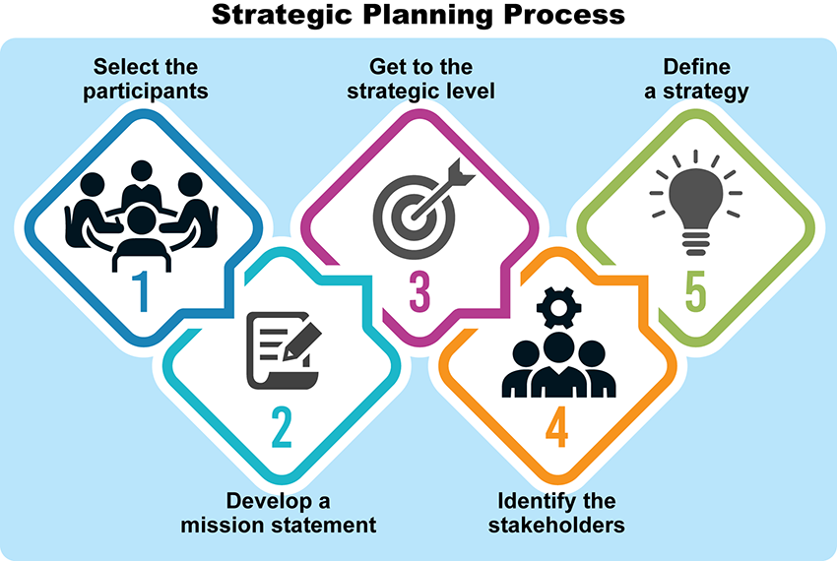

Strategic Planning Process Image Description

Capital Budgets
A capital budget is a plan for the acquisition of long-term investments. For example, a hospital may be planning to purchase new or replacement equipment, undertake a new service, or plan for a renovation or expansion of an existing facility. Fundamental to capital budgeting is that the asset being acquired has a lifetime that extends beyond the year of purchase. Therefore, the asset is only partly used up in one year, and, in any one year, the organization earns only part of the revenues that the capital assets generate over their useful lifetimes (Jones et al., 2019).
The capital budget serves as the basis for setting some of the critical quality and operating targets. Creating a capital budget proposal that quantifies the costs and benefits of the proposed investment is the starting point in the capital budgeting process. The governing board approves capital budgets. There is often a lack of sufficient funds at the organizational level to approve all capital budget requests. Therefore, it is also important to provide a justification for each requested purchase and specify the consequences if funding is not made available.

Forecasting Model
View the following video to learn about forecasting models.
Forecasting Model (2:45)

Section: Break-Even Analysis
The break-even analysis is used to determine at what point a new program or service will break even and then start to make money or be profitable.
Click through the following interactive to view the break-even analysis formula.

Break-Even Analysis Interactive Transcript
There would be a loss at a quantity lower than Q; at a quantity higher than Q, there would be a profit. P, or price, is assumed to be the average amount collected per patient or the average revenue the organization ultimately receives per patient. The basis for the formula is the underlying relationship between revenues and expenses. If total revenues are greater than expenses, there is a profit. If total revenues are less than expenses, there is a loss. If revenues are just equal to expenses, there is neither a profit nor a loss, and the service is said to break even (Jones et al., 2019).
When there are different types of patients, the break-even analysis becomes more complicated. If there are different types of patients with different prices, it is necessary to find the weighted average contribution margin.
Click the following tabs to view examples.
- Example 1
- Example 2
The following is an example of a break-even analysis for a home health agency with different types of patients with different prices.
Type of Patient | Price | Variable Cost | Contributing Margin
Complex | $100 | $30 | = $70
Moderate | $75 | $30 | = $45
Simple | $50 | $30 | = $20
The crucial piece of information for calculating the breakeven point is the relative proportion of each type of visit. Let's say that 20% of all visits are complex, 50% are moderate, and 30% simple. This information can be used to calculate the weighted average contribution margin. This requires multiplying each type of contributing margin by the percentage of patients that type of visit makes up, and then adding the sum of those results to attain the total weighted average contribution margin.
Type of Patient | % of Visits | Contributing Margin | Weighted Average Contribution Margin
20% | 20% | $70 | = $14.00
Moderate | $50 | $45 | = $22.50
Simple | $30 | $20 | = $6.00
Total Weighted Average Contribution Margin |  |  | = $42.50
The $42.50 represents the average contribution margin for all types of visits. It can be used to calculate the break-even quantity. Assume that fixed costs are at $10,000 What is the total number of home visits that the agency would need to make to break even?
$10,000$42.50=236 Visits
The answer is 235.29 visits. Because there is a decimal, we round the number up to the next whole digit because it is not possible to have a .3 patient visit. The total visit number is 236.
- 47 would be expected to be complex care visits (20%),
- 118 moderate care visits (50%), and
- 70 simple care visits (30%).
The same weighted average approach could be used to find the break-even volume when there are more than three different types of patients.

Pro Forma Financial Statement and Business Planning
An effective business plan has to include Pro Forma financial statements. Pro Forma financial statements are used to facilitate comparisons of historic data and projections of future performance. These statements are used to forecast future revenues, expenses, and profits and/or losses resulting from the program’s operations. Pro Forma statements are based on three main accounting statements:
- Profit or loss income statement
- Balance sheet
- Cash flow statement
A business plan is a detailed proposed program, project, or service. The plan is an important step in managing all businesses and it assists the DNP-prepared nurse in identifying customers, market and competition, projected revenues and expense, and time frame for achieving a break-even position. The depth and complexity of the business plan will vary by the project and for projects with large operating expenses or capital investments, a thorough business plan is crucial (Jones et al., 2019).

Lesson 2
Financial Contributions of the Nurse Practitioner

Financial Contribution of the Nurse Practitioner to a Practice
Advanced practice registered nurses (APRNs) have become increasingly more important in the delivery of healthcare in the United States. APRNs include nurse practitioners (NP), clinical nurse specialists (CNS), nurse anesthetists, and nurse midwives, and all play an important role in delivering essential care services.
Nurse practitioners have been delivering primary care services since 1965 and currently represent the largest and most visible group of APRNs. However, many are “hidden providers” whose financial contribution to healthcare is often difficult to assess.
A business skill important for nurse practitioners is calculating their financial contributions to the practice (Waxman & Knighten, 2023). Nurse practitioners should be skilled in calculating how much revenue they generate and how this compares with their salary.
View the following graphic to become familiar with the steps to determine the financial contribution of a nurse practitioner to the practice.

Financial Contribution Interactive Transcript
Click on the following hourglass and take a moment to reflect.

Time to Pause Interactive Transcript

Financial Contributions of the Nurse Practitioner

References
Jones, C., Finkler, S., Kovner, C. T., & Mose, J. (2019). Financial management for nurse managers and nurse executives (5th ed.). W.B. Saunders, Co.
Waxman, K. T., & Knighten, M. L. (2023). Financial and business management for the Doctor of Nursing Practice (3rd ed.). Springer Publishing Company.

Reflection on Learning and Practice Readiness

Discussion

Purpose
The purpose of this discussion is to reflect on your readiness to practice as a DNP-prepared nurse and consider what you learned in this course and how this knowledge will impact your practice.

Instructions
Each week, you have been reminded that reflective inquiry allows for expansion of self-awareness, identification of knowledge gaps, and assessment of learning goals. As you reflect on your own readiness to practice as a DNP-prepared nurse, it is important to consider what you learned in this course.
As you review the course outcomes and your experience in this course, address the following:
- Analyze and evaluate how your thinking was challenged in this course related to project management and financial management competencies.
- Considering this new knowledge, examine how this learning prepares you to practice as a DNP-prepared nurse.
Please click on the following link to review the DNP Discussion Guidelines on the Student Resource Center program page:
- Link (webpage): DNP Discussion GuidelinesLinks to an external site.

Program Competencies
This discussion enables the student to meet the following program competencies:
- Integrates scientific underpinnings into everyday clinical practice. (POs 3, 5)
- Uses analytic methods to translate critically appraised research and other evidence into clinical scholarship for innovative practice improvements. (POs 3, 5)
- Appraises current information systems and technologies to improve healthcare. (POs 6, 7)
- Analyzes healthcare policies to advocate for equitable healthcare and social justice to all populations and those at risk due to social determinants of health. (POs 2, 9)
- Leads others in professional identity, advanced clinical judgment, systems thinking, resilience, and accountability in selecting, implementing, and evaluating clinical care. (POs 1, 4)

Course Outcomes
This discussion enables the student to meet the following course outcomes:
- Examine the role of the DNP-prepared nurse in leading financial planning and management across healthcare settings. (PCs 5, 8; POs 2, 4, 9)
- Formulate a needs-based organizational assessment to inform strategic leadership decision-making. (PCs 1, 3, 4; POs 3, 5, 7)
- Develop strategies to lead project planning, implementation, management, and evaluation to promote high-value healthcare. (PCs 1, 3, 4; POs 3, 5, 7)

Due Dates
- Initial Post: By 11:59 p.m. MT on Wednesday
- Follow-Up Posts: By 11:59 p.m. MT on Saturday
Search entries or authorSearch entries or author
Filter replies by unreadUnread Collapse replies Expand replies
Subscribe
ReplyReply to Week 8: Discussion | Reflection on Learning and Practice Readiness

Collapse SubdiscussionMary Nimmo
Manage Discussion Entry
Welcome to our Week 8 Discussion. The purpose of this discussion is to reflect on your readiness to practice as a DNP-prepared nurse and reflect what you learned in this course and how this knowledge will impact your practice.
Reflect upon your learning and how you might incorporate this learning into your current and future career.
Our interactive discussion addresses the following course outcome:
  - CO 1 Examine the role of the DNP-prepared nurse in leading financial planning and management across healthcare settings. (POs 2, 4, 9)
  - CO 2 Formulate a needs-based organizational assessment to inform strategic leadership decision-making. (POs 3, 5, 7)
  - CO 3 Develop strategies to lead project planning, implementation, management, and evaluation to promote high-value healthcare. (POs 3, 5, 7)
We are all here for your success!! Don’t hesitate to let me know if you have any questions this week.

