WK 5 Discussion

Student Lesson Plan

Overview
- Program Competencies
- Course Outcomes
- Weekly Objectives
- Main Concepts
- Integrates scientific underpinnings into everyday clinical practice. (POs 3, 5)
- Uses analytic methods to translate critically appraised research and other evidence into clinical scholarship for innovative practice improvements. (POs 3, 5)
- Appraises current information systems and technologies to improve healthcare. (POs 6, 7)
- Analyzes healthcare policies to advocate for equitable healthcare and social justice to all populations and those at risk due to social determinants of health. (POs 2, 9)
- Leads others in professional identity, advanced clinical judgment, systems thinking, resilience, and accountability in selecting, implementing, and evaluating clinical care. (POs 1, 4)

Schedule
Section | Read/Review/Complete | Course Outcomes | Due
Prepare | Assigned Readings | COs 1, 3 | Wednesday
Explore | Lesson | COs 1, 3 | Wednesday
Translate to Practice | Discussion: Initial Post | COs 1, 3 | Wednesday
Translate to Practice | Discussion: Follow-Up Posts | COs 1, 3 | Sunday
Reflect | Reflection | COs 1, 3 | No submission

Foundations for Learning
Agency for Healthcare Research and Quality. (2021). Operating plan for fiscal year 2021.Links to an external site. https://www.ahrq.gov/cpi/about/mission/operating-plan/index.html
Institute for Healthcare Improvement. (2021). About us: Finances.Links to an external site. http://www.ihi.org/about/Pages/Finances.aspx

Student Learning Resources
Click on the following tabs to view the resources for this week.
- Required Textbooks
- Required Articles
- Additional Resources
Waxman, K. T., & Knighten, M. L. (2023). Financial and business management for the Doctor of Nursing Practice (3rd ed.). Springer Publishing Company.
- Read Chapters 1, 5, 8

Learning Success Strategies
- Review the assigned readings to ensure you understand the key terms and can relate them to the changing and evolving roles of the DNP-prepared nurse.
- As you review weekly content, consider how each concept and discussion can be translated into practice at your unique setting.
- Importantly, consider the Global Burden of Disease and National Practice Problems facing us every day in our healthcare settings. You will begin to consider your ability to bring forward practice changes as you search for research solutions.
- Be ready to share your thoughts through the interactive discussion. It is important to share your own thoughts so that we hear your voice. Also, support your positions with evidence from the literature. Growing in your ability to share your ideas is encouraged, and the use of first person is accepted for the discussion board.
- Review the discussion guidelines and rubric to optimize your performance.
- You have access to a variety of resources to support your success. Click on the DNP Resources tab on the home page to access program and project resources.
- Your course faculty is here to support your learning journey. Reach out for guidance with study strategies, time management, and course-related questions.

Interacting with Feedback
Each week your course faculty will provide feedback in the rubric on any assignment you have submitted. Take a moment to review the following video on how to view rubric feedback in Canvas. (After clicking the link, scroll down or click on the title in the Summary area to jump directly to the video.)
- Link (video): Looking at FeedbackLinks to an external site. (2:26)
Review the following video on how to accept/reject track changes when viewing course faculty feedback on your assignment:

Lesson 1
Healthcare Finance and Economics

Healthcare Financing
There are major considerations in analyzing financial performance. The DNP-prepared nurse should consider the current financial state, the capacity for the organization to perform its mission, and efficiency in the delivery of services.
Several methods for analyzing financial performance may be used:
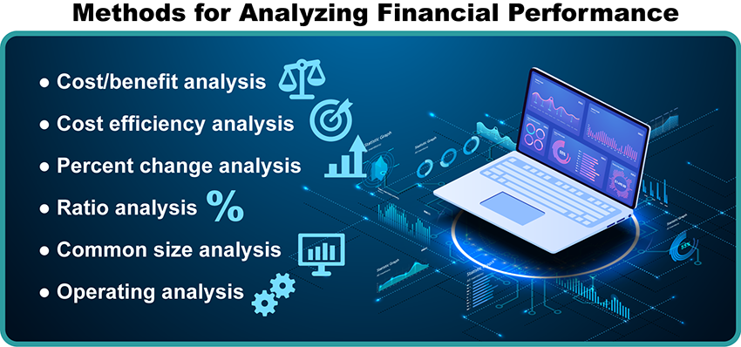

Methods for Analyzing Financial Performance Image Description
The relationship of fixed costs to variable costs may be calculated relative to profitability. Percentages may be calculated based on data from financial statements to compare an organization's financial performance over time or among other similar healthcare organizations. Ratios may be calculated from financial statement data for analysis and comparison. Operating analysis, using data not usually found in the financial statements, may also be calculated and interpreted.
Efficiency is an important concept in examining finances and the healthcare market. Four types of efficiency may be attained: Pareto, technical, production, and allocative.

Efficiency Types Interactive Transcript

Healthcare Economics
DNP-prepared nurses are witnessing massive changes in how care is delivered. Whatever the reason for hospitalization, patients are being managed in a manner very different from just a few years ago. Economic and financial knowledge is essential because all healthcare agencies are under pressure to provide high-quality, cost effective, and patient-centered care. Care is now designed to be delivered by interdisciplinary teams using a variety of staff members who perform increasingly more complex patient-care tasks, yet the expectation is that the cost of care should be less if efficiency is managed appropriately.
Review the following video to discover more about healthcare economics.
Healthcare Economics (4:50)

Financial Management Competencies
The American Organization for Nurse Leadership (AONL) (2015) developed Nurse Manager competencies. Over the next four weeks, these competencies will be explored.

Financial Management Competencies
- Recognize the impact of reimbursement on revenue.
- Anticipate the effects of changes on reimbursement programs for patient care.
- Maximize care efficiency and throughput.
- Understand the relationship between value-based purchasing and quality outcomes with revenue and reimbursement.
- Create a budget.
- Monitor a budget.
- Analyze a budget and explain variance.
- Conduct ongoing evaluation of productivity.
- Forecast future revenue and expenses.
- Capital budgeting » Justification » Cost benefit analysis (AONE & AONL, 2015)

Lesson 2
Financial Statements

Common Financial Statements
DNP-prepared nurse leaders and APNs pursuing independent practice options must understand the most common types of financial statements:
- Statement of revenue and expenses
- Statement of net worth
- Statement of cash flow
- Balance sheet
Click through the following interactive to learn about each of these statements:

Common Financial Statements Interactive Transcript

Lesson 3
Budget Analysis

Operating Budgets
The DNP-prepared nurse leader has accountability for budgetary expenditures related to the delivery of healthcare. It is imperative that the DNP-prepared nurse has knowledge of various financial tools to successfully manage the workforce and ultimately provide high-quality care.
There are various types of budgets that healthcare organizations utilize to monitor and track the financial status of their organization. One type of budget, the operating budget, is designed to monitor anticipated day-to-day activities, various supplies, personnel, and resources. The key components of an operating budget are expenses and revenue (Rundio, 2022). The budget aims to identify the expected workload volume (such as procedures, patient days, visits, etc.) or units of service (UOS), identify human resource allocations (hours and FTEs), and define the direct and total hours worked per unit of service (Waxman & Knighten, 2023).

Essential Operating Budget Components
Click on the following tabs to learn about the essential components of an operating budget.
Expand AllPanels Collapse AllPanels

Workload or Unit of Service (UOS)

Admission, Discharge and Transfer Work Intensity Index©

Cost Center

Hours per Patient Day or Unit of Service

Basic Formulas

Full Time Equivalents (FTEs)

Full-Time Equivalents and Formulas

Productive Cost or Dollar per Patient Day

Self-Check
Complete the following self-check to test your knowledge.

Self-Check Interactive Transcript

References
American Organization of Nurse Executives & American Organization for Nursing Leadership. (2015). AONL nurse manager competencies. https://www.aonl.org/system/files/media/file/2019/04/nurse-manager-competencies.pdf
Jones, C. B., Finkler, S. A., Kovner, C. T., & Mose, J. N. (2019). Financial management for nurse managers and executives (5th ed.). Elsevier.
Rundio, A. (2022). The nurse manager’s guide to budgeting and finance (3rd ed.). Sigma Theta Tau International.
Waxman, K. T., & Knighten, M. L. (2023). Financial and business management for the Doctor of Nursing Practice (3rd ed.). Springer Publishing Company.

Operating Budget

Discussion

Purpose
The purpose of this discussion is to explore the role DNP-prepared nurse in creating a budget, effective financial planning, and determining the allocation of resources.

Instructions
Reflect upon your readings and professional experience and examine the role of the DNP-prepared department or organizational leader in navigating the following:
- Planning and executing the operating budget
- Controlling cost overruns and overtime
- Explaining variances: i.e., Defending overtime hours associated with patient census or acuity fluctuations
- Securing funds for staff’s ongoing competency training and professional development
Please click on the following link to review the DNP Discussion Guidelines on the Student Resource Center program page:
- Link (webpage): DNP Discussion GuidelinesLinks to an external site.

Program Competencies
This discussion enables the student to meet the following program competencies:
- Integrates scientific underpinnings into everyday clinical practice. (POs 3, 5)
- Uses analytic methods to translate critically appraised research and other evidence into clinical scholarship for innovative practice improvements. (POs 3, 5)
- Appraises current information systems and technologies to improve healthcare. (POs 6, 7)
- Analyzes healthcare policies to advocate for equitable healthcare and social justice to all populations and those at risk due to social determinants of health. (POs 2, 9)
- Leads others in professional identity, advanced clinical judgment, systems thinking, resilience, and accountability in selecting, implementing, and evaluating clinical care. (POs 1, 4)

Course Outcomes
This discussion enables the student to meet the following course outcomes:
  - Examine the role of the DNP-prepared nurse in leading financial planning and management across healthcare settings. (PCs 5, 8; POs 2, 4, 9)
  - Develop strategies to lead project planning, implementation, management, and evaluation to promote high-value healthcare. (PCs 1, 3, 4; POs 3, 5, 7
ReplyReply to Week 5: Discussion | Operating Budget

Apr 19, 2024Local: Apr 19 at 8:45am
Course: Apr 19 at 6:45am
Manage Discussion Entry
Welcome to Week 5!
Class,
Welcome to our Week 5 Discussion. The purpose of this discussion is to explore the role of the DNP-prepared nurse in creating a budget, effective financial planning, and determining the allocation of resources. We are focusing our discussion on the activities of planning and executing the operating budget, controlling cost overruns and overtime, explaining resource variances, and planning to allocate budget resources for professional development.
Our textbook and readings that support your learning this week are Waxman (2018) chapter 7, and the Waman (2018) and Smith and Welch (2021) articles.
Reflect upon your readings and personal or professional experience.
Our interactive discussion addresses the following course outcomes:
  - CO 1 Examine the role of the DNP-prepared nurse in leading financial planning and management across healthcare settings. (POs 2, 4, 9)
  - CO 3 Develop strategies to lead project planning, implementation, management, and evaluation to promote high-value healthcare. (POs 3, 5, 7)

