Student Lesson Plan- 705 Wk7
Overview
- Program Competencies
- Course Outcomes
- Weekly Objectives
- Main Concepts
- Integrates scientific underpinnings into everyday clinical practice. (POs 3, 5)
- Applies organizational and system leadership skills to affect systemic changes in corporate culture and to promote continuous improvement in clinical outcomes. (PO 6)
- Uses analytic methods to translate critically appraised research and other evidence into clinical scholarship for innovative practice improvements. (POs 3, 5)
- Appraises current information systems and technologies to improve health care. (POs 6, 7)
- Analyzes health care policies to advocate for equitable health care and social justice to all populations and those at risk due to social determinants of health. (POs 2, 9)
- Creates a supportive organizational culture for flourishing collaborative teams to facilitate clinical disease prevention and promote population health at all system levels. (PO 8)
- Translates a synthesis of research and population data to support preventative care and improve the nation’s health. (PO 1)
- Leads others in professional identity, advanced clinical judgment, systems thinking, resilience, and accountability in selecting, implementing, and evaluating clinical care. (POs 1, 4)
Schedule
Section | Read/Review/Complete | Course Outcomes | Due
Prepare | Assigned Readings | COs 2, 3, 4 | Wednesday
Explore | Lesson | COs 2, 3, 4 | Wednesday
Translate to Practice | Discussion: Initial Post | COs 2, 3, 4 | Wednesday
Translate to Practice | Discussion: Follow-Up Posts | COs 2, 3, 4 | Sunday
Reflect | Reflection | COs 2, 3, 4 | No submission
Foundations for Learning
Bemker, M., Ralyea, C., & Schreiner, B. (2021). The successful completion of your DNP project: A practical guide with exemplars. DESTech Publications.
- Read Chapter 16
Harris, J. L., Roussel, L., Dearman, C., & Thomas, P. L. (2020). Project planning and management: A guide for nurses and interprofessional teams (3rd ed.). Jones & Bartlett.
- Read Chapters 1, 2, 3
McCauley, L. A., Broome, M. E., Frazier, L., Hayes, R., Kurth, A., Musil, C. M., Norman, L. D., Rideout, K. H., & Villarruel, A. M. (2020). Doctor of nursing practice (DNP) degree in the United States: Reflecting, readjusting, and getting back on track.Links to an external site. Nursing Outlook, 68(4), 494-503. https://doi.org/10.1016/j.outlook.2020.03.008
Student Learning Resources
Click on the following tabs to view the resources for this week.
- Required Textbooks
- Required Articles
- Additional Resources
None
Learning Success Strategies
- Resources
  - Read the additional resources to provide an understanding of key items in the weekly topics. Supplemental resources are not mandatory but can provide additional knowledge and understanding.
  - Remember the vast number of resources available to you! The library is very helpful with a wide variety of resources.
  - Your course faculty is here to support your learning journey.
- Appointments & Forums
  - Attend the weekly Let's Check-In sessions that will guide you through the course.
  - Attend the weekly Writing Workshops. See course announcements for the link.
- Discussions
  - Review the discussion guidelines and rubric to optimize your performance.
  - Post on the discussion board weekly according to the guidelines.
- Project
  - Focus this week on completing the required IRB documents.
  - Work on any remaining IRB prescreening supplement revisions and discussions with your course faculty about your project plans. These items need to be completed this week.
  - If revisions to the IRB prescreening supplement form are required, be sure to expedite these revisions back to your course faculty.
  - Stay in touch with the practicum site and be sure you have submitted your project for review at the practicum if this is required for approval and implementation.
  - Remember to remind your preceptor to complete the final preceptor evaluation so you can sign it and upload it to Canvas.
  - Complete practicum hour logs.
Interacting with Feedback
Each week your course faculty will provide feedback in the rubric on any assignment you have submitted. Take a moment to review the following video on how to view rubric feedback in Canvas. (After clicking the link, scroll down or click on the title in the Summary area to jump directly to the video.)
- Link (video): Looking at FeedbackLinks to an external site. (2:26)
Review the following video on how to accept/reject track changes when viewing course faculty feedback on your assignment:
- Link (video): Word: Track Changes and Comments (4:19)

Lesson
Development of the DNP Essentials

Development of the DNP Essentials
This week includes a discussion surrounding your project implementation plan. As you reflect on the development of your project and selection of the evidence-based intervention, consider how the DNP Essentials not only framed your learning but how the DNP Essentials helped you conceptualize and develop your project. Your work on your DNP practice change project helps to demonstrate your growing competencies with the DNP Essentials and your emerging professional identity.

Endorsement of the Practice Doctorate by AACN
Critical among the events leading to the practice doctorate was the degree endorsement by the American Association of Colleges of Nursing (AACN, 2004).
Click through the following timeline to explore the role of the AACN in advancing the DNP degree.

Timeline Interactive Transcript
Early mandates by the AACN called for programs to offer entry into advanced nursing practice at the DNP level. However, this met great resistance from advanced practice nurses, employers, professional organizations representing advanced practice nurses, and the public in general. As a result, the mandate for advanced practice nurses to have a DNP by 2015 was removed. Currently, there is no mandate for the DNP degree as the educational standard for advanced practice nurses.
Although the mandate for the DNP degree has yet to be realized as a requirement for all advanced practice nurses, the growth in the number of DNP programs has exploded as schools of nursing are transitioning to the DNP degree.
Review the following graphic to compare the number of DNP graduates of these programs since 2004.
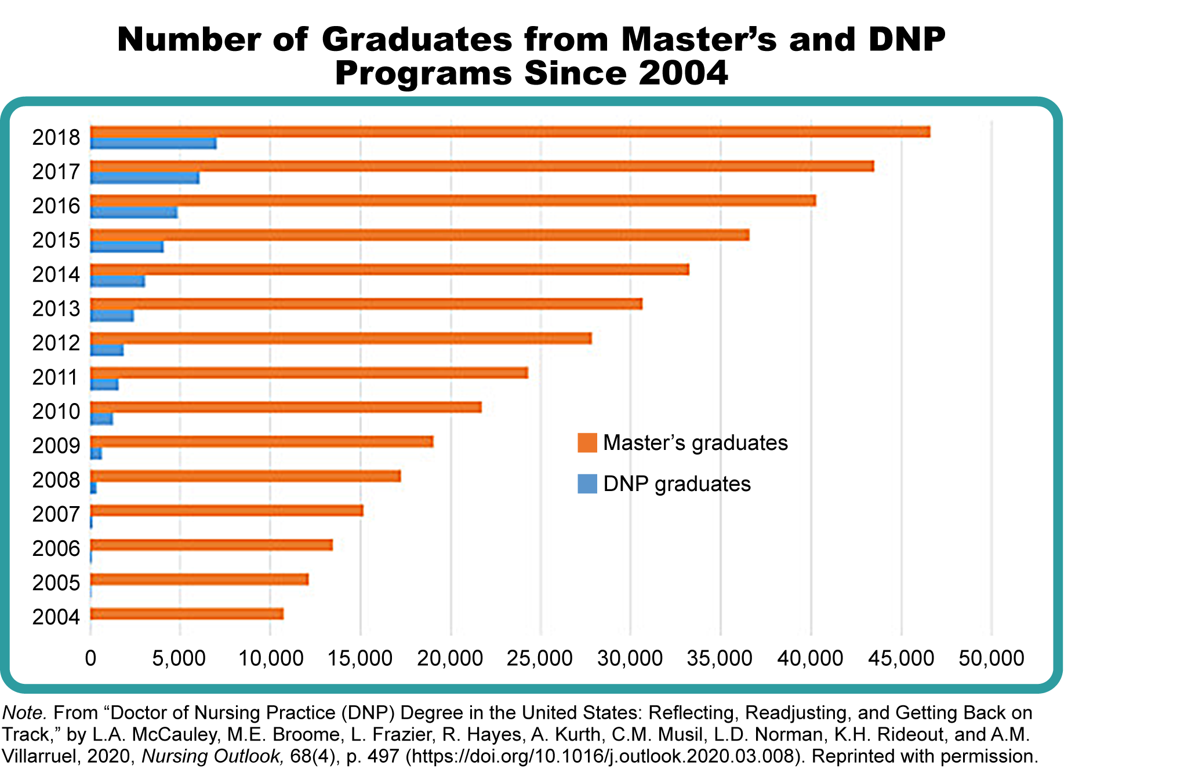

DNP Graduates Image Description
A paradigm shift in doctoral education in nursing is underway. The nation's complex healthcare environment has called for nurses to have the highest level of scientific knowledge and practice expertise possible. The Doctor of Nursing Practice (DNP) degree was established to improve practice proficiency and accelerate the translation of evidence into practice. As leaders in the clinical realm, DNP-prepared nurses appraise and implement the knowledge generated by our Ph.D. colleagues and work to bring this discovery to the bedside through quality improvement and practice change projects. The goal of the DNP-prepared nurse is to use translational science to improve healthcare delivery at the meso, macro, and micro systems levels.
References
American Association of Colleges of Nursing. (2004). AACN position statement on the practice doctorate in nursing. https://www.aacnnursing.org/DNP/Position-Statement
American Association of Colleges of Nursing. (2006). The essentials of doctoral education for advanced nursing practice. https://www.aacnnursing.org/DNP/DNP-Essentials
McCauley, L. A., Broome, M. E. , Frazier, L., Hayes, R., Kurth, A., Musil, C. M., Norman, L. D., Rideout, K. H., & Villarruel, A. M. (2020). Doctor of Nursing Practice (DNP) degree in the United States: Reflecting, readjusting, and getting back on track. Nursing Outlook, 68(4), 497. https://doi.org/10.1016/j.outlook.2020.03.008
2 Replies
UnsubscribedManage Discussion
Discussion Topic: Week 7: Discussion | Project Implementation PlanWeek 7: Discussion | Project Implementation Plan
Week 7Project Implementation Plan
Discussion
Purpose
The purpose of this discussion is to share a summary of your project implementation plan and changes you may have made to this plan during your time in NR705.
Instructions
Review this week’s readings and provide your response in 150 words or less:
- State your practice question in PICOT format.
- Summarize your project implementation plan in Weeks 2-9 to include your activities as the DNP project leader (including observational formative evaluation).
- Explain any changes you have made to the implementation plan, with rationale for the changes, since your arrival in NR705.
Use Grammarly and current APA format for the posts. Do not repeat the prompts in the post. Provide respectful and thought-provoking feedback to your student colleagues and ask for clarification and elaboration if needed.
Please click on the following link to review the DNP Discussion Guidelines on the Student Resource Center program page:
- Link (webpage): DNP Discussion GuidelinesLinks to an external site.
Program Competencies
- Integrates scientific underpinnings into everyday clinical practice. (POs 3, 5)
- Applies organizational and system leadership skills to affect systemic changes in corporate culture and to promote continuous improvement in clinical outcomes. (PO 6)
- Uses analytic methods to translate critically appraised research and other evidence into clinical scholarship for innovative practice improvements. (POs 3, 5)
- Appraises current information systems and technologies to improve health care. (POs 6, 7)
- Analyzes health care policies to advocate for equitable health care and social justice to all populations and those at risk due to social determinants of health. (POs 2, 9)
- Creates a supportive organizational culture for flourishing collaborative teams to facilitate clinical disease prevention and promote population health at all system levels. (PO 8)
- Translates a synthesis of research and population data to support preventative care and improve the nation’s health. (PO 1)
- Leads others in professional identity, advanced clinical judgment, systems thinking, resilience, and accountability in selecting, implementing, and evaluating clinical care. (POs 1, 4)
Course Outcomes
This discussion enables the student to meet the following course outcomes:
- Demonstrate effective project management strategies. (PCs 1, 2, 3, 4, 5, 6; POs 2, 3, 6, 7, 8)
- Explore the contribution of the DNP within collaborative teams across diverse healthcare systems. (PCs 7, 8; PO 1)
- Apply theory and evidence from management, policy, and clinical perspectives to support quality improvement and patient safety in healthcare systems. (PCs 1, 2, 3, 4, 8; POs 3, 4, 5, 6)
Due Dates
- Initial Post: By 11:59 p.m. MT on Wednesday
- Follow-Up Posts: By 11:59 p.m. MT on Sunday
Reply
Angele Davis
Aug 20 9:09pm
Manage Discussion by Angele Davis
Reply from Angele Davis
Hello Wonderful NR705 Students,
As a part of the practicum experience, students will enter practicum hours for the work they are doing in the practicum courses to meet the AACN Essentials; this means that all practicum hours must be entered within seven days of the activity being completed and please do not enter more than 12 hours per day. The Practicum Log Assignment in Week 8 requires you to enter the number of practicum hours indicated by your course letter. By the end of the program, you are required to have a minimum total of 1,024 approved hours. You can find your course letter by selecting people on the left navigation bar in your canvas course. Please take a moment to find your course letter by your name under people. Next please review the Week 8 Practicum Log Assignment for the number of practicum hours you will need approved. Entries cannot contain multiple activities; please enter a separate log for each additional activity. The “Notes” section you enter must be detailed and substantiate the number of hours logged for the entry.
Please Note for this Week 8 Practicum Log Assignment:
- Partial Points will Not be given.
- An Excel (not a PDF) Practicum Hour Report for your "Case Duration Total" (Total Approved Hours) is required to be submitted by the due date of Wednesday of Week 8 for the Practicum Log Assignment. (Need link specific to this report: https://cdn.brandfolder.io/74235FBJ/at/r4wgxs758qp98brrcqfm3j/DNP_Student_Medtrics_User_Guide.pdfLinks to an external site.
- The Late Assignment Policy will be applied if the assignment is not completed by the due date.
To find a list of Activities that can be entered for Practicum Hours in NR705 please review our Course Announcement: “Important Notice for the Week 8 Practicum Log Assignment” and review the activities listed in the DNP Practicum Activities Document.

- Reply to post from Angele DavisReply
- Mark as UnreadMark as Unread

Angele Davis
Aug 20 9:03pm
Manage Discussion by Angele Davis
Reply from Angele Davis

Welcome to Week Seven!
The discussion for this week is focused on your DNP project implementation plans. The following course outcomes, program competencies, and program outcomes will guide your learning this week:
- CO 2: Demonstrate effective project management strategies. (PCs 1, 2, 3, 4, 5, 6; POs 2, 3, 6, 7, 8)
- CO 3: Explore the contribution of the DNP within collaborative teams across diverse healthcare systems. (PCs 7, 8; PO 1)
- CO 4: Apply theory and evidence from management, policy, and clinical perspectives to support quality improvement and patient safety in healthcare systems. (PCs 1, 2, 3, 4, 8; POs 3, 4, 5, 6)
For our discussion this week, please share your DNP project implementation plan. How do you plan to kick off and implement your DNP practice change project? Share with your peers any changes that have been made to your implementation plan since completing the IRB prescreening process. If no changes were made, let us know.
Provide us with an update on your DNP project’s implementation plans. Share any successes, challenges, or barriers you experienced this week.
When posting, please share your PICOT practice question and respond to the weekly question. This will help provide quality feedback in these weekly discussions.
Practicum Site IRB Determination
If your practicum site requires your project to be reviewed by their IRB, please ensure that you apply to the practicum site IRB today if you have not done so already.
Some practicum site IRBs require another committee to review your project first, and after the committee’s review, then you can submit your project to the practicum site IRB. Sometimes this process takes 8 weeks, 12 weeks, or even longer. So please start this process today if you have not done so already.
Please let me know that your practicum site requires IRB approval, council approval, or committee approval.
If your practicum site IRB requires Chamberlain’s IRB Prescreening determination first, let me know and complete your IRB Prescreening Supplement form and the associated documents in week one. Use the instruction documents for the IRB Prescreening Supplement form and submit the documents early, if possible. You can find the instruction documents in the announcements for this course and I also have the instruction documents.
For all students whose practicum site requires a committee or council review and/ or IRB review, these approvals must be received before the end of NR705.
I am looking forward to our discussion.

