WEEK 1- 709 Discussion
Student Lesson Plan
Overview
- Program Competencies
- Course Outcomes
- Weekly Objectives
- Main Concepts
- Integrates scientific underpinnings into everyday clinical practice. (POs 3, 5)
- Applies organizational and system leadership skills to affect systemic changes in corporate culture and to promote continuous improvement in clinical outcomes. (PO 6)
- Uses analytic methods to translate critically appraised research and other evidence into clinical scholarship for innovative practice improvements. (POs 3, 5)
- Appraises current information systems and technologies to improve health care. (POs 6, 7)
- Creates a supportive organizational culture for flourishing collaborative teams to facilitate clinical disease prevention and promote population health at all system levels. (PO 8)
- Leads others in professional identity, advanced clinical judgment, systems thinking, resilience, and accountability in selecting, implementing, and evaluating clinical care. (POs 1, 4)
Schedule
Section | Read/Review/Complete | Course Outcomes | Due
Prepare | Assigned Readings | CO 1 | Wednesday
Explore | Lesson | CO 1 | Wednesday
Translate to Practice | Discussion: Introduction Posts | n/a | Wednesday
Translate to Practice | Discussion: Initial Post | CO 1 | Wednesday
Translate to Practice | Discussion: Follow-Up Posts | CO 1 | Sunday
Translate to Practice | Assignment 1 | CO 4 | Sunday
Translate to Practice | Assignment 2 | CO 4 | Sunday
Reflect | Reflection | CO 1 | No submission
Foundations for Learning
American Association of Colleges of Nursing (AACN). (2006). The essentials of doctoral education for advanced nursing practice.Links to an external site. https://www.aacnnursing.org/DNP/DNP-Essentials
Student Learning Resources
Click on the following tabs to view the resources for this week.
- Required Textbooks
- Required Articles
- Additional Resources
Bemker, M., Ralyea, C., & Schreiner, B. (2021). The successful completion of your DNP project: A practical guide with exemplars. DESTech Publications.
- Read Chapter 2
  - Section: Collecting and Managing Data
  - Section: Implementing the Data Analysis Plan
- Read Chapter 3
  - Section: Data Collection
  - Section: Analysis of the Data
Roush, K. (2023). A nurse’s step-by-step guide to writing a dissertation or scholarly project (3rd ed.). Sigma Theta Tau International.
- Read Chapter 4
Learning Success Strategies
- Reflection on Learning: As you familiarize yourself with the course layout, you will see the system of information prepared for your learning. Please look at each section, moving systematically will assist you as you learn throughout the course.
  - The Prepare section will have the objectives, key terms, and direct you to the readings to broaden your knowledge.
  - Moving next to the Explore section, there will be information about the topics and additional readings, links, and references to continue to build your knowledge.
  - Next, the Translate section is where you apply your new knowledge answering the discussion questions for the week and completing the assignments.
  - Finally, we close off the week with a Reflect section to recap what you learned and give you pause to consider the value of the new knowledge you are gaining.
- Resources
  - Review the assigned readings to ensure you understand the key terms and can relate them to the role of the DNP-prepared nurse leader.
  - As you review weekly content, consider how each concept and discussion can be translated into practice in your unique setting.
  - You have access to a variety of resources to support your success. Click on the DNP Resources tab on the home page to access program and project resources.
  - Your course faculty is here to support your learning journey. Reach out for guidance with study strategies, time management, and course-related questions. Review rubric feedback and individual comments to optimize performance.
- Forums
  - Let's Check-In: Tips for Success are available several weeks throughout the course. If unable to attend, listen to the recording posted in the announcements.
- Discussions
  - Review the discussion board guidelines and rubric. These will guide your responses and optimize your performance in this course.
  - Be prepared to share your thoughts and leadership experiences through the interactive discussion. It is important to share your thoughts so that we hear your voice. Also, support your responses with evidence from the literature.
- Practicum Hours
  - Check your practicum hours to identify the number of hours remaining to reach the required minimum of 1,024 approved practicum hours for completion of NR709 and the DNP degree program.
  - Log your practicum hours weekly.
  - Remember to use the resources in the Project & Practicum section of the DNP Program Resources page for guidance on these entries.
  - Enter no more than 4 hours for each entry and ensure that the activities represent the block of time requested. Be sure to select the correct DNP Essential and activity that matches your activity in your notes.
  - If you do not meet the required hours by the end of Week 8, you will receive an incomplete for this course.
- Project
  - Begin working on your final manuscript this week, as it must be turned in by the due date. Review your manuscript carefully for grammar, APA, and content prior to submission. After submitting your Final DNP Project Manuscript by the due date and receiving feedback from your course faculty, you will have the opportunity to revise and resubmit your manuscript one time, and your manuscript will then be graded. After receiving feedback from your course faculty, the revised manuscript must be returned to your course faculty in seven (7) days.
  - Ensure you are available on Thursday of Week 7 to present your Final Professional Poster live in Webex to your peers and DNP course faculty.
Interacting with Feedback
Each week your course faculty will provide feedback in the rubric on any assignment you have submitted. Take a moment to review the following video on how to view rubric feedback in Canvas. (After clicking the link, scroll down or click on the title in the Summary area to jump directly to the video.)
- Link (video): Looking at FeedbackLinks to an external site. (2:26)
Review the following video on how to accept/reject track changes when viewing course faculty feedback on your assignment:
- Link (video): Word: Track Changes and Comments (4:19)

Week 1Lesson
Data Collection and Management

Introduction
This week launches the last phase of your DNP degree journey as you fulfill the final requirements for completion of the program. In your writing, you will be articulating your identified practice problem, the significance of the practice problem, and the aim of the evidence-based intervention. You will describe the data collection and analysis, implications for healthcare and nursing, and your project conclusion. As you explore the multiple resources in the course and the readings, remember to reflect on the knowledge and skills you have mastered in the DNP degree program to complete this scholarly work.
Review the conceptual project portrait to consider your journey up to this point.
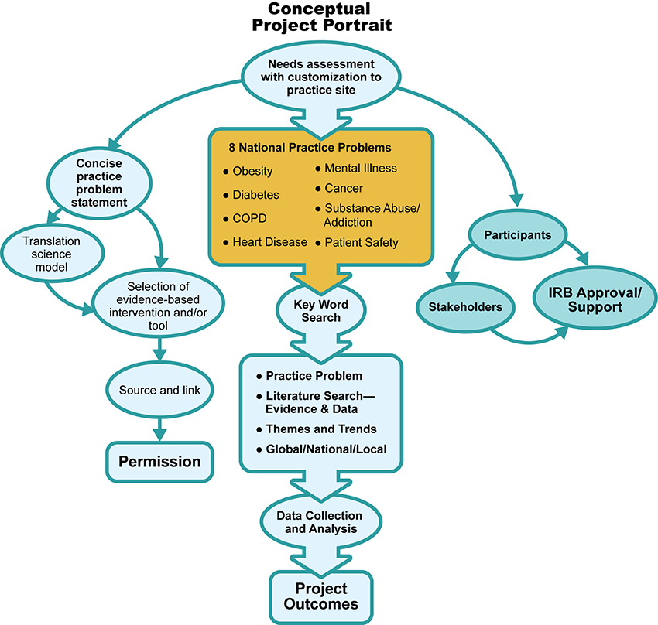

Conceptual Project Portrait Image Description

Data Management
Data management is one of the most important aspects of a DNP practice change project. The collection of data should not be an afterthought when implementing a change in practice. The process of data management should be planned before practice change or project development. This will help ensure that a strategic process is designed for the collection and management of data and that unnecessary data is not collected. When data is not governed and effectively managed, there exists a high risk for data error. The data you have collected should answer your practice problem question and demonstrate if your practice change positively impacted the identified population.

The Quality, Accuracy, and Completeness of Data
You may be asking, what is the big deal if I collect extra data? Can’t I just ignore it? Each data point that you collected as part of your DNP practice-change project is connected to an individual or an organization in a specific manner. It is important to demonstrate integrity, accuracy, and rigor when collecting data. Healthcare administrators, clinicians, payor systems, and policy advocates make critical determinations under the belief that quality control measures were in place during data collection and that the results are reliable and valid (White et al.,2021).
When data is not complete, accurate, and consistently collected, there can be significant implications and repercussions to project results. Only a small amount of data needs to be omitted to radically influence the analysis process. When preparing for data analysis, if it is discovered that data is missing or inaccurate, discuss the issue with your statistician. The customary method of addressing this type of issue is to restrict your analysis only to the participants for whom you have complete data for all variables being analyzed.

Finalizing Data Set(s) for Analysis
Your data is collected, organized, and finalized. Now you are ready to begin the data analysis process. During this stage of your DNP practice change project, it is critical to utilize the expertise of a statistician or someone who has vast experience in data analysis. Reliable and valid data analysis requires a unique skill set, which many nurses are not accustomed to utilizing. As you learned in previous courses early in your DNP-degree program, there are two primary methods for data analysis. The two methods are qualitative data analysis and quantitative data analysis.
Explore the following interactive to learn about the five most commonly utilized types of data analysis.

Data Analysis Interactive Transcript
As you learned in NR716—Analytic Methods, in any practice change project or research study where data is numerical, data analysis begins with descriptive statistics, which seek to summarize and organize data. This allows data to be easily described and understood, which is vital to your stakeholders and those who seek to replicate your DNP practice change project.
References
White, K., Dudley-Brown, S., & Terhaar, M. F. (2021). Translation of evidence into nursing and health care (3rd ed.). Springer Publishing Company.
Data Collection, Management, and Project Update
Discussion
Purpose
The purpose of this discussion is to examine the data you have collected, analyzed, and are using to evaluate the effectiveness of your DNP practice change project.
Instructions
Reflect on your readings this week and respond to the following in 150 words or less:
- Describe your plan for data analysis. Attach any tool that you are using for your project evaluation.
- Explain and appraise how you will evaluate your project outcome.
Please click on the following link to review the DNP Discussion Guidelines on the Student Resource Center program page:
- Link (webpage): DNP Discussion GuidelinesLinks to an external site.
Program Competencies
This discussion enables the student to meet the following program competencies:
- Integrates scientific underpinnings into everyday clinical practice. (POs 3, 5)
- Applies organizational and system leadership skills to affect systemic changes in corporate culture and to promote continuous improvement in clinical outcomes. (PO 6)
- Uses analytic methods to translate critically appraised research and other evidence into clinical scholarship for innovative practice improvements. (POs 3, 5)
- Appraises current information systems and technologies to improve health care. (POs 6, 7)
Course Outcomes
This discussion enables the student to meet the following course outcomes:
- Evaluate the outcomes of your DNP practice change project using narrative and statistical methods. (PCs 1, 2, 3, 4; POs 3, 5, 6)

Please The Implementation continued throughout the Holiday period making it to be in week 8. During week 7, A patient dropped out for bi-weekly PHQ9 got higher and needed to be on anti-depressant medication. Remaining patients 42 out of 45 stated.

