Cultural Competence Educational Program in Psychiatric Mental Health Settings

A Scholarly Project
Presented to
The Faculty of Regis College

In Partial Fulfillment
of the Requirements of the
Doctor of Nursing Practice Degree
by
Bruce Nsubuga, MSN, RN
1/21/2025

Cultural Competence Educational Program in Psychiatric Mental Health Settings
Chapter I: Introduction
In the United States of America, research suggests that there is a substantial enhancement in cultural diversity related to the proliferation in international migrations (Sahamkhadam et al., 2023). Nonetheless, the healthcare personnel fail to match the amplified heterogeneity, aggravating health variations (Marcelin et al., 2019). Although there has been a significant upsurge in patient demographic, there are numerous difficulties which may derail the delivery of culturally competent and sensitive care (Stubbe, 2020).
The dearth of a cultural competence training can give rise to incompetence during the delivery of healthcare processes, triggering derisory outcomes such as faulty treatment care procedures, and poor patient engagement (Sahamkhadam et al. 2023; Nair & Adetayo, 2019; Stubbe, 2020). The clinical concern akin to disparities within the healthcare sector and abysmal outcomes have been reported to misguide provider communication given the predictability of various unconnected cultural stances on health and illness, gaps in cultural values, language inhibitions and racism and perceptual biases encounters (Alkhamees & Alasqah, 2023). Evidence indicates that cultural incompetence can stimulate nurses’ partialities, subtle prejudice and typecasts towards patients (Cruz et al., 2019). Consequently, provider microaggressions, preconceptions and compartmentalizing patients may accelerate poor patient care, making it difficult for patients from seeking the necessary care (Stubbe, 2020). Besides, nurses’ cultural ineffectiveness can destabilize the delivery of top-notch care and further impede patients’ enthusiasm to adhere to the prescribed treatment care plans (Stubbe, 2020). The scholarly practice project (SPP) will investigate the effect of a cultural competence education program in order to assess it's impact on the efficiency of cognitive mental health delivery and patient outcomes. The project will be conducted in the psychiatric unit of a large facility that provides wide-ranging medical and mental health care.
Background
Nurses' cultural competence and the cumulative diversity of patient populations directly influences cognitive mental health services (AHRQ, 2019). As such, training nurses on cultural competence can improve their clinical practice efficiency and lessen healthcare disparities in culturally diverse populations (Eken et al., 2021). Psychiatric nurses, who regularly interact with patients to improve their health, consider themselves moderately culturally competent (Sahamkhadam et al.,2023). Chu et al. (2022) discovered that engaging and working in tandem with clients from different cultural settings can boost healthcare providers' cultural competence. However, prior to collaborating with patients, nurses should identify their individual biases, norms, and prejudices to become well-suited to provide bespoke and efficient healthcare services that esteem and prioritizes patients' cultural identities (Sahamkhadam et al., 2023).
Research studies state that during client interactions, clinicians who are culturally incompetent may radiate an unyielding demeanor and cease to recognize their client’s anguish on account of poor therapeutic alliance. As such, the providers may dismiss patients by not including them during treatment decisions and tailoring informed care plans. This may precipitate inadequate patient outcomes and instigate numerous health inequities (Alkhamees & Alasqah, 2023). Patients from marginalized and minority groups often experience discrepancies like stigma and biases which negatively affect their quality of life and determination to seek appropriate psychiatric care for instance therapy (Cruz et al., 2019; Gopal et al., 2021). Stubbe (2020) opined that most nurses experience delivery complexities when caring for clients from varied cultural affiliations. The negative encounters may rouse cultural incompetence, poor provision of care, and workflow ineffectiveness. As such, nurses should use these experiences as a driving force to engage in cultural competence training and lifelong learning to address the ever-evolving health requirements of divergent healthcare clientele (Desai et al., 2020). Essentially the aptitude to deliver culturally competent care can be attributed to the impeccability of clinicians providers in offering culturally holistic, congruent, and sensitive care, making it easier for them to accomplish ideal healthcare delivery processes and patient outcomes (Desai et al., 2020).
Cultural competence accredits nurses with satisfactory expertise in providing equitable care which complements the inimitable health necessities of patients from disparate cultural backgrounds (Arruzza & Chau, 2021). Even so, an inadequacy in cultural competence among mental health nurses can prompt redundant medical blunders which can increase incompetence’s (Chu et al., 2022). Some clinicians are often adamant in recognizing their biases and may make assumptions that patients are apathetic in receiving necessary care, giving rise to a gamut of health inequalities like discrimination, microaggressions, and unawareness (Handtke et al., 2019). When nurses project their prejudices and bias towards patients from diverse cultural backgrounds, they become culturally insensitive and fail to address the patients’ diversity. As such, they may stereotype their clients, especially those seeking mental health care and make hurtful statements which may lead to microaggressions (Cruz et al., 2019). It is critically important to note that the outcomes may dishearten clients, making it difficult for them to seek the care they so deserve. Unfortunately, the lack of proper treatment mechanisms can deteriorate their quality of life and upsurge the risk of mortality and morbidity rates (Cruz et al., 2019).
According to Handtke et al. (2019), a variety of nurses report that they grapple with cultural incompetence, particularly in scenarios in which clients do not constantly adhere to the stipulated treatment recommendations. The process enhances nurse’s negative assumptions and may think the patients do not value well-being. Similarly, when clients with pain issues request for pain medication, nurses might put labels on the clients by referring them to as drug-seekers rather than individuals grappling with mental health ailments (Cruz et al., 2019). These assumptions and typecasts can aggravate healthcare disparities, such as discrimination, language impediments, and lack of cultural awareness (Handtke et al., 2019). Therefore, clinicians ought to introduce cultural competence training at their work places to better fathom their patients' cultural behaviors and tailor treatment plans that are reliant on their values. Ethnic minority clusters are often bombarded with social aspects that intensify health inequalities, including lower socioeconomic status, localized access to healthcare, and contradictory beliefs about health, aging, and cognitive deterioration.
Cultural proficiency plays a critical role in helping nurses recognize their biases and respect the diversity of their patients (Lin & Hsu, 2020). More so, cultural competence improves nurse’s cultural awareness, enabling them to provide more sensitive care and lessen existing healthcare disparities. As vital affiliates of the healthcare system, nurses are responsible for building trust with patients, streamlining psychiatric care processes, and addressing challenges arising from cultural differences (Lin & Hsu, 2020). On the other hand, healthcare administrators and leaders are central in promoting cultural competence by educating nurses to espouse essential elements such as cultural understanding, knowledge, motivation, experiences, and skills.
Cultural competence is closely linked to cultural awareness because it develops effective communication between nurses and patients from diverse backgrounds. It also helps nurses design effective care strategies (Handtke et al., 2019). According to Arruzza and Chau (2021), training healthcare providers in cultural competence elevates their skills, leading to better treatment outcomes, higher patient satisfaction, and efficient information sharing. While cultural competence is an unending procedure that inspires clinicians to familiarize their care practices with the needs of diverse patients more effectively, there are still barriers to fully integrating cultural competence education into healthcare (Liu et al., 2021).
Impact of Discrimination on Patient Experiences
It is critical for healthcare organizations to edify their workforce, on effective strategies such as cultural competence training and materials to help providers better understand the diverse cultural backgrounds of their patients (Nair & Adetayo, 2019). The lack of care can induce poor health outcomes, both mentally and physically (Cruz et al., 2019). A major approach to mitigating this gap is promoting discourse Healthcare on the impact of prejudice and discrimination on patients. The training through discussions can help nurses understand the eminence of cultural competence education (Chu et al., 2022). On the other hand, healthcare leaders can strengthen more culturally sensitive care by amalgamating training initiatives with organizational guiding principles designed to eradicate racism and discrimination (Chu et al., 2022). The project will assess the impact of cultural competence training on healthcare providers' knowledge, attitudes, and behavior, as well as its effect on patient outcomes. As such, the assessment will help raise awareness on the current gaps and provide effective ways of addressing them.
Significance
Cultural competence is a significant topic which healthcare providers are mandated to incorporate in their practice in order to deliver respectful and empathic care that holds in high regard the diverse beliefs, values, and behaviors of patients with dissimilar characteristics. It is important for nurses to espouse culturally informed and health-literate approaches to enhance competence (AHRQ, 2019). For instance, when they fail to adopt cultural competence strategies, they are susceptible to jeopardizing their clients safety and instigating adverse disparities, such as diagnostic errors, missed screenings, adverse medication reactions, and substandard cognitive health services (AHRQ, 2019). There are merits associated with cultural competence training such as augmented nurses’ awareness, understanding, knowledge, and skills, positive behavioral vicissitudes and better patient outcomes (Sahamkhadam et al., 2023). Thus, training nurses in cultural competence can assist nurses, overcome cultural differences, and build a stronger culture of trust and transparency (AHRQ, 2019). Cultural competence is essential across nursing, research, clinical practice, education, and leadership.
Nursing Practice
Culturally competent nurses demonstrate increased knowledge, behaviors, and attitudes that improve the efficiency of mental healthcare delivery (Nair & Adetayo, 2019; Chae et al., 2020). Additionally, nurses who are culturally aware are better equipped to meet their patients' health needs, resulting in timely diagnoses, effective treatments, and stronger relationships throughout the care process (Stubbe, 2020. In nursing practice, positive communication and affinity between patients and providers enhance patients’ engagement and adherence to treatment plans (Stubbe, 2020). However, biases, stereotypes, and microaggressions can undermine cultural competence, potentially harming the quality of care within healthcare sector (Stubbe, 2020). Additionally, language and cultural barriers can lead to miscommunication, making patients less likely to follow treatment recommendations and resulting in poorer outcomes (Arruzza & Chau, 2021).
Nurses should prioritize educational programs associated with cultural proficiency so as to provide adequate patient-centric care (Lin & Hsu, 2020). Regardless of their own cultural background, nurses who are culturally competent can offer care that aligns with patients' values, attitudes, and behaviors, highlighting the importance of ongoing cultural competence education. Healthcare disparities can be addressed when organizations, administrators, and nurse leaders collaborate to promote cultural competence through training and continuous learning. These initiatives help the workforce better understand patients' cultural affiliations, which encourages patients to be more engaged and open about their care (Lin & Hsu, 2020). Cultural competence among providers gives rise to positive patient outcomes such as treatment adherence, satisfaction, and engagement improve. Healthcare gaps can be tackled by ensuring the entire team of clinicians are well-educated on the tenets of cultural competence (Sahamkhadam et al., 2023).
Nursing Education
Nursing tutors should assimilate cultural competence training into the nursing curriculum to better prepare nurses to deliver optimal care that aligns with their clients cultural preferences and needs (Ličen & Prosen, 2023). Therefore, inculcating nurses on cultural competence can boost their cultural knowledge and enable them to address care gaps that arise from cultural differences. Teaching nurses to provide unbiased care creates a more skilled, diverse, and confident nursing workforce capable of addressing the distinct needs of their patients (Arruzza & Chau, 2021). This approach ultimately enhances healthcare delivery and patient outcomes. Nursing institutions face challenges in creating comprehensive curricula that cover all aspects of cultural competency. Therefore, nursing educators must reassess the methods used to teach cultural competence and ensure that future nurses are equipped to provide culturally appropriate care (Arruzza & Chau, 2021).
Nursing Leadership
Culturally competent leadership helps enhance staff engagement and motivation, encourages innovation, and promotes the adaptation of diverse cultural practices, all of which improve patient care (Cerveny et al., 2022). By focusing on patient-centered care, culturally competent leaders create a healthcare environment that values individualized understanding and high-quality care (Gulati & Weir, 2022). Nurse leaders should emphasize the development of skills, knowledge, and attitudes necessary for providing culturally competent care. These efforts can improve patient-provider relationships and empower nurses to design care plans that are culturally appropriate (Arruzza & Chau, 2021).
Nurse leaders and managers play a crucial role in advocating for cultural competence within their institutions. They create strategies to implement culturally sensitive practices and inspire culturally competent behavior throughout the workforce (Manlangit et al., 2022).
Nursing Research
Cultural competence is also essential in nursing research, as it helps researchers develop effective training approaches and communicate the importance of culturally competent care (Kaihlanen et al., 2019). Research on cultural competence provides insights into cultural awareness, skills, and knowledge, helping address differences in cultural expression and improving care delivery (Sahamkhadam et al., 2023). Studies consistently show that cultural competence enhances healthcare providers’ ability to navigate multicultural encounters and promote inclusive care (Cerveny et al., 2022).
Problem Statement
Cultural incompetence??? hinder nurses from delivering effective care to clients with dissimilar cultural backgrounds, beliefs, behaviors, and morals (Nair & Adetayo, 2019). As a result, they may give rise to aggressive issues like miscommunication, mistrust, and patient dissatisfaction, ultimately compromising care (Arruzza & Chau, 2021). Microaggressions and poor judgement made against marginalized populations encourage provider cultural incompetence which can lead to provider insensitivity and misconceptions, which can have a negative impact on patient care (Cruz et al., 2019). While culturally competent leadership is aware of the importance of patients' cultural backgrounds, this awareness alone does not guarantee that providers will deliver culturally competent care (Gulati & Weir, 2022). To prevent undermining inclusivity and impartiality, it is crucial to address the lack of cultural competence training to ensure all patients, regardless of their cultural or linguistic backgrounds, receive high-quality mental healthcare.
At the project site, a needs assessment was conducted prior to starting the initiative. This project will be implemented in a psych homecare agency which caters to patients with varying mental health issues. The survey conducted during the need’s assessment revealed that the cultural competence of mental health nurses was below standard. It also found that nurses struggled to care for culturally diverse patients with limited English proficiency due to a lack of interpreters. As a result, many patients missed appointments, and others had poor medication management. Nurses also reported that these issues disrupted and hindered the efficiency of mental health care delivery. The principal investigator shared these findings with the unit's charge nurse and hospital administration, highlighting gaps in practice and proposing interventions. This scholarly practice project will implement a cultural competence education program in the mental health unit to evaluate its effect on improving the efficiency of mental health care delivery.
Clinical/Practice Questions
The project will employ the PICO(T) framework, which is an extensively acknowledged and operative strategy in clinical research. PICO(T) stands for Population (P), Intervention (I), Comparison (C), Outcome (O), and Time (T). The following is the clinical query for this project: “In psych settings (P), does the implementation of a cultural competence education program (I) compared to standard care (C) impact the effectiveness of cognitive mental health delivery processes and nurses’ levels of cultural competence (O) over ten weeks (T)?”
Purpose of the Project
The overarching determination of the project is to investigate the impact of a cultural competence education program on the effectiveness of cognitive mental health care delivery. Specifically, the project will evaluate how provider knowledge, motivation, attitudes, and behaviors change as a result of cultural competence training. It will also explore the program's effect on patient outcomes and healthcare disparities.
Project Objectives/Aims
The main goal of this project is to train psychiatric-mental health nurses in culturally competent care to enhance the delivery of cognitive health services. The objectives can be achieved by collating quantitative data using the cultural competence self-assessment checklist from the Central Vancouver Island Multicultural Society. Pre- and post-assessments will be carried out to gauge the program's effectiveness in improving the efficiency of cognitive mental health care. As the lead investigator, the DNP student will manage the ongoing cultural competence training sessions within the mental health unit.
Theoretical or Conceptual Framework
Leininger’s culture care theory is a cornerstone of this Doctor of Nursing Practice (DNP) project, which aims to implement a cultural competence educational intervention (See Figure !; See Appendix A & B). This framework is germane to the project because it supports the objective of providing culturally competent care. Leininger’s framework helps healthcare providers make evidence-based decisions that honor the diverse cultural beliefs, values, and practices of patients, particularly those who may not share common cultural backgrounds (McFarland & Wehbe-Alamah, 2019). Leininger’s theory interlaces cultural elements into nursing care, creating room for enhancing cultural competence within healthcare environments (McFarland & Wehbe-Alamah, 2019).
add the model sunrise graphic here-use APA format for figures and tables in this document going forward.
Figure 1
Leininger's Sunrise Model
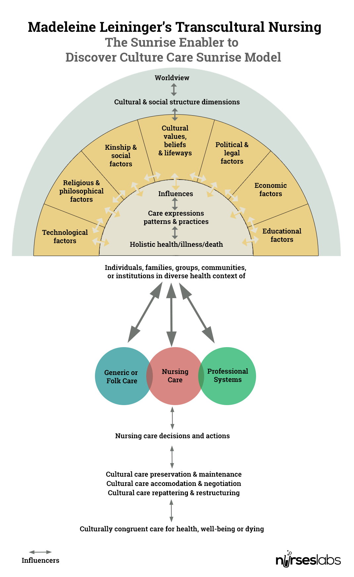

Leininger’s framework is based on five key principles: respecting diversity, conducting cultural self-evaluations, understanding the dynamics of cultural changes, integrating cultural knowledge, and adapting to diversity (McFarland & Wehbe-Alamah, 2019). As such, the tenets can be used in the project to stress the relevance of a cultural competence education. For example, respecting diversity suggests embodying cultural differences. Conversely, self-evaluations allow nurses to ruminate on their cognizance of cultural diversity and confront any biases they may hold. Additionally, grasping cross-cultural dynamics and promoting open communication are essential for enhancing patient care (McFarland & Wehbe-Alamah, 2019). Thus, the student will draw inferences from these insights and assimilate them in the project as optimal resources (Sahamkhadam et al., 2023).
Philosophical Assumptions
The investigators who coined the Leininger’s culture care theory made certain that the framework can be used to frame other projects which seek to investigate the efficacy of cultural competence trainings and inculcations in nursing research. The theory articulates that cultural elements have greater effect on people’s health practices, beliefs, and behaviors (McFarland & Wehbe-Alamah, 2019).
Just state what the theory assumptions are here alone
Evidence-based Practice (EBP) Model Johns Hopkins Nursing Evidence-Based Practice (JHNEBP) Model
The Johns Hopkins Nursing Evidence-Based Practice (JHNEBP) Model is a well-established framework that will guide the project plan for implementation (See Figure 2; See Appendix C & D). This model integrates the latest research findings into clinical nursing practices using practical tools (Dang et al., 2022). It follows a systematic approach that empowers nurses to make evidence-based decisions, which enhance patient outcomes and improve the efficiency of cognitive mental health services. The JHNEBP model utilizes user-friendly tools, such as evidence-based practice instruments, that streamline the use of research evidence in clinical settings (Johns Hopkins Nursing, n.d.). The model will support the project’s implementation in the mental health unit by guiding the principal investigator through each step to ensure successful adoption. The JHNEBP model operates in three phases: defining the practice question, finding the best available evidence, and translating that evidence into practice (Dang et al., 2022). These steps form the PET process—Practice question, Evidence, and Translation.
PET Steps
The PET process of the JHNEBP model is essential for guiding healthcare providers through evidence-based practice (EBP) (Johns Hopkins Nursing, n.d.). The first phase begins with identifying the practice question, which involves outlining the issue, formulating the question, and assembling a project team (Dang et al., 2022). This initial step will help the student achieve the project’s goals by clearly defining the objectives and aligning them with EBP principles.
The second phase focuses on evidence, which involves gathering, reviewing, and synthesizing evidence, followed by making practice change recommendations (Dang et al., 2022). Lastly, translation, equips researchers with the skills to synthesize evidence and create clinical recommendations. This phase includes planning, securing stakeholder support, implementing the plan, evaluating outcomes, and communicating results (Dang et al., 2022).
The Link Between the Project and the JHNEBP Model
The JHNEBP model’s PET stages correspond directly with the phases of the project’s research process. These include clearly articulating the practice question, collecting and appraising relevant evidence, and applying the theoretical framework (Dang et al., 2022). The initial stage helped formulate the clinical question, while the evidence phase supports the acquisition and appraisal of pertinent research. Finally, the translation phase facilitates the implementation of research findings into practice, with continuous assessment for improvement. This approach will help determine if the cultural competence education program requires adjustments based on ongoing evaluations. The subsequent figures illustrate the correlation between the JHNEBP model and the project (See Figures 1 and 2).

Figure 2
JHNEBP Model

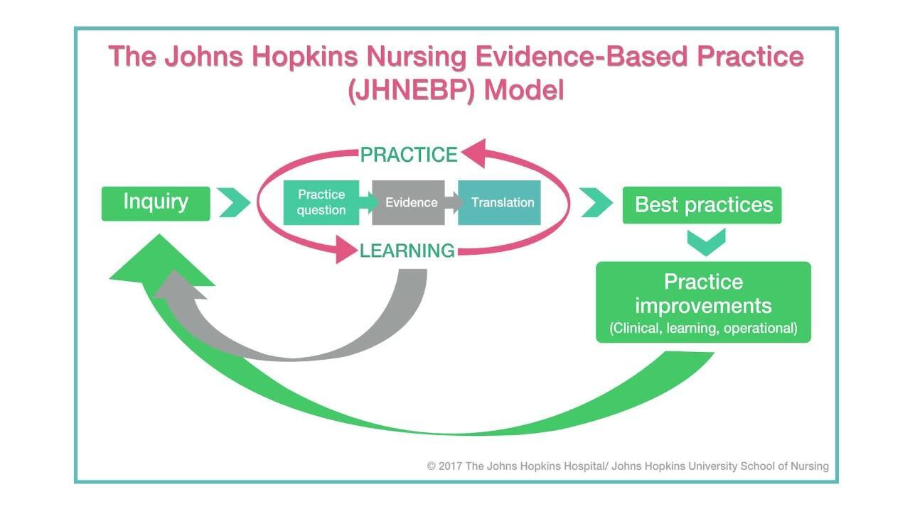
(Dang et al., 2022).
Application of the JHNEBP Model in the Project
Figure 2.

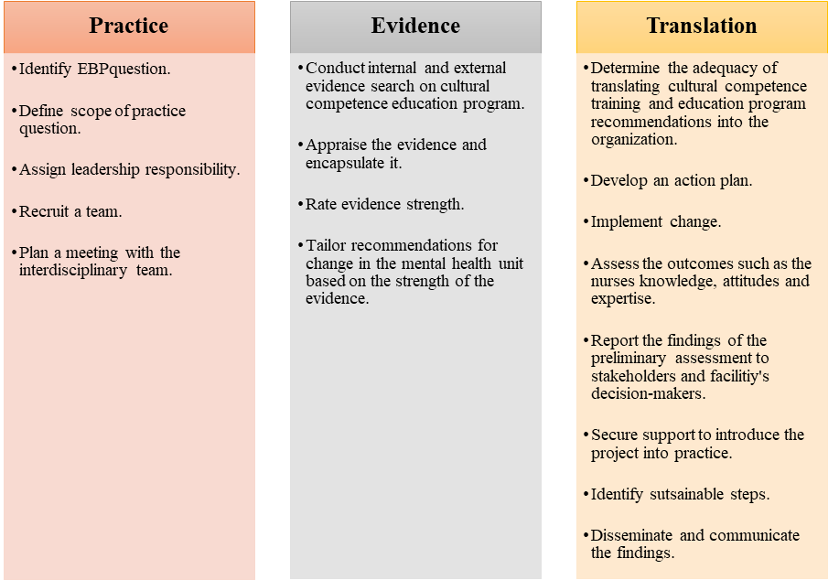
Clinical Practice Question.
EBP best practices

Conclusion
In summary, the absence of a cultural competence education program in a mental health unit can significantly hinder the effectiveness of mental health services, impact patient outcomes, and limit the cultural knowledge, skills, and awareness of healthcare providers. The project aims to provide a discourse on momentous significant gaps in evidence along with rudiments that contribute to culturally incompetent psychiatric delivery services. Its primary goal is to improve patient outcomes and safety, streamline cognitive mental health delivery processes, and reduce healthcare inequalities. These objectives will be achieved by assessing changes in provider motivation, cultural knowledge, behaviors, and attitudes resulting from cultural competence education programs. Leininger's culture care theory will serve as the guiding framework for the project. The JHNEBP model will provide essential evidence-based practice tools and the PET process to ensure the project's success.
Chapter II: Review of Literature
Introduction
The second chapter adds on what is known about the scholarly project topic of cultural incompetence among mental health nurses. The chapter will encapsulate the literature underpinning the study including the search strategy along with the most pertinent themes. Yu et al. (2023) suggested the paucity in cultural competence in mental health services negatively affect patient outcomes and the general healthcare delivery process.
Literature Review Overview
A literature evaluation is a crucial element of nursing research since it enables investigators to judiciously appraise and amalgamate findings from manifold studies evidence (Snyder, 2019).
Search Strategy
The student selected academic databases such as PubMed, Google Scholar, Cumulative Index of Nursing and Allied Health Literature (CINAHL), and PsycINFO to find relevant literature. These databases selected had advanced search features, such as Medical Subject Headings (MeSH), article type, publication year, language, and text format. The student applied Boolean operators to refine searches and focus on the most current and relevant evidence. The keywords were "cultural competence," "education program or training," "nurses," and "health delivery processes."
The literature search was initiated in the summer of 2024, whereby the student included articles published between August 1, 2019, and 2024. Inclusion criteria required full-text articles in English related to the clinical question, while exclusion criteria removed articles older than five years, abstract-only publications, and those unrelated to the clinical question. The student also conducted a manual search of key references to ensure all relevant studies were included. The clinical question, framed using the PICO(t) model, is: “In psych settings (P), does the implementation of a cultural competence education program (I) compared to standard care (C) impact the effectiveness of cognitive mental health delivery processes and nurses’ levels of cultural competence (O) over ten weeks (T)?”
Comprehensive Literature Review
The student used the selected databases, keywords, and Boolean operators to perform a comprehensive literature search following the Preferred Reporting Items for Systematic Reviews and Meta-Analyses (PRISMA) guidelines. The initial search produced 352 articles, which were screened for duplicates and irrelevant content that did not align with the clinical question. After removing 152 irrelevant articles, 200 articles remained. The inclusion and exclusion criteria were applied, eliminating 158 more articles for reasons such as being older than five years, only available as abstracts, not peer-reviewed, or unrelated to the clinical question. The remaining 48 full-text studies were further evaluated against more detailed inclusion and exclusion criteria. Ten studies were excluded for lacking peer review, and 26 did not focus on cultural competence education interventions. Ultimately, 12 studies were included in the final literature review as they met all the necessary criteria. These studies highlighted key themes that aligned with the project's clinical research question.
Improved Nurses' Cultural Awareness
Numerous studies have underscored the importance of cultural competence educational interventions. Kaihlanen et al. (2019) performed a qualitative study to investigate nurses' perspectives on cultural competence training and awareness. The study revealed the importance of inculcating nurses on cultural competence to boost their cultural awareness and effective communication (Kaihlanen et al., 2019). Albeit, the sample size was localized, the insights can be generalized to specific populaces such as psychiatric nursing and inform the researcher educational methods which can elevate nursing practice and promote cultural awareness. Cultural awareness equips clinicians with the aptitude to self-reflect, identify their prejudices, and stop labeling patients from different backgrounds (Kaihlanen et al., 2019).
This study offers valuable insights into nurses’ cultural awareness, which can be integrated into the project and train psychiatric nurses about the relevance of cultural competence and addressing health disparities. Manlangit et al. (2022) imposed the necessity of scrutinizing the manner in which cultural awareness, sensitivity, and behaviors affect nurse leaders. The sleuths used the Cultural Competence Assessment instrument and the Decision-Making Quality Scale questionnaire, and disseminated it to 122 participants who were affiliated with a Saudi Arabian institution. The findings showcased that cultural awareness and sensitivity are inextricably entangled with nurses' cultural competence and their capacity to make informed cultural founded decisions (Manlangit et al., 2022).
Additionally, cultural competence training proliferates cultural awareness of nurse leaders and their team, making it easier for them to make informed, evidence-based decisions which can achieve ideal patient and health outcomes (Manlangit et al., 2022). Mukhalalati et al. (2022) appraised how cultural competence training is pertinent to nurses' cultural awareness. The qualitative element of the study implied that healthcare educators have positive attitude towards cultural competence training. In the meantime, the quantitative results proved a noteworthy increment in cultural awareness suggestive that cultural competence training also equips nurses with the necessary skills to deliver impartial care (Mukhalalati et al., 2022). Most importantly, these findings bolster the project's aim of improving cultural awareness. As such, the student will leverage these insights to inform psychiatric nurses about the benefits of cultural competence training in enhancing cultural awareness.
The Influence of Cultural Competence Education
The second theme identified in the search strategy was the effect of cultural competence education and training on healthcare providers. Research indicates a positive link between cultural awareness, skills, knowledge, attitudes, and behaviors. Several studies prove the validity of educational initiatives in boosting nurses' cultural competencies to achieve the best health results. Slobodin et al. (2020) tailored a culturally informed educational intervention at improving healthcare students' cultural competence. The qualitative segment of the study involved semi-structured interviews with ten participants. The researchers used interpretative phenomenological analysis to evaluate the data (Slobodin et al., 2020).
In the quantitative phase, participants were divided into intervention and non-intervention groups. The study began in September 2018 and lasted for two years, focusing on addressing gaps in cultural competence curricula and training. Slobodin et al. (2020) reported incorporating cultural competence education programs can develop providers' understanding of cultural diversity. Therein lessening cultural dissonance and cultivating efficient communication and outcomes between patients and providers. The findings support the project's goal of enhancing healthcare providers' cultural competence, to positively impact psychiatric settings.
Lin and Hsu (2020) conducted a randomized control study where they randomly assigned respondents to experimental (n=47) and control (n=50) groups. The results showed that the experimental group's cultural competence scores of 0.51 were higher than the control groups, both at follow-up and post-intervention (Lin & Hsu, 2020). The study demonstrated that cultural competence training can significantly improve nurses' cultural aptitude and overall competence. These findings support the project's purpose of implementing a cultural competence education program to enhance workflow efficiencies in the mental health unit.
Cultural Competence on Nurses’ Cultural Knowledge and Skills
Argyriadis et al. (2022) conducted a mixed-methods study to explore healthcare professionals’ knowledge and skills levels associated with their cultural competence. The researchers used the Cultural Competence Self-Assessment Checklist from the Central Vancouver Island Multicultural Society for the quantitative data and 62 semi-structured interviews to collect data qualitative data (Argyriadis et al., 2022). They found that nurses are often sensitive to cultural competence practices. The training and educational materials can offer providers with culturally competence expertise when working in tandem with patients from diverse backgrounds (Argyriadis et al., 2022). These findings can be used to tailor a detailed cultural competence educational program, which can expand providers' expertise on cultural competence.
Arruzza and Chau (2021) conducted a scoping review study to appraise the usefulness of educational learning materials in boosting nursing students’ knowledge, skills, attitudes, and routines when they conducted a scoping review. The researchers incorporated an experimental study design in which they reviewed ten experimental research studies. Based in the research verdicts, nurses who were inculcated on cultural competence reported higher scores concomitant with adequate cultural knowledge and heightened skills (Arruzza & Chau, 2021). Furthermore, cultural knowledge and skills gained through training enhance nurses' understanding of cultural concepts during healthcare delivery (Arruzza & Chau, 2021). The findings from the study article correspond with the project’s purpose of ensuring nurses, specifically those working in a mental health unit are culturally competent to successfully delivery cognitive mental health care.
Supporting Literature
Importance of Cultural Competence
Agency for Healthcare Research and Quality (AHRQ, 2019) reported that cultural competence is a crucial aspect of healthcare that enables health systems to deliver patient-centered care by integrating patients' values, beliefs, and practices. Culturally competent care makes patients feel safe and respected, as they are treated by a workforce that values their cultural journey without judgment (AHRQ, 2019).
The Centers for Disease Control and Prevention (CDC) elucidated that cultural competence is a combination of attitudes, policies, and behaviors that enable healthcare providers to work effectively in cross-cultural situations (NPIN.CDC.gov., n.d.). These merits arouse top-notch quality care and impeccable delivery processes (NPIN.CDC.gov., n.d.). As such, adopting the concepts of the studies and integrating the recommended principles of cultural competence in educational materials, the project can augment cognitive mental health delivery processes and patient outcomes (AHRQ, 2019; NPIN.CDC.gov., n.d.).
Conclusion
In conclusion, the chapter includes a literature review and synthesized important themes which relate to the clinical question used in the project. Some of the studies suggested that educating healthcare providers in cultural competence expedites effective communication and optimizes health delivery processes. The second theme greatly demonstrated the impact of cultural competence education, showing its direct effect on nurses' cultural proficiency, which leads to better health outcomes. The literature review also provided a discourse on the importance of improving nurses' cultural skills and knowledge.

Chapter III: Methodology
Introduction
Cultural competence is an indispensable skill in healthcare, but many nurses still lack the training necessary to fulfill the cultural requirements of their clients. The paucity of proper training has precipitated an increment in cultural incompetence. As such, this gap in practice can instigate poor patient outcomes, dissatisfaction with care, and misunderstandings in psychiatric settings (Arruzza & Chau, 2021). At the project’s site, many of the psychiatric nurse’s report grappling with challenges in delivering culturally appropriate care, which affects their ability to effectively support clients from disparate cultural milieus. Furthermore, the lack of cultural competence has been shown to impact the quality and consistency of mental health care. Intrinsically, the issue of cultural incompetence can be tackled by incorporating an evidence-based cultural competence education program to help clinicians provide equitable and culturally tailored care, especially for patients from diverse backgrounds (Arruzza & Chau, 2021).
The educational intervention based on Leininger’s theory will focus on enhancing key elements of cultural competency such as cultural awareness, knowledge, and skill development. The rudiments of cultural competency aim at fostering positive behavioral change among nurses and improving patient outcomes (Sahamkhadam et al., 2023). The cultural proficiency training will help psychiatric nurses understand cultural nuances, utilize effective communication techniques, and incorporate culturally sensitive practices into their care routines. Leininger's culture care theory and the Johns Hopkins Nursing Evidence-Based Practice (JHNEBP) model will guide the steps of the project, providing an evidence-based foundation. The third chapter will encapsulate the methodology which will be used for the scholarly project (SPP). As such, it will detail the project’s design, guiding EBP model, methods, participant recruitment, ethical considerations, plans and procedures, tools, data analysis, timetable, limitations and transferability. The goal is to describe the project’s design, implementation, and evaluation of the program to measure its impact on enhancing cultural competence among psychiatric nurses in a Northeastern U.S. home care facility.
Project Design
The principal investigator will employ a quality improvement design, thereby assimilating current evidence-based practices to implement and measure the cultural competence educational program within a psychiatric unit. In addition, the project will be customized to address gaps in culturally competent care by augmenting nurses’ cultural awareness, expertise, and knowledge. The Johns Hopkins Nursing Evidence-Based Practice (JHNEBP) model will serve as the project’s basis. The model will enable the principal investigator to leverage the PET approach which comprises the practice question, evidence, and translation procedure, which is advantageous for structured EBP initiatives (Dang et al., 2022).
The primary goals are to improve cultural competence among psychiatric nurses and the delivery processes of patient care by providing culturally sensitive care. The project will also foster a more all-encompassing clinical milieu that acknowledges and respects patients varied cultural upbringings. The probable results include improved cultural competence, as evaluated by the Vancouver Cultural Competence Checklist, and greater patient gratification regarding perceived cultural sensitivity in the care they receive.
Project Methods
The JHNEBP model will provide the principal investigator with a blueprint which will bolster the identification, collation, translation, and application of evidence akin to cultural competence (Dang et al., 2022). The following model's PET process has three stages that expedite the evidence-based practice (EBP) approach.
PET Procedure
The first level of the PET process involves categorizing a practice question, which includes delineating the EBP issue, articulating the question, and affirming the project’s goals. This stage will help the principal investigator form an interdisciplinary team, designate project roles, involve stakeholders, and prepare for cohort meetings (Dang et al., 2022).
The second segment consists of the evidence level which was used to obtain, review, recap and synthesize evidence, as well as recommend practice modifications (Dang et al., 2022). The principal investigator conducted a thorough appraisal of studies probing cultural competence interventions in psychiatric settings. Some of the keywords used related to the practice question, and using credible databases like PubMed and CINAHL to locate suitable evidence. The JHNEBP model buttressed the appraisal of quality literature, allowing the principal investigator to utilize first-class studies that are directly relevant to the practice question (Dang et al., 2022). As such, the process expedited a well-founded synthesis of evidence to assess the effectiveness of a cultural competence program and identify existing gaps in literature.
At the translation level, the principal investigator will bring evidence into practice by developing and implementing an actionable plan in the psychiatric unit. This phase will involve working in tandem with key stakeholders, including the project mentor and psychiatric nursing staff, to gain support and foster engagement in the initiative. The implementation plan will involve tailoring the educational program to fit the practice environment, with pre-and post-intervention assessments conducted using the Central Vancouver Island Multicultural Society’s Cultural Competence Self-Assessment Checklist.
Plan and Procedures
List the Step you will take:

1. Create the educational intervention based on Leininger power point and record and narrate it in Zoom. Include YouTube clips from experts, evidence, supporting literature.
2. Obtain external site permission.
3. Obtain permission to use the instrument-add to appendices. Consider another instrument? Jeffries Cultural Competence theory has several. COnsider open-ended questions for the nurses about their feelings-are you concerned they have stigmatized views?
4. Create a Demographic Survey that is comprehensive.
5. Become familiar with Qualtrics videos-all of your project will go here, not using lunch time sessions as it wastes time. All data is collected here.
6. Become familiar with IntellectusStatistics and secure a Statistician consult.

Evidence-Based Clinical/Practice Question
Does the implementation of a culturally competent educational intervention improve the levels of confidence in the use of cultural competence for Psychiatric Mental Health Registered Nurses?

Setting
The principal investigator will launch the project at a psychiatric home care agency, which is located in the Northeast, once external site approval is obtained (See Appendix ?). It is worth noting, that the home care agency serves individuals with mental health issues in the community, offering services such as in-home therapy, daily living activities, and medication management. The facility has a capacity of 370 beds and delivers rounded and wide-ranging treatment, with ease, and care to clients facing psychiatric challenges. How many nurses-are they RNs?
Sample
A sample serves as a representative segment of a larger population, allowing researchers to make inferences that can potentially be applied to similar populations (Andrade, 2020). The following are the rudimentary elements akin to a sample. Who is the target population from which you will draw your participants?
Recruitment Plan
The project’s principal investigator will obtain approval from the facility’s quality appraisal committee, which undertakes improvement efforts. In particular, the quality improvement committee’s primary goals include classifying areas necessitating improvement, enabling constructive vicissitudes, guaranteeing compliance with established regulations, inculcating the workforce and practitioners, and accentuating key enhancement prospects (Polit & Beck, 2021). The committee will be briefed on the study’s purpose and significance, rationale for selecting the location, details of the research, and the commitment to upholding ethical standards. Besides, the principal investigator will then collaborate with psychiatric nurse leaders and a project mentor to identify eligible participants based on established inclusion criteria (Purna Singh et al., 2023). The eligible respondents will receive informed consent documents via an email link, detailing the project’s goals, processes, expectations, and the voluntary nature of participation.
Sample Size
Due to the trivial inherent nature of the project, the most suitable sample size is forty participants. Please do a G*power analysis for this
Sampling
A convenience sampling method will be used, allowing for easy access to participants. This sampling approach is cost-effective, time-efficient, and practical for involving colleagues already working at the project’s location (Purna Singh et al., 2023). expand on this and the rationale.
add the following to the consent once I approve
Inclusion Criteria-put these in a list format- be very specific are they only RNs, how many years of experience, educational level?, certification?
The project investigator will include registered nurses and psychiatric nurses working at the project site. The key qualifications for the inclusion criteria include having a nominal of two years of nursing experience, and direct care for clientele in the psych unit.
Exclusion Criteria- put these in a list format-make sure these match in order and that they will be excluded
On the contrary, nurses with less than two years’ experience, nurses positioned in other departments, and directorial personnel not directly engaged in psychiatric patient care.
Ethical Considerations
Ethical considerations are fundamental to the successful conduct of any scholarly project, particularly one involving human participants. This project will focus on a cultural competence educational intervention for nursing staff-which ones?, aiming to improve mental health service delivery for diverse patient populations and levels of cultural competence. The principal investigator will adhere to ethical tenets, ensuring that participants are protected, respected, and fully informed about their involvement in the study. The primary ethical considerations in this project include informed consent, beneficence, respect for secrecy and confidentiality, and respect for privacy. expand this section
Informed Consent
The principal investigator will provide each human subject with an informed consent document that clearly demarcates and elucidates all relevant information about the project of cultural competence. In addition, the informed consent will also be concise on the respondents' right to voluntarily participate or opt-out (Polit & Beck, 2021). The document will detail the project's goals and objectives, explain the data collection procedures, and describe how participants will be involved. It will also include a clause ensuring the discretion and obscurity of the respondents. Crucially, the participants will be advised of their own choice to pull out of the study at any period without facing any consequences. The investigator will seek approval from the Institutional Review Board (IRB) at Regis College and the hospital’s quality improvement committee to guarantee that the project is conducted morally, and that respondents’ privileges and safety are safeguarded.
Beneficence
The principal of beneficence requires the project investigator to not expose participants to harm and instead maximize benefits while minimizing risks. Therefore, the principal investigator will ascertain that every effort will be made to prevent any form of harm to participants (Polit & Beck, 2021). The cultural competence education program is designed to enhance skills and improve patient outcomes, providing potential benefits for participants' professional development, levels of cultural competence and patient care quality. Risks are anticipated to be minimal, as this study involves an educational intervention. Nonetheless, any potential discomfort or unintended negative consequences of the intervention will be monitored and addressed promptly to ensure participants’ well-being.
Anonymity and Confidentiality
The project leader will respect the participants' anonymity and confidentiality to uphold trust and integrity throughout the research process. Per se, the respondents’ data will be de-identified by assigning codes to participants rather than using personal identifiers. Consequently, only their aggregate data will be reported, ensuring that no individual can be identified from the findings. Furthermore, access to any identifying information will be restricted to the research investigator, and data will be stored securely in encrypted files to prevent unauthorized access (Polit & Beck, 2021). These measures will help protect participants’ identities and maintain the confidentiality of their information.
Respect for Privacy
Respecting respondents’ privacy is critical, particularly when dealing with sensitive topics such as cultural competence and mental health care. Hence, the participants will be informed about the types of data being collected and how the information will be used. They will have control over the extent of their participation in completing the cultural competence self-assessment questionnaire and the volition to refute to complete any queries they feel uncomfortable with. As a result, this strategy will play a focal role in respecting their right to privacy (Polit & Beck, 2021).
Measurement of Variables
1. Demographic Survey (See Appendix ?):
In addition, demographic data will be collected through the demographic data sheet which will comprise various measures including means, medians, frequencies, and percentages to summarize participant characteristics like age, gender, and years of experience.

2. Cultural Competence Self-Assessment Checklist (See Appendix ?):
The Cultural Competence Self-Assessment Checklist has been validated for use among healthcare professionals. According to Argyriadis et al. (2022), the tool’s reliability was established using Cronbach’s alpha with average values of 0.78 across the three sections, indicative of a great level of internal homogeneity. Additionally, a confirmatory factor analysis (CFA) validates the tool’s structure, confirming its robustness and reliability for assessing cultural competence. These metrics bolster the use of the checklist in the project, ensuring that it provides consistent and accurate data to measure changes in cultural competence.
The cultural competence checklist is grounded on a Likert scale format, in which participants rate their responses to items that assess cultural awareness, knowledge, and skills. In this light, the checklist includes multiple items that address specific aspects of cultural competence across the three domains. The founders of the questionnaire ascertained that the Likert scale items are structured in a way that the participants can indicate the magnitude to which they agree or disagree with statements (Argyriadis et al., 2022). The checklist enables capturing the degree of cultural competence among respondents.
It is essential to note that the cultural competence cohort focuses on fathoming cultural distinctions, self-awareness, and stereotypes. In this light, greater scores indicate a more developed awareness of cultural differences. On the other hand, the cultural knowledge scale dictates elements which assess understanding of cultural histories, discrimination, and cultural boundaries. As such, a high score reflects enhanced knowledge, and vice versa is true. The cultural expertise section includes questions on diversity acceptance, support for individuals from various backgrounds, and communication skills (Argyriadis et al., 2022).

3. Confidence Scale (C-Scale, Grundy 1993):

4. Open-ended Questions:

Educational Intervention
The cultural competence educational intervention will be designed to boost psychiatric Registered Nurse levels of cultural competency including knowledge, awareness, and expertise.
expand on this and add power point to the appendices

Data Collection and Analysis

All data will be collected in Qualtrics software. Once the participant is given access to the informed consent, they will agree to participate, they will be deidentified, and given a random numerical value. Only the Primary Investigator (PI) and the Project Chair will have access to this data in a password protected computer. The data will be stored for three years and then destroyed.
The data will be downloaded from Qualtrics once it has been cleaned and then securely uploaded to IntellectusStatistics, an online software program.
Limitations
The limitations for this project include a small sample size and a single-setting. The small sample size can localize the statistical significance of the project’s findings. Primarily, the principal investigator postulates that the findings will elevate psychiatric nurses’ cultural competency and healthcare delivery processes. Granting that the small sample size may inhibit the generalizability, it may prompt incredible sophisticated and precise measurements. Secondly, the single-setting may not exemplify the cultural multiplicity of the nursing staff across disparate working environments. Consequently, this may restrict the extent to which the outcomes would be transferred to supplementary continuums of care.
Transferability
The project will impart readers with apt knowledge on cultural competence, enabling them to make deductions like grasping the effect of cultural knowledge, cognizance, and expertise on cognitive health and nurses’ levels of cultural aptitude. Furthermore, health backgrounds like emergency units can conjecture the study’s findings given that they contend with corresponding intricacies when caring to clients from incongruent cultural relations. More precisely, the study will expand on nurses’ standpoints on the obstructions in patient interactions which instigate cultural inequalities such as language barriers. As such, this will accelerate the procedure of permitting readers infer acuities from the project’s results.
Timetable-put this in a table!
Hearing Proposal is first, then IRB, takes about six weeks to do these
The project is intended to take four weeks starting in the May of 2025. Primarily, the first two weeks will involve obtaining an IRB approval from the institution and the project’s location quality improvement committee. As such, this will help ascertain that the project adheres to ethical considerations and protects participants’ rights. In addition, the initial two weeks will also comprise recruiting participants grounded on the inclusion criteria and designing informed consent forms and disseminating them to the respondents. Providing participants with written informed consent documents will provide them with concise expectations, making sure they comprehend their rights. During the third week until the end of week six of spring 2025, the principal investigator will administer the pre-intervention questionnaire to establish baseline data and appraise the respondents’ current cultural competency levels. Thereafter, the principal investigator will conduct the training sessions and distribute PowerPoint and posters on cultural competence.
During the training sessions, the principal investigator will continuously monitor participants progress, ascertaining consistency. Additionally, the principal investigator will administer the post-intervention survey in week eight which will be similar to the pre-intervention survey. Data will be analyzed in week nine using Intellectus Statistics using a paired t-test to measure the impact of the cultural competence educational program on the participants, acknowledging statistically substantial alterations on psych nurses’ levels of competency and workflow processes. In week ten, the principal investigator will compile and disseminate the findings for organizational and academic reviews. Thereafter, the findings will be disseminated to the stakeholders to enlighten them about the project’s outcomes, nurturing their support.
Summary
In conclusion, the chapter discussed key components such as the project’s site, actions, design, informed consent, inclusion and exclusion measures, IRB approval, tool, and data analysis. The project will comprise a sample size of forty human subjects who will complete pre-and post-intervention queries. Besides, the principal investigator will ascertain they adhere to the ethical standards required for conducting research with human subjects and foster a trustworthy environment that encourages honest and open participation. The Cultural Competence Self-Assessment Checklist is an effective and unswerving tool for assessing changes in cultural competence among nurses. The instrument will provide comprehensive data to gauge the influence of the intervention on nurses' cultural awareness, knowledge, and skills, ultimately supporting the project's aim of boosting cognitive health delivery procedures. Although the project is marred by a small sample which may restrict the generalizability of the results, the sample may provide precise and sophisticated measurements. Most importantly, the findings will allow for transferability to other clinical contexts, ensuring that readers draw insights on the significance of culturally competent nursing workforce. Ultimately, the timeline provides an ideal structure in which the project advances efficiently, meeting all critical deadlines within the stipulated timeframe.

References

Appendices

Appendix A-Theoretical Framework

Appendix B-Permission for Use

Appendix C-Evidence Based Model

Appendix D-Permission for Use

Appendix E-Levels of Evidence Table

Appendix F-External Site Permission

Appendix G-Demographic Survey

Appendix H-Instrument #1

Appendix I-Permission for Use

Appendix J-Instrument #2 (C-Scale)
C-Scale

Directions: Circle the number which best describes how you perceive your current ability to perform strategies to become competent in the use of add your topic here!

(NOTE: Make sure that the circle encloses just ONE number.)

1. I am certain that my performance is correct:

1 |  | 2 |  | 3 |  | 4 |  | 5
not at all certain |  | certain for only a few steps |  | fairly certain for a good number of steps |  | certain for almost all steps |  | absolutely certain for all steps
2. I feel that I perform the task without hesitation:

1 |  | 2 |  | 3 |  | 4 |  | 5
I have much hesitation |  | a fair amount of hesitation |  | a good part of it without hesitation |  | almost completely without hesitation |  | absolutely no hesitation
3. My performance would convince an observer that I'm competent at this task:

1 |  | 2 |  | 3 |  | 4 |  | 5
not at all |  | agree, a little |  | for much of it |  | for almost all of it |  | for absolutely all of it
4. I feel sure of myself as I perform the task:

1 |  | 2 |  | 3 |  | 4 |  | 5
not at all |  | very little |  | for much of it |  | for almost all of it |  | for absolutely all of it
5. I feel satisfied with my performance:

1 |  | 2 |  | 3 |  | 4 |  | 5
not at all |  | very little |  | for much of it |  | for almost all of it |  | absolutely satisfied with all of it

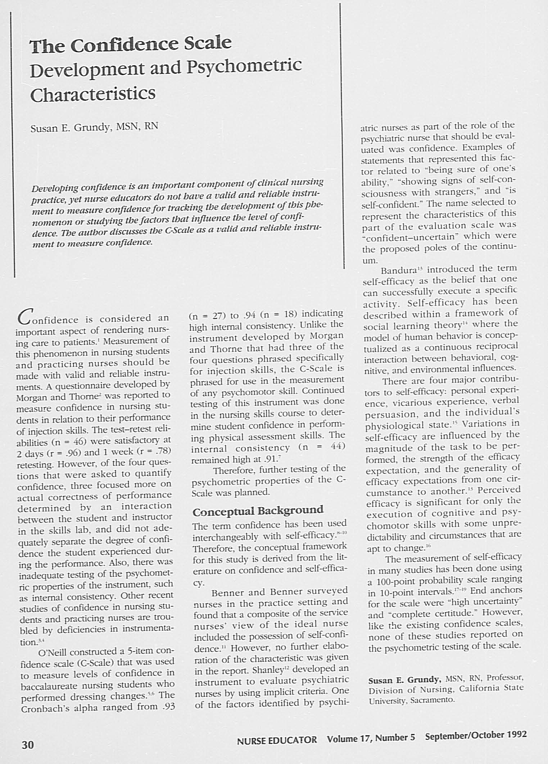
Appendix K-Permission for Use

Appendix L-Open-Ended Questions
based on Leininger and feelings you want to know

Appendix M-Educational Intervention Slides

Appendix N-Regis College IRB Informed Consent

Informed Consent-add to correct format with letterhead and use their wording, except change everything from study to project
Informed Consent to Join in the Study about the Influence of a Cultural Competence Educational Program on the Effectiveness of Cognitive Psychiatric Health Delivery Procedures
Researcher: Bruce Nsubuga
Introduction
Please read this informed consent form attentively. The investigator is requesting you to join in a research study of educating psychiatric health nurses on the impact of a cultural proficiency on the efficiency of psychiatric health delivery processes. You were carefully chosen to participate in this study since you are a nurse who has worked directly with individuals in the psychiatric inpatient or emergency department (ED), have a nursing experience of more than two years, your specialty is psychiatric mental health, you work in the psychiatric department and in the organization which the project will take place, and you are a registered nurse. You do not qualify to join if you are not a registered nurse, you work in other stations rather than the ED or inpatient psych unit, and you are not directly involved with patients suffering from psychiatric conditions. Please, ask any queries you may have prior to agreeing to engage in the study.
Purpose of the Study
The research study seeks to investigate whether introducing cultural competence education program in the psychiatric unit can positively influence efficient mental health delivery processes. The main purpose of the study is to evaluate the changes in the mental health nurses’ knowledge, attitudes, behaviors, proficiency, and motivation related to cultural competence. In addition, the project seeks to establish whether a cultural competence educational program can boost mental health nurses’ level of cultural proficiency while caring for individuals affiliated with different cultural backgrounds.
Description of Study Details
If you decide to join in this study, we would ask you to attend an educational training on cultural proficiency tailored for mental health nurses who work in a psychiatric unit. When you take part in the education program, you will be asked to complete three questionnaires. The questionnaires will involve pre-and-post assessments for a period of eight weeks. The first level of the project will be to evaluate the participants baseline level of cultural competence, especially the five constructs of cultural competence which include cultural awareness, encounters, skills, desire, and knowledge using the Vancouver cultural competence self-assessment checklist as a pre-test.
You will also complete a post-test to appraise whether the intervention elevated your levels of cultural competence. Most importantly, the principal investigator will provide you with a post-education survey to enquire about your experiences and perspectives about the cultural competence educational program. You will also be given additional information such as a PowerPoint presentation about cultural competence. Once you decide to participate in the study you will receive a URL link via email to complete the pre-test which will be online and secure. Your details will be anonymous and deidentified to protect your privacy. The pre-test will take three weeks to complete, giving everyone ample time to answer the pre-test.
PowerPoint presentations about cultural competence, health disparities, cultural competence constructs, and Leininger’s model will take place during lunch hours for two weeks. The presentations will occur in four phases, that is two presentations every week for 30 minutes. The principal investigator will also send educational links on cultural competence. Subsequently, you will also receive a post-test link via email. The timeframe is equivalent to the pre-test. The post-test questions will encompass similar questions as those of the pre-test to assess whether the intervention had an impact on your levels of cultural competence. You will take a survey which will consist of three questions to assess your experiences and perceptions about the program.
Benefits of Being in this Study
The benefits are free lunch, satisfaction that information you provide may help others, supplementary knowledge about your level of cultural competence and access to potentially beneficial information on cultural competence, health disparities, cultural competence constructs, and individual biases which might otherwise be unavailable.
Risks and Discomforts of Participating in this Study
The are no chances of risk outside what happens in your daily endeavors.
Payments
You will not pay to participate in the study.
Cost
As a participant, you will not incur any costs.
Choosing to participate and Quit the Study
You have the freewill to engage in the study. Nonetheless, your decision to refrain from being a participant will not impact your present or affiliations with the organization and employment standing. It is your choice to refuse to reply queries or leave whenever you prefer without giving any reasons. You will not be penalized for not participating or for leaving.
Getting Dismissed from the Study
The project lead might discharge you from this study for the subsequent causes: The lack of adhering to the study guidelines. You are swamped with work and cannot make time.
Privacy
The investigator will maintain participants privacy and anonymity all through the study. The digital records will be password protected in a secure online survey website. Only the project lead can access the study data. Participants will refrain from using any identifying data.
Contacts and Questions
The project lead conducting this study is: Bruce Nsubuga. For any clarification and queries, you can reach the investigator via: [phone number and email address]. For any queries or concerns regarding your rights, reach out to Dr. Colleen who is the chair of Regis Institutional Review Board:
Dr. Colleen C. Malachowski, PhD
781-768-7373
colleen.malachowski@regiscollege.edu
Consent Statement
After duly reading this informed consent form and being motivated to ask queries. I agree to partake in this research study. I obtained answers to my queries. I am well aware of the risks and distresses related to the abovementioned study and comprehend I may leave the study at any given moment and I will not be penalized.
Signature(s)/Date
Participant Printed Name: ___________________________________
Participant Signature: ___________________________________ Date: __________

Appendix O-Flesch-Kincaid Grade Level for Informed Consent

Appendix P- CITI Training Certificates

Appendix Q-Primary Investigator Resume

References
AHRQ. (2019, December 27). Cultural competence and patient safety. Agency for Healthcare Research and Quality (AHRQ). Patient Safety Network (PSNet). https://psnet.ahrq.gov/perspective/cultural-competence-and-patient-safety
Alkhamees, M., & Alasqah, I. (2023). Patient-physician communication in intercultural settings: An integrative review. Heliyon, 9(12). https://doi.org/10.1016/j.heliyon.2023.e22667
Argyriadis, A., Patelarou, E., Paoullis, P., Patelarou, A., Dimitrakopoulos, I., Zisi, V., Northway, R., Gourni, M., Asimakopoulou, E., Katsarou, D., & Argyriadi, A. (2022). Self-assessment of health professionals’ cultural competence: knowledge, skills, and mental health concepts for optimal health care. International Journal of Environmental Research and Public Health, 19(18). https://doi.org/10.3390/ijerph191811282
Arruzza, E., & Chau, M. (2021). The effectiveness of cultural competence education in enhancing knowledge acquisition, performance, attitudes, and student satisfaction among undergraduate health science students: A scoping review. Journal of Educational Evaluation for Health Professions, 18. https://doi.org/10.3352/jeehp.2021.18.3
Chae, D., Kim, J., Kim, S., Lee, J., & Park, S. (2020). Effectiveness of cultural competence educational interventions on health professionals and patient outcomes: A systematic review. Japan Journal of Nursing Science, 17(3), e12326. https://doi.org/10.1111/jjns.12326
Chu, W., Wippold, G., & Becker, K. D. (2022). A systematic review of cultural competence trainings for mental health providers. Professional Psychology, Research and Practice, 53(4), 362. https://doi.org/10.1037/pro0000469
Cruz, D., Rodriguez, Y., & Mastropaolo, C. (2019). Perceived microaggressions in health care: A measurement study. PLOS ONE, 14(2), e0211620. https://doi.org/10.1371/journal.pone.0211620
Dang, D., Dearholt, S., Bissett, K., Ascenzi, J., & Whalen, M. (2022). Johns Hopkins evidence-based practice for nurses and healthcare professionals: Model and guidelines. 4th ed. Sigma Theta Tau International
Desai, M. U., Paranamana, N., Restrepo-Toro, M., Davidson, L., & Stanhope, V. (2020). Implicit organizational bias: Mental health treatment culture and norms as barriers to engaging with diversity. The American Psychologist, 76(1), 78. https://doi.org/10.1037/amp0000621
Eken H. N., Dee E. C., Powers A. R. III, Jordan A. (2021). Racial and ethnic differences in perception of provider cultural competence among patients with depression and anxiety symptoms: A retrospective, population-based, cross-sectional analysis. The Lancet Psychiatry, 8(11), 957–968. https://doi.org/10.1016/S2215-0366(21)00285-6
Gopal, D. P., Chetty, U., Gajria, C., & Blackadder-Weinstein, J. (2021). Implicit bias in healthcare: Clinical practice, research, and decision making. Future Healthcare Journal, 8(1), 40–48. https://doi.org/10.7861/fhj.2020-0233
Handtke, O., Schilgen, B., & Mösko, M. (2019). Culturally competent healthcare – A scoping review of strategies implemented in healthcare organizations and a model of culturally competent healthcare provision. PLoS ONE, 14(7). https://doi.org/10.1371/journal.pone.0219971
Hietapakka, L., & Heponiemi, T. (2019). Increasing cultural awareness: Qualitative study of nurses' perceptions about cultural competence training. BMC Nursing, 18(1). https://doi.org/10.1186/s12912-019-0363-x
Johns Hopkins Nursing. (n.d.). Evidence-based practice. Johns Hopkins Medicine, based in Baltimore, Maryland. https://www.hopkinsmedicine.org/nursing/center-nursing-inquiry/nursing-inquiry/evidence-based-practice
Kaihlanen, A., Hietapakka, L., & Heponiemi, T. (2019). Increasing cultural awareness: Qualitative study of nurses' perceptions about cultural competence training. BMC Nursing, 18(1). https://doi.org/10.1186/s12912-019-0363-x
Ličen, S., & Prosen, M. (2023). The development of cultural competences in nursing students and their significance in shaping the future work environment: A pilot study. BMC Medical Education, 23(1), 819. https://doi.org/10.1186/s12909-023-04800-5
Lin, M., & Hsu, H. (2020). Effects of a cultural competence education program on clinical nurses: A randomized controlled trial. Nurse Education Today, p. 88, 104385. https://doi.org/10.1016/j.nedt.2020.104385
Liu J., Gill E., Li S. (2021). Revisiting cultural competence. The Clinical Teacher, 18(2), 191–197. https://doi.org/10.1111/tct.13269
Manlangit, A. T., Jabonete, F. G. V., & Ridulme, Q. R. (2022). Cultural competence and decision-making of nurse leaders in a university hospital in Saudi Arabia: A descriptive correlational study. Journal of Nursing Management, 30(5), 1215–1224. https://doi.org/10.1111/jonm.13631
Marcelin, J. R., Siraj, D. S., Victor, R., Kotadia, S., & Maldonado, Y. A. (2019). The impact of unconscious bias in healthcare: How to recognize and mitigate it. The Journal of Infectious Diseases, 220(220 Suppl 2), S62–S73. https://doi.org/10.1093/infdis/jiz214
Mukhalalati, B., Ahmed, A., Elshami, S., & Awaisu, A. (2022). Cultural competence among healthcare professional educators: A mixed-methods study. Sustainability, 15(18), 13793. https://doi.org/10.3390/su151813793
Nair, L., & Adetayo, O. A. (2019). Cultural competence and ethnic diversity in healthcare. Plastic and Reconstructive Surgery Global Open, 7(5). https://doi.org/10.1097/GOX.0000000000002219
NPIN.CDC.gov. (n.d.). Cultural competence in health and human services. National Prevention Information Network (NPIN)| Centers for Disease Control and Prevention (CDC). https://npin.cdc.gov/pages/cultural-competence-health-and-human-services
Rosumeck, S., Wagner, M., Wallraf, S., & Euler, U. (2020). A validation study revealed differences in design and performance of search filters for qualitative research in PsycINFO and CINAHL. Journal of Clinical Epidemiology, 128, 101-108. https://doi.org/10.1016/j.jclinepi.2020.09.031
Sahamkhadam, N., Andersson, A. K., Golsäter, M., Harder, M., Granlund, M., & Wahlström, E. (2023). Testing the assumptions in the process of cultural competence in the delivery of healthcare services using empirical data, focusing on cultural awareness. Journal of Transcultural Nursing, 34(3), 187-194. https://doi.org/10.1177/10436596231152212
Sarvarizadeh, M., Miri, S., Darban, F., & Farokhzadian, J. (2024). Innovative cultural care training: the impact of flipped classroom methods on critical cultural competencies in psychiatric nursing: A quasi-experimental study. BMC Nursing, 23(1), 340. https://doi.org/10.1186/s12912-024-02001-z
Slobodin, O., Clempert, N., Kula, Y., & Cohen, O. (2020). Educating health professionals for cultural competence in emergency situations: A study protocol for a randomized controlled trial. Journal of Advanced Nursing, 76(1), 380–386. https://doi.org/10.1111/jan.14245
Stubbe, D. E. (2020). Practicing cultural competence and cultural humility in the care of diverse patients. Focus: Journal of Life Long Learning in Psychiatry, 18(1), 49-51. https://doi.org/10.1176/appi.focus.20190041

