 | IRB Expedited and Full Review Application Form
 | Instructions: Complete this form to request an expedited IRB review of research involving human participants. The checklist below is for general guidance to help researchers submit complete application materials and facilitate the review process. Incomplete or unreadable applications will extend the IRB review process. If you are collecting data at a hospital, please seek hospital IRB approval prior to Regis College IRB approval. Please note, pilot studies and scale development studies should be submitted to the IRB as well. Please submit an electronic application and all research materials (consent form, surveys, interview guides, etc.) to irb@regiscollege.edu.
A Complete Application Packet Should Include:
An electronic copy of the IRB application form, research summary, and research instruments. Types of research instruments that should be attached include:
- Recruitment materials: emails, letters, recruitment scripts, flyers, posters, brochures, etc.
- Data collection materials: questionnaires, surveys, data collection forms, focus group scripts, interview
scripts, etc.
Signature page with faculty advisor and student signatures
(Approval will be withheld without signatures.)
Copies of CITI training certificates for all key research personnel who will interact with subjects or collect data
Consent forms(s)—You must use the Regis College IRB Informed Consent Template found on the Regis College IRB website when creating your informed consent form(s).
If minors (under 18) will be research participants, you must create a Child Assent Form and a Debriefing Form using the templates found on the Regis College IRB website.
All appendices are labeled and are in order.

NOTE: DO NOT REMOVE THE HEADINGS FROM THIS APPLICATION!

Student Researchers:
Faculty research advisor was consulted in the study design and has reviewed and signed the application.

Research in Hospitals or HIPAA-Covered Entities
Submit copies of the IRB approval letter and IRB approved consent form(s) from the participating institution(s).

Research in Public Schools:
Submit copies of the permission letter to perform research from each school principal via email.
Submit copies of IRB approval if the school has an IRB.

Research at sites other than Regis College:
Submit copies of the site permission letter to perform research from administrator via email.
Submit copies of IRB approval if the site has an IRB.

Federally funded research: Wait until you have been funded before submitting an IRB Application.
Submit documentation of funding status with this protocol application.
Submit a complete copy of the federal grant/contract proposal including face page.

 |  |  |  |  |  | Regis College Institutional Review Board  Office of Academic Affairs  235 Wellesley Street  Weston, MA 02493-1571  (781) 768-7430  email: irb@regiscollege.edu
IRB Expedited and Full Application Form
For Initial IRB Review Only
I. Study Title:  (If funded, the study title must match the sponsored title.) |  |  | The Implementation of a Cultural Competence Educational Intervention in a Psychiatric Mental Health Setting |  |  |  |  |  | Today's Date: 05/29/25
II. Principal Investigator Information
A. Name of Principal Investigator |  |  |  | Bruce P. Nsubuga, DNP(c), LPN, RN, BSN, MSN-PMHNP |  |  |  |  |  | B. Are You? (Please check)
 |  |  |  |  |  |  |  |  |  | Faculty
C. Mailing Address: |  |  |  | 19th Rhodes ST Billerica, MA 01821 |  |  |  |  |  | Staff
 |  |  |  |  |  |  |  |  |  | Undergraduate Student
D. Department: |  |  |  | Young School of Nursing |  |  |  |  |  | Graduate Student
 |  |  |  |  |  |  |  |  |  | Postdoctoral fellow
E. Email address: |  |  |  | bnsu987@regiscollege.edu |  |  |  |  |  | Other:
F. Primary Phone Number: |  |  |  | (774) 360-7328 | G. Alternate Phone:
H. Faculty Advisor's Name: |  |  |  | Dr. Celeste M. Baldwin, PhD, MS, APRN-CNS, SGAHN | I. Faculty Advisor's Phone: |  |  |  |  | (808) 269-1219
J. Faculty Advisor's Email: |  |  |  | celeste.baldwin@regiscollege.edu
III. Funding
A. None (Go on to Section IV)
Do you plan to apply for funding in the future? Yes No If yes, please explain:
B. University Funded: List source:
C. External, non-federal*: List source and grant number:
D. Federal*: List agency, department, and sponsor's award number:

*Wait until you have been notified that your project will be funded before seeking IRB approval unless otherwise instructed by the funding source. If federal funding is involved, submit documentation of funding status with a complete copy of the funding proposal with this form.

E. Is Regis College the primary awardee for the grant? Yes No If no, please list primary awardee:
F. Are there subcontracts? Yes No If yes please list sub-contractors:

IV. General Study Information
A. Anticipated number of participants: Thirty four participants.  B. Participant Ages (please check)  0-7 (requires written parental informed consent and oral child assent)  7-17 (requires written parental informed consent and child written assent)  18-65 (requires written informed consent)  65+ (requires written informed consent) |  |  |  |  |  |  |  | C. Estimated Project Duration  *Start Date:  End Date:  D. Why is this project being conducted?  Faculty/Staff Research  Undergraduate Coursework  Master's Thesis  Doctoral Research  Quality Improvement or Evaluation  Other:  *The project cannot start without IRB approval.
E. Will this study involve long-term follow-up with participants? Yes No
If yes, please describe:

F. Vulnerable Populations (Check if applicable.)
Minors (under 18 years)
Pregnant women and fetuses
Neonates
Prisoners
Cognitively impaired (Diminished capacity for consent)
Other:

V. Research Risk
Research must present no more than minimal risk to human participants in order to qualify for expedited review. Minimal risk means that the "probability and magnitude of harm or discomfort anticipated in the research are not greater in and of themselves than those ordinarily encountered in daily life or during the performance of routine physical or psychological examinations or tests." (45 CFR 46.102)
A. Does the research propose greater than minimal risk to participants? Yes* No
*If yes, skip to part C of this section.

B. Does the research include prisoners? Yes* No
*If research includes prisoners, the application must be reviewed by the full IRB.

C. Check all procedures that apply to the research:
(1) Clinical studies of drugs and medical devices.
(2) Collection of blood samples by finger stick, heel stick, ear stick, or venipuncture.
(3) Prospective collection of biological specimens for research purposes by noninvasive means. Examples: hair and nail clippings; saliva; deciduous teeth at time of exfoliation or extracted during routine care; excreta and external secretions (including sweat); un-cannulated mucosal and skin cells collected by buccal scraping or swab, skin swab, or mouth washings; sputum collected after saline mist nebulization.
(4) Collection of data through noninvasive procedures routinely employed in clinical practice, excluding procedures involving x-rays or microwaves. Examples: physical sensors that are applied either to the surface of the body or at a distance and do not involve input of significant amounts of energy into the participant or an invasion of the participant's privacy; weighing or testing sensory acuity; magnetic resonance imaging; electrocardiography, electroencephalography, thermography, detection of naturally occurring radioactivity, electroretinography, ultrasound, diagnostic infrared imaging, doppler blood flow, and echocardiography; moderate exercise, muscular strength testing, body composition assessment, and flexibility testing where appropriate given the age, weight, and health of the individual.
(5) Research involving materials (data, documents, records, or specimens) that have been collected, or will be collected, solely for non-research purposes (such as medical treatment or diagnosis).
(6) Collection of data from voice, video, digital, or image recordings made for research purposes.
(7) Research on individual or group characteristics or behavior (including, but not limited to, research on perception, cognition, motivation, identity, language, communication, cultural beliefs or practices, and social behavior) or research employing survey, interview, oral history, focus group, program evaluation, human factors evaluation, or quality assurance methodologies.
(8) Continuing review of research previously approved by the convened IRB as follows: (a) where (i) the research is permanently closed to the enrollment of new participants, (ii) all participants have completed all research-related interventions, and (iii) the research remains active only for long-term follow-up of participants; or (b) where no participants have been enrolled and no additional risks have been identified; or (c) where the remaining research activities are limited to data analysis.
None of the above categories apply.

For a comprehensive list of expedited categories see http://www.hhs.gov/ohrp/policy/expedited98.html

D. Does this study involve any of the following? (Check all that apply.)
Deception
Punishment
Use of drugs
Covert observation
Induction of mental and/or physical stress
Procedures which may risk physical/mental harm to the participant
Materials/issues commonly regarded as socially unacceptable
Information relating to sexual attitudes, sexual orientation, or practices
Information relating to the use of alcohol, drugs, or other addictive products
Procedures that might be regarded as an invasion of privacy
Information pertaining to illegal conduct
Genetic information that may be linked to a participant's health status, such as genetic markers for cancer, heart disease, etc.
Information normally recorded in a patient's medical record, which if disclosed could reasonably lead to social stigmatization or discrimination
Information pertaining to an individual's psychological wellbeing or mental health
Information that if released could reasonably damage an individual's financial standing, employability, or reputation within the community

Please provide details on all procedures checked above: How are they integral to the study?

VI. Research or EBP Summary:
Please insert responses to each question using the topic headers A-I below (do NOT attach separate answers for each question – answer ON this form). Be sure to dedicate about 1 page to the review of literature and include 3-5 references at the end of this review. Please use simple language and avoid technical jargon. Be sure to address each item.

Note: Grant, thesis, dissertation or course work proposals may not be submitted in lieu of the Research Summary because traditional proposals do not include specific information on risks, benefits and detailed informed consent procedures. Please insert responses to each question under each question on this
A. Introduction and Background:
1. State the research, clinical practice, or evaluation question.
Does the implementation of a culturally competent educational intervention improve the levels of confidence in the use of cultural competence for psychiatric mental health registered nurses?
2. Provide the scientific or scholarly literature for this study and background on the topic (maximum of one page with 3-5 references).
Nurses' cultural competence and the cumulative diversity of patient populations directly influences cognitive mental health services (AHRQ, 2019). As such, training nurses on cultural competence can improve their clinical practice efficiency and lessen healthcare disparities in culturally diverse populations (Eken et al., 2021). Psychiatric nurses, who regularly interact with patients to improve their health, consider themselves moderately culturally competent (Sahamkhadam et al.,2023). Chu et al. (2022) discovered that engaging and working in tandem with clients from different cultural settings can boost healthcare providers' cultural competence. However, prior to collaborating with patients, nurses should identify their individual biases, norms, and prejudices to become well-suited to provide bespoke and efficient healthcare services that esteem and prioritizes patients' cultural identities (Sahamkhadam et al., 2023).Culturally edified psychiatric personnel are effectively equipped to provide cultural rapport and competent care to their clients, expediting access to care (Fante-Coleman & Jackson-Best, 2020). However, research studies state that during client interactions, a paucity of cultural understanding can have dire repercussions for the providers. For instance, they may radiate an unyielding demeanor and cease to recognize their client’s anguish on account of poor therapeutic alliance (Fante-Coleman & Jackson-Best, 2020). As such, the providers may inadvertently dismiss patients by not including them during treatment decisions and tailoring informed care plans. These challenges may precipitate inadequate patient outcomes and instigate numerous health inequities (Alkhamees & Alasqah, 2023). Patients from marginalized and minority groups often experience barriers to care like stigma and biases, which negatively affect their quality of life and determination to seek appropriate psychiatric care (Cruz et al., 2019; Gopal et al., 2021). Stubbe (2020) opined that most nurses experience delivery complexities when caring for clients from varied cultural affiliations.
The challenges may perpetuate a lack of culturally competent care, and workflow ineffectiveness. As such, nurses should use these experiences as a driving force to engage in cultural competence training and lifelong learning to address the ever-evolving health requirements of divergent healthcare clientele (Desai et al., 2020). Essentially the aptitude to deliver culturally competent care can be attributed to the impeccability of providers in offering culturally holistic, congruent, and sensitive care, making it easier for them to accomplish ideal healthcare delivery processes and patient outcomes (Desai et al., 2020). Cultural competence accredits nurses with satisfactory expertise in providing equitable care which complements the inimitable health necessities of patients from disparate cultural backgrounds (Arruzza & Chau, 2021). Even so, an inadequacy in cultural competence among mental health nurses can prompt redundant medical blunders which can increase incompetence’s (Chu et al., 2022).
Some clinicians are often adamant in recognizing their biases and may make assumptions that patients are apathetic in receiving necessary care, giving rise to a gamut of health inequalities like discrimination, microaggressions, and unawareness (Handtke et al., 2019). When nurses project their prejudices and bias towards patients from diverse cultural backgrounds, they become culturally insensitive and fail to address the patients’ diversity. As such, they may stereotype their clients, especially those seeking mental health care and make hurtful statements which may lead to microaggressions (Cruz et al., 2019). These consequences may lead to misunderstanding patients’ cultural representations of their experiences, contributing to distrust of the psychiatric healthcare system (Fante-Coleman & Jackson-Best, 2020). It is critically important to note that the outcomes may dishearten clients, making it difficult for them to seek the care they so deserve. Unfortunately, the lack of proper treatment mechanisms can deteriorate their quality of life and upsurge the risk of mortality and morbidity rates (Cruz et al., 2019).
According to Handtke et al. (2019), a variety of nurses’ report that they grapple with the lack of cultural understanding, particularly in scenarios in which clients do not constantly adhere to the stipulated treatment recommendations. The process enhances nurse’s negative assumptions and may presume the patients do not value their well-being. The misunderstanding may alienate patients from engaging in mental health services and impede access to quality care (Fante-Coleman & Jackson-Best, 2020). Similarly, when clients with pain issues request for pain medication, nurses might put labels on the clients by referring them to as drug-seekers rather than individuals grappling with mental health ailments (Cruz et al., 2019). These assumptions and typecasts can aggravate healthcare disparities, such as discrimination, language impediments, and lack of cultural awareness (Handtke et al., 2019). Mental healthcare providers also face difficulties akin to organizational barriers such as praxis which makes it difficult to bridge the gap between acknowledging the necessity for equitable care and implementation within the paradigm of care (Fante-Coleman & Jackson-Best, 2020).Therefore, clinicians ought to introduce cultural competence training at their work place to better fathom their patients' cultural behaviors and tailor treatment plans that are reliant on their values (Fante-Coleman & Jackson-Best, 2020). Introducing a cultural competence education program will boost cultural competence among providers. As a result, patients may feel comfortable expressing their health concerns and adhering to the administered treatment plans. As United States continues to diversify, providers may register an increment in healthcare inequalities, making it paramount for Doctor of Nursing Practice (DNP) scholars and other practitioners to implement cultural competence training within the continuum of care (Sahamkhadam et al., 2023).
The strategic approach ensures that providers are well-equipped to provide culturally competent care. Cultural proficiency plays a critical role in helping nurses recognize their biases and respect the diversity of their patients (Lin & Hsu, 2020). More so, cultural competence improves nurse’s cultural awareness, enabling them to provide more sensitive care and lessen existing healthcare disparities (Rukadikar et al., 2022). As vital affiliates of the healthcare system, nurses are responsible for building trust with patients, streamlining psychiatric care processes, and addressing challenges arising from cultural differences (Lin & Hsu, 2020). On the other hand, healthcare administrators and leaders are central in promoting cultural competence by educating nurses to espouse essential elements such as cultural understanding, knowledge, motivation, experiences, and skills (Kaihlanen et al., 2019).
Cultural competence is closely linked to cultural awareness because it develops effective communication between nurses and patients from diverse backgrounds. It also helps nurses design effective care strategies (Handtke et al., 2019). According to Arruzza and Chau (2021), training healthcare providers in cultural competence elevates their skills, leading to better treatment outcomes, higher patient satisfaction, and efficient information sharing. While cultural competence is an unending procedure that inspires clinicians to familiarize their care practices with the needs of diverse patients more effectively, there are still barriers to fully integrating cultural competence education into healthcare (Liu et al., 2021). Cultural competence training enhances healthcare delivery processes and mitigate abysmal patient outcomes (Sahamkhadam et al., 2023). Patients seeking mental healthcare frequently occur at manifold stages of society such as systemic, provider-connected, and individual-linked barriers. Specifically, provider-akin barriers entail racism and discrimination from clinicians, the ineptitude to deliver culturally competent care and the paucity of organizational backing (Fante-Coleman & Jackson-Best, 2020). Nonetheless, a culturally competent psychiatric nursing workforce serve as enablers of cultural competence.
Training a nursing personnel in cultural competence boosts their capacity to delivering cultural effective and sensitive care. The training can result in optimal outcomes such as aligned treatment care plans and enhanced patient engagement (Sahamkhadam et al., 2023; Nair & Adetayo, 2019; Stubbe, 2020). Research also suggests that a lack of cultural competence can contribute to unconscious biases, stereotypes, and microaggressions among healthcare providers, which may further alienate patients and discourage them from seeking necessary care (Cruz et al., 2019; Stubbe, 2020). The project will address the concern pertaining to cultural ineptitude by implementing a cultural competency education program in a psych homecare agency that provides comprehensive medical and mental health care. The education program will comprise cultural competence learning materials such as PowerPoint presentation, case study, YouTube clips from experts, and additional links (See Appendix L). Educating the nurses will ascertain they espouse the focal constructs of cultural competence including cultural cognizance, expertise, and knowledge.
Madeline Leininger Transcultural Nursing Culture Care Theory
Leininger’s culture care theory is a cornerstone of this Doctor of Nursing Practice (DNP) project, which aims to implement a cultural competence educational intervention (See Appendix A & B) program. This framework is germane to the project because it supports the objective of providing culturally competent care. Leininger’s framework helps healthcare providers make evidence-based decisions that honor the diverse cultural beliefs, values, and practices of patients, particularly those who may not share common cultural backgrounds (McFarland & Wehbe-Alamah, 2019). Leininger’s theory interlaces cultural elements into nursing care, creating room for enhancing cultural competence within healthcare environments (McFarland & Wehbe-Alamah, 2019).
Leininger’s framework is based on five key principles: respecting diversity, conducting cultural self-evaluations, understanding the dynamics of cultural changes, integrating cultural knowledge, and adapting to diversity (McFarland & Wehbe-Alamah, 2019). As such, the tenets can be used in the project to stress the relevance of a cultural competence education. For example, respecting diversity suggests embodying cultural differences. Conversely, self-evaluations allow nurses to ruminate on their cognizance of cultural diversity and confront any biases they may hold. Additionally, grasping cross-cultural dynamics and promoting open communication are essential for enhancing patient care (McFarland & Wehbe-Alamah, 2019). Thus, the PI will draw inferences from these insights and assimilate them in the project as optimal resources (Sahamkhadam et al., 2023).
Johns Hopkins Nursing Evidence-Based Practice (JHNEBP) Model
The Johns Hopkins Nursing Evidence-Based Practice (JHNEBP) Model is a well-established framework that will guide the project plan for implementation (See Appendix C & D). This model integrates the latest research findings into clinical nursing practices using practical tools (Dang et al., 2022). It follows a systematic approach that empowers nurses to make evidence-based decisions, which enhance patient outcomes and improve the efficiency of cognitive mental health services. The JHNEBP model utilizes user-friendly tools, such as evidence-based practice instruments, which streamline the use of research evidence in clinical settings (Johns Hopkins Nursing, n.d.). The model will support the project’s implementation in the mental health unit by guiding the principal investigator through each step to ensure successful adoption. The JHNEBP model operates in three phases: defining the practice question, finding the best available evidence, and translating that evidence into practice (Dang et al., 2022). These steps form the PET process, which entails the practice question, evidence, and translation stages.
PET Steps
The PET process of the JHNEBP model is essential for guiding healthcare providers through evidence-based practice (EBP) (Johns Hopkins Nursing, n.d.). The first phase begins with identifying the practice question, which involves outlining the issue, formulating the question, and assembling a project team (Dang et al., 2022). This initial step will help the student achieve the project’s goals by clearly defining the objectives and aligning them with EBP principles.
The second phase focuses on evidence, which involves gathering, reviewing, and synthesizing evidence and making practice change recommendations (Dang et al., 2022). Lastly, translation equips researchers with the skills to synthesize evidence and create clinical recommendations. This phase includes planning, securing stakeholder support, implementing the plan, evaluating outcomes, and communicating results (Dang et al., 2022).
B. Specific Aims/Study Objectives:
1. List the purpose(s) of the study (What you are hoping to learn or discover as a result of the study?).
- The purpose of the study is to train psychiatric-mental health registered nurses on culturally competence to boost their levels of cultural competence.
- Collect quantitative data on cultural competence training using the Central Vancouver Island Multicultural Society Cultural Competence Self-Assessment Checklist.
- Collect demographic data to gauge participants traits like gender, nursing experience, age, and education level.
- Administer confidence scale pretest and posttest to assess participants confidence levels in providing culturally competent care.
C. Materials, Methods, and Analysis (quantitative and qualitative):
1. Describe data collection methods (procedures)—Be specific.
- Familiarize with Qualtrics to collect data.
- Send invitation to participate link created via Qualtrics (See Appendix E).
- Once the participants sign the informed consent, the data will be stored in Qualtrics.
- Data will be deidentified once the participants sign informed consent and each participant will receive a numerical code in Qualtrics.
- Participants will then complete the demographic survey.
- Pre- and post-survey will be conducted using Vancouver cultural competence self-assessment checklist (See Appendix G) and confidence scale (See Appendix I).
- Create the educational intervention based on Leininger power point. The presentation will be recorded and narrated it in Zoom. PI will include YouTube clips from experts, evidence, supporting literature (See Appendix L).
- Obtain external site permission (See Appendix M).
- Obtain permission to use instrument the Vancouver cultural competence self-assessment checklist (See Appendix H) and confidence scale (See Appendix J).
- Create open-ended questions for the nurses about their feelings (See Appendix K).
- Tailor a comprehensive demographic Survey (See Appendix F).
- Become familiar with Intellectus Statistics and secure a Statistician consult.
2. Describe the specific materials or tools that will be used to collect the data. Include proposed measures as an appendix.
Demographic Survey: The PI will collect demographic data using a demographic data sheet. This tool will capture participant characteristics such as age, gender, and years of experience (See Appendix F). Descriptive statistics, including means, medians, frequencies, and percentages, will be used to summarize the data, ensuring that the sample is well-described and contextualized. Central Vancouver Island Multicultural Society Cultural Competence Self-Assessment Checklist:
The principal investigator will use the Central Vancouver Island Multicultural Society Cultural Competence Self-Assessment Checklist to collect pretest and posttest data (See Appendix G & H). The tool has been validated for use among healthcare professionals and its reliability was established using Cronbach’s alpha with average values of 0.78 across the three sections, indicative of a great level of internal homogeneity (Argyriadis et al., 2022). Additionally, a confirmatory factor analysis (CFA) validates the tool’s structure, confirming its robustness and reliability for assessing cultural competence. These metrics bolster the use of the checklist in the project, ensuring that it provides consistent and accurate data to measure changes in cultural competence (Argyriadis et al., 2022).
Additionally, the Central Vancouver Island Multicultural Society Cultural Competence Self-Assessment Checklist is grounded on a Likert scale format, in which participants rate their responses to items that assess cultural awareness, knowledge, and skills. In this light, the checklist includes multiple items that address specific aspects of cultural competence across the three domains. The founders of the questionnaire ascertained that the Likert scale items are structured in a way that the participants can indicate the magnitude to which they agree or disagree with statements (Argyriadis et al., 2022). The checklist enables capturing the degree of cultural competence among respondents.
It is essential to note that the cultural competence cohort focuses on understanding cultural distinctions, self-awareness, and stereotypes. In this light, greater scores indicate a more developed awareness of cultural differences. On the other hand, the cultural knowledge scale dictates elements which assess understanding of cultural histories, discrimination, and cultural boundaries. As such, a high score reflects enhanced knowledge, and vice versa is true. The cultural expertise section includes questions on diversity acceptance, support for individuals from various backgrounds, and communication skills (Argyriadis et al., 2022).
Confidence Scale (C-Scale, Grundy 1993): The confidence scale (C-scale) will help measure the participants confidence levels in providing culturally competent care (Grundy, 1993). This instrument is suitable since it strives to evaluate the efficacy of educational intervention such as the cultural competence educational intervention (See Appendix I & J). The C-scale is a structured Likert-scale questionnaire in which participants rate their level of confidence about specific statements akin to cultural competence across several domains. These domains include cultural awareness, expertise, encounters, and knowledge (Grundy, 1993). The C-scale is a corroborated tool with a strong validity and dependability, demonstrating strong psychometric properties. Grundy (1993) elucidates that the C-scale’s internal consistency is bolstered by a superior Cronbach’s alpha value and construct validity which validate the tool’s accuracy. The PI will administer the tool to the participants before and after the intervention to measure their confidence levels. The analysis will help determine the efficacy of the educational intervention
Open-ended Questions:
PI will provide the participants with open-ended questionnaires to gather their perspectives on cultural competence training (See Appendix K). As such, the questionnaires will help understand participants’ challenges, insights, and areas for improvement. The PI will use thematic analysis to recognize emerging patterns and themes akin to cultural competence in psychiatric care settings.
Educational Intervention
The PI will measure the independent variable which is a cultural competency educational program (See Appendix L). The cultural competence educational intervention program will be designed to boost psychiatric Registered Nurses’ levels of cultural competency including knowledge, awareness, and expertise. The educational intervention will include a PowerPoint presentation on cultural competence, disparities, and cultural sensitivity. Additionally, the PI will incorporate case studies demonstrating pragmatic scenarios about cultural diversity, and poster to reinforce critical cultural competence concepts.
3. Describe timeline of the procedures and how long each procedure will last.
The project is intended to take fourteen weeks starting May of 2025. See the following tables for the timeline (See Tables 1 & 2).
Table 1.
Activity | Timeline | Details
Proposal Hearing | Week 1 | Present project to committee, gather feedback.
IRB Approval | Weeks 2–6 | Submit IRB application to secure approval from the Institution’s IRB and await approval.
Participant Recruitment and Distribution of Informed Consent Forms | Weeks 7–8 | Recruit eligible participants based on the inclusion and exclusion criteria, obtain informed consent. Disseminate informed consent to participants via Qualtrics
Pre-Intervention Survey | Week 9 | Administer the Central Vancouver Island Multicultural Society Cultural Competence Self-Assessment Checklist and confidence scale as pre-intervention surveys to establish baseline data on participants’ current cultural competence status.
Educational Intervention | Weeks 10–12 | Conduct cultural competence training sessions via Zoom and distribute educational materials.
Post-Intervention Survey | Week 13 | Re-administer the Central Vancouver Island Multicultural Society Cultural Competence Self-Assessment Checklist and confidence scale.
Data Analysis | Week 14 | Use Intellectus Statistics, conduct paired t-tests to evaluate changes in cultural competence levels.
Compile and Disseminate Findings | Week 14 | Present findings to stakeholders and academic reviewers. Share outcomes with stakeholders.
Table 2
Items | Title | Length of Time
Consent | Document | 5 minutes
Demographics | Survey | 5 minutes
Pretest I | Confidence scale | 5 minutes
Pretest II | Central Vancouver Island Multicultural Society Cultural Competence Self-Assessment Checklist | 10 minutes
Intervention | Educational Module/PowerPoint | 30 minutes
Posttest I | Confidence scale | 5 minutes
Posttest II | Central Vancouver Island Multicultural Society Cultural Competence Self-Assessment Checklist | 10 minutes
Open-Ended Questions | Created by DNP Student | 10 minutes
Total Time |  | 80 minutes
4. Describe how you will analyze your data based on the modality; describe the analysis type and procedures including statistics and scientific or scholarly justification for the use of these analyses—be specific.
- Demographic Survey: Descriptive statistics and percentages will be used to create a profile of the sample make-up.
- Central Vancouver Island Multicultural Society Cultural Competence Self-Assessment Checklist and C-Scale: A paired sample t-test will be utilized to analyze the collected data in IntellectusStatistics software with the assistance of a Statistician. Comparison of group means between the pretest and the posttest will be completed and a p-value will be determined with the minimum of <0.05.
D. Research Population & Recruitment Methods:
Describe:
- Inclusion and exclusion criteria (What participant traits are needed to be included? What traits exclude participants?) (please put in a list format)
Inclusion Criteria:
- Licensed practice nurses.
- Psychiatric mental health registered nurses working at the project site.
- Direct care for clientele in the psychiatric unit.
Exclusion Criteria
- Psychiatric mental health registered nurses.
- Nurses working in other departments.
- Those holding directorial positions.
- Nurses not directly engaged in psychiatric patient care.
- What is the scientific or scholarly justification for the number, gender, age, or race of the population you intend to recruit?
The project will focus on enhancing cultural competence within a homecare agency, an area where nurses frequently encounter diverse populations. It will include 34 participants. No gender, gender, or race restrictions will be applied.
- How did you choose the source of participants or data?
- The source was selected after conducting a needs assessment within the project site. The source caters to a diverse patient population and the psychiatric nurses provide care to patients from divergent cultural backgrounds.
- Recruitment procedure (if applicable) including who will recruit participants.
- The PI will obtain approval from the facility's quality appraisal committee which undertakes improvement efforts.
- The PI will brief the committee about the project’s purpose and significance, rationale for selecting the location, details of the project, and the commitment to upholding ethical standards.
- The PI will I collaborate with psychiatric nurse leaders and a project mentor to identify eligible participants based on established inclusion/exclusion criteria.
- The eligible participants respondents will receive an Invitation to Participate on Regis letterhead with a link to informed consent documents via an email link, detailing the project's goals, processes, expectations, and the voluntary nature of participation.
- To participate, the nurses will click the link and sign the Regis IRB approved informed consent detailing the project. Once the consent is signed, the participants name is removed and replaced with a random numerical code. No identifiers will be present, and the PI will not know which participant is answering the surveys.
- This project protects the confidentiality and anonymity of each participant.
- The PI will download the cleaned de-identified data to an Excel spreadsheet and upload it to Intellectus Statistics for analysis with a Statistician.
- Tools that will be used to recruit (payment, advertisements and flyers—Attach copies to this application.)
- The eligible participants will receive an Invitation to Participate on Regis letterhead with a link to Qualtrics.
- To participate, the nurses will click the link and sign the Regis IRB approved informed consent detailing the project.
- There is no payment for being in the project.
(Note: participant payment beyond $600 must be reported to the IRS, and this requirement must be added to the consent form. Incentives should not exceed $50 per participant)
E. Informed Consent Procedure:
Describe:
- Who will perform the informed consent procedure?
- The principal investigator will conduct the informed consent process and be available by email for questions.
- How will that person be trained? (previous related coursework, previous experience, one-on-one training with PI or faculty, etc.)
- Both the PI and the Project Chair have had CITI training and a current certificate.
- How will the prospective participant's competence or understanding of the procedures be assessed? Will participants be asked questions about the procedures or encouraged to ask questions?
- They will be asked to sign an informed consent document to ascertain comprehension.
- Yes, the respondents will be asked questions and encouraged to ask queries.

F. Confidentiality:
Describe the provisions for participant and data confidentiality:
- Where will the data be stored, and who will have access to the data and the area (note: data should be kept for a minimum of three years)?
- The data will be stored on a password protected computer for three years and then destroyed. No data will remain in the software used.
- How and in what format (hard or electronic copy, identifiable or de-identified) will the data be stored?
- The format is electronic copy and the data will be de-identified in both Qualtrics and IntellectusStatistics to protect the participants.
- Will the participants' identities be coded? Will the codes to identify participants be stored with the data? (Note: If you are working with a hospital or clinic, please see information on HIPAA and research at http://privacyruleandresearch.nih.gov/ )
- The data collected will be deidentified once the consent is signed and the participants will be coded anonymously so that the PI and Project Chair do not know any identifiers.
G. Potential Research Risks or Discomforts to Participants:
1. Indicate the type of risk that may result from participation. Consider psychological or emotional risks, social stigma, change in status or employment, physical risks or harms, information risks including breach of confidentiality and any effect loss of confidentiality may have on status, employment, or insurability. If the protocol involves treatment, what are the risks compared to other treatments in terms of "standard of care"? (For example: Psych Referral 24 hours 7 days a week; This study poses minimal risks to participants. Two potential but unlikely risks that you may experience are fatigue and possible emotional distress about the topic. Should the intervention make you feel distressed or upset, please utilize the National Institute of Health link here to access counseling or providers immediately nationwide https://www.nimh.nih.gov/health/find-help)
- This project will have minimal risks, which include fatigues and the time needed to complete the entire project.
- Each participant will be encouraged to take breaks.
2. Consider the likelihood and magnitude of the risks or discomforts occurring? Are they unlikely or likely to occur, and what effect would the discomforts or risks have on the individual should they occur?
- It is possible to have fatigue from the length of time the project may take.
- How will you minimize risks? Some examples include informed consent, adequate staff training and experience, debriefing, and monitoring adverse effects on participants.
- Assuring that the informed consent contains all details of the project and includes the time needed for the participant to devote.

H. Potential Research Benefits to Participants:
1. Indicate the type of benefit that may result from participation. Consider psychological or emotional benefits, learning benefits, physical benefits and discuss if participant will benefit directly or if the benefit is largely to gather generalizable knowledge or provide scientific or social information on a topic that may benefit society. DO NOT OVERSTATE the benefit.
- Increased cultural knowledge, skills, and attitude for the participants and contribution to the body of knowledge about cultural competence.
I. Investigator Experience. Please complete the NIH Bio Sketch below for the PI.

BIOGRAPHICAL SKETCH for PI
Provide the following information for the PI and other significant contributors.
Follow this format for each person. DO NOT EXCEED ONE PAGE.
NAME: Bruce P. Nsubuga, DNP(c), LPN, RN, BSN, MSN-PMHNP
POSITION TITLE: DNP Student
EDUCATION/TRAINING (Begin with baccalaureate or other initial professional education, such as nursing, include postdoctoral training and residency training if applicable. Add/delete rows as necessary.)
INSTITUTION AND LOCATION | DEGREE  (if applicable) | Completion Date  MM/YYYY | FIELD OF STUDY
Mass Bay Community College – Wellesley, MA | Associate of Arts | September, 2009 | Liberal Arts and General Studies
St. Joseph School of Nursing – Nashua, NH | Licensed Practical Nurse Certificate | Jan, 2004 | Nursing
Salem State University, – Salem, MA. | Bachelor of Science | Jan, 2012 | Nursing
Regis College, Weston, MA | Master of Science | Jan, 2023 | PMHNP
Regis College, Weston, MA | Doctor of Nursing Practice | Current | PMHNP

A. Personal Statement: I am a highly proficient RN, APRN and PMHNP with over 17 years of experience in providing individualized patient care. I am committed to delivering top-notch patient care through effective education and counseling. I have proven leadership expertise focused on increasing and enhancing patient care and satisfaction. Highly skilled at providing streamlined safety protocols for comprehensive patient care.

B. Positions and Honors
- Registered Nurse (BSN-RN, ADN-RN), 2012.
- Licensed Practical Nurse since (LPN) 2004

C. Contributions to Science
- Sigma Theta Tau International Honor Society of Nursing: Member of Pi Epsilon at-Large Chapter Emmanuel College, Laboure College of Health Care, Regis College
D. Additional Information: Research Support and/or Scholastic Performance

I. Project Chair Experience. Please complete the NIH Bio Sketch below for the DNP Faculty.
BIOGRAPHICAL SKETCH for DNP Project Chair
Provide the following information for the PI and other significant contributors.
Follow this format for each person. DO NOT EXCEED ONE PAGE.

NAME: Celeste M. Baldwin, Ph.D., MS, APRN-CNS, SGAHN
POSITION TITLE: Assistant Professor for the Online DNP Program
EDUCATION/TRAINING (Begin with baccalaureate or other initial professional education, such as nursing, include postdoctoral training and residency training if applicable. Add/delete rows as necessary.)

INSTITUTION AND LOCATION | DEGREE (if applicable) | Completion Date MM/YYYY | FIELD OF STUDY
Bowling Green State University  Bowling Green, Ohio  Education Administration and Supervision | Ph.D. | 08/1998 | Educational
The University of Illinois at Chicago  Nursing Ph.D. coursework (2 years) | Ph.D. | 08/1991-05/1993 | Nursing
DePaul University Chicago | Masters of Science in Nursing/Minor in Nursing Education | 05/1991 | Nursing
Clinical Nurse Specialist in Acute Pediatrics | CNS | 05/1991 | Nursing
St. Louis University | BSN | 05/1997 | Nursing

A. Personal Statement: I have been a nurse for 48 years and a nursing educator for 34 years. My passion includes self-care and the care of patients in a wholistic manner with unconditional acceptance of the patient, facilitation of care with the patient and family, and nurturance. This is based on the theory of Modeling and Role-Modeling by Erickson, Tomlin, and Swain (1983). I utilize these same principles of the role of the nurse in my education of my students as they are my patients in this case. Mentoring them, guiding them to practice self-care, maintaining physical health, and levels of hope, control, support, and satisfaction with daily living. My research is varied and wide focusing on obstetrics, pediatrics, oncology, and what makes thing best for patients and my students. My current research has been on Human Papilloma Virus (HPV) in the community and Imposter Phenomenon in DNP students.
Licensure:
Hawaii APRN (828) and RN (56783) 2005 to present expires
06/30/2025

Massachusetts RN (2338614) 2019-present expires
08/24/2024
Positions and Honors:

Appointments and Experience:
Regis College, Weston, MA. Assistant Professor Online DNP Nursing Faculty
January 6, 2020-present
Young School of Nursing
Currently an Assistant Professor and Course Coordinator for the Online DNP Program teaching the 700 level research courses, as well as guiding students that are working on their project proposals through their proposal hearing, application to the Regis IRB, and securing their external site. In addition, I serve on several DNP Project Committees as Chair or Second Reader. As a member of the Regis IRB, the Faculty Learning Community, the SON Curriculum Committee, and the College Wide Assessment Committee, I have vast experience.

I was previously an adjunct graduate nursing faculty in spring 2020 for NU-740-05 and NU-601-10 teaching DNP students asynchronously. Provided close mentoring of the five NU-740 students enrolled as they developed their Evidenced Based Practice projects or SPP. This required weekly zoom meetings and frequent revision of the proposal. The NU-601 19 students were also asynchronous and included nursing theories and critique of a theory or model. These students needed frequent feedback online to help develop writing skills and refine their ability to analyze theory.
In Summer 2020, NU-740 included 4 students creating and revising their proposals. Research basics are shared in this cohort as well as the prior NU-740 cohort to assist in pulling together how to measure concepts of interest and further refine their ability to analyze various theories and assumptions.
In Fall 2020, assumed the Course Coordinator position supervising 13 sections of the NU-740 Scholarly Project Proposal DNP I. Also, revised the NU-635 Complementary and Alternative Therapies in Nursing course updating and completely re-doing the content, text, SLOs, and evaluation methods. Additionally, taught the 8 week Culture and Health: Perspectives course managing 16 students
The University of Hawaii Maui College
July 1, 2011-May 21, 2019
Ph.D., Department of Allied Health
Instructor converted to a tenure track faculty position in May
2012. Course coordinator for N 320 Health and Family Illness II and N 360 Health and Illness III. Faculty in N 220 Health and Illness I for lab lecture portion of the course and taught content related to Oncology and Gas Exchange. This program is part of the University of Hawaii Nursing Consortium seamless curriculum. N 220 is a 9credit hour course covering basic medical surgical content. N 320 is a 10-credit hour course with content related to OB, Peds, and Women’s Health. N 360 is a 9-credit hour course related to more advanced medical surgical nursing with rotations to highly acute clinical areas. ATI testing Champion for second level of the RN program. Served on the Curriculum Committee as Chair and was a lead faculty in moving the curriculum to a Concept Based Curriculum to be in line with our Hawai’i State Nursing Consortium. Developed community-based sites for the pediatric rotations including asthma screening in partnership with Kihei-Wailea Rotary. Developed and revised simulations for the RN level of the nursing program for Obstetrics, Pediatrics, and Medical Surgical courses.
The University of Hawaii at Manoa School of Nursing and Dental Hygiene
January 1, 2008-2020 Ph.D., Department of Graduate Nursing DNP Program
Adjunct Graduate Nursing Faculty for UH Manoa for the Maui Students for Advanced Clinical Lab NUR 612L. Coordinate clinical lab experiences for students at UH Maui CC campus lab including live demonstrations with patients providing head to toe check-off’s and comprehensive Physical Exam/History and Physical.
In addition, taught NUR 617, NUR 618 (CNS Coursework),and NUR 633 Pediatrics. This was done as needed per diem to supplement the graduate coursework Faculty shortages in Hawai’i. Currently teach NUR 676L, NUR 678L, and NUR 679L DNP Practicum and serve on DNP project committees.
David S. Crow, MD, PhD, LLC Otolaryngology for Adults and Children, ENT, Maxillofacial Reconstruction
Advanced Practice Registered Nurse (APRN), Clinical Nurse Specialist (CNS)
October 2007-2010
Clinical Nurse Specialist and APRN for this busy practice seeing patients and providing comprehensive care coordination. Managing oncology patients with head and neck cancers throughout the continuum of their disease process including attendance at Maui Memorial Medical Center Tumor Board meetings. Responsible for allergy program and running of allergy testing and allergy shot management. See patients and complete H & P as well as management of care at all levels. Provide complete orders for labs and diagnostics, as well as, treatment, medications, and follow up.
The University of Phoenix. March 2007 to 2008. Ph.D., Department of Nursing Graduate Program Honolulu, Hawaii Campus
Adjunct Graduate Nursing Faculty for the NUR 518 Graduate Research course. A three credit hour research course focusing on analysis of multiple types of nursing research, application of research to practice, and in-depth review of methodology, analysis, and preparation of research proposals and final summaries. This course is taught in person on the Honolulu campus with approximately 11 students.
Maui Memorial Medical Center Unit Manager Wailuku, Hawai’i
Oct. 2005-Jan. 2007
Unit Nurse Manager for Oncology, Palliative Care, PIC IV Therapy Team, and Pain Management. Supervised an outpatient oncology unit and tumor registry with 14 employees and developed a new Palliative Care program with Pain Management for the entire hospital. Worked to begin a strategic plan for re-accreditation for the hospital in cancer care issued by the American College of Surgeons. Provided normal management duties including hiring, termination, and evaluation of all employees. Interacted with the disciplinary team including physicians and nurses to elevate the quality of care for cancer in Maui County. Provided leadership in creating community linkages through inclusion of other cancer care providing entities both on island, statewide, as well as national organizations. Utilized resources to bring national speakers on campus to provide access by all healthcare personnel to educational opportunities regarding the latest treatments for cancer patients. Participated in the MMMC Tumor Board and Cancer Committee, as well as the American Cancer Society outreach and Relay events.
The University of Toledo in Toledo, Ohio Tenured May 2004
Director of Nursing and Associate Professor August 1998 to May 2004
Department of Health Professions College of Health and Human Services
In this position, I was responsible for the oversight of the Nursing Program, teaching, clinical supervision and evaluation of full time and part time faculty totaling to 35 members. Duties included development of a twenty-two item systematic plan of evaluation, complete curriculum revision, education of faculty and students regarding program changes and overhaul of program structure, as well as creation of a comprehensive new policy manual for the program and student handbook. Conducting research, application for grants, publication of findings, advising, teaching and service are part of the faculty role. Co-Editor of a national refereed nursing journal and board president of a Charter School for at-risk youth are additional accomplishments. Preparation of self-study materials for multiple site visits from: the Ohio Board of Nursing over the last five years and an upcoming visit from the National League for Nursing Accreditation Commission are included in the role of the Director. Moving the nursing program from near closure to a respectable facility with increased board passage rates remains a crucial part of the Director’s responsibility.
A site visit from the Ohio Board of Nursing showed an increase in licensing examination scores above the minimum cut score for Ohio (85%). Faculty development and enforcement of newly established policies were the focus of the year, with implementation of the curriculum and evaluation of student and faculty performance at the forefront. Increased enrollment contributed to increased acquisition of needed resources for the program. Student perceptions of the program were beginning to become more positive, indicating a confidence in the faculty, as well as the new changes. National League for Nursing Accrediting Commission approval was achieved in spring 2004.
In addition, I participated in the Nursing Program and
Department curriculum committee, Faculty Senate, applied for a HUD COPC grant and was funded in 2001, which provided for a graduate assistants each year to help with Asthma Outreach in the Toledo Public Schools to use portable pulmonary function testing to assess the incidence of asthma. The Toledo Public Schools asthma incidence was equal to 13%, which at the time was a nationwide incidence rate. Created unique clinical experiences for nursing students in church-based and clinics in public housing to accommodate the needs of a very urban minority community. Extended health outreach at these sites to do vital signs, check pulmonary function, and refer patients, that attended programs within each facility including Narcotics Anonymous (NA) and Alcoholic Anonymous (AA). Served on the UT IRB Committee as well as the St. Vincent Mercy Medical Center IRB and Ethics Committee.
Bowling Green State University August 1994-1997
Graduate Assistant
Department of Education Administration and Supervision
Doctoral Student/Graduate Assistant to
Dr. Eugene T. Sanders, Chair EDAS
Organized the database of students for both graduate and undergraduate student records for the department. Created literature reviews on varying topics in education for the Department Chair. Assisted in running conferences, honor society meetings, and department meetings. Creation of power point materials for faculty and general clerical duties were included.
Lourdes College and St. Vincent Mercy Toledo, Ohio
MSN Full Time Joint Appointment as Assistant Professor/Clinical
Supervisor and Program Director (Non-Tenure Track) January 1995-1998 Responsible for a teaching load for bachelor and R.N. completion nursing students and oversight of the SVMMC nursing research program for all nursing personnel at the hospital. Creation of lesson plans in teaching nursing research, pediatric nursing, fundamentals of nursing, and adaptation coursework were included in the duties. Organization of conferences, nursing grand rounds topics and speakers and membership on faculty committees (Evaluation and Curriculum Committee) were completed. Created and implemented an at-risk nursing student program at Lourdes College. In addition, clinical supervision of students was required for pediatrics and fundamentals of nursing. Membership on the SVMMC hospital Nursing Research Committee (chair), physician research, and Human Subjects committees were part of the Director role. Created a Student SUCCESS at-risk nursing student program for tutoring nursing students and succeeded at increasing test scores. Served on the Lourdes College IRB Committee, as well as the St. Vincent Mercy Medical Center Medical IRB, Nursing Research Committee, and the SVMMC Ethics Committee.
The University of Illinois Chicago August 1991-1993
School of Graduate Nursing Doctoral Student and Graduate Assistant
Department of Maternal/Child Nursing Chicago, Illinois
Responsible for attending full time coursework and teaching clinical at Children’ Memorial Hospital in Chicago for pediatric nursing students obtaining bachelors in nursing. Served as a nursing tutor for fundamentals nursing students at-risk for failure. Conducted literature searches through computer databases for research on premature infants related to cocaine exposure and multi-modal interventions testing premature infant responses to sensory input. Taught clinicals for nursing students enrolled in undergraduate studies.
DePaul University Chicago, Illinois August 1989-1991 Nursing Graduate Assistant Department of Nursing Graduate Studies Chicago, Illinois
Sr. Jeremy Buckman, Ph.D., R.N. Chair of Nursing Masters Student, Graduate Assistant, and Clinical Supervisor
Responsible for attending full time studies and completing data searches for the Department Chair. Completed coursework regarding curriculum design and evaluation of teaching effectiveness for nurses. Completed student teaching practicum at St. Joseph’s Hospital, Chicago in Maternal/Child Nursing in labor and delivery care for DePaul nursing students.
Minor in Nursing Education-One year of coursework in curriculum creation and revision, lesson plan development, teaching methods and evaluation of course SLOs, as well as, PLOs and program outcomes. Creation of an exam matrix test-plan and visit to the NCSBN. Practicum in OB Labor and Delivery and Postpartum for undergraduate nursing students at De Paul University in third semester OB course. From January 1991-May 1991 at St. Joseph’s Hospital OB Unit and rotations to Northwestern Hospital in Chicago, Illinois.
Good Shepard Hospital Barrington, Illinois January 1987-August 1993
BSN RN Staff Nurse
Worked on a busy Medical Surgical combined unit with Pediatric patients from northwest Illinois, including adult cancer patients. Within one year transferred units to new OB unit rotating in an LDRP unit from Postpartum to Newborn Nursery. Worked with patients that labored and delivered and were discharged home from the same room. Scrubbed for C-sections and cared for acute newborns in the nursery including preparation for transfer to Children’s Memorial Medical Center in Chicago for open heart surgery. Simultaneously worked part time at Children’s Memorial frequently caring for the same families transferred from Good Shepard. Acute OB patients often transferred to Northwestern Hospital System with same interns and residents as
Children’s Memorial.
Children’s Memorial Hospital Chicago, Illinois Department of Nursing 1987-1993 BSN, RN, Nursing Resource Pool Staff Nurse/Home Care for Acute Pediatrics Responsibilities included floating to all units including critical care and recovery room providing nursing care for children ages 0-18 years. Duties included those of an advanced R.N. with greater than 15 years of practice in pediatric nursing. Floated to NICU premie stepdown unit prn. Take on additional hours in home care for private duty caring for patients from Children’s Memorial with trachs, g-tubes, ventilators, and central lines. Cared for patients in Neuro Step-down unit and Oncology with leukemia, brain tumors, lymphoma, and bone marrow transplant.
The University of Colorado Health Sciences Center Department of Nursing
May 1979-1986 BSN, RN, Assistant Head Nurse, and Acting Head Nurse Denver, Colorado
Responsibilities included those of a new graduate, later that of a new nurse, and eventually those of a seasoned manager specific to the infant and toddler population caring for patients from a five state area with cardiac defects, biliary atresia, child abuse, failure to thrive, and various general surgical repairs including preliminary liver transplantation and experimental cardiac surgery. Cross-trained to work on both the floor and in critical care for infants and toddlers at risk. The state facility was a large teaching hospital caring for indigent populations in conjunction with the medical school. Specialty care for open heart acute Peds patients for a five state region. Research and clinical trials with Dr. Starzel and biliary atresia patients undergoing the Kasai procedure just prior to the first liver transplants in pediatrics. University Hospital was the center for child abuse and oversight provided by C. Henry Kemp, MD. Therefore, established a high level relationship with medical students, residents, and attending physicians in caring for acute premature, newborn, toddlers, school aged children and teens attending rounding on all patients.
St. Francis Hospital Colorado Springs, Colorado April 1978-April 1979 BSN, RN, New Graduate Staff Nurse
New graduate Staff Nurse on a busy medical-surgical floor on evening shift as the only RN for 25 patients. Started IV’s, passed medications, supervised staff, and notified physicians of concerning patient conditions. Moved to a busy surgical floor on day shift providing care for post-operative patients. Shortly after this experience was promoted to Acting Head Nurse for the Pediatric unit caring for infants and children with acute care needs such as burns, infections, and dehydration.
Honors:
1991 Clark-Fila Award for Excellence in Graduate Nursing, DePaul University, Chicago, Illinois.
1998 William York Graduate Research Award, Bowling Green State University, Bowling Green, Ohio
2001 Cum Laude Research Award, Mercy Health Partners, Toledo, Ohio
2003 Sigma Theta Tau Zeta Theta Chapter International Honor Society Nurse Excellence Award
2014 Nominated for Teaching Excellence at UHMC in Department of Allied Health

C. Contributions to Science Professional Publications:
Baldwin, C. (1996). Perceptions of Hope: Lived Experiences of Elementary School Children in an Urban Setting. The Journal of Multi-Cultural Nursing and Health, 2, 3 Summer.
Baldwin, C. and French, E. (1998). A Qualitative Inquiry Assessing Urban Teacher Attitudes Towards Elementary School Children. The Journal of Multi-Cultural Nursing and Health, 4, 1 Summer.
Baldwin, C. (1998). Changing Health Outcomes for African-American
Children Utilizing a Self-Care Health Curriculum in an Urban Third Grade Setting. The Journal of Multi-Cultural Nursing and Health, 4, 1 Summer.
May, J. and Baldwin, C. (1998). Parental Views: Circular Hopelessness. The Journal of Multi-Cultural Nursing and Health, 4, 1 Summer.
Baldwin, C., Bevan, C., Beshalske, A. (2000). At-risk minority populations in a church-based clinic: communicating basic needs. The Journal of Multi-Cultural Nursing and Health, 6, 2 Fall.
Baldwin, C. & Riley-Eddins, E. (2001). Community-based action research and self-care clients as stakeholders. Editorial. The Journal of Multi-Cultural Nursing and Health, 7, 3.
McLean, S., Baldwin, C., & Riley-Eddins, E. (2002). Intercultural communication. The Journal of Multi-Cultural Nursing and Health, 8, (3), 5.
Baldwin, C., Hibbeln, J., Herr, S., Lohner, L., & Core, D. (2002). Selfcare as defined by members of the Amish community utilizing the theory of modeling and role-modeling. The Journal of Multi-Cultural Nursing and Health, 8, (3), 60-64.
Baldwin, C. (2002). Early menopause & self-care: gauging it’s impact on holistic health. AWHONN Lifelines Reflections on Women’s Health, 6, (4), 373-376.
Baldwin, C. & Herr, S. (2003). Providing self-care in chronic cystitis. Urological Nursing. Summer Issue 2003.
Baldwin, C. (2003). Chronic Cystitis: A case study. Urological Nursing, Summer Issue 2003.
Baldwin, C. &Riley-Eddins, E.A. (2006). The shifting paradigm of cancer care: What about the cultural beliefs and values of the patient? The Journal of Multi-Cultural Nursing and Health, 12(2) Summer.
Baldwin, C. (2006). Case study of non-small cell lung cancer: Adenocarcinoma in a non-smoking patient. The Journal of Multi-Cultural Nursing and Health, 12(2), Summer.
Todd, J.A. & Baldwin, C. (2006). Palliative care and culture: An optimistic view. The Journal of Multi-Cultural Nursing and Health, 12(2), Summer.
Logan, B., Fukuda, M., & Baldwin, C. (2006). Hawaiian medicine, where did it come from? Where is it now? The Journal of Multi-Cultural Nursing and Health, 12(2), Summer.
Luo, Y., Anyou, W., & Baldwin, C. (2006). Chinese medicine: Perspectives from the West. The Journal of Multi-Cultural Nursing and Health, 12(2), Summer.
Todd, J. & Baldwin, C. (2006). An opinion on death and dying: A picture worth painting. The Journal of Multi-Cultural Nursing and Health, 12(2), Summer.
*all of the above journals are peer reviewed
V. Book Chapters:
Baldwin, C. (2010). Cultural differences in cancer care. In Cancer Basics. Oncology Nursing Society.
Baldwin, C. (2020). The role of nursing in preventing HPV-related cancers (Guest Editorial). Clinical Journal of Oncology Nursing, 24(5) (October)
Baldwin, C. & Rinke, L. (2021). Preventing Human Papilloma 03 Virus through Community 04 Education and Vaccination. Book Chapter. IntechOpen-open access. Creative Commons.
VI. Book Review:
Geiser, A., Ball, C. & Nanning, B. (2003). Fundamentals of Nursing: Beginning Nursing. San Francisco, CA: J. H. Lippincott, Inc.

Kocisko, D.M. & Diaz, M. (2021). Cultural, Spiritual, and Environmental Influences on the Child. In Rudd, Pediatric Nursing (3rd Edition).

VII. Thesis and Dissertation:
Infants Exposed to Cocaine In Utero: A Qualitative Study of Nurses Attitudes.”
Patricia Wagner, Ph.D., R.N., Thesis Chair (Faculty Emeritus, DePaul University)
“Changing Health Outcomes for Urban Elementary School Children through Implementation of an Innovative Self-Care Curriculum as Compared to the Regular Classroom Teaching of Health.”
Eugene T. Sanders, Ph.D., Dissertation Chair (Superintendent of Cleveland Schools)
D. Additional Information: Research Support and/or Scholastic Performance
Funding:
1996 Sigma Theta Tau, Zeta Theta Chapter Research and Scholarship Award for dissertation work entitled Changing Health Outcomes for Urban Children Utilizing a Self-Care Curriculum in the Elementary School Setting. $500.00
1996 St. Vincent Mercy Medical Center Department of Maternal Child Nursing for dissertation entitled Changing Health Outcomes for Urban Children Utilizing a Self-Care Curriculum in the Elementary School Setting. $500.00
1996 Sigma Theta Tau, Zeta Theta Chapter Research Award. $500.00
1997 Bowling Green State University York Research Award $500.00
1998 Funding for Survey of Nursing Leadership Qualities-National Study of Nurse Administrators. $3,500.00.
1998 Housing and Urban Development (HUD) funding for Community Partnership (COPC) grant with colleagues from The University of Toledo. $399,000.00 (funded for three years)
1999 Kellogg Foundation grant $150,000.00.
2000 Kellogg Foundation grant re-submission for extension of grant submitted September 2000. (funded) Sigma Theta Tau Honor Society Research grant. $750.00.
2000 Submitted funding for $100,000.00 Commission on Minority Health grant for the study and education of residents in the Latino Community with Adelante, Inc. (not funded)
2000 Sigma Theta Tau Honor Society Research grant. $750.00. (funded)
2001 National Institutes of Health Nursing Research grant submission entitled: “Changing children’s health by preventing asthma in the Toledo Public Schools.”
$768,900.00 (not funded).
2002 American Legacy Foundation for Tobacco Cessation. Asthma Prevention in the Latino Community entitled: “Puente de Salud.” $279,000.00 (funded for three years)
2002. Housing and Urban Development (HUD) Lead and Technical Studies entitled: “Comprehensive Community and Home Based Interventions for Asthma.” $697,850.00 (not funded)
2003 Sigma Theta Tau Honor Society Research grant entitled: “Decreasing the Adverse Impact of Childhood Asthma Utilizing an Intervention Program.” Through the Toledo Public Schools. $500.00 (funded)
2012 UHMC WU Funding for community service for HPV community outreach education through ACS Maui Chapter. $300.00. (funded)
2012 Sigma Theta Tau International Nursing Honor Society Research Grant-Local Chapter. $1,000.00. (funded)
2013 The University of Hawaii at Manoa and Queen’s Medical Center partnership grant for qualitative study of cancer survivors on Maui and Oahu. $25,000.00. (funded)
2013 Kaiser Foundation grant with Dental Hygiene Program for home visits to new mothers. $1,600.00. (funded)
2013 Team Based Learning grant to fund rotations of nursing students to Kihei Youth Center to provide Open Airways Curriculum utilizing a team based approach. $2,500.00 (not funded)
2013 Kihei Wailea Rotary grant to fund asthma outreach efforts with Kihei Youth Center and St. Anthony Grade School for $4,000.00 (funded)
2014 “Asthma Prevention for Children and Families in Maui County utilizing UHMC Nursing Students.” Wo Endowment’s Community Building Award. Wo Learning Champions. University of Hawaii Community Colleges. November 29, 2014. $300.00 (not funded)
Professional Memberships:
1991-present. Sigma Theta Tau International Honor Society for Nursing Gamma Psi Chapter.
1993-1998. Phi Delta Kappa Honor Society for Educators
1993-present Society for the Advancement of Modeling and Role Modeling.
1993-1999 Society of Pediatric Nurses.
1998-2004 National League for Nursing.
1998-2004 Ohio Counsel of Associate Degree Nurse Executives Association.
1999-2004 Midwest Nursing Research Society.
2002-2004 Asthma Coalition for Northwest Ohio, Chair.
2002-2004 Aurora Academy Charter School, Board President.
2003-2012 Campus Community Partnerships in Health (CCPH).
2005-present American Cancer Society Volunteer.
2005-present Oncology Nurses Society member-review of grant proposal research committee, and quality of life commitment.
2005-2017 ONS peer reviewer for research articles in Oncology Nursing Forum and Clinical Journal of Oncology Nursing.
2005-2014 National Association of Clinical Nurse Specialists NACNS.
2014-2016 Abstract reviewer for the NACNS for “The Clinical Nurse Specialist: The Essence of Transformational Health Care.”
2014-2020 Module Reviewer for the Team Based Learning Collaborative(TBLC).
2018-2020 Editor, Team Based Learning Collaborative (TBLC) Resource Portal Modules.
2017-2020 Associate Editor for the Oncology Nursing Society (ONS) Clinical Journal of Oncology Nursing (CJON) column “Clinical Moments.”
2019-2021 Associate Editor for the Oncology Nursing Society (ONS) Clinical Journal of Oncology Nursing (CJON) column “Practice Innovations.”
2021-present Associate Editor for the Oncology Nursing Society (ONS) Clinical Journal of Oncology Nursing (CJON) column “DNP Projects.”
2020-present Editor, ONS DNP Certification Review Book 3rd Ed. (in Press) (Four Chapters).

VII. Informed Consent
A. The informed consent document should include all required elements of consent (See the Regis IRB informed consent template on our website and/or below). Confirm that each element is included in your consent form:

A statement that the study involves research
A statement that they are being asked to participate in research and how they were selected to participate
The purpose of the research in lay terms (in language understandable to the participants)
The expected duration of the participants' participation (e.g., "You will be asked to complete a survey every month for 1 year.”)
The total time commitment of participation in the procedures (e.g., "The survey will take 20 minutes to complete.”)
A brief but complete description of all procedures to be followed (Invasive biological, clinical, or behavioral interventions require specific descriptions of the procedure. If research includes treatment, describe which procedures are experimental and alternatives to those procedures.)
The benefits to the participant or others that are reasonably expected from the research
The risks or discomforts that are reasonably expected from the research and a statement that "There may be unknown risks."
A statement describing any payments for being in the study or that there is no payment for being in the study
A statement indicating that there is no cost to the participant for being in the study
A statement that participation is entirely voluntary and may be discontinued at any time
A statement that withdrawal from participation will not result in denial of entitled benefits or harm the participant's relationship with Regis
A statement of confidentiality describing how the participants' personal information will be kept private
A statement that provides the participants with a contact at the institution who may be reached if injury occurs or confidentiality is breached
The consent form must be signed and dated, or oral consent must be witnessed and signed and dated by the witness.

Note: Individuals with added protections require both permission of a legal representative and assent of the individual.



Informed Consent for a DNP Project Entitled:
The Implementation of a Cultural Competence Educational Intervention in a Psychiatric Mental Health Setting
Primary Investigator (PI) Researcher: Bruce Nsubuga, DNP(c), LPN, RN, BSN,
MSN-PMHNP
Introduction
Please read this form carefully. The PI is inviting you to participate in a DNP project. This project will provide training on cultural competency. The PI selected you because you; work directly with patients suffering from mental health issues, specialize in psychiatric mental health nursing, and are a registered nurse (RN) or licensed practical nurse (LPN). You cannot take part if you; are not an RN or LPN and do not work in the emergency department or psychiatric unit.
Purpose of the Project
The purpose of this project is to train you on cultural competence to elevate your levels of cultural competence. The PI will collect quantitative and demographic data. Quantitative data will be collected using two instruments before and after the intervention. If you join, you will attend training sessions as shown in the timeline table below.
Items | Title | Length of Time
Consent | Document | 5 minutes
Demographics | Survey | 5 minutes
Pretest I | Confidence scale | 5 minutes
Pretest II | Central Vancouver Island multicultural society cultural competence self-assessment checklist | 10 minutes
Intervention | Educational Module/PowerPoint | 30 minutes
Posttest I | Confidence scale | 5 minutes
Posttest II | Vancouver self-assessment cultural competence checklist | 10 minutes
Open-Ended Questions | Created by DNP Student | 10 minutes
Total Time |  | 80 minutes
Benefits of Being in this Project
You will contribute to the body of knowledge about nurses and cultural competence.
Risks and Discomforts of Participating in this Project
You may experience fatigue and need to set aside time to complete the project. You can take breaks as needed. There are no risks beyond what you might normally experience in daily life.
Payments
You will not be paid for participating in the project.
Cost
Participating is free.
Choosing to Participate and Quit the Project
Participating in this project is voluntary. You do not have to answer any question you do not want to answer. You may choose to withdraw from this project at any time without penalty. If you decide to withdraw from this project, please inform the principal investigator. Your decision will not affect your relationship with Regis or your employer.
Getting Dismissed from the Project
The PI may discharge you from the project if; you do not adhere to the project’s guidelines, have a busy schedule, cannot make time, and the PI decides to end the project.
Privacy
The PI will ensure that the information you provide as part of this project remains confidential. Your identity will not be revealed in any reports resulting from this project. No names will be used. The PI and project chair will store your data in a password-protected file. You will not use any identifying data. The PI will destroy the collected data after three years.
Contacts and Questions
If you have questions, you are free to ask them now. If you have questions later, you may contact the principal investigator at Bruce Nsubuga, DNP(c), LPN, RN, BSN, MSN-PMHNP (774) 360- 7328 and bnsu987@regiscollege.edu. If you have questions about your rights, please contact Dr. Colleen, the chair of the Regis Institutional Review Board:
Dr. Colleen C. Malachowski, PhD
781-768-7373
colleen.malachowski@regiscollege.edu
Signature(s)/Date
Participant Printed Name: ___________________________________
Participant Signature: ___________________________________ Date: __________

C. The Regis IRB recommends that the reading level of the informed consent document should be no higher than an 8th grade level. The IRB recognizes that some consent forms are of such a technical nature that it may not be possible to keep to an 8th grade reading level. The comprehension level of the consent document must be verified to ensure it is consistent with the comprehension level of the participants. Please use the Flesch-Kincaid Grade Level score to verify the comprehension level and insert it below. Instructions for assessing the Flesch-Kincaid Grade Level score using MSWord are on the first page of the informed consent and child assent templates, or you can paste your text into www.readability-score.com . (After pasting the text in the box, place the curser at the end of the text and hit "Enter" or you will not get a reading from the website.)
 | Flesch-Kincaid Grade Level Score:
 | 8.0 (See Appendix )
VIII. Research Staff (e.g., PI, Co-PI, Research Assistant, etc.). Please attach a list and submit CITI certificates for all personnel who will interact or collect data. The CITI Training is required.
Name and Credentials |  | Date of CITI Training Certificate | Research Role | University/Department
Bruce P. Nsubuga, DNP(c), LPN, RN, BSN, MSN-PMHNP |  | 8/11/24 | Principal Investigator | Regis College, Young School of Nursing
Celeste M. Baldwin, Ph.D., MS, APRN-CNS, SGAHN |  | 10/23/2023 | Project Chair | Regis College, Young School of Nursing
IX. Performance Sites:
If the institution has an IRB, IRB approval may have to be received from that institution as well as Regis College. If the institution does not have an IRB, the institution must authorize or provide permission for the research activities (Please include a site permission letter from an institutional official – these letters should be signed by an official on the institutions letterhead. If you are using social media sites, please include permission from the administrator of that site). If you are collecting data at a hospital with an IRB, seek hospital approval prior to submitting the Regis IRB initial application form. Please also include any data use agreements and/or review agreements.
Name of Institution |  |  |  |  | Date of IRB Approval
Alternative Home Health Care |  |  |  |  | 01/22/2025

X. Acknowledgement
SUBMISSION OF A PROPOSAL TO THE REGIS COLLEGE IRB REQUIRES THAT THE PRINCIPAL INVESTIGATOR (AND MENTOR IF THE PI IS A STUDENT OR FELLOW) READ THE DEFINITION OF "SCIENTIFIC MISCONDUCT" AND ANSWER ALL "CONFLICT OF INTEREST" QUESTIONS BELOW.

Scientific Misconduct
"Scientific Misconduct" shall be considered to include:
- Fabrication, falsification, plagiarism or other unaccepted practices in proposing, carrying out, or reporting results from research;
- Material failure to comply with federal requirements for the protection of human participants, researchers and/or the public;
- Failure to meet other material legal requirements governing research;
- Failure to comply with established standards regarding author names on publications;
- Failure to adhere to issues of confidentiality as provided in the participant consent form, the study protocol, and as outlined in the Code of Federal Regulations (45 CFR 46).
B. Conflict of Interest
1. Are you or any member of your immediate family (spouse or domestic partner and/or dependent children) an officer, director, partner, trustee, employee, advisory board member, or agent of any of the following: (Check all that apply.)
An external organization funding this project
Any external organization from which goods and services will be obtained under this project (including
those to which you may be subcontracting a portion of the project work)
Any external organization whose financial condition could benefit from the results of this project
Any external organization having business dealings in an area related to the work under this project
2. Are you or any immediate family member the actual or beneficial owner of more than five percent (5%) of the voting stock or controlling interest of (a) the external organization funding this project, (b) any external organization from which goods and services will be obtained under this project (including those to which you may be subcontracting a portion of the project work), (c) any external organization whose financial condition could benefit from the results of this project, or (d) any external organization having business dealings in an area related to the work under this project? Yes No
3. Have you or any member of your immediate family derived income within the past year, or do you or any member of your immediate family anticipate deriving income, exceeding $10,000 per year from: (Check all that apply.)
An external organization funding this project
Any external organization from which goods and services will be obtained under this project (including those to which you may be subcontracting a portion of the project work),
Any external organization whose financial condition could benefit from the results of this project
Any external organization having business dealings in an area related to the work under this project
Do not include funds that would pay your university salary under a sponsored project budget.
*If you checked any of the above, please specify the extent of involvement:
4. For those projects funded by any external entities, do you have a current, up-to-date Conflict of Interest Disclosure on file with the Office of Academic Affairs that describes this financial relationship? Yes No (If no, you must submit an undated COI disclosure before IRB review.)

SIGNATURES
SIGNATURE OF PRINCIPAL INVESTIGATOR
The undersigned accept(s) responsibility for the study, including adherence to the ethical guidelines set forth in the Belmont Report, Declaration of Helsinki, the Nuremberg Code, the ethical principles of your discipline, the Common Rule and Regis policies regarding protections of the rights and welfare of human participants participating in this study. In the case of student protocols, the faculty supervisor and the student share responsibility for adherence to policies.

Bruce P. Nsubuga | Bruce P. Nsubuga | 04/11/2025
Printed Name of Principal Investigator | Signature of Principal Investigator | Date
SIGNATURE OF FACULTY RESEARCH SUPERVISOR--REQUIRED FOR STUDENT RESEARCH
By signing this form, the faculty research supervisor attests that s/he has read the attached protocol submitted for Regis IRB review and agrees to provide appropriate education and supervision of the student investigator and share the above Principal Investigator responsibilities.
Dr. Celeste M. Baldwin | Celeste M. Baldwin | 04/11/2025
Printed Name of Faculty Research Supervisor | Signature of Faculty Research Supervisor | Date
SIGNATURE OF DEPARTMENT CHAIR OR ASSISTANT/ASSOCIATE DEAN--REQUIRED FOR FACULTY RESEARCH ONLY
Your signature below affirms that you have been informed of the research.
Printed Name of Department Chair or Dean | Signature of Department Chair or Dean | Date

References
AHRQ. (2019, December 27). Cultural competence and patient safety. Agency for Healthcare Research and Quality (AHRQ). Patient Safety Network (PSNet). https://psnet.ahrq.gov/perspective/cultural-competence-and-patient-safety
Alkhamees, M., & Alasqah, I. (2023). Patient-physician communication in intercultural settings: An integrative review. Heliyon, 9(12). https://doi.org/10.1016/j.heliyon.2023.e22667
Argyriadis, A., Patelarou, E., Paoullis, P., Patelarou, A., Dimitrakopoulos, I., Zisi, V., Northway, R., Gourni, M., Asimakopoulou, E., Katsarou, D., & Argyriadi, A. (2022). Self-assessment of health professionals’ cultural competence: knowledge, skills, and mental health concepts for optimal health care. International Journal of Environmental Research and Public Health, 19(18). https://doi.org/10.3390/ijerph191811282
Arruzza, E., & Chau, M. (2021). The effectiveness of cultural competence education in enhancing knowledge acquisition, performance, attitudes, and student satisfaction among undergraduate health science students: A scoping review. Journal of Educational Evaluation for Health Professions, 18. https://doi.org/10.3352/jeehp.2021.18.3
Chae, D., Kim, J., Kim, S., Lee, J., & Park, S. (2020). Effectiveness of cultural competence educational interventions on health professionals and patient outcomes: A systematic review. Japan Journal of Nursing Science, 17(3), e12326. https://doi.org/10.1111/jjns.12326
Chu, W., Wippold, G., & Becker, K. D. (2022). A systematic review of cultural competence trainings for mental health providers. Professional Psychology, Research and Practice, 53(4), 362. https://doi.org/10.1037/pro0000469
Cruz, D., Rodriguez, Y., & Mastropaolo, C. (2019). Perceived microaggressions in health care: A measurement study. PLOS ONE, 14(2), e0211620. https://doi.org/10.1371/journal.pone.0211620
Dang, D., Dearholt, S., Bissett, K., Ascenzi, J., & Whalen, M. (2022). Johns Hopkins evidence-based practice for nurses and healthcare professionals: Model and guidelines. 4th ed. Sigma Theta Tau International
Desai, M. U., Paranamana, N., Restrepo-Toro, M., Davidson, L., & Stanhope, V. (2020). Implicit organizational bias: Mental health treatment culture and norms as barriers to engaging with diversity. The American Psychologist, 76(1), 78. https://doi.org/10.1037/amp0000621
Eken H. N., Dee E. C., Powers A. R. III, Jordan A. (2021). Racial and ethnic differences in perception of provider cultural competence among patients with depression and anxiety symptoms: A retrospective, population-based, cross-sectional analysis. The Lancet Psychiatry, 8(11), 957–968. https://doi.org/10.1016/S2215-0366(21)00285-6
Fante-Coleman, T., & Jackson-Best, F. (2020). Barriers and facilitators to accessing mental healthcare in Canada for Black youth: A scoping review. Adolescent Research Review, 5(2), 115-136. https://doi.org/10.1007/s40894-020-00133-2
Gopal, D. P., Chetty, U., Gajria, C., & Blackadder-Weinstein, J. (2021). Implicit bias in healthcare: Clinical practice, research, and decision making. Future Healthcare Journal, 8(1), 40–48. https://doi.org/10.7861/fhj.2020-0233
Handtke, O., Schilgen, B., & Mösko, M. (2019). Culturally competent healthcare – A scoping review of strategies implemented in healthcare organizations and a model of culturally competent healthcare provision. PLoS ONE, 14(7). https://doi.org/10.1371/journal.pone.0219971
Hietapakka, L., & Heponiemi, T. (2019). Increasing cultural awareness: Qualitative study of nurses' perceptions about cultural competence training. BMC Nursing, 18(1). https://doi.org/10.1186/s12912-019-0363-x
Johns Hopkins Nursing. (n.d.). Evidence-based practice. Johns Hopkins Medicine, based in Baltimore, Maryland. https://www.hopkinsmedicine.org/nursing/center-nursing-inquiry/nursing-inquiry/evidence-based-practice
Kaihlanen, A., Hietapakka, L., & Heponiemi, T. (2019). Increasing cultural awareness: Qualitative study of nurses' perceptions about cultural competence training. BMC Nursing, 18(1). https://doi.org/10.1186/s12912-019-0363-x
Ličen, S., & Prosen, M. (2023). The development of cultural competences in nursing students and their significance in shaping the future work environment: A pilot study. BMC Medical Education, 23(1), 819. https://doi.org/10.1186/s12909-023-04800-5
Lin, M., & Hsu, H. (2020). Effects of a cultural competence education program on clinical nurses: A randomized controlled trial. Nurse Education Today, p. 88, 104385. https://doi.org/10.1016/j.nedt.2020.104385
Liu J., Gill E., Li S. (2021). Revisiting cultural competence. The Clinical Teacher, 18(2), 191–197. https://doi.org/10.1111/tct.13269
Manlangit, A. T., Jabonete, F. G. V., & Ridulme, Q. R. (2022). Cultural competence and decision-making of nurse leaders in a university hospital in Saudi Arabia: A descriptive correlational study. Journal of Nursing Management, 30(5), 1215–1224. https://doi.org/10.1111/jonm.13631
Marcelin, J. R., Siraj, D. S., Victor, R., Kotadia, S., & Maldonado, Y. A. (2019). The impact of unconscious bias in healthcare: How to recognize and mitigate it. The Journal of Infectious Diseases, 220(220 Suppl 2), S62–S73. https://doi.org/10.1093/infdis/jiz214
McFarland M. R., Wehbe-Alamah H. B. (2018b). Leininger’s Sunrise Enabler to Discover Culture Care. In McFarland M. R., Wehbe-Alamah H. B. (Eds.), Leininger’s Transcultural Nursing Concepts, Theories, Research, & Practice (4th edition; p. 47). New York, NY: McGraw-Hill Education.
Mukhalalati, B., Ahmed, A., Elshami, S., & Awaisu, A. (2022). Cultural competence among healthcare professional educators: A mixed-methods study. Sustainability, 15(18), 13793. https://doi.org/10.3390/su151813793
Nair, L., & Adetayo, O. A. (2019). Cultural competence and ethnic diversity in healthcare. Plastic and Reconstructive Surgery Global Open, 7(5). https://doi.org/10.1097/GOX.0000000000002219
NPIN.CDC.gov. (n.d.). Cultural competence in health and human services. National Prevention Information Network (NPIN)| Centers for Disease Control and Prevention (CDC). https://npin.cdc.gov/pages/cultural-competence-health-and-human-services
Raval, V. V., Gopal, B., Aggarwal, P., Mohan, M. P., Padmakumari, P., Thomas, E., Luebbe, A. M., & Hay, M. C. (2024). Training in cultural competence for mental health care: A mixed-methods study of students, faculty, and practitioners from India and USA. Culture, Medicine and Psychiatry, 48(4), 699–730. https://doi.org/10.1007/s11013-024-09867-3
Rosumeck, S., Wagner, M., Wallraf, S., & Euler, U. (2020). A validation study revealed differences in design and performance of search filters for qualitative research in PsycINFO and CINAHL. Journal of Clinical Epidemiology, 128, 101-108. https://doi.org/10.1016/j.jclinepi.2020.09.031
Rukadikar, C., Mali, S., Bajpai, R., Rukadikar, A., & Singh, A. K. (2022). A review on cultural competency in medical education. Journal of Family Medicine and Primary Care, 11(8), 4319. https://doi.org/10.4103/jfmpc.jfmpc_2503_21
Sahamkhadam, N., Andersson, A. K., Golsäter, M., Harder, M., Granlund, M., & Wahlström, E. (2023). Testing the assumptions in the process of cultural competence in the delivery of healthcare services using empirical data, focusing on cultural awareness. Journal of Transcultural Nursing, 34(3), 187-194. https://doi.org/10.1177/10436596231152212
Sarvarizadeh, M., Miri, S., Darban, F., & Farokhzadian, J. (2024). Innovative cultural care training: the impact of flipped classroom methods on critical cultural competencies in psychiatric nursing: A quasi-experimental study. BMC Nursing, 23(1), 340. https://doi.org/10.1186/s12912-024-02001-z
Slobodin, O., Clempert, N., Kula, Y., & Cohen, O. (2020). Educating health professionals for cultural competence in emergency situations: A study protocol for a randomized controlled trial. Journal of Advanced Nursing, 76(1), 380–386. https://doi.org/10.1111/jan.14245
Stubbe, D. E. (2020). Practicing cultural competence and cultural humility in the care of diverse patients. Focus: Journal of Life Long Learning in Psychiatry, 18(1), 49-51. https://doi.org/10.1176/appi.focus.20190041

Appendices
Appendix A
Leininger's Sunrise Model
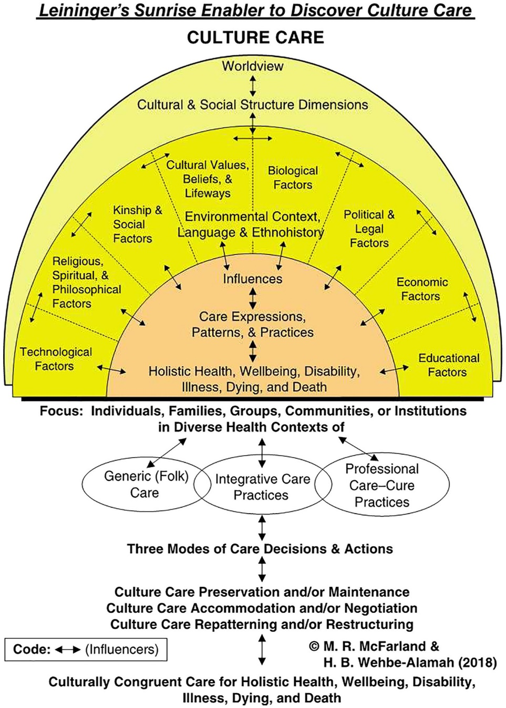
Appendix B
Permission for Use

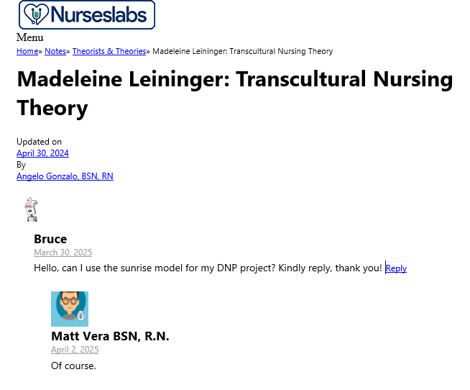
Appendix C
JHNEBP Model
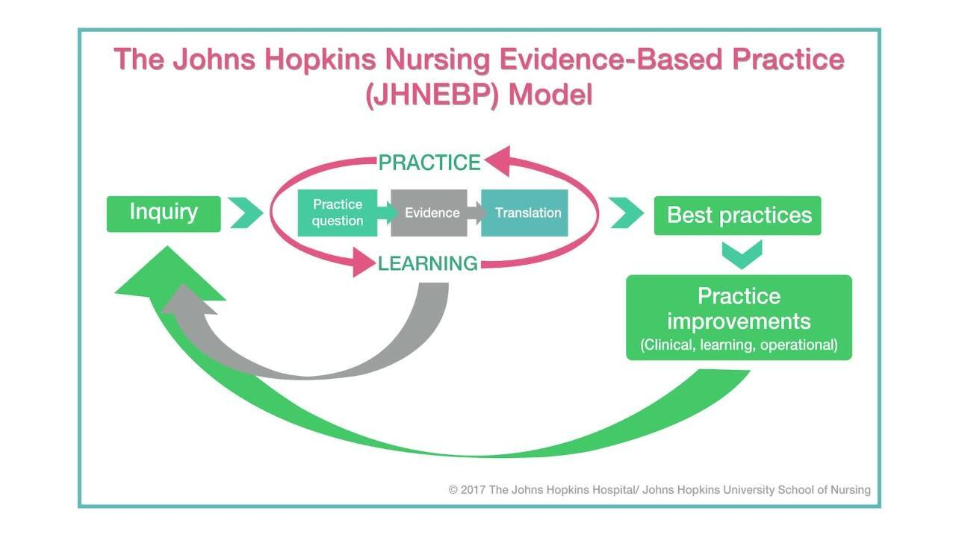

Appendix D
Permission for the use of the JHNEBP Model graphic

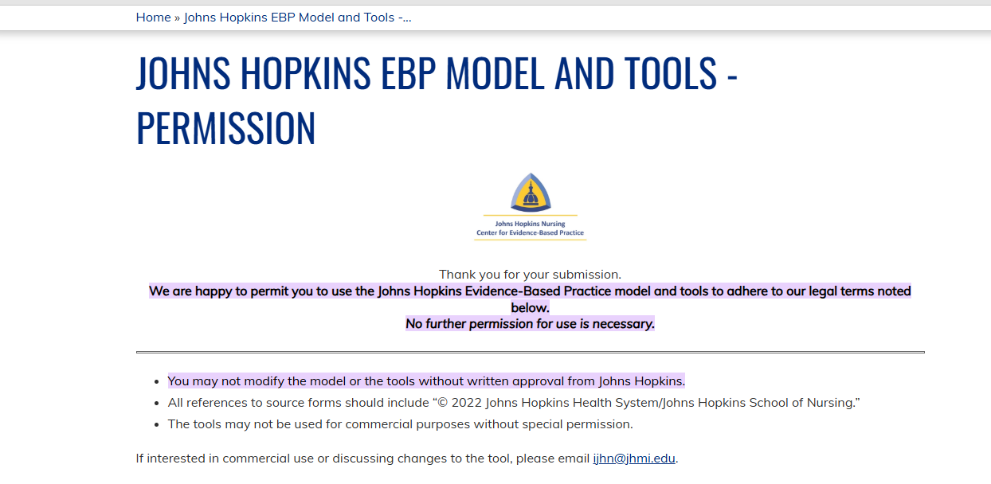

Appendix E
Invitation to Participate
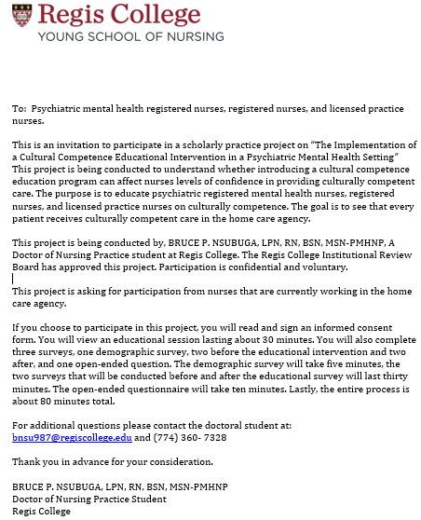

Appendix F
Demographic Survey
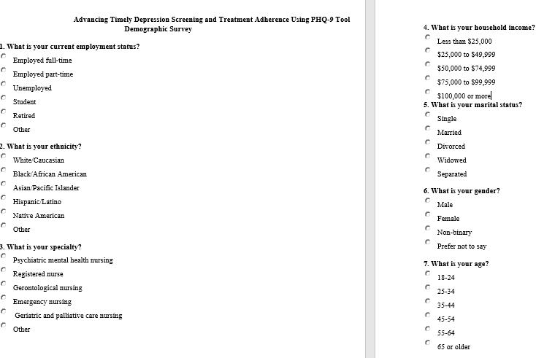
Appendix G
Instrument #1
Central Vancouver Island Multicultural Society’s Cultural Competence
Self-Assessment Checklist
This self-assessment tool is designed to explore individual cultural competence. This tool allows us to obtain your input on the training series entitled “Culturally Relevant Programs for Probation” which will enable us to tailor this training series to fit your needs. This training supports the Enhanced Outcome-Based Supervision (EBOS) model by helping to enrich interactions with diverse populations. The checklist looks at your general skills, knowledge, and awareness pertaining to culture in the world around you—not necessarily specific to your role in supervision. It is important for us to understand your history and experiences pertaining to people with different cultural backgrounds so please answer these questions honesty. All responses are anonymous.
Please note the term ‘culture’ includes race, ethnicity and ancestry, but also the culture (e.g. beliefs, common experiences and ways of being in the world) shared by people with characteristics in common. It’s important to consider that many of the interpersonal skills you’ve developed during your lifetime through your interactions with people from differing cultural backgrounds are transferable and can be applied across various settings.
Directions: Read each entry and place a check mark in the appropriate column that best represents your opinion.

Awareness | Statement | Never | Sometime/occasionally | Fairly often/pretty well | Always/very well
Value Diversity | I view difference as positive and a reason to celebrate.
Know myself | I have a clear sense of my own ethnic, cultural and racial identity.
Share my culture | I am aware that in order to learn more about others I need to understand and be prepared to share my own culture.
Be aware of areas of discomfort | I am aware of my discomfort when I encounter differences in race, color, religion, sexual orientation, language, and ethnicity.
Check my assumptions | I am aware of the assumptions that I hold about people of cultures different from my own.
Challenge my stereotypes | I am aware of my stereotypes as they arise and have developed personal strategies for reducing the harm they cause.
Reflect on how my culture informs my judgement | I am aware of how my cultural perspective influences my judgment about what are ‘appropriate’, ‘normal’, or ‘admirable’ behaviors, values, and communication styles.
Accept ambiguity | I accept that in cross-cultural situations, there can be uncertainty, and that can cause uneasiness.
 | I take the time needed to get more information in cross-cultural situations.
Be curious | I take any opportunity to put myself in places where I can learn about difference and create relationships.
Aware of racial privilege | I am aware that having “racial privilege” means one’s race does not create barriers to goal attainment or justice.
 | Those who are perceived as having racial privilege may also be perceived as having certain advantages and benefits when compared to those who are perceived as not having racial privilege.
 |  | 1 pt x | 2 pt x | 3 pt x | 4 pt x

Knowledge |  | Never | Sometime/occasionally | Fairly often/pretty well | Always/  very well
Gain from my mistakes | I will make mistakes and will learn from them.
Assess the limits of my knowledge | I recognize that my knowledge of certain cultural groups is limited and will commit to creating opportunities to learn more.
Ask questions | I will really listen to the answers before asking another question.
Acknowledge the importance of difference | If I am working with a person of a different culture, ethnicity, etc. I understand that I may be perceived as a person with different degrees of power or privilege, and that I may not be seen as ‘unbiased’ or as an ally.
Know the historical experiences of non-European Americans | I am knowledgeable about historical incidents in America’s past that demonstrate racism and exclusion towards Americans of non-European heritage (e.g. the Japanese internment, slavery, Jim Crow, Islamophobia…).
Understand the influence culture can have | I recognize that cultures change over time and can vary from person to person, as does attachment to culture.
Commit to life-long learning | I recognize that achieving cultural competence involves a commitment to learning over a life-time.
Understand the impact of racism, sexism, homophobia | I recognize that stereotypical attitudes and discriminatory actions can dehumanize and even encourage violence against individuals because of their membership in groups which are different from myself.
Know my own family history | I know my family’s story of immigration and assimilation into America.
Know my limitations | I continue to develop my capacity for assessing areas where there are gaps in my knowledge of other cultures.
 |  |  | 2 pt x | 3 pt x | 4 pt x

Skills | Statement | Never | Sometime/occasionally | Fairly often/pretty well | Always/  very well
Adapt to different situations | I am developing ways to interact respectfully and effectively with individuals and groups.
Challenge discriminatory and/or racist behavior | I can effectively intervene when I observe others behaving in a racist and/or discriminatory manner.
Communicate across cultures | I am able to adapt my communication style to effectively interact with people who speak in ways that are different from my own.
Seek out situations to expand my skills | I seek out people who challenge me to maintain and increase the cross-cultural skills I have.
Become engaged | I am actively involved in initiatives, big or small, that promote understanding among members of diverse groups.
Act respectfully in cross-cultural situations | I act in ways that demonstrate respect for the culture and beliefs of others.
Practice cultural protocols | I am learning about and put into practice the specific policies and procedures related to culture which are necessary for my work.
Act as an ally | My colleagues who are of a different ethnicity than I am consider me to be an ally and know that I will support them in culturally appropriate ways.
Be flexible | I work hard to understand the perspectives of others and consult with my diverse colleagues about culturally respectful and appropriate courses of action.
Be adaptive | I know and use a variety of relationship building skills to create connections with people who are different from me.
 |  | 1 pt x | 2 pt x | 3 pt x | 4 pt x

Appendix H
Permission for Use of the Cultural Competence Checklist
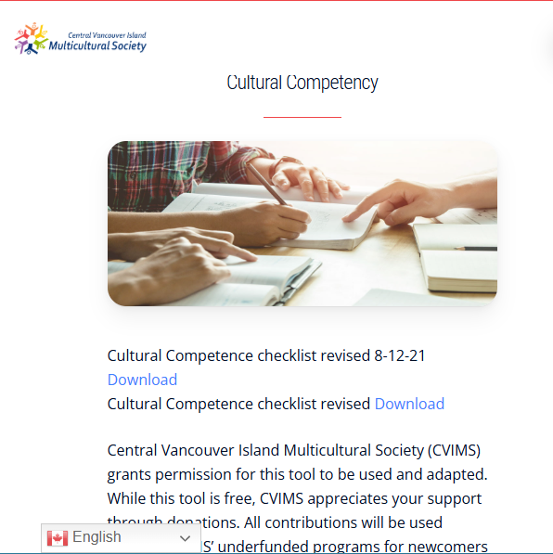

Appendix I
Instrument #2
Confidence Scale (C-Scale)
Directions: Circle the number which best describes how you perceive your current ability to perform strategies to become competent in Cultural Competence while practicing as a nurse.

(NOTE: Make sure that the circle encloses just ONE number.)

1. I am certain that my performance is correct:

1 |  | 2 |  | 3 |  | 4 |  | 5
not at all certain |  | certain for only a few steps |  | fairly certain for a good number of steps |  | certain for almost all steps |  | absolutely certain for all steps
2. I feel that I perform the task without hesitation:

1 |  | 2 |  | 3 |  | 4 |  | 5
I have much hesitation |  | a fair amount of hesitation |  | a good part of it without hesitation |  | almost completely without hesitation |  | absolutely no hesitation
3. My performance would convince an observer that I'm competent at this task:

1 |  | 2 |  | 3 |  | 4 |  | 5
not at all |  | agree, a little |  | for much of it |  | for almost all of it |  | for absolutely all of it
4. I feel sure of myself as I perform the task:

1 |  | 2 |  | 3 |  | 4 |  | 5
not at all |  | very little |  | for much of it |  | for almost all of it |  | for absolutely all of it
5. I feel satisfied with my performance:

1 |  | 2 |  | 3 |  | 4 |  | 5
not at all |  | very little |  | for much of it |  | for almost all of it |  | absolutely satisfied with all of it

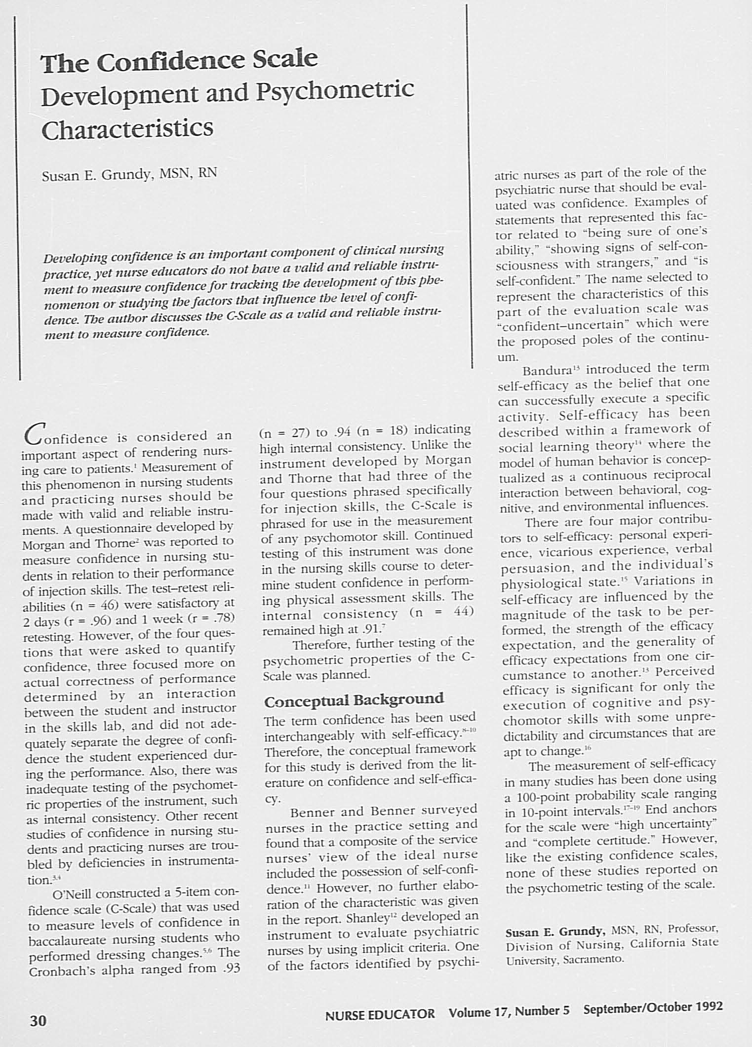
Appendix J
Permission for Use
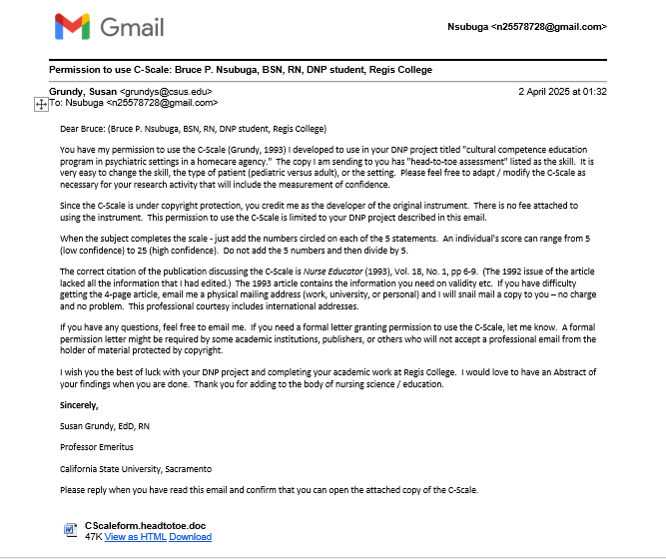
Appendix K
Open-Ended Questions
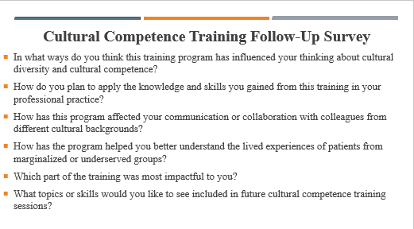
Appendix L
Educational Intervention Slides, Expert YouTube Links, Additional Resources, and Case Study
Educational Intervention Slides
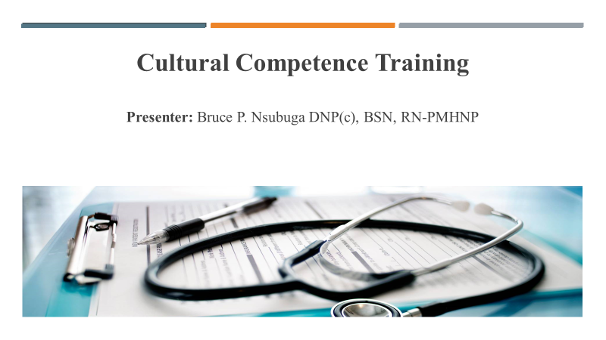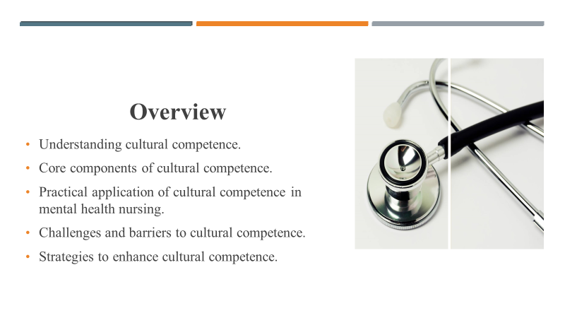
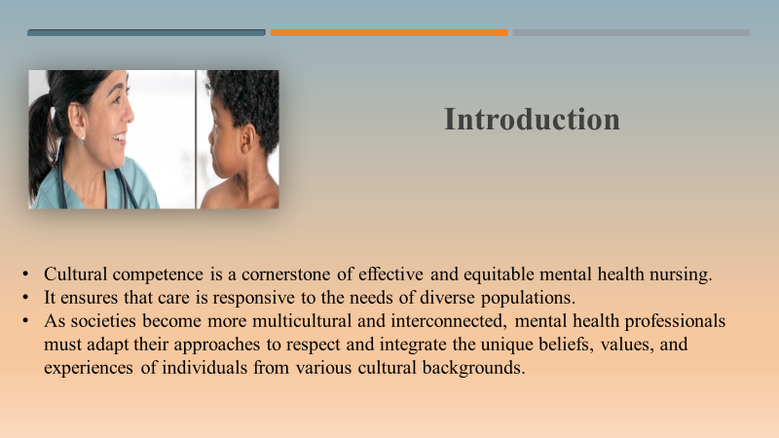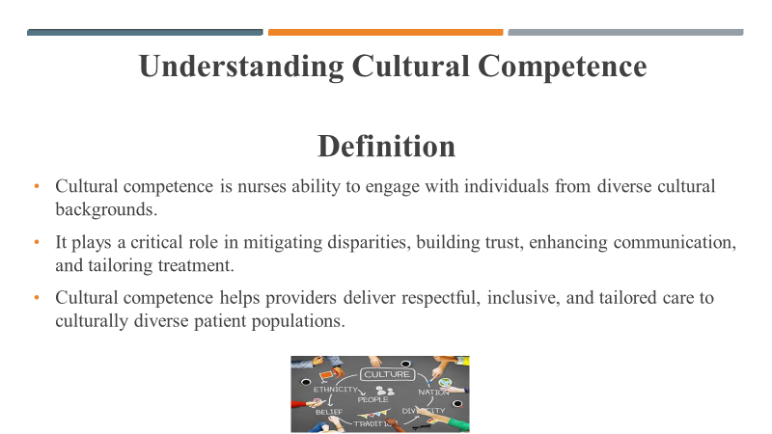
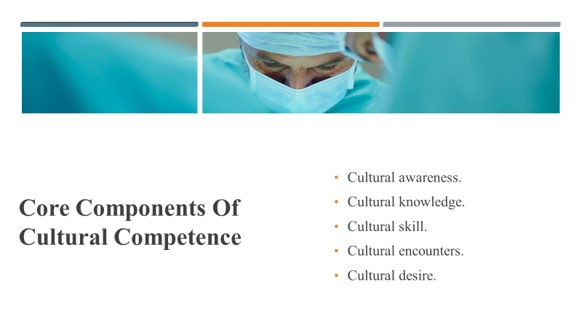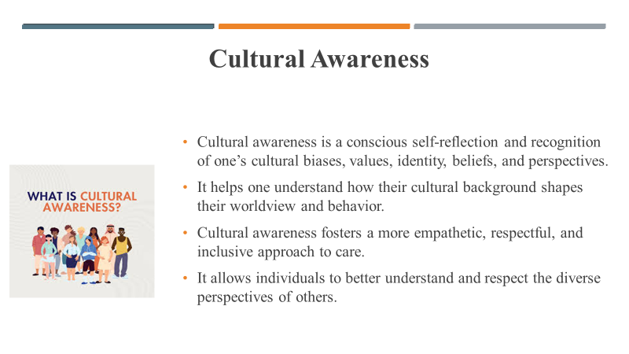

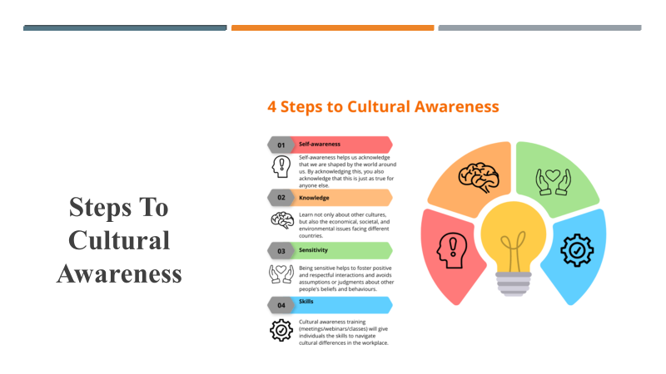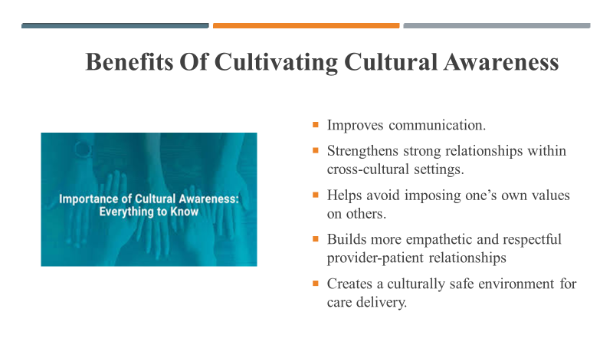
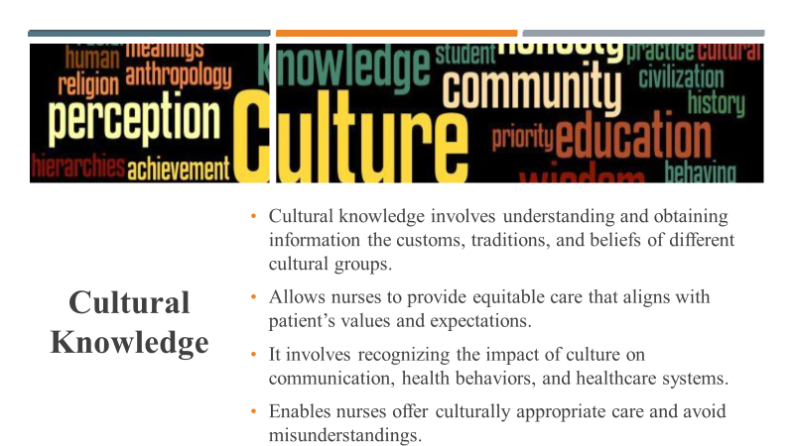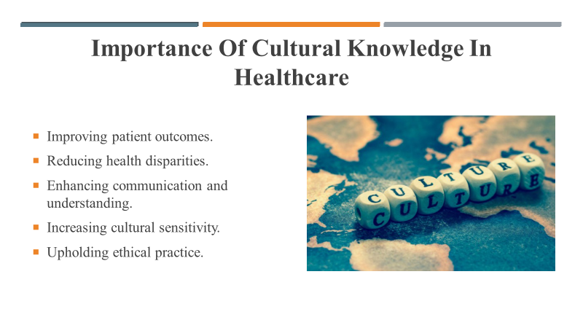
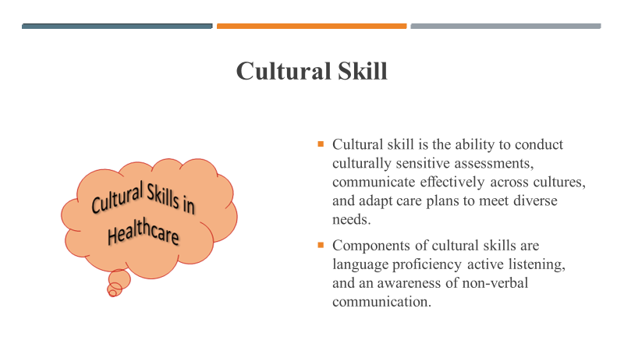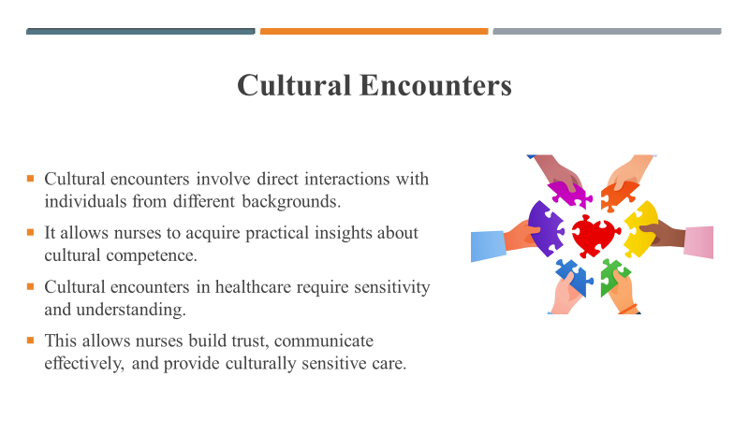
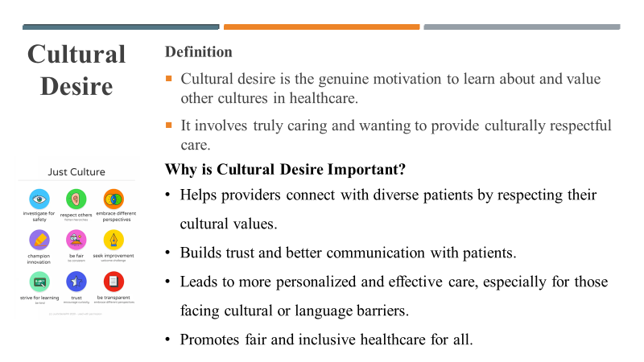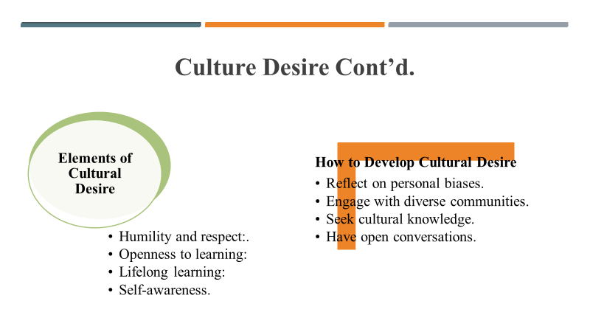
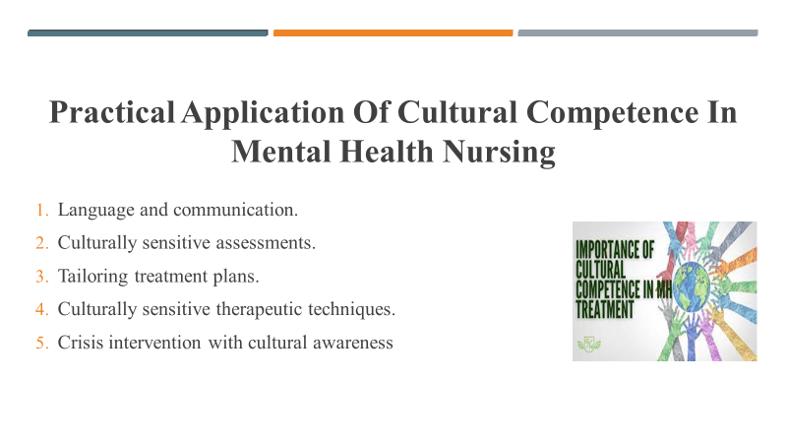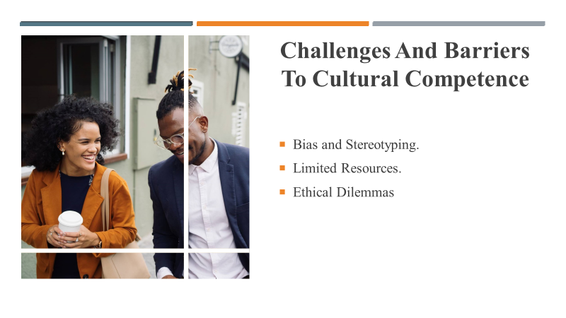
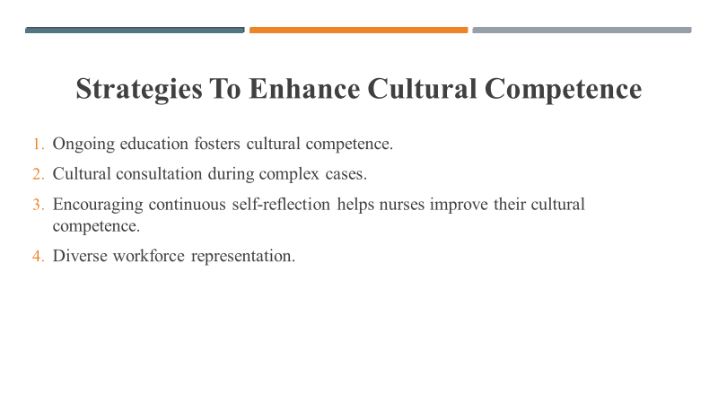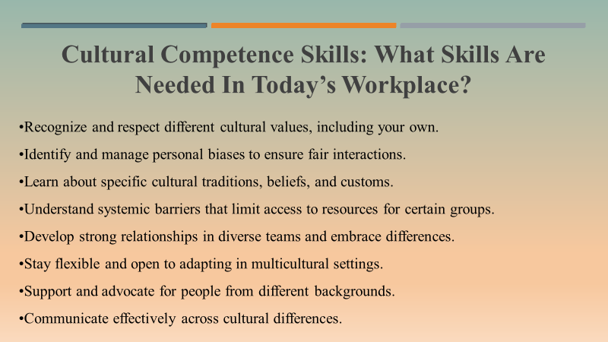
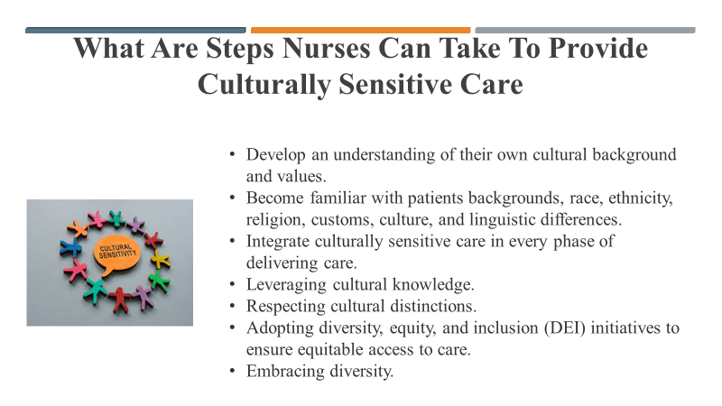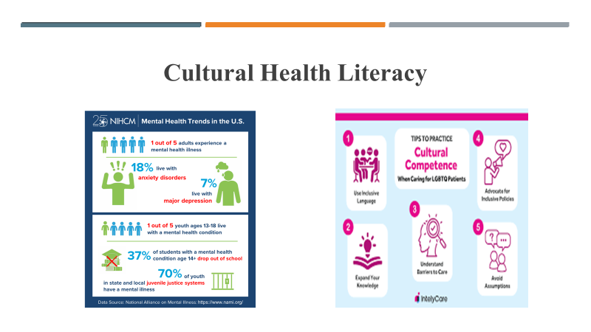
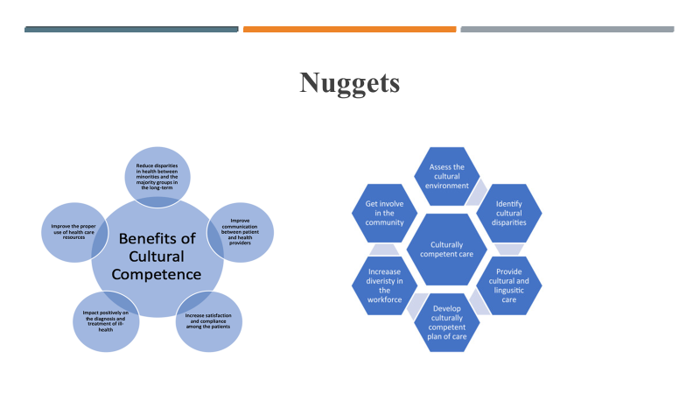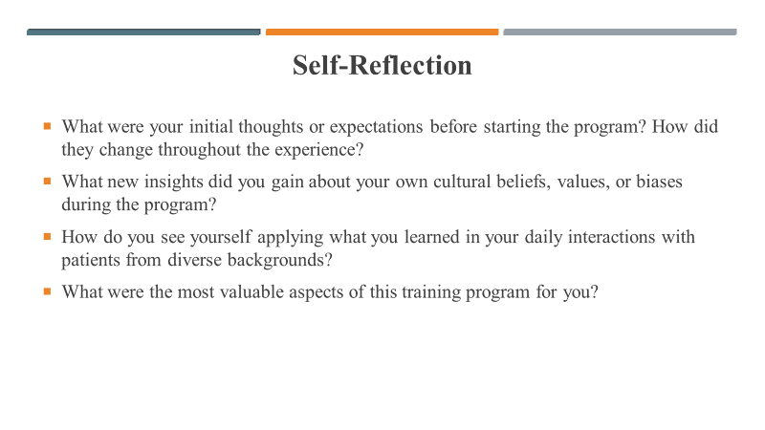
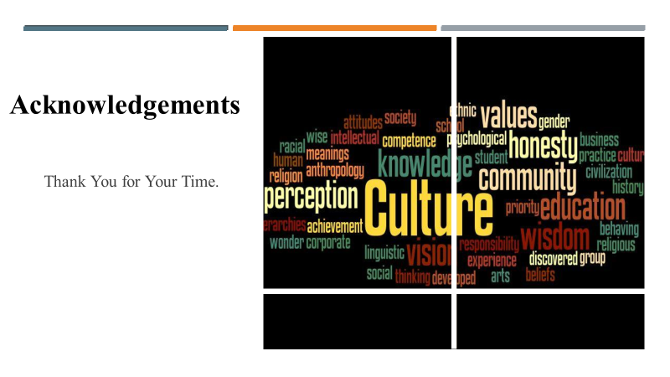

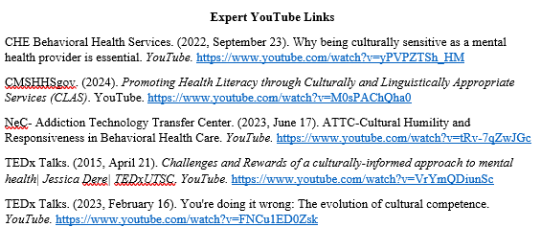

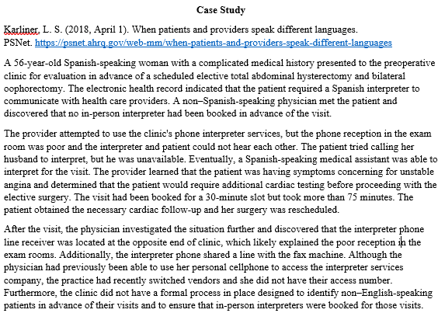

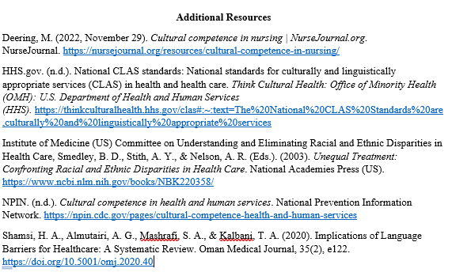

Appendix M
External Site Permission
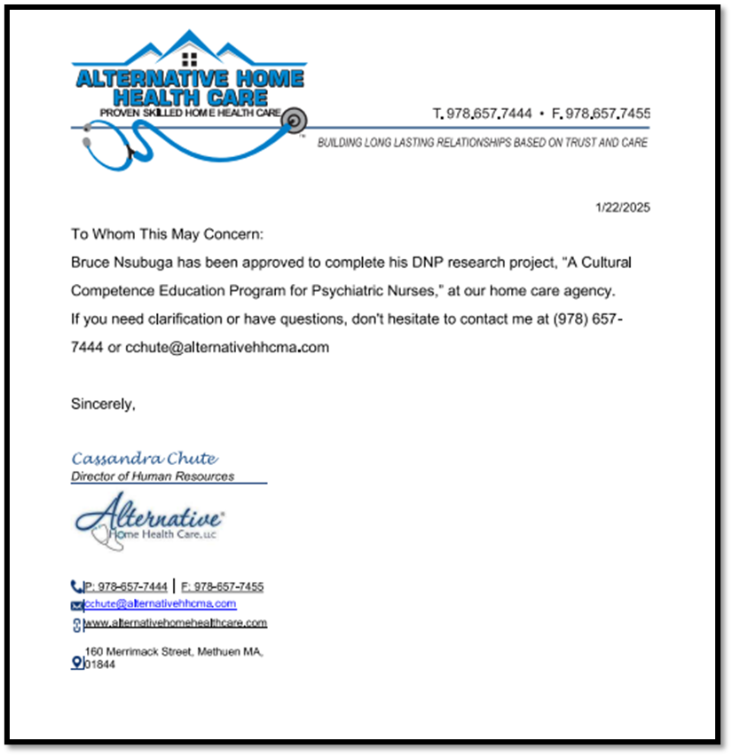

Appendix N
CITI Training Certificates
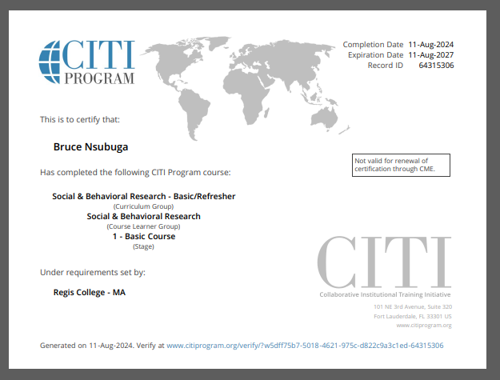
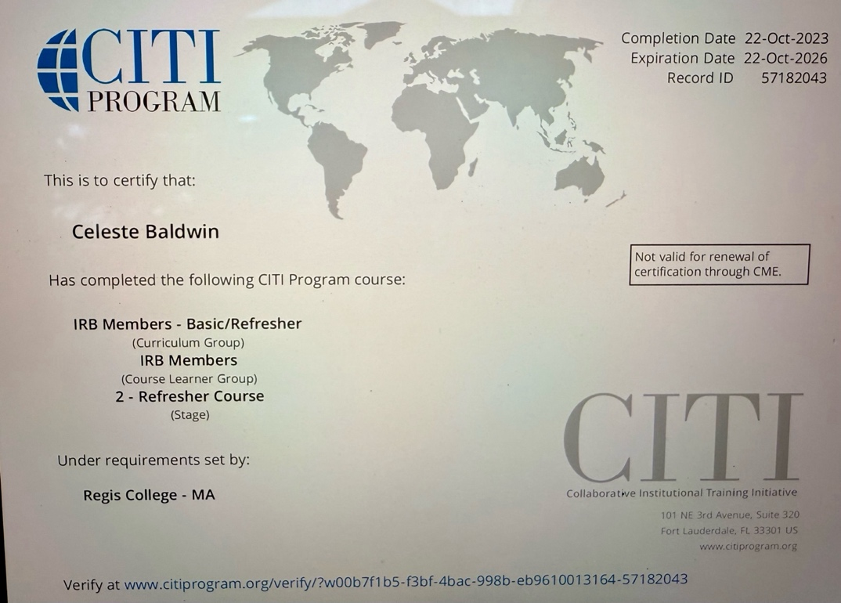
Appendix O
Primary Investigator Resume
BRUCE P. NSUBUGA, DNP(c), LPN, RN, BSN, MSN-PMHNP
19th Rhodes ST
Billerica, MA 01821
(774) 360- 7328
bnsu987@regiscollege.edu
Profile |  |  | As a highly proficient DNP(c), LPN, RN, BSN, MSN-PMHNP with over 17 years of nursing experience, I specialize in delivering bespoke, evidence-based mental health care to clients. I am committed to delivering top-notch patient care through effective education and counseling. I have proven leadership expertise focused on increasing and enhancing patient care and satisfaction. With a strong background in leadership, I specialize in implementing streamlined safety protocols and enhancing the overall quality of care.
KEY SKILLS AND COMPETENCIES |  |  | - Adept supervisory expertise  - Excellent in impeccable communication and problem-solving skills  - Possess sturdy verbal and written communication skills  - Compassion  - Proficient in cultural awareness  - Provides camaraderie and emotional support  - Patient-focused care  - Competent in recording patients’ vital signs  - Direct patient care expertise  - Proficient at conducting comprehensive patient assessments  - Skillfully manages medical records  - Tube feeding and medications familiarity  - Skilled at wound care  - Possess a gamut of dementia and Alzheimer’s knowledge
EDUCATION |  |  | Doctor of Nursing Practice, Jan 2023 - Current  - Regis College, Weston, MA  Master of Science Psychiatric Mental Health Nurse Practitioner (PMHNP), Jan 2021 – Jan 2023  - Regis College, Weston, MA  Bachelor of Science (BSN), Jan 2008 – Jan 2012  - Salem State University, – Salem, MA.  Licensed Practical Nurse Certificate (LPN: Nursing), Jan 2003 – Jan 2004  - St. Joseph School of Nursing – Nashua, NH  Associate of Arts: Liberal Arts and General Studies, June 2002 – September 2009  - Mass Bay Community College – Wellesley, MA
WORK EXPERIENCE |  |  | Tewksbury State Hospital, Mental Health, Tewksbury, MA, Psychiatric Mental Health Nurse Practitioner (PMHNP), 2018-01 – Current  Roles and Responsibilities  - Participates in continuous improvement by generating suggestions and engaging in problem-solving activities to support teamwork  - Performs frequent, ongoing assessments of patient's status  - Reviews post-operative orders and continuously monitors patients’ post-operative vitals.  - Delivers top-tier quality care to diverse populations while overseeing patient admission and triaging based on acuity and appropriate department admission  - Responsible for administering medications and treatment to patients and monitoring their responses while working with healthcare teams to adjust care plans  - Facilitates therapeutic communication, conflict resolution, and crisis intervention  - Complies with HIPAA laws and prevents information breaches effectively  - Updates patient charts on the EHR with data to keep records current and support accurate treatments  - Observe and document patient factors to understand conditions and actively modify treatment plans  - Recommend patients referrals to different specialists  - Reports findings to the quality department after conducting routine restraint audits  - Assesses patients’ physical and mental status by analyzing complaints and symptoms  - Educates patients and family members about medical conditions and mental health medications, treatment, and preventive measures  - Develops a treatment plan for mental health problems and psychiatric disorders based on evidence-based standards of care, biopsychosocial theories, and current practice guidelines.  - Crisis intervention.  - Perform intake screenings, initial evaluation, and triage.  - Work collaboratively with interdisciplinary teams.  Alternative Home Care Services, Methuen MA, Registered Nurse (Mental Health), 2012-01 – Current  Roles and Responsibilities  - Responsible for assessing patients’ physical and mental status  - Educating patients and family members about medical conditions  - Evaluating, ordering, and interpreting diagnostic tests to assess and identify patients’ conditions  - Performs frequent, ongoing assessment of patients’ status to address changes or any abnormal changes  - Reviews post-operative orders and continuously monitors patients’ post-operative vitals  - Leverages feedback and process improvement opportunities to create a safer and healthier environment and increase patient satisfaction  - Administers medications and treatment to patients  - Adheres to all personal and health data procedures to effectively comply with HIPAA laws  - Updates patient charts using [software]  - Partners with other healthcare providers to develop and implement individualized care plans and document all patient interactions and interventions in electronic charting systems  - Uses first-hand knowledge and clinical expertise to advocate for patients under care and enact prescribed treatment strategies  - Performs and documents a comprehensive psychiatric evaluation that includes evaluation of mental status, current and past history of violence, suicidal or self-harm behavior, substance use, level of functioning, health behaviors, trauma, sexual behaviors, and social and developmental history  - Develops a treatment plan for mental health problems and psychiatric disorders based on evidence-based standards of care, biopsychosocial theories, and current practice guidelines  - Manages patients recovering from medical or surgical procedures  - Provide patients and their families information regarding the benefits and risk of various medications  - Provide consultative psychiatric evaluations and recommendations within the continuum of mental health care  - Develop rapport and trust with patients and their families by using therapeutic communication techniques  Hospice, Danvers, MA, Registered Nurse (Hospice), 2012-01 – Current  Roles and Responsibilities  - Admissions and gathering patients’ history  - Confers with physicians to discuss diagnoses and devise well-coordinated treatment approaches  - Establishing hospice care services for elderly and disabled patients  - Building rapport with patients, families, and physicians by utilizing exemplary communication and active listening  - Provides high-level quality, compassionate care to patients and caregivers during each nursing shift  - Responsible for medication and iv administration, catheter insertion, and airway management  - Reports patients’ status and delegates nurse assignments to achieve optimal outcomes  - Monitoring patient vital signs.  - Appraising clients’ comfort levels  - Acknowledging mechanisms to personalize care  - Offering physical, emotional, and mental support to patients and their families  - Educates family members and caregivers on patient care instructions  - Provides holistic hospice health care
LICENSURE |  |  | - Registered Nurse (BSN-RN, AND-RN), 2012  - Licensed Practical Nurse since 2004
CERTIFICATIONS |  |  | - Phlebotomy  - First Aid and CPR  - Palliative care certificate  - Occupational Safety and Health Administration (OSHA) certificate  - Dementia training  - IV start certified.  - CITI training certificate
PROFESSIONAL AFFILIATIONS |  |  | - Sigma Theta Tau International Honor Society of Nursing: Member of Pi Epsilon at-Large Chapter Emmanuel College, Laboure College of Health Care, Regis College
LANGUAGES |  |  | - English
QUALIFICATIONS |  |  | - Admissions.  - Care plan development.  - Precepting.  - Chronic care management.  - Pleura drain care.  - Supervising staff.  - Implementing physician orders.  - Discharge teaching and planning.  - End of life care.  - Emergency response and management.  - Mechanical ventilators.  - IV access of peripheral line infusion.  - Management of peripheral lines, midlines, and PICC lines.  - Wound care.  - Medication administration, management, and documentation.  - Serving as a patient or family advocate.

Appendix P-Flesch-Kincaid Grade Level for Informed Consent

Flesch-Kincaid Grade Level Score
8.0

